GMAW Welding Assignment
Name: _________________
Date: _________________

Description:
This final project will test students on their GMAW (MIG) welding ability. Students will be proficient in reading plans and figuring out how you would layout the project. Students will demonstrate that they can perform arc welding proficiently. Students will demonstrate good workmanship by assembling this project correctly, neatly, and accurately.

Materials:
¼” x 4” Mild Steel Bar
¼” x 2” Mild Steel Bar
1 ¼” Black Pipe
7018 x 1/8” welding rod

Tools:
GWAW Welder
Oxy- Acetylene Torch
Bench Grinder
Angle Grinder
Hydraulic Shear
Chop Saw
Chipping Hammer
Wire Brush
Square
Soapstone

Procedure:
- Pay attention to layout, neatness and workmanship
- Dress in appropriate welding safety gear, leather gloves, welding helmet, welding jacket
- Cut 1 ¼” pipe 1” long using the chop saw.
- Cut 3 pieces of ¼” x 2” bar 5” long with the shear.
- Cut 1 piece of ¼” x 4” bar 5” long with the shear.
- With an oxy- acetylene torch cut the 4” x 5 plate into 2 pieces (1 ½” and 2 ½”).
- Grind the edges as need to prepare for welding.
- By using the attached drawing determine the order of how you want to weld the plates together
- Perform all welds on your diagram
- Once finished with construction, clean the welds.
- Make sure to label with your project and turn in your paper for grading.

Notes:
____________________________________________________________________________________________________________________________________________________________________________________________________________________________________________________________________________________________________________________________________________________

Photo/Drawing:

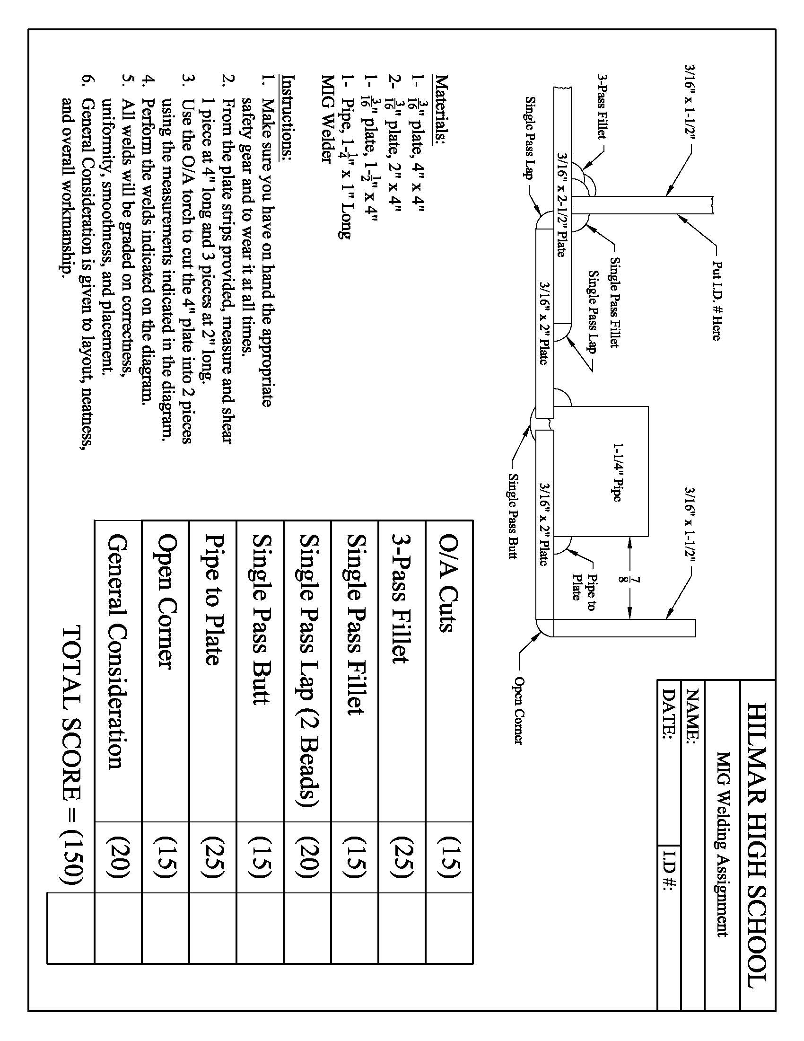
GMAW Welding Worksheet
Name: ______________
Date: _______________

Complete before you start:
- What materials will you be using?
___________________________________________________________________________
- What tool is used to cut the pipe?
___________________________________________________________________________
- Determine the weld order. Number the welds on the drawing.
- Why is it important to tack the project before welding?
___________________________________________________________________________
- How will you ensure the vertical pieces are square?
___________________________________________________________________________

Grading Rubric:
CRITERIA | POSSIBLE | SCORE
Oxy- acetylene cuts | 15
3 Pass fillet | 25
Single pass fillet | 15
Single pass lap | 20
Single pass butt | 15
Pipe to Plate | 125
Workmanship | 20
Total: | 150

Arc Welding Teachers Notes:
This is designed to be a summative exercise to demonstrate welding ability.

Agricultural Standards Met:
B7.0 Students understand oxy-fuel cutting and welding:
B7.1 Understand the role of heat and oxidation in the cutting process.
B7.2 Know how to properly set up, adjust, shut down, and maintain an oxy-fuel system.
B7.3 Know how to flame-cut metal with an oxy-fuel cutting torch
B8.0 Students understand electric arc welding processes:
B8.1 Know how to select, properly adjust, safely employ, and maintain appropriate welding equipment (e.g., gas metal arc welding, shielded metal arc welding, gas tungsten arc welding).
B8.2 Apply gas metal arc welding, shielded metal arc welding, or flux core arc welding processes to fusion-weld mild steel with appropriate welding electrodes and related equipment.
B8.3 Weld a variety of joints in various positions.
B8.4 Know how to read welding symbols and plans, select electrodes, fit-up joints,and control heat and distortion.
B1.0 Students understand personal and group safety:
B1.1 Practice the rules for personal and group safety while working in an agricultural mechanics environment.
B1.2 Know the relationship between accepted shop management procedures and a safe working environment.

Objectives:
By properly completing this project, students will be able to:
- Read a plan and layout dimensions
- Be proficient in arc welding
- Constructing a sound, neat and correct project

Alternative Tools/Methods/Materials:
- All steel could be cut with a Chop Saw or a torch used for more pieces.
- Oxy Cutting could be omitted (use 2” pieces).

Safety Review:
- Welding attire
- Oxy- Acetylene torch use
- MIG Welding
- Hydraulic Shear
- Chop Saw

Project Time:
Demonstration: | 10 minutes
Build: | 2 hours

Demonstration Notes
- Set shear stop to 5”.
- Show a finished project.
- Discuss the possible order of the welds.

Bill of Materials:

Project from Hilmar High School, Dick Piersma..

