Arc Welding Assignment – Tee Joint
Name: _________________
Date: _________________

Description:
An arc welding assignment sheet with single and multiple pass welds.

Materials:
See assignment for materials and electrode.

Tools:
SMAW Welder
Hydraulic Shear
Chipping Hammer
Wire Brush
Soapstone

Procedure:
- Review the attached plan and rubric.
- Follow the instructions on the plan.
- Dress in appropriate welding safety gear, leather gloves, welding helmet, welding jacket
- Make sure to label with your project and turn in your paper for grading.

Notes:

Drawing:
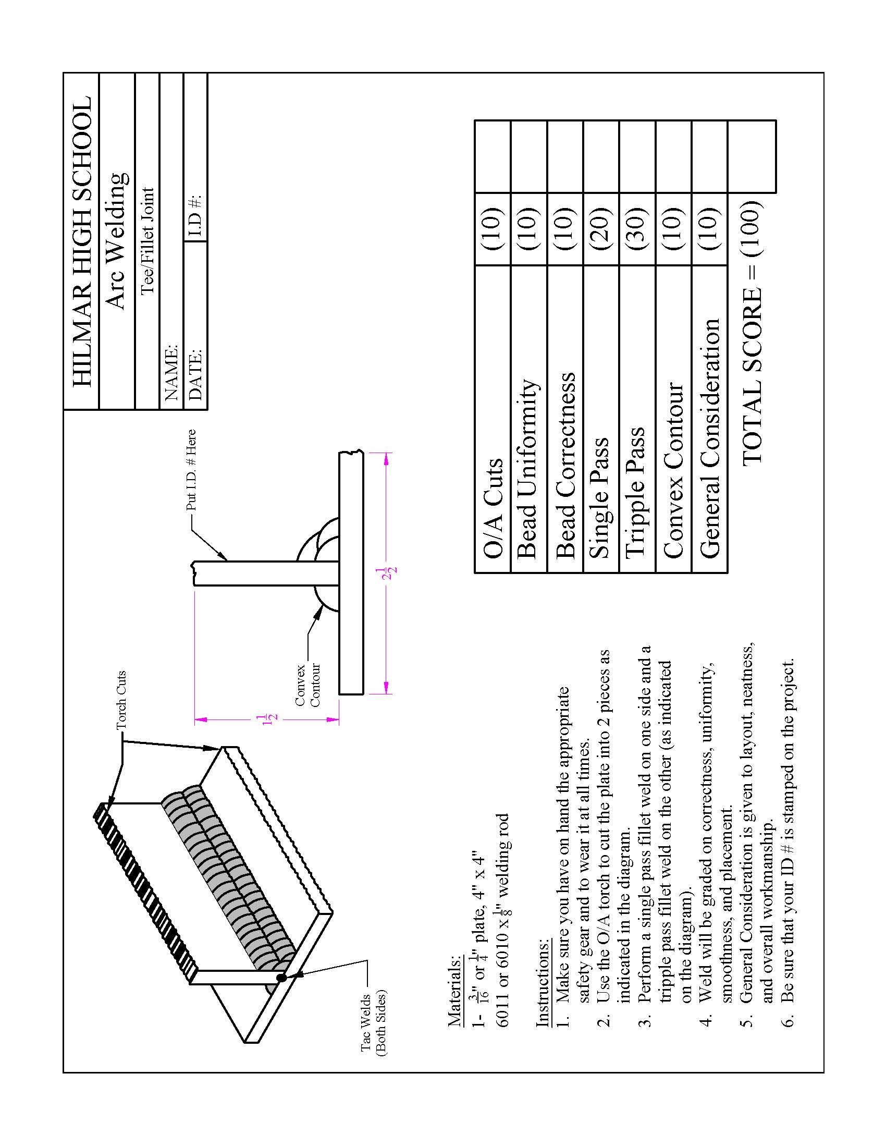

Arc Welding Worksheet
Name: ______________
Date: _______________

Complete before you start:
- What materials will you be using?
___________________________________________________________________________
- What position and electrode will you be using?
___________________________________________________________________________
- How will you prepare the metal for welding?
___________________________________________________________________________
- Why is it important to tack the project before welding?
___________________________________________________________________________
- How will you ensure the vertical pieces are square?
___________________________________________________________________________

Grading Rubric:
(See assignment sheet)

Arc Welding Teachers Notes:
This is designed to be a summative exercise to demonstrate welding ability.

Agricultural Standards Met:
B7.0 Students understand oxy-fuel cutting and welding:
B7.1 Understand the role of heat and oxidation in the cutting process.
B7.2 Know how to properly set up, adjust, shut down, and maintain an oxy-fuel system.
B7.3 Know how to flame-cut metal with an oxy-fuel cutting torch
B8.0 Students understand electric arc welding processes:
B8.1 Know how to select, properly adjust, safely employ, and maintain appropriate welding equipment (e.g., gas metal arc welding, shielded metal arc welding, gas tungsten arc welding).
B8.2 Apply gas metal arc welding, shielded metal arc welding, or flux core arc welding processes to fusion-weld mild steel with appropriate welding electrodes and related equipment.
B8.3 Weld a variety of joints in various positions.
B8.4 Know how to read welding symbols and plans, select electrodes, fit-up joints,and control heat and distortion.
B1.0 Students understand personal and group safety:
B1.1 Practice the rules for personal and group safety while working in an agricultural mechanics environment.
B1.2 Know the relationship between accepted shop management procedures and a safe working environment.

Objectives:
By properly completing this project, students will be able to:
- Read a plan and layout dimensions
- Be proficient in arc welding
- Constructing a sound, neat and correct project

Alternative Tools/Methods/Materials:
- All steel could be cut with a Chop Saw or a torch used for more pieces.
- Oxy Cutting could be omitted (use 2” pieces).

Safety Review:
- Welding attire
- Oxy- Acetylene torch use
- Arc Welding
- Hydraulic Shear
- Chop Saw

Project Time:
Demonstration: | 10 minutes
Build: | 2 hours

Demonstration Notes
- Demonstrate the preparation for welding
- Demonstrate tacking.
- Demonstrate the weld.
- Show a finished project.

Project from Hilmar High School (Dick Piersma)

