Book Holder
Name: ________________________
Date: ________________________

Description:
This project consists of building a book holder with an adjustable end. The project uses common woodworking tools. When building the project, you will practice layout with a combination square.

Materials:
1" x 6" #3 Pine
½” hardwood dowel
Glue
120 grit Sandpaper
Paint/Stain

Tools:
Power Miter Saw
Drill Press
½” & 5/8” Forstner Bits
Claw Hammer
Band Saw
Combination Square
Steel Tape
Pencil

Procedure:
- Cut ends to length using the miter saw.
- Layout corners and holes.
- Drill the holes on the drill press.
- Cut the corners using the bandsaw.
- Sand the edges.
- Cut the dowels on the miter saw. CAUTION. Hold tight so the dowel cannot roll.
- Insert the dowels into the fixed end using a small amount of glue. Remove any excess glue.
- After the glue has dried do a final sanding.
- Paint or stain as desired.

Cutting List:
2 | 3/4"x5 1/2” x 7 ½” | #3Pine
2 | ½” x 11 ½” | Dowel

Notes:
___________________________________________________________________________________________________________________________________________________________________________________________________________________________________________________________________________________________________________________________________________________________________________________________________________________________________________________________________________________________________________________________________________________________________________________________________________________

Photo/Drawing:
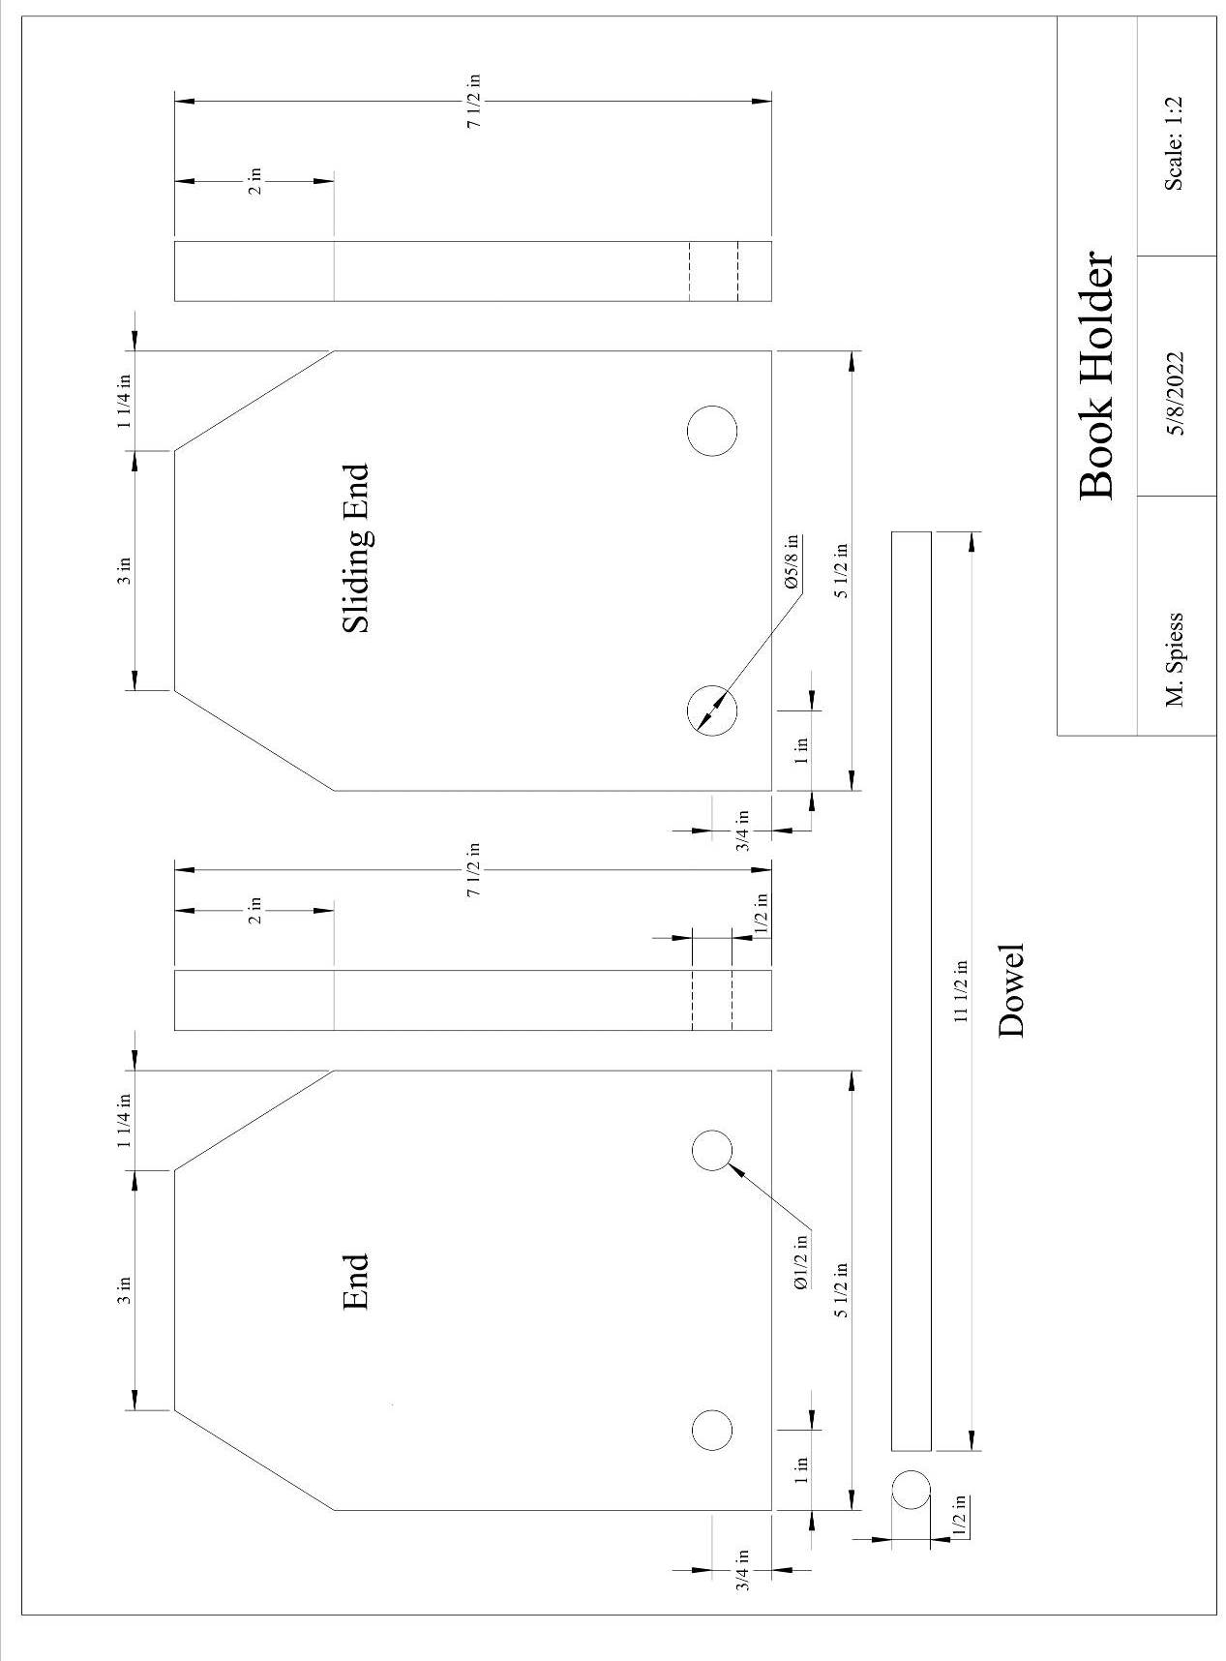
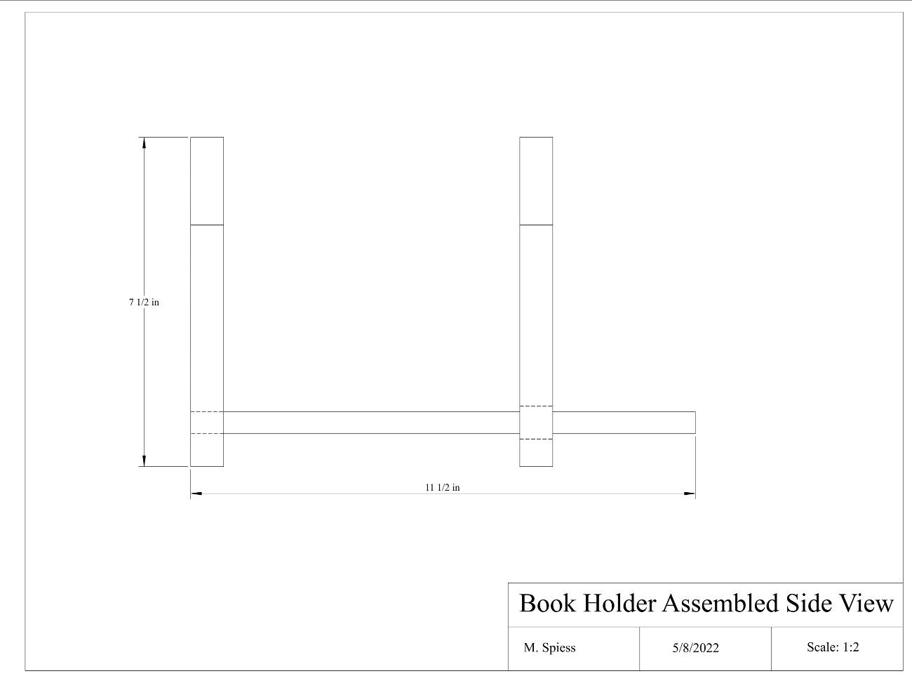
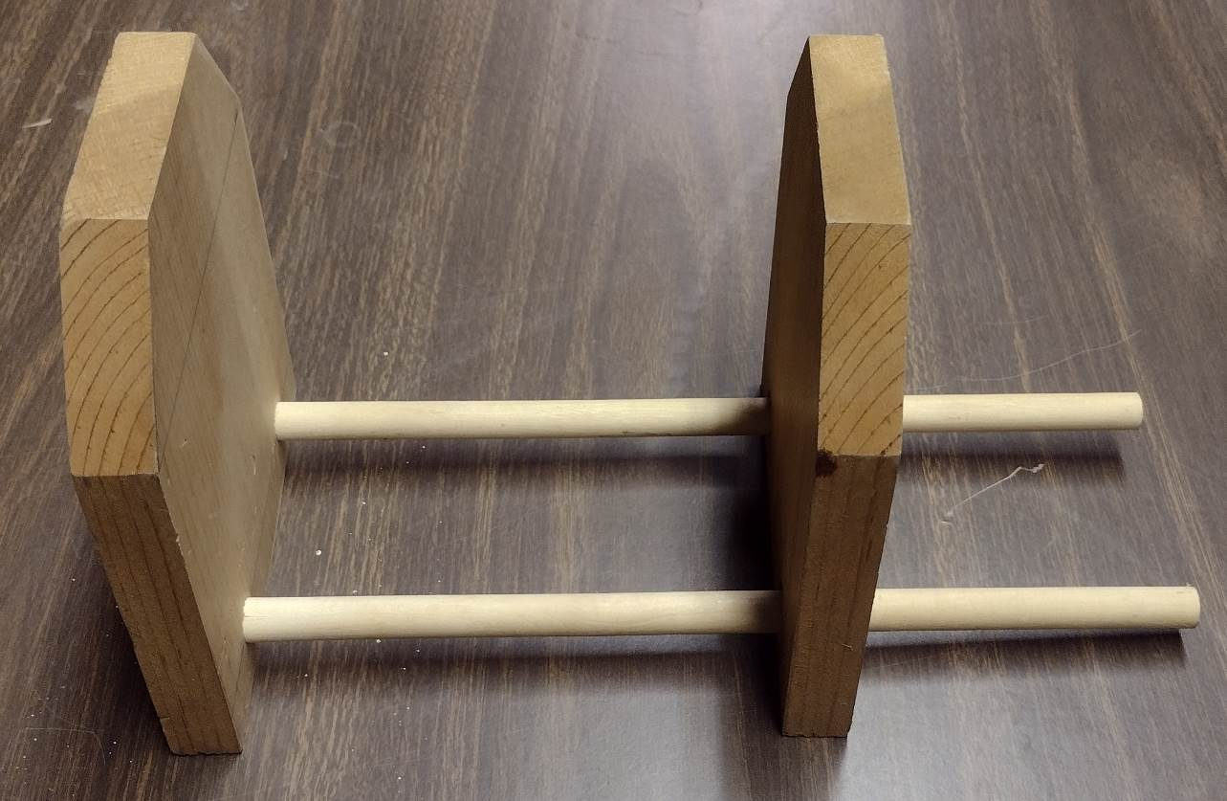

Pre-Building Worksheet
Name: ________________________
Date: ________________________

- What two materials will you use for the project?

- Why is wood selection important for this project?

- What type of bit is used to drill the holes?

- What tool did you use to layout the project?

- Why should you not use the miter saw to cut the corners?

Grading Rubric:
CRITERIA | POSSIBLE | SCORE
Correct measurements (height) | 5
Corner angles are correct | 5
Dowel holes are proper size | 5
Proper assembly | 5
Workmanship (cuts, sanding) | 5
TOTAL | 25

Teachers Notes:
- This is a good introductory project for practice using the miter saw, drill press, and band saw. Good layout practice with a combination square.
- This a forgiving project in that cutting to the wrong dimensions still can result in a useful project.
- The corners need not be beveled if a band saw is not available.
- The project could be done using hand tools and a brace to drill the holes.

Agricultural Standards Met:
6.0 Health and Safety. Students understand health and safety policies, procedures, regulations, and practices, including the use of equipment and handling of hazardous materials:
6.1 Know policies, procedures, and regulations regarding health and safety in the workplace, including employers’ and employees’ responsibilities.
6.2 Understand critical elements of health and safety practices related to storing, cleaning, and maintaining tools, equipment, and supplies.
6.4 Maintain safe and healthful working conditions.
6.5 Use tools and machines safely and appropriately.
6.6 Know how to both prevent and respond to accidents in the agricultural industry.
B1.0 Students understand personal and group safety:
B1.1 Practice the rules for personal and group safety while working in an agricultural mechanics environment.
B1.2 Know the relationship between accepted shop management procedures and a safe working environment.

B2.0 Students understand the principles of basic woodworking:
B2.1 Know how to identify common wood products, lumber types, and sizes.
B2.3 Know how to identify, select, and implement basic fastening systems.
B2.4 Complete a woodworking project, including interpreting a plan, developing a bill of materials and cutting list, selecting materials, shaping, joining, and finish­ing

Objectives:
By properly completing this project, students will be able to:
- Read a plan and implement layout dimensions.
- Use power tools to cut wood.
- Fasten all components together using nails and screws.
- Select kinds, grades, and quantity of lumber for a given task.

Alternative Tools/Methods/Materials:
Can be built using hardwood. Ends can be rounded. Length is easy to alter to make a longer book holder. Can be cut from 1”x12” lumber if you want to introduce the table saw. CAUTION: Do not rip shot boards.

Safety Review:
- Safety Glasses
- Miter Saw Safety
- Drill Press
- Bandsaw

Project Time:
Demonstration: | 15-20 minutes
Build: | 1-2 hours

Demonstration Notes:
- Rip the 1 x 12 to 5 ½” strips on the table saw if you are using 1”x12” lumber.
- Explain how to avoid knots when selecting lumber.
- Demonstrate “measure, mark, cut” using the miter saw. Place a “X” on the side of the cut mark where the kerf will be. Remind students that one small mark is all that is needed since the miter saw cuts square and that cutting on the middle of the line will result in short pieces.
- Demonstrate the layout of the corners and centers of the holes using a combination square.
- Demonstrate cutting the corners on the band saw. Explain why the bandsaw is safer to use for this process than the miter saw. (Hard to hold small pieces against the fence.)
- Demonstrate drilling the holes. IMPORTANT: one end has ½” holes and one 5/8” holes. Hint: if you have 2 drill presses set one with a ½” drill and one with the 5/8” drill. Show how a scrap placed under the project will help in not having rough edges.
- Demonstrate how to cut the dowels by holding securely and cutting slowly so they cannot roll.
- Demonstrate sanding. You can make blocks from scrap 2x4.
- Demonstrate assembly. Be sure dowel is flush and sticking out a tiny bit (sand flush after glue dries).

Bill of Materials:
Plan by M. Spiess (CDE Project)

