Chaining Pin
Name: ___________________
Date: ___________________

Description:
You will learn to shape metal while hot. These projects will be heated using an oxy-acetylene torch with a rosebud or large welding tip. This skill is quite useful in repair of farm equipment. The chaining pin is useful in measuring fields and layout of building sites.

Materials:
20”- ¼” Mild Steel Round Stock
Emery cloth
Orange spray paint

Tools:
Blacksmith’s or Engineer’s Hammer
Anvil
Tongs/Pliers
Hacksaw
Oxy-acetylene with Rosebud Tip
Welding glove

Directions:
- Cut the round stock to length with a hacksaw.
- Cleanup the cut ends with a file.
- Use a center punch to mark the bend of the eye (7”).
- Heat a small area at the mark and bend to 90º.
- Heat the entire “eye” to red hot. DO NOT OVERHEAT!!! When the color is gone reheat as needed,
- Beginning at the end of the round stock form the eye over the anvil horn by tapping gently with the hammer.
- Trim to length (about 11 ½” from the bottom of the eye).
- Heat the end to be pointed and “draw out” the point to make the finished project 12”.
- Cool the project.
- Clean up with emery cloth.
- Paint at desired.

Notes:
____________________________________________________________________________________________________________________________________________________________________________________________________________________________________________________________________________________________________________________________________________________________________________________________________________________________________________________________________________________________________________________________________________________________________________________________________________________________________________________________________________________________________________________________________________________________________________________________________________________________________________________________________________________________________________________________________________________________________________________________________________________________________________________________

Photo/Drawing:
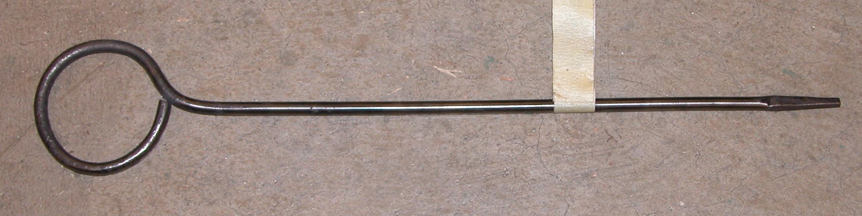

Chaining Pin Worksheet
Name: ________________________
Date: ________________________

- When using the Oxy-Acetylene torch, which tank do you turn on first, and which do you turn on second?
First:_____________________ Second:_____________________
- What are the most important safety precautions while completing this project:
_______________________ __________________________
- Always work the steel when _____________________. DO NOT _____________________!!!
- Form the eye by bending the stock at _____°
- 90 B. 45 C. 120 D. 360
- Always remember to _____________ the project before turning it in.

Grading Rubric:
CRITERIA | POSSIBLE | SCORE
Eye correct Size | 5
Eye Round | 5
Correct Length of Pin | 5
Point clean and neat | 5
Workmanship (shape, finish, paint) | 5
Total | 25

Chaining Pin Teachers Notes:

Agricultural Standards Met:
6.0 Health and Safety. Students understand health and safety policies, procedures, regulations, and practices, including the use of equipment and handling of hazardous materials:
6.1 Know policies, procedures, and regulations regarding health and safety in the workplace, including employers’ and employees’ responsibilities.
6.2 Understand critical elements of health and safety practices related to storing, cleaning, and maintaining tools, equipment, and supplies.
6.4 Maintain safe and healthful working conditions.
6.5 Use tools and machines safely and appropriately.
6.6 Know how to both prevent and respond to accidents in the agricultural industry.
B1.0 Students understand personal and group safety:
B1.1 Practice the rules for personal and group safety while working in an agricultural mechanics environment.
B1.2 Know the relationship between accepted shop management procedures and a safe working environment.
B7.0 Students understand oxy-fuel cutting and welding:
B7.2 Know how to properly set up, adjust, shut down, and maintain an oxy-fuel system.
B9.0 Students understand advanced metallurgy principles and fabrication techniques:
B9.1 Understand metallurgy principles, including distortion, hardening, tempering, and annealing.
B9.5 Understand how to finish a metal project by implementing proper sequencing

Objectives:
By properly completing this project, students will be able to:
- Read a plan to and layout dimensions.
- Cut metal using hacksaw
- Heat metal to proper temperature using oxy-acetylene torch
- Work hot metal

Alternative Tools/Methods/Materials:
- Could be made on forge.

Safety Review:
- Oxy-Acetylene Torches
- Oxy-Acetylene Tanks
- Hot Steel

Project Time:
Demonstration: | 30 minutes
Build: | 1 hour

Demonstration Notes
- Caution the students about handling hot steel around other students.
- You may wish to clamp the torch in a vise and have the students move the metal over the flame. Another method is to have the students work in pairs and one heats while the other forms, then they switch.
- Explain about the color. Red hot is good. Bright red or orange is too hot and metal will oxidize. When color is gone, metal is too cold.
- The trick in the project is the technique in making the eye. Always start with the 90º bend so the eye is centered. Bend the back over the shaft of the pin by placing the hot end over the horn of the anvil and tapping just past where the metal touches the anvil. As the metal bends advance the straight rod to continue the curl. Done correctly you will rapidly close the eye. Small adjustments in shape can be made on the horn after the eye is formed.
- Show how to draw out the point by heating the end, hold the pin up off the anvil a bit so the point angle is achieved on both sides. The point is square so shape two sides then turn 90º. Rotate often to make the point even. Reheat as needed.
- Instill in students the importance of workmanship. This is a simple project, but develops good skills.

Bill of Materials:
Project from: Mike Spiess; Plan by: Emmalea Wilkinson

