California CDE Board Electrical Wiring Projects
Name:_____________________
Date: _____________________

Description:
Students will learn how to properly install and wire using common industrial devices on an electrical Board. Students will practice using common electrical testers.

Materials*:
Single gang ½” plaster ring
2 gang ½” plaster ring
3” round ½” plaster ring
4” square blank cover.
Duplex Receptacle
Lamp holder with pig tails (must be connectable with wire nuts like common light fixtures) and mountable in the round plaster ring.
SPST switch
3 way switches SPDP
4 way switch DPDT
240V 20A receptacle
14/2 w/Gnd NM Cable
14/3 w/Gnd NM Cable
12/2 w/Gnd NM Cable
14 ga THHN conductor (various colors)
12 ga THHN conductor (various colors)
*Not all supplies will be used for each scenario.

Tools:
Screwdriver
Needle Nose Pliers
Wire cutter/stripper
Utility knife or cable ripper for NM cable

Procedure:
- Review the rules for wiring (text book). Key points are:
  - Color coding of wire and terminals. Green=ground, white=neutral, other colors are hot. Brass terminals are hot wires, silver terminals are neutral, green terminals are ground.
  - 6” of free conductor.
  - Use of wire nuts: tight and no bare wire showing.
  - Grounding: boxes and devices.
  - Proper connection to a screw terminal: Clockwise, loop ¾ around, no insulation under the screw, no bare wire past the device.
  - Breaker is an appropriate size for the circuit and wire is sized correctly.
- Complete the worksheet.
- Wire the assigned project.
  - Determine the proper circuit and how you will wire it BEFORE you start wiring.
  - Wire the ground wires first.
- Double check that you have followed the rules and that the wiring is neat.
- Secure the devices to the boxes with screws for testing.
- Attach a temporary power cord using wire nuts. OBSERVE color-coding.
- Using the Testing Circuit Breaker box, plug in your board and test the circuit using a lamp and/or a duplex receptacle tester. Have this portion graded.
- Disconnect your board. Use a piece of tape to label the board with your name. Remove the screws from the devices and turn in the board for grading.

Terms:
- Stub out: Leave 6” of conductor in the box unconnected for a future connection.
- Rough in: Boxes are grounded and wires connected as needed in boxes. Plaster rings are installed. Devices are left unconnected.

Notes:_________________________________________________________________________________________ ________________________________________________________________________________________________________________________________________________________________________________________________________________________________________________________________________________________________________________________________________________________________________________________________________________________________________________________________________________________________________________________________________________________________________________________________________________________________________________________________________________________________________________________________________________________________________________________________________

The Wiring Board:
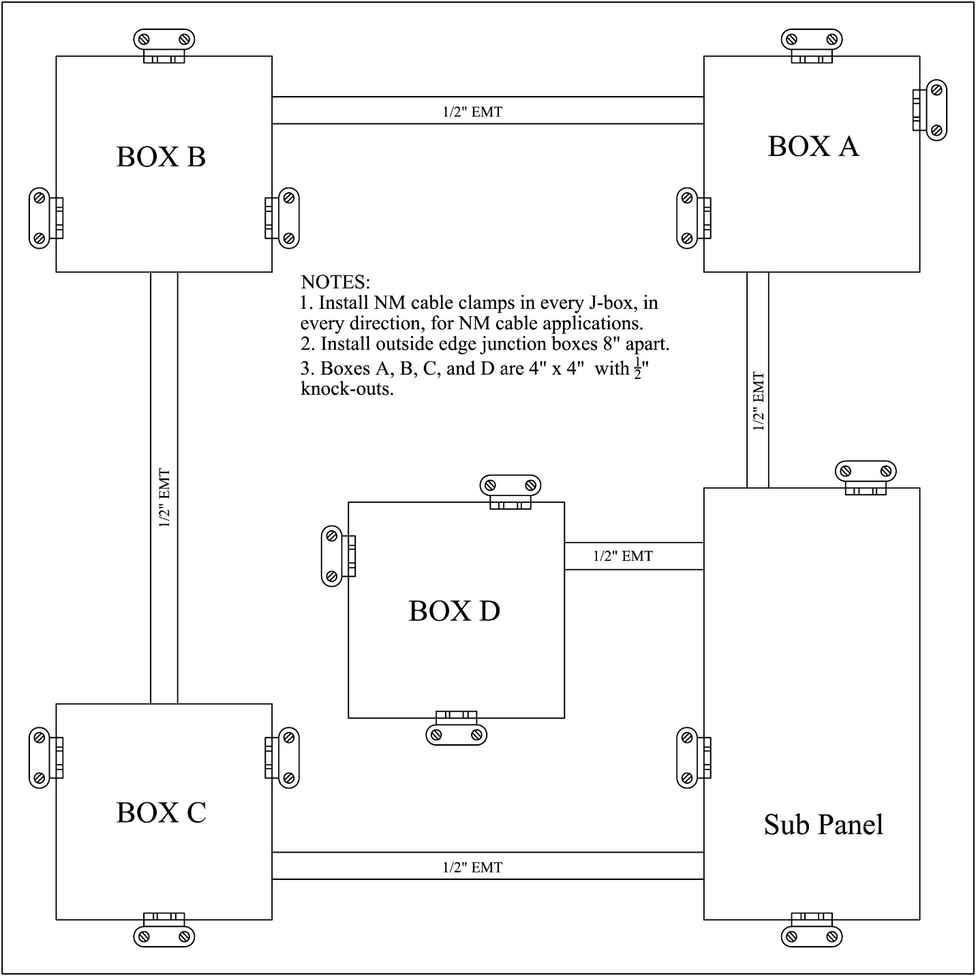
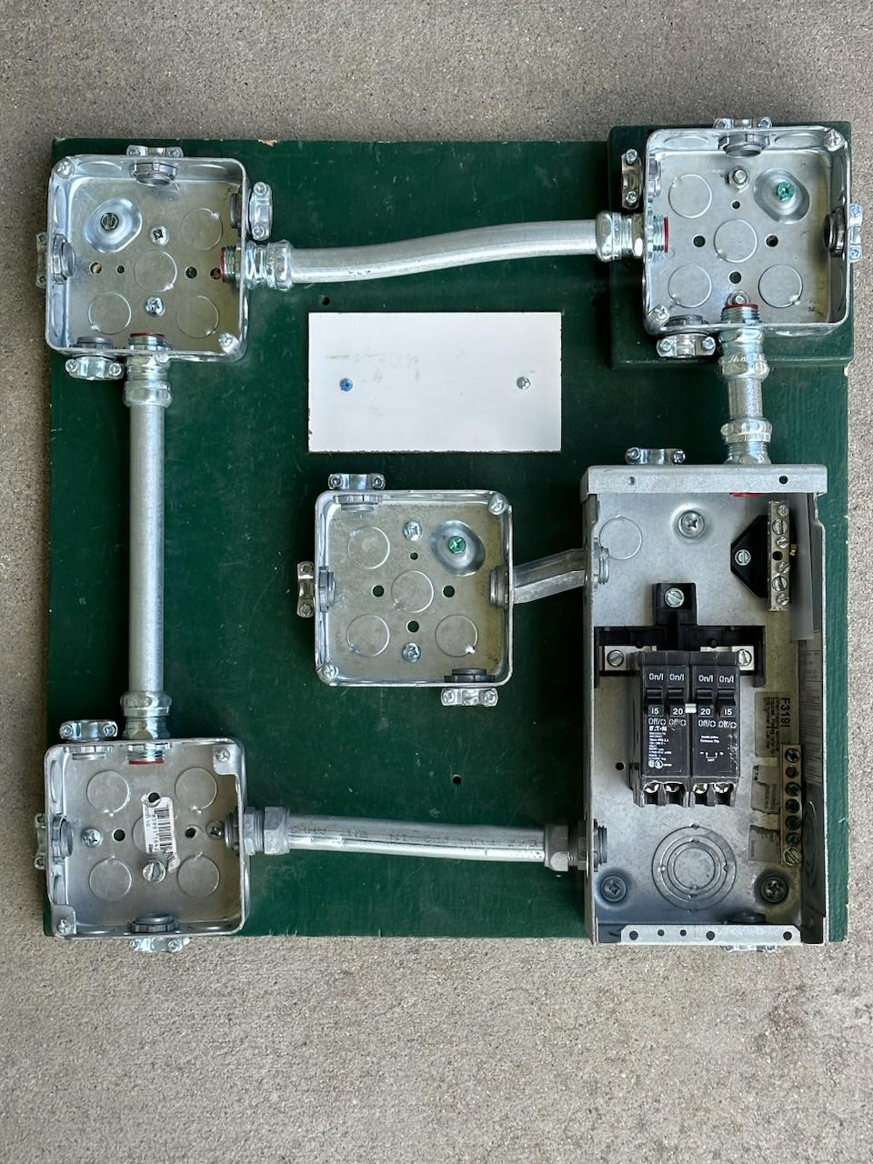

Wiring Projects:
- Boxes should have plaster rings or covers as per code.
- All circuits should be connected to a circuit breaker unless noted.
- Panel is assumed to be grounded.
Complete one or more of the scenarios below.

Service Entrance Wiring (Optional):
Your board may be pre-wired to the panel. Wiring to sub-panels is commonly for 60A service. Wiring for service entrance panels (SEP) is commonly 200A service. In both cases 240V single phase power is provided. The scenarios below provide practice connecting a panel using 10 gauge wire. The connections are the same but in practice the wire is too small.
- Using the provided NM 10-3 cable wire the panel as if it were a service entrance. In this case ground and neutral conductors are connected together and the buss bar is connected to the panel ground.
- Using the provided NM 10-3 cable wire the panel as if it were a sub panel. In this case ground and neutral conductors are NOT connected together and the buss bar is NOT connected to the panel ground.
- Using the provided 10 gauge THHN conductor wire the panel as if it were a sub panel. Stub out wire in box A.
- Using the provided 10 gauge THHN conductor connect the panel as if it were a service entrance. Stub out wire in box A.

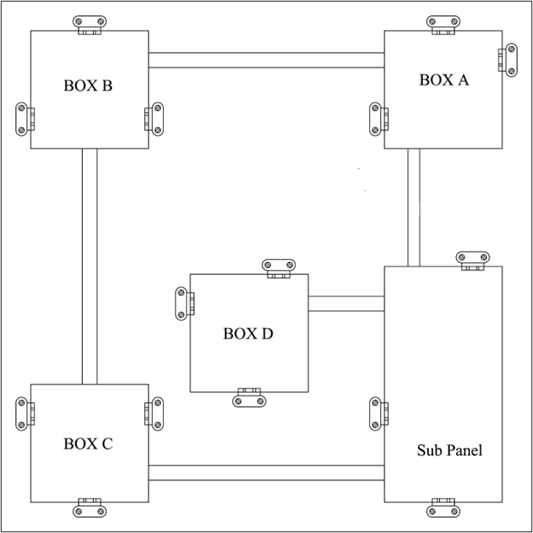

Simple Circuits:
- Wire a DR in Box C using a 20 Amp circuit and conduit.
- Wire a DR in Box C using a 20 Amp circuit and NM Cable.
- Install a lamp in Box A controlled by a switch in Box B. 15A Circuit using conduit.
- Wire a Lamp in Box B controlled by a switch in Box C using a 15 A circuit and conduit.
- Wire a lamp in Box A controlled by a switch in Box B using a 15A circuit and NM Cable.

More Complex Circuits:
- Wire a DR in Box B and Box C on separate 15 A circuit using conduit.
- Wire a DR in Box B and Box C on the same 20 A circuit using conduit.
- Wire a 240v 20A receptacle in Box D using NM Cable.
- Wire a 240v 20A receptacle in Box D using conduit.
- Wire 3 way switches in Boxes A and C to control a lamp in Box B. Power is from Box A using NM cable. 15 Amp circuit.
- Wire 3 way switches in Boxes A and B to control a lamp in Box C using conduit. Power is from Box A. 15 Amp circuit.
- Wire 3 way switches in Boxes A and C and a 4 way switch in Box B to control a lamp in Box B using conduit. Power is from Box A. 15 Amp circuit.
- Install two DR’s in Box C on separate 20A circuits using conduit. Note: You may share a neutral wire (balanced circuit). Explain why this will work.
- Install a switch and DR in Box B. Install a lamp in Box A controlled by the switch using NM cable. 15 A circuit.
- Install a switch and DR in Box C. Install a lamp in Box B controlled by the switch. Use NM cable and a 15 A circuit.
- Wire a 240v 20A receptacle and a DR (15 A circuit) in Box D using conduit.
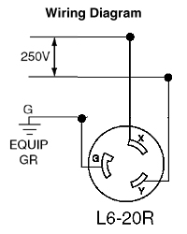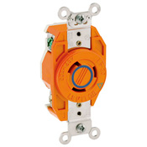

Electrical Wiring Worksheet
Name: ________________________
Date: ________________________

- What do the following wire colors indicate (hot, neutral, ground)?
  - White:_________________
  - Green:_________________
  - Black:__________________
  - Red:___________________
- How much free conductor is required for device wiring? _______________
- What do the following terminals (hot, neutral, ground)?
  - Brass:_________________
  - Silver:_________________
  - Green:_________________
- What type of wire is used in the conduit?___________________________________
- What direction does the wire wrap on a screw terminal? _______________________
- Neatly diagram your circuit. Show wire connections with a line and label or use the wire color.

Grading Rubric:
CRITERIA | POSSIBLE | Score
Proper device location | 5
Properly grounded | 5
Wire color coding | 5
Screw terminals | 5
Wire nuts | 5
Workmanship(no nicks, clockwise loops, neat) | 5
Correct circuit (works) | 5
TOTAL | 35

Score
Worksheet (10)
Projects
Total

Electrical Wiring Teachers Notes:
For more details of the wiring board look at the CATA Ag Mechanics Curricular Code. With these boards you can make many circuit variations.

Agricultural Standards Met:
6.0 Health and Safety. Students understand health and safety policies, procedures, regulations, and practices, including the use of equipment and handling of hazardous materials:
B1.0 Students understand personal and group safety:
B1.1 Practice the rules for personal and group safety while working in an agricultural mechanics environment.
B1.2 Know the relationship between accepted shop management procedures and a safe working environment.
B3.0 Students understand the basic electricity principles and wiring practices commonly used in agriculture:
B3.3 Analyze and correct basic circuit problems (e.g., open circuits, short circuits, incorrect grounding).
B3.4 Understand proper basic electrical circuit and wiring techniques with nonmetallic cable and conduit as defined by the National Electric Code.
B3.5 Interpret basic agricultural electrical plans.

Objectives:
By properly completing this project, students will be able to:
- Identify the allowable wire color for the types of conductors.
- Explain the correct names of materials.
- Correctly use of wire nuts.
- Can properly wire a circuit.
- Can solve the problem if circuit is not working.
- Demonstrate how to properly wire an electrical device.

Alternative Tools/Methods/Materials:
Similar projects can be developed by using boxes mounted to 2 x 4s. If only NM cable wiring is used then plastic boxes can be used. The project can be modified by changing the scenarios.

Safety Review:
- All power is turned off or disconnected
- Do not use wire with any nicks in it!
- Do not touch electrical with wet hands of feet.
- Check switches, outlets, fixtures or extension cords for damage before using
- Disconnect power source is burning smell or hot.
- Properly wire and double check before testing it!
- Working with electricity can be dangerous. However, electricity can be safe if properly respected.

Project Time:
For 1 project:
Demonstration: | 20 minutes
Build: | 30 -60 minutes

Demonstration Notes
For scenarios using conduit the path of the wire is generally clear as all wire must be in conduit. Wires may run through a box without splicing. For scenarios using NM cable wire paths may be less clear there may be more than one way to run the NM cable and have the correct circuit.
- Review electrical section of an Ag Mechanics text.
- Review the types of wire, terms, and names of devices.
- Cover the basic rules of wiring and discuss the National Electric Code:
  - Color coding of wire and terminals
  - 6” of free conductor – reason: allows replacement of devices without having to replace the wire.
  - Use of wire nuts: tight and no bare wire showing.
  - Grounding: boxes and devices.
  - Proper connection to a screw terminal: Clockwise, loop ¾ around, no insulation under the screw, no bare wire past the device.
- Cover making “pig tails” to connect devices to multiple wires.
- Cover basic circuits. Tip: Have students trace a few complete circuits.
- 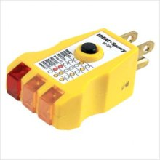How to make a proper eye for terminals (bend back 90º first). Practice this and look like a pro!
- Plaster rings are optional, but should be used if you plan on testing the board with live power as devices can easily short against metal boxes. If not used demonstrate how they are installed and used for mounting the devices.
- Build a board with a GFCI, a switch, and a power cord to use for testing. This will protect the student and you if the circuit is bad.
- Temporary power cords are simply a piece of 14/3 NM cable with a cord cap wired to one end. NOTE: The panel is wired 240V. However the two hot legs can be connected together to test all 120V circuits. Connecting the panel to a 240V source is not recommended for safety reasons.
- Use a simple circuit tester. When testing duplex receptacles. Explain how this tester works.
- At least loosely screw in the devices before connecting to power so they cannot ground to the metal boxes or be touched.
- Circuits are easily visually checked. It is OK to connect an improper circuit. When it doesn’t work ask the student to troubleshoot. Sometimes they learn more this way!

Bill of Materials:
Consumables for all projects. Materials in full spools as shown below will build approximately 100 projects. Wire can often be reused. Actual consumption will be determined by the number of scenarios and type of scenario (ex. 4 way, 20A 240v)

Materials (per board):
These are basically non-consumable. Prices are 2023 (Home Depot).
Quantity | Description | Cost | Amount
0.125 | ½ CC Plywood board (8 per sheet) | $ 65.00 | $ 8.13
1 | 60-100A surface mount panel with separate grounding bar | $ 30.00 | $ 30.00
1 | Quad breaker 15A/20A | $ 30.00 | $ 30.00
4 | 4” sq. Electrical boxes with ½” KO | $ 3.60 | $ 14.40
10 | ½” EMT Box connectors (5 pk) | $ 0.80 | $ 8.00
0.25 | ½” EMT (10’) | $ 6.50 | $ 1.63
0.04 | Grounding screws installed in the boxes (100) | $ 11.00 | $ 0.44
1 | Two gang plaster ring* | $ 1.00 | $ 1.00
3 | Single gang plaster ring* | $ 1.70 | $ 5.10
1 | 3” round plaster ring* | $ 2.11 | $ 2.11
3 | 4” square blank cover* | $ 1.00 | $ 3.00
15 | ½” NM cable clamps | $ 0.60 | $ 9.00
2 | Duplex Receptacle | $ 1.90 | $ 3.80
2 | Lamp holder with pig tails and mountable in the round plaster ring. | $ 2.33 | $ 4.66
2 | Switch (SPST, toggle) | $ 1.35 | $ 2.70
2 | 3 way switches | $ 3.00 | $ 6.00
1 | 4 way switch | $ 12.60 | $ 12.60
1 | 20 amp, 240 Volt Receptacle | $ 6.65 | $ 6.65
0.04 | Yellow wire nuts (500) | $ 25.00 | $ 1.00
 |  |  | $ 150.21
* For actual wiring plaster rings are required to mount devices to boxes. They may be omitted if the devices are not mounted.

