Wood Herb Box 2
Name: __________________
Date: __________________

Description:
Students will complete a wood working project by building a wood herb box. The herb box will be big enough to hold 3 – 4” square pots. Project has holes for hanging (on a porch). Project is built from common cedar fence boards. Great project for Christmas or Mother’s Day.

Materials:
1” X 6” x 6’ Cedar Fence Board (actual size 5/8” x 5 ½”x 6’)
4d galvanized finish nails
Waterproof Wood Glue
Stain (optional)
Sandpaper
¼” rope
Tools:
Table Saw
Power Miter Saw
Drill Press
½” & 3/8” Forstner bits
Hammer
Steel Tape
Combination square
Pencil

Procedure:
- Obtain a cedar fence board. Measure the dimensions with the steel tape.
- Determine the best use of the lumber. Where are the knots?
- Adjust the table saw rip fence so it measures 4 1/4” from the fence to the inside of the saw blade.
- Rip the fence board to 4 1/4” wide.
- Determine the layout before you begin to cut. Cut around the knots.
- Crosscut bottom piece from the 4 1/4” board using the plan and cut list as a guide.
- Layout the holes in the bottom. Drill 3 holes using a ½” Forstner bit as shown in the plan.
- Crosscut the ends and sides from the remainder of the 4 1/4” board using the plan and cut list as a guide.
- Layout the holes in the ends and drill using a 3/8” Forstner bit.
- Put your project together without glue and nails. Does it fit? If so continue.
- Nail the ends to the bottom using glue and 4d nails. HINT: Use a scrap as a spacer.
- Nail the sides to the bottom and ends using glue and nails. Be sure to properly align the sides (see plan). Hint: Top edges are flush.
- Sand your project edges. DO NOT sand the nails.
- Stain the project for completion (optional)

Cutting List:
Quantity | Size |  | Material
2 | 5/8” x 4 ¼” x 14 ½” | Sides | Cedar
1 | 5/8” x 4 ¼” x 12 ¼” | Bottom | Cedar
2 | 5/8” x 4 ¼” x 4 7/8” | Ends | Cedar

Notes:

________________________________________________________________________

________________________________________________________________________

________________________________________________________________________

________________________________________________________________________

________________________________________________________________________

________________________________________________________________________

Photo/Drawing:

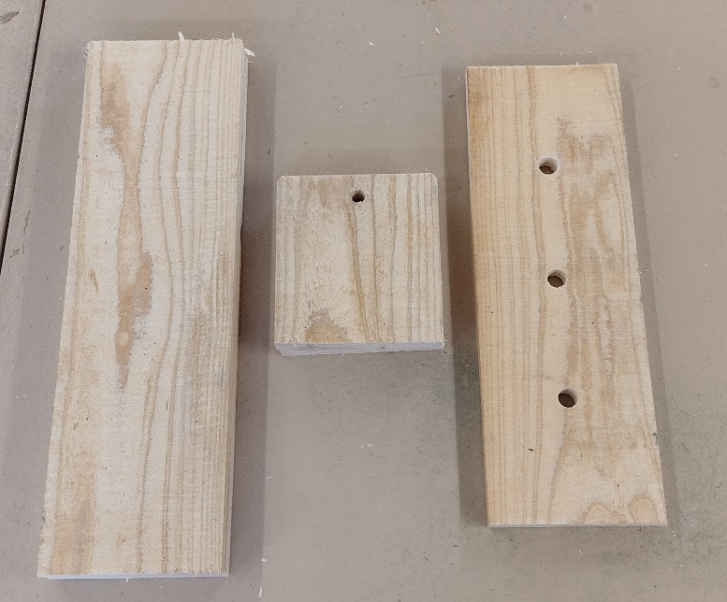
Cut out pieces

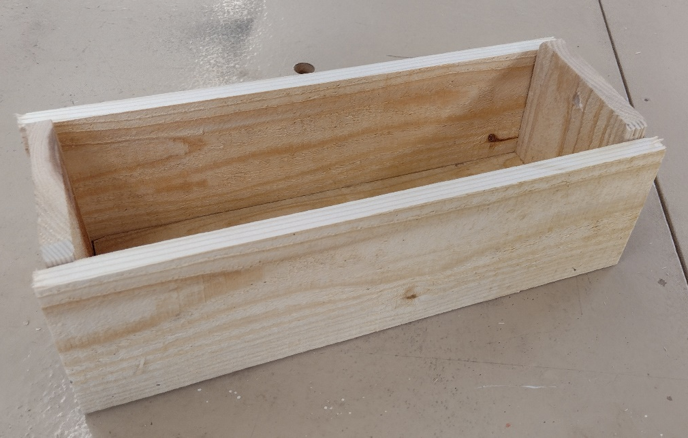
Assembled project
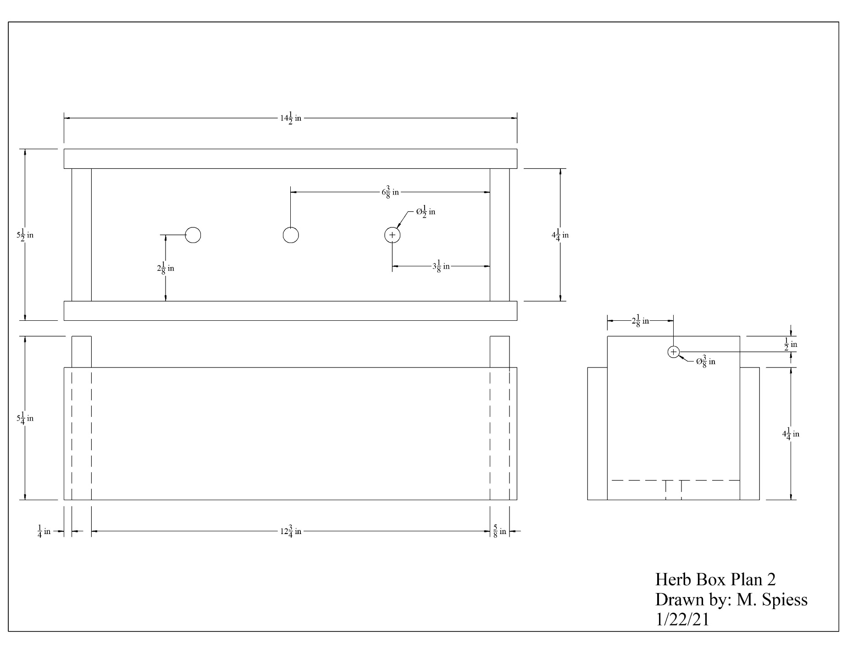

Wood Planter Box Worksheet
Name: __________________
Date: __________________
- What tool is used to layout the holes in the bottom?

- What are the safety precautions when using the table saw?

- When using a table saw why must two people help rip a large piece of wood?

- When using the table saw why must you always measure from the fence to the inside of the saw blade?

- When using the table saw why must the top of the saw blade be ¼” to 1/8” above the top of the wood?

- What are the safety precautions when using the power miter saw?

- What type of drill bit is used and why?

Grading Rubric:
CRITERIA | POSSIBLE | SCORE
Length | 5
Width | 5
Bottom Hole Location/Size | 5
End Hole Location/Size | 5
Planter box is square and joints fit well. | 5
Workmanship (sanding, nails, cut quality, etc) | 5
Total | 30

Wood Planter Box Teachers Notes:
This is a very simple and quick project to build. Measuring in 1/8”s and hole layout are good practice for more complex projects. There are 4 variations of this project. SLO’s and tools vary with each plan.

Agricultural Standards Met:
6.0 Health and Safety. Students understand health and safety policies, procedures, regulations, and practices, including the use of equipment and handling of hazardous materials:
6.1 Know policies, procedures, and regulations regarding health and safety in the workplace, including employers’ and employees’ responsibilities.
6.2 Understand critical elements of health and safety practices related to storing, cleaning, and maintaining tools, equipment, and supplies.
6.4 Maintain safe and healthful working conditions.
6.5 Use tools and machines safely and appropriately.
6.6 Know how to both prevent and respond to accidents in the agricultural industry.
B1.0 Students understand personal and group safety:
B1.1 Practice the rules for personal and group safety while working in an agricultural mechanics environment.
B1.2 Know the relationship between accepted shop management procedures and a safe working environment.
B1.0 Students understand personal and group safety:
B1.1 Practice the rules for personal and group safety while working in an agricultural mechanics environment.
B1.2 Know the relationship between accepted shop management procedures and a safe working environment.
B2.0 Students understand the principles of basic woodworking:
B2.1 Know how to identify common wood products, lumber types, and sizes.
B2.3 Know how to identify, select, and implement basic fastening systems.
B2.4 Complete a woodworking project, including interpreting a plan, developing a bill of materials and cutting list, selecting materials, shaping, jointing, and finishing.

Objectives:
By properly completing this project, students will be able to:
- Read a plan to and layout dimensions.
- Students will identify proper wood type used for the project
- Students will properly layout project design
- Students will safely use a table saw
- Students will safely cut wood using the power miter saw
- Students will use a drill press to successfully drill drainage holes
- Students will learn the proper way to glue and assemble the project
- Students will learn how to sand and stain their planter box

Alternative Tools/Methods/Materials:
- You can chamfer the ends using a power disk sander. This will introduce another tool.
- You may wish to make all holes 3/8” if you have only one drill press.
- Other fasteners can be used. For example it can be assembled with a brad nailer or crown stapler. #6 x 1 ¼” Deck screws can be used, counter sink first.
- Ripping the lumber ahead of time removes the table saw and will speed the project.
- The project can be built with hand tools. Pre-ripping is recommended.
- While the project is designed to hold 4” nursery pots, you can plant directly in the box.

Safety Review:
- Table Saw
- Power Miter Saw
- Drill Press
- Power Driver (optional)
- Pneumatic nailer (optional)

Project Time:
Demonstration: | .5 hours
Build: | 2 hours

Demonstration Notes:
- Demonstrate how to select lumber, cutting around knots. Project allows for some waste. You may wish to simply rip all of the boards.
- Explain why the direction of the grain is important.
- Be sure to address safety tips as we work on each machine.
- Many of the dimensions are in 1/8”, review measuring.
- Demonstrate mark-cut-mark-cut technique used for cross cutting so pieces are correct length.
- Workflow note: Students can cut the bottom, do the layout of the holes, drill the holes, the cut and assemble. This will help spread the students out in the shop and avoid bottlenecks.
- Demonstrate hole layout using a combination or try square.
- Drill holes before ends are glued and nailed on to the bottom piece.
- Nailing the ends to the bottom first then adding the sides is generally easier.
- Keep scrap pieces separate to avoid confusion.
- Nail sizes. Explain types and sizes.
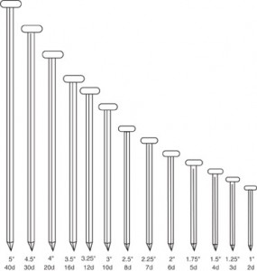

Bill of Materials:
Project from: Mike Spiess

