PEX Plumbing Project
Name: ________________________
Date: ________________________

Description:
A small project to introduce students to PEX plumbing. PEX is commonly used in residential plumbing due to it low cost and ease of use (compared to copper). Note: After the project is graded (pressure tested) the student can drill 1/8” holes around the parameter of the ring to make a sprinkler.

Materials:
½” PEX Male Adapter
½” PEX Tee
4’ of PEX Pipe (Type A for Expansion fittings)
4 - Expansion, crimp, or Clamp rings
Optional:
½” FPT x ¾” FHT PVC adapter
Pipe joint compound

Tools:
PEX Tubing Cutter
Steel Tape
PEX Tool to match fastening system
Optional:
Drill
1/8” bit

Directions:
Read the directions before beginning the project. Note the completed project should lay flat.
- Cut the two pieces of PEX pipe as shown in the plan.
- Lay out the pipe and fittings as shown in the plan. Note: PEX pipe should be at least at room temperature to allow it to ben without kinking.
- Review the operation of the PEX Tools provided. Install the fittings using the tools (4 connections).
  - Crimp Ring: Insert the ring over the pipe, Crimp the ring using the crimping tool. Check Go-No Go.
  - Clamp: Insert the clamp over the pipe. Tighten the clamp with the clamp tool.
  - Expansion: Insert the expansion ring over the end of the pipe. Expand with the expansion tool. Quickly insert the fitting and hold in place until the pipe is tight on the fitting.
- Optional:
  - Install the PVC Adapter on the Male Adapter using pipe joint compound.
  - Remove excess compound with a rag.
- Have your project pressure test checked. Label with your name for final grading.
- Optional (for sprinkler):
  - Using a marker mark every 1” around the top of the ring. Using a drill (or drill press) and 1/8” bit drill holes on the top of the ring at the marks.

Notes:
____________________________________________________________________________________
____________________________________________________________________________________
____________________________________________________________________________________
____________________________________________________________________________________
____________________________________________________________________________________
____________________________________________________________________________________
____________________________________________________________________________________
____________________________________________________________________________________
____________________________________________________________________________________
____________________________________________________________________________________
____________________________________________________________________________________

Photo/Drawing
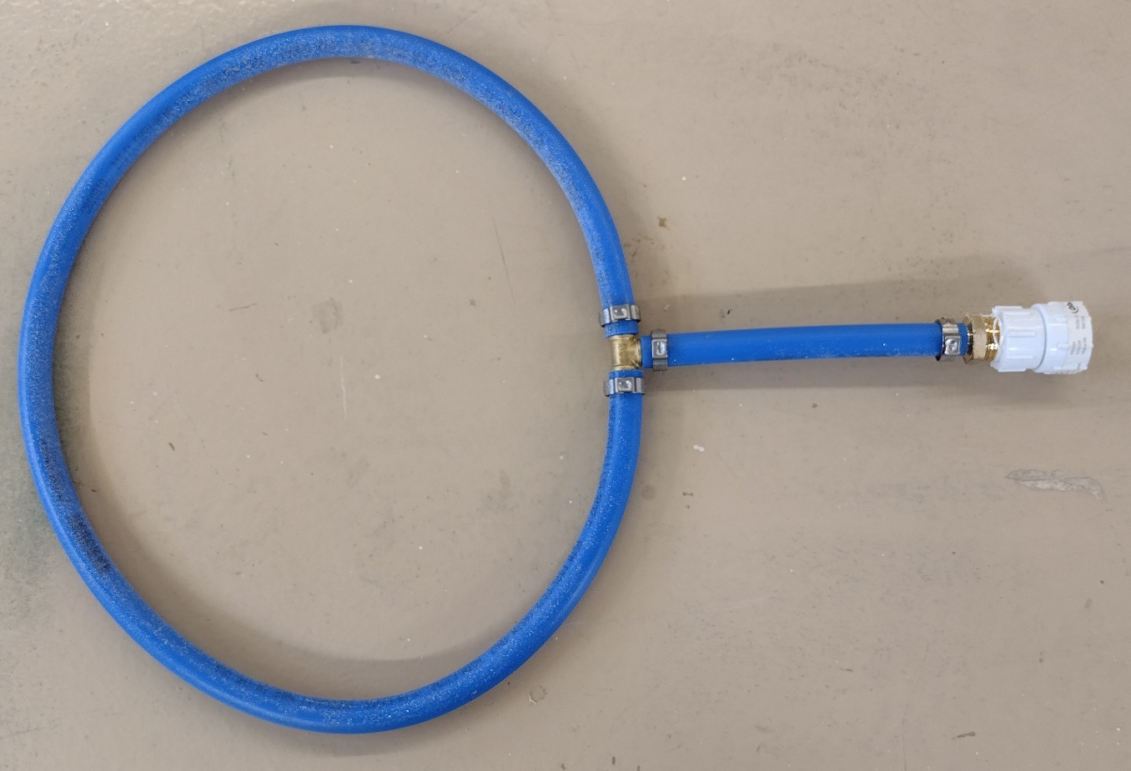

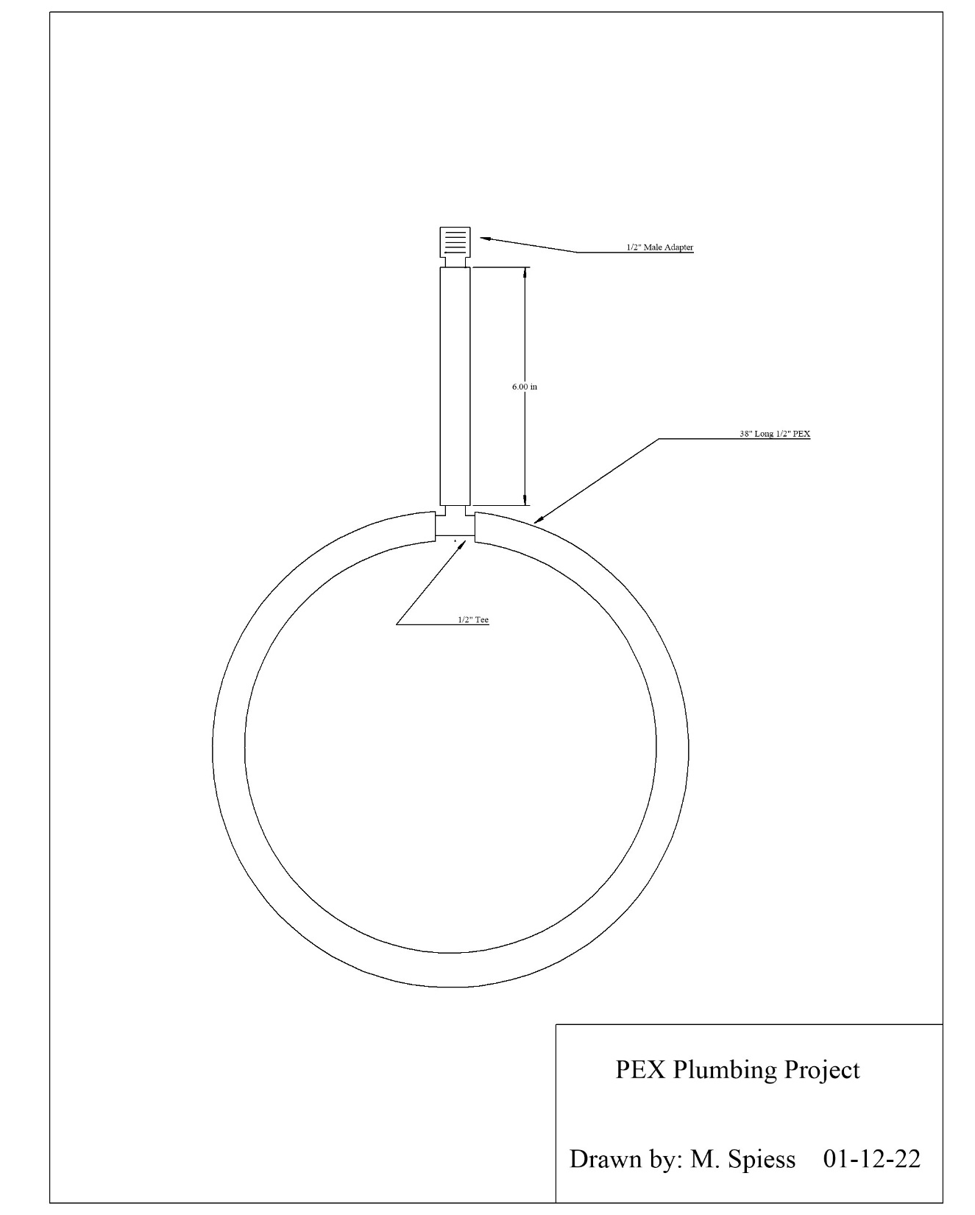

Plumbing Project Student Worksheet:
Name: ________________________
Date: ________________________

Complete this worksheet prior to starting the project.
- How long are the two pieces of pipe?
- What is the size and type of PEX (A, B, C) pipe we are using:_____________________________
- List the fittings we are using: ______________________________________________
- What type of fastening system are you using to attach the pipe to the fittings?
___________________________________________________________________________
___________________________________________________________________________
___________________________________________________________________________
___________________________________________________________________________
___________________________________________________________________________
- Explain why primer is not used for this specific project:
___________________________________________________________________________
___________________________________________________________________________

Grading Rubric:
Criteria | Possible | Score
Graded During Class:
Pressure Test (5 per joint, pass/fail) | 40
Graded Later:
Pipe length | 5
Assembly/workmanship  (damaged pipe, poor assembly) | 5
TOTAL | 50

Plumbing Project Teacher Notes:

Agriculture Standards Met:
4.0 Technology. Students know how to use contemporary and emerging technological resources in diverse and changing personal, community, and workplace environments:
4.6 Differentiate among, select, and apply appropriate tools and technology.
5.0 Problem Solving and Critical Thinking. Students understand how to create alternative solutions by using critical and creative thinking skills, such as logical reasoning, analytical thinking, and problem-solving techniques:
5.1 Apply appropriate problem-solving strategies and critical thinking skills to work-related issues and tasks.
5.3 Use critical thinking skills to make informed decisions and solve problems.
6.0 Health and Safety. Students understand health and safety policies, procedures, regulations, and practices, including the use of equipment and handling of hazardous materials:
6.1 Know policies, procedures, and regulations regarding health and safety in the workplace, including employers’ and employees’ responsibilities.
6.2 Understand critical elements of health and safety practices related to storing, cleaning, and maintaining tools, equipment, and supplies.
6.4 Maintain safe and healthful working conditions.
6.5 Use tools and machines safely and appropriately.
6.6 Know how to both prevent and respond to accidents in the agricultural industry.
7.0 Responsibility and Flexibility: Students know the behaviors associated with the demonstration of responsibility and flexibility in personal, workplace, and community settings:
7.6 Know how to apply high-quality craftsmanship to a product or presentation and continually refine and perfect it.
B1.0 Students understand personal and group safety:
B1.1 Practice the rules for personal and group safety while working in an agricultural mechanics environment.
B1.2 Know the relationship between accepted shop management procedures and a safe working environment.
B4.0 Students understand plumbing system practices commonly used in agriculture:
B4.1 Know basic plumbing fitting skills with a variety of materials, such as copper, PVC (polyvinyl chloride), steel, polyethylene, and ABS (acrylonitrile butadiene styrene).
B4.4 Complete a plumbing project, including interpreting a plan, developing a bill of materials and cutting list, selecting materials, joining, and testing.

Objectives:
By successfully completing this project students will be able to:
- Read a plan to obtain critical dimension
- Measure and layout a plumbing project using PEX Pipe and a fastening system.
- Identify by pipe Type and fitting types
- Select and properly use PEX tools.

Alternate Tools/Methods/Materials:
Three types of PEX systems can be used. The photo shows clamps. Expansion and crimp systems are also used. Project could be part of a larger project with other systems like PVC, copper, and steel.

Safety Review:
- Keep fingers out of cutter.
- Potential pinching hazards.

Project Time:
Demonstration: | 10 minutes
Build: | 1 hours

Demonstration Notes:
NOTE: There is some variation in the technique used for each fastening system. Taylor your demonstration to the system you are using.
- Begin by reviewing materials and tools used for the project
- Show other fittings like stub outs and manifolds used in PEX and describe their use.
- Review the plan and show how the plan describes the project
- Review names of fittings while demonstration is in process
- Review the process of cutting and fitting.
- Demonstrate use of the fastening tools. Describe the other fastening systems used for PEX.
- Demonstrate how to remove a fitting.
- Assembled project should lay flat.
- Pressure test at 30 PSI (not to exceed 60 psi).

Bill of Materials
(Excel, update with local prices)
Project from: Mike Spiess

