Ropework & Securing Loads
Name ______________________

Description:
In this exercise the student will learn to work with rope by tying common knots. Students will demonstrate securing loads with common binders and rope.

Materials:
12’ – 3/8” polypropylene rope or pre-cut pieces
6”x ½” dowel or PVC pipe
Masking or Electrical tape (to prevent fraying)
20-30’ of ½” poly rope (for truckers’ knot)

Tools:
Sharp utility knife or NM cable cutters
Propane torch (to melt ends)
Steel tape
Lashing Straps
Chain Binder (optional)

Directions:
- Cut rope into three 4 foot pieces if needed. Wrap the area to be cut with tape before cutting. This will prevent the ends from fraying. Use a propane torch to lightly melt the ends. Caution: Hot molten plastic will burn.
- Tie a bowline in the end of one rope. REMEMBER: This knot forms a loop.
- Tie the first rope to another rope with a square knot.
- Tie the two ropes to the third with a sheet bend.
- Tie a figure 8 knot in the free end of the third rope.
- Tie a clove hitch between the square knot and the sheet bend around the dowel/pipe.
- Pull all the knots tight and inspect to see that they are tied correctly.
- Label the project with tape and a marking pen.
- Tie a trucker's hitch and secure with a clove hitch and have the instructor sign your grade sheet.
- Secure the load with the chain binder and have the instructor sign your grade sheet.
- Secure the load with the webbing binder and have the instructor sign your grade sheet.
- Turn in the grade sheet and the project.

Drawing:

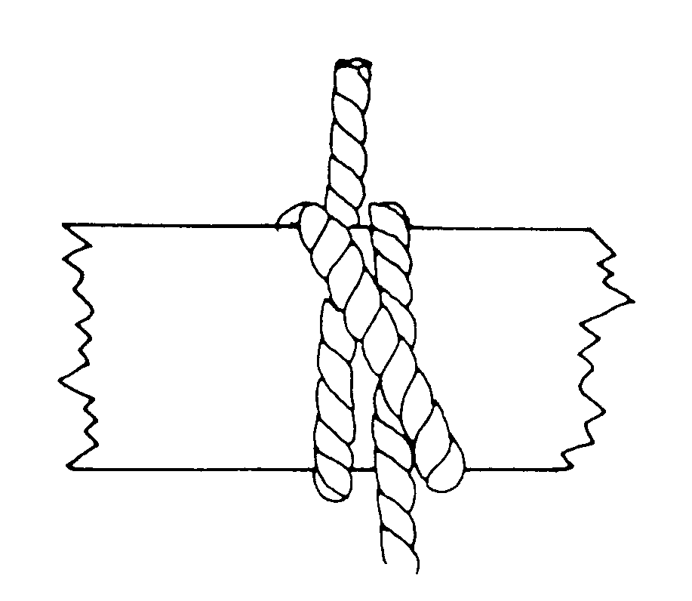
Clove Hitch
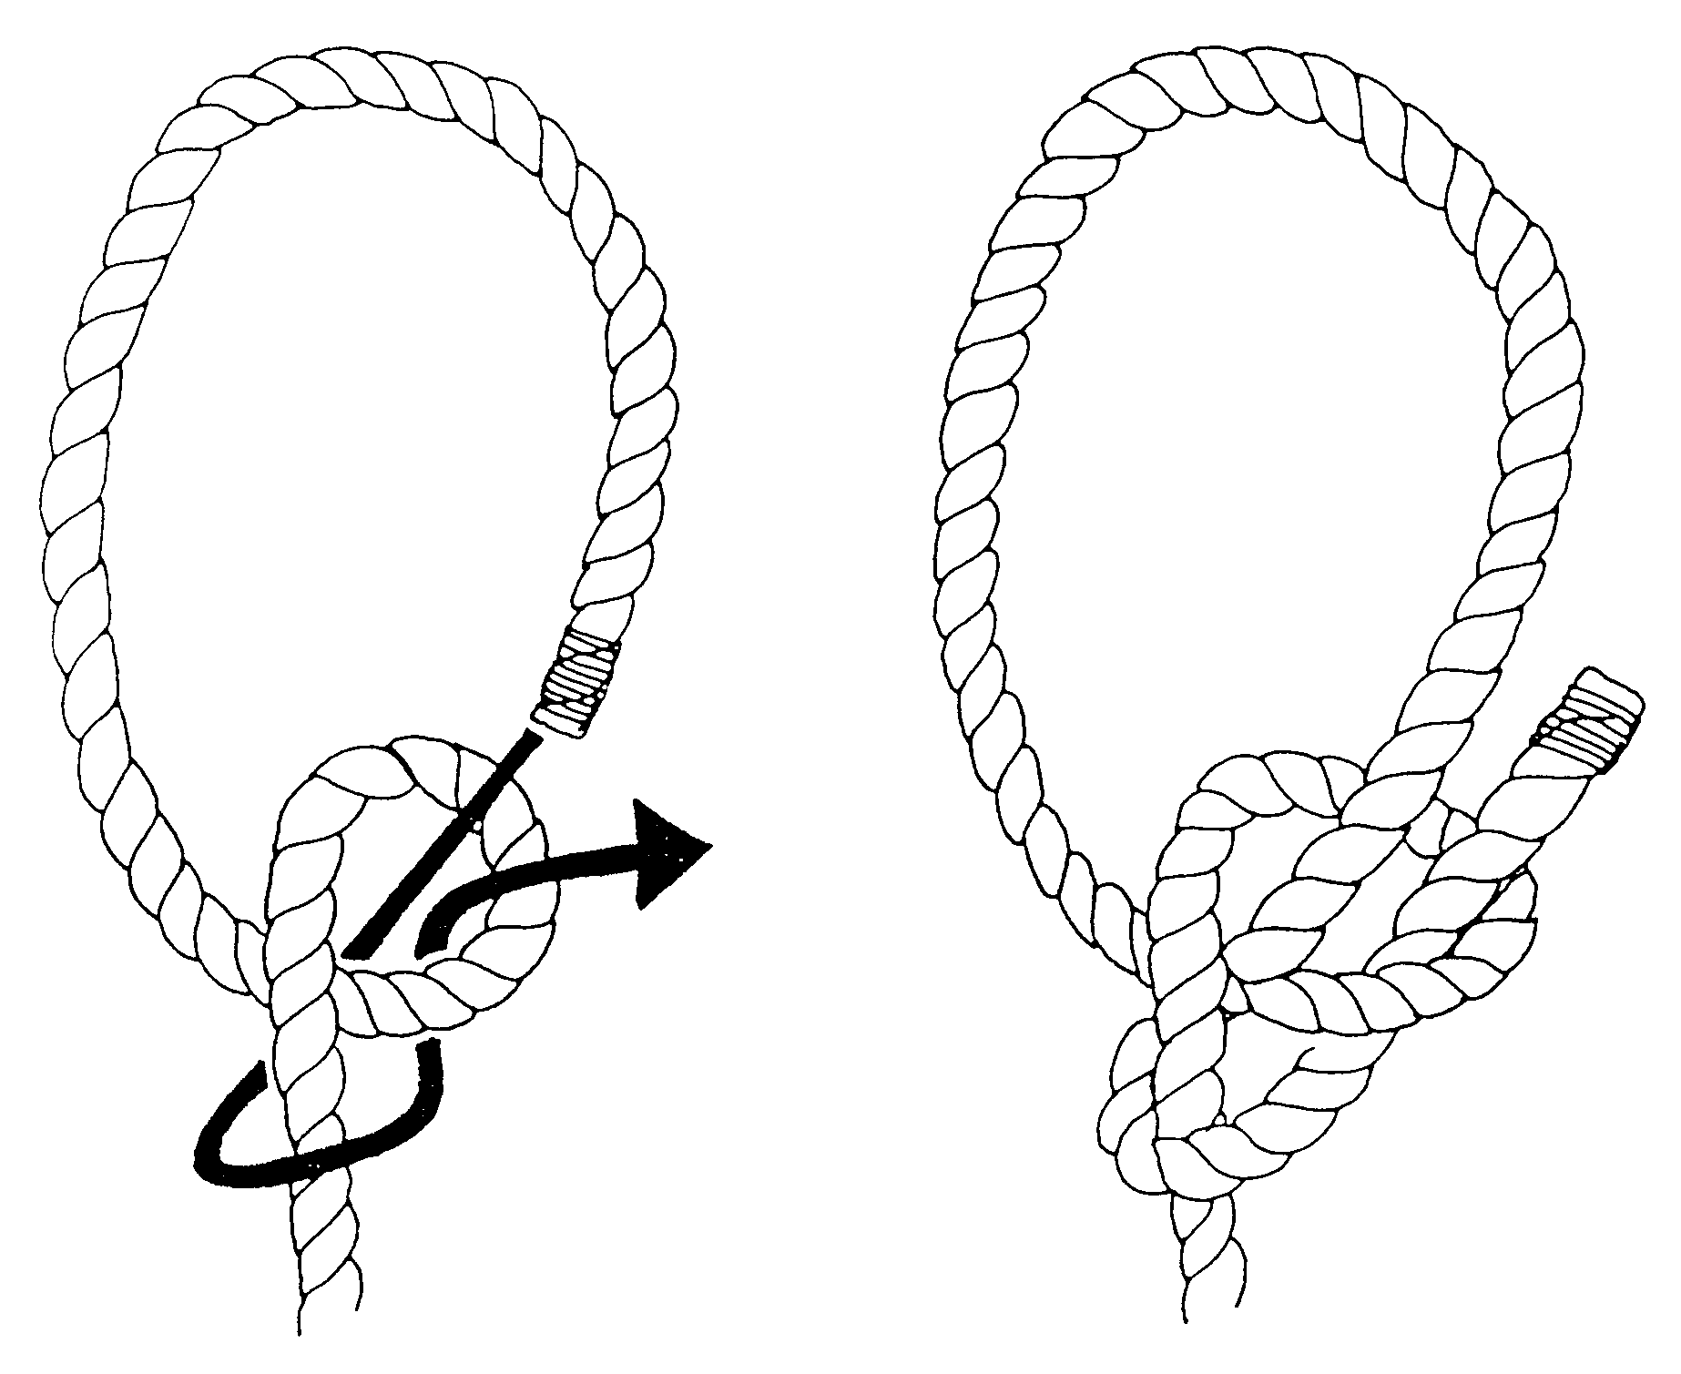
Bowline

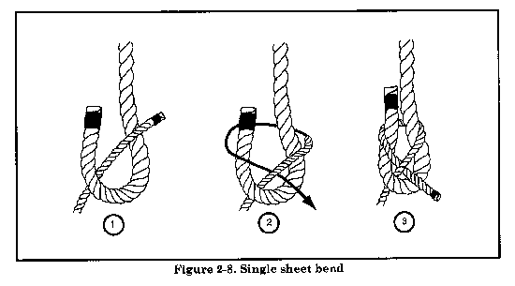
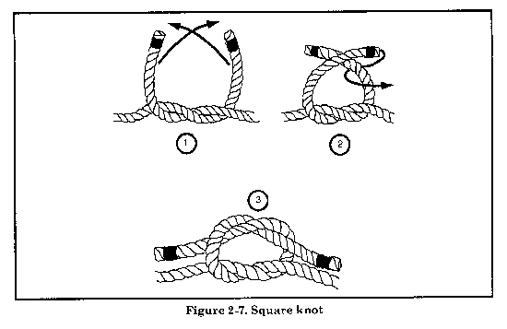
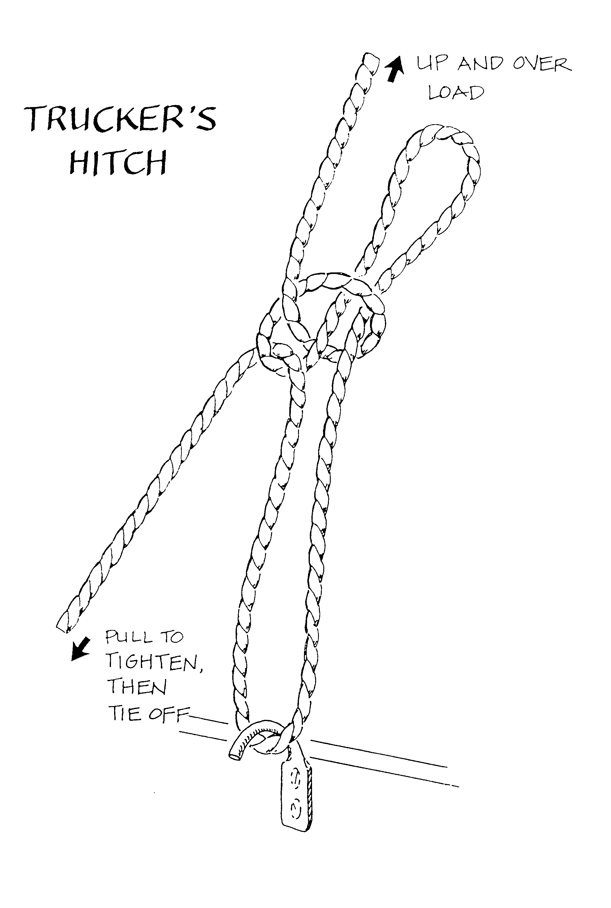
Add extra twist to the loop and secure end with a clove hitch.
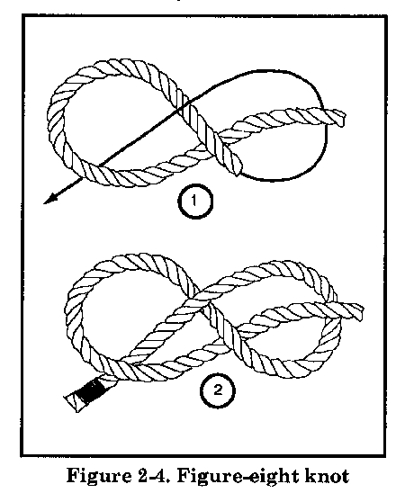

Worksheet
Name: ________________________
Date: ________________________

- What is a bowling knot used for?
__________________________________________________________________________
- What does WLL (Working Load Limit) mean?
______________________________________________________________________________
- What Type of rope will you use for this project (describe size, material, and construction).
____________________________________________________________________________
- Name three common rope materials.
___________________________ ____________________________ _______________________
- What knot is used to secure a trucker’s hitch?
__________________________________________________________________________________

Grading Rubric:
Criteria | Possible | Score
Chain binder Checked by _________ | 4
Lashing Straps Checked by _________ | 4
Truckers Hitch Checked by _________ | 4
Clove hitch | 2
Bowline | 2
Square knot | 2
Sheet bend | 2
Figure 8 | 2
Workmanship/presentation | 3
Total | 25

Teachers Notes:

Agricultural Standards Met:
B1.0 Implement personal and group safety practices.
B1.1 Practice the rules for personal and group safety while working in an agricultural mechanics environment.
B1.2 Integrate accepted shop management procedures and a safe working environment.
B1.3 Safely secure loads on a variety of vehicles.

Objectives:
By properly completing this project, students will be able to:
- Tie common knots
- Identify and describe common types of rope and binders
- Secure a load

Alternative Tools/Methods/Materials:
Knots can be tied with inexpensive kernmantle (braided) rope instead of laid poly rope. This comes in colors and holds the knots better. Use “truckers’ poly rope for truckers’ hitch (black and orange).

Safety Review:
- Safety Glasses
- Use of propane torch (melted ends are hot)
- Utility knife

Project Time:
Demonstration: | 15-25 minutes
Build: | 1-2 hours

Demonstration Notes:
- Knot tying videos can be found at: https://www.animatedknots.com/indexbasics.php
- Have students prepare rope pieces – stress proper length. Note you may have saved pieces from old projects so cut only enough so each student has 3 pieces.
- Demo each knot and leave a sample so students can compare.
- Square knot. Students will commonly tie a “granny” show them the difference.
- Truckers’ hitch. This can be done on a trailer or truck rack with hooks. An alternate is to add hooks to the underside of workbench and place the “load” on the bench. Screw on hooks can be found at most hardware stores. Add an extra twist to the loop so poly rope will not slip. Secure with a clove hitch. Show them how to maintain tension on the load while looping the rope around the hook.
- Lashing straps. 1” straps work, but 2” straps are better (10,000 lb). Be cautious in tightening on a work bench as you might pull out hooks! Show how to secure the loose end.
- Chain binders. If you choose to do this portion used a trailer and a piece of equipment like a tractor. Show how to install so binders pull against each other.

Bill of Materials:
Project and plan by Mike Spiess.

