6’ x 10’ Storage Shed

Description:
Small storage sheds can be built in a variety of sizes in a shop and transported to final location or built in place. This design sits on sleepers and can be easily moved. The plan can be scaled to accommodate different needs. This plan call for a pre-hung door, but a door can be constructed from 2”x4” lumber covered with siding.

Skills Required:
Basic knowledge of constriction and construction skills are need as well as layout and plan reading.

Materials:
Tools Required:
- Framing hammer
- Chalk line
- Staple gun
- Level
- Circular Saw
- Power Miter Saw
- Framing Square
- Steel Tape
- Table Saw (optional)

- 4’x8’x3/4” tongue and grove plywood subfloor
- 4’x8’x1/2” exterior plywood siding
- 4’ x 8’ x ½” OSB
- 2” x 4” x 8’ #2 or Btr Fir (studs)
- 2” x 4” x 8’ #2 or Btr Fir (Truss)
- 2” x 4” x 12’ #2 or Btr Fir (truss)
- 2” x 4” x 12’ #2 or Btr Fir (Plates)
- 1”x4” rough sawn trim
- 3-0 exterior door pre-hung
- 2-0 x 2-0 window
- 15# Roofing felt
- House Wrap (optional)
- Composition shingles (or rolled roofing)
- 10’-Drip rails
- 10’ “Z” strip flashing
- Eave vents (optional)
- Truss clips
- Shim shingles
- 4”x4”-10’ PT Fir
- 2”x6”-10’ PT Fir
- 2”x4”x12’ PT Fir
- 16d Sinkers
- 16d Hot Dipped Box Nails
- 8d Sinkers
- 6d EG Box nails
- ¾” roofing nails
- Tube roofing caulking
- Lock Set for door
- )

Bill of Materials:
Complete the bill of materials below for this project. Use the completed bill of materials for your record book budget by entering the name of the project and the total amount as an expense
Size | Description | Units | Qty/Project | Cost/Unit | Order | Amount
 |  |  |  |  | Total

Project Price:
Enter the expected price you will receive for the project in your record book budget (income). $_______

Estimated Construction Time:
45 hours.

Directions:
Floor construction
- Cut four 4" x4" beams (pressure treated) at a 45” degree angle as shown in the plan.
- Build the 2”x6” frame for the floor. Use galvanized nails with all PT lumber.
- Add the 2”x4” floor joists inside the 2”x6” frame. (build upside down)
- Flip the floor frame and set on top of the 4”x4” sleepers. Sleeper fit inside the frame. Nail in place
- Square the frame by measuring the diagonals.
- Nail the plywood flooring in place on top of the frame.
- Level the floor so it will be easier to complete the building.
Trusses
- Build 6 trusses as shown in the plans. These must all be identical so measure carefully.
- Determine angle for a 1/6 pitch. Cut the rafter parts using a power miter saw.
- Cut the joist part using a circular saw.
- OSB (or plywood) gussets can be ripped to width then cut from strips. Note that side gussets as 1 ½” in from the edge of the building to allow for blocking.
- Trusses are assembled with nails and glue.
Walls
- Cut 8’ 2”x4” lumber to 85 ¼” length for studs. The height of the walls is less than 8’ to allow the use of 8’ siding that will lap the floor frame.
- Layout the plates marking the stud locations on 24” centers.
- Frame the end walls first since they are the same and have no openings.
- Frame one end side with a window opening. The header is made from 2”x4” lumber with a piece of scrap OSB between the two pieces.
- Frame the second side wall with the door opening. NOTE: Check the rough opening against the actual door to insure a good fit.
- NOTE: Door and window placement can be easily moved to different positions or walls as desired.
- Square the walls and install a temporary brace on the inside of the wall.
- Assemble the wall sections on floor. Tack the bottom plate to the floor then tack the wall section to each other. Check for plumb. Check for square at the top of the walls.
- Complete the walls by adding the top plates. Nail all sections to each other and to the floor.
- Optionally install house wrap on the walls. Make sure that it is smooth (no wrinkles) as it will show on the interior.
Roof (part1)
- Layout the truss locations on the top plate.
- Install the trusses on the roof (24” OC spacing). Use a 2x4 to hold the spacing at the top of the roof.
- Use truss clips to hold the interior trusses. Toenail the exterior trusses.
- Install blocking/vents between the trusses.
- Add OSB sheeting to one side of the roof, remove the 2”x4” brace and complete the other side of the roof. Sheeting seams should be lapped.
- Optionally add a 2”x 6” fascia board to the eaves. Fascia is flush with OSB to trim raw end.

Door and Window
- Install the window in the framed opening. Use a level to insure that it is plumb.
- Remove the bottom plate in the door opening.
- Install the pre-framed door using shims to insure that the door is plumb.
Siding
- Install the siding on the walls (6d EG nails). Nail siding every 6” on the edges and 12” in the middle. It may help to snap a chalk line as a nailing guide.
- On the gable ends install the “z” strip at 8’. Layout and cut the gable end. Do this carefully to avoid wasting siding.
- Trim the corners.
- Add a piece of trim to the gable ends.
Roof (2)
- Cover the rood with roofing felt.
- Install the edge flashing over the trim.
- Install the shingles.

Drawing:
.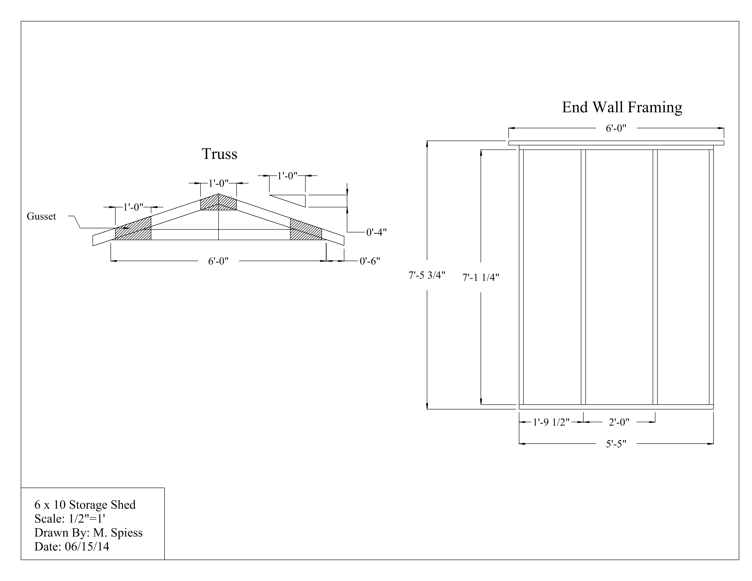
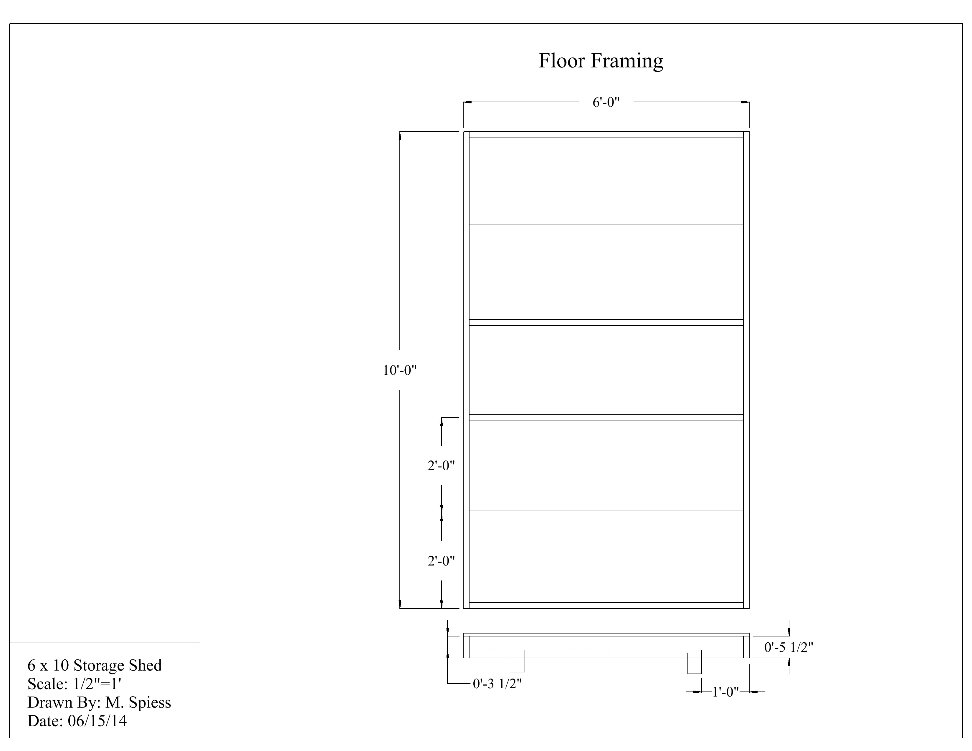
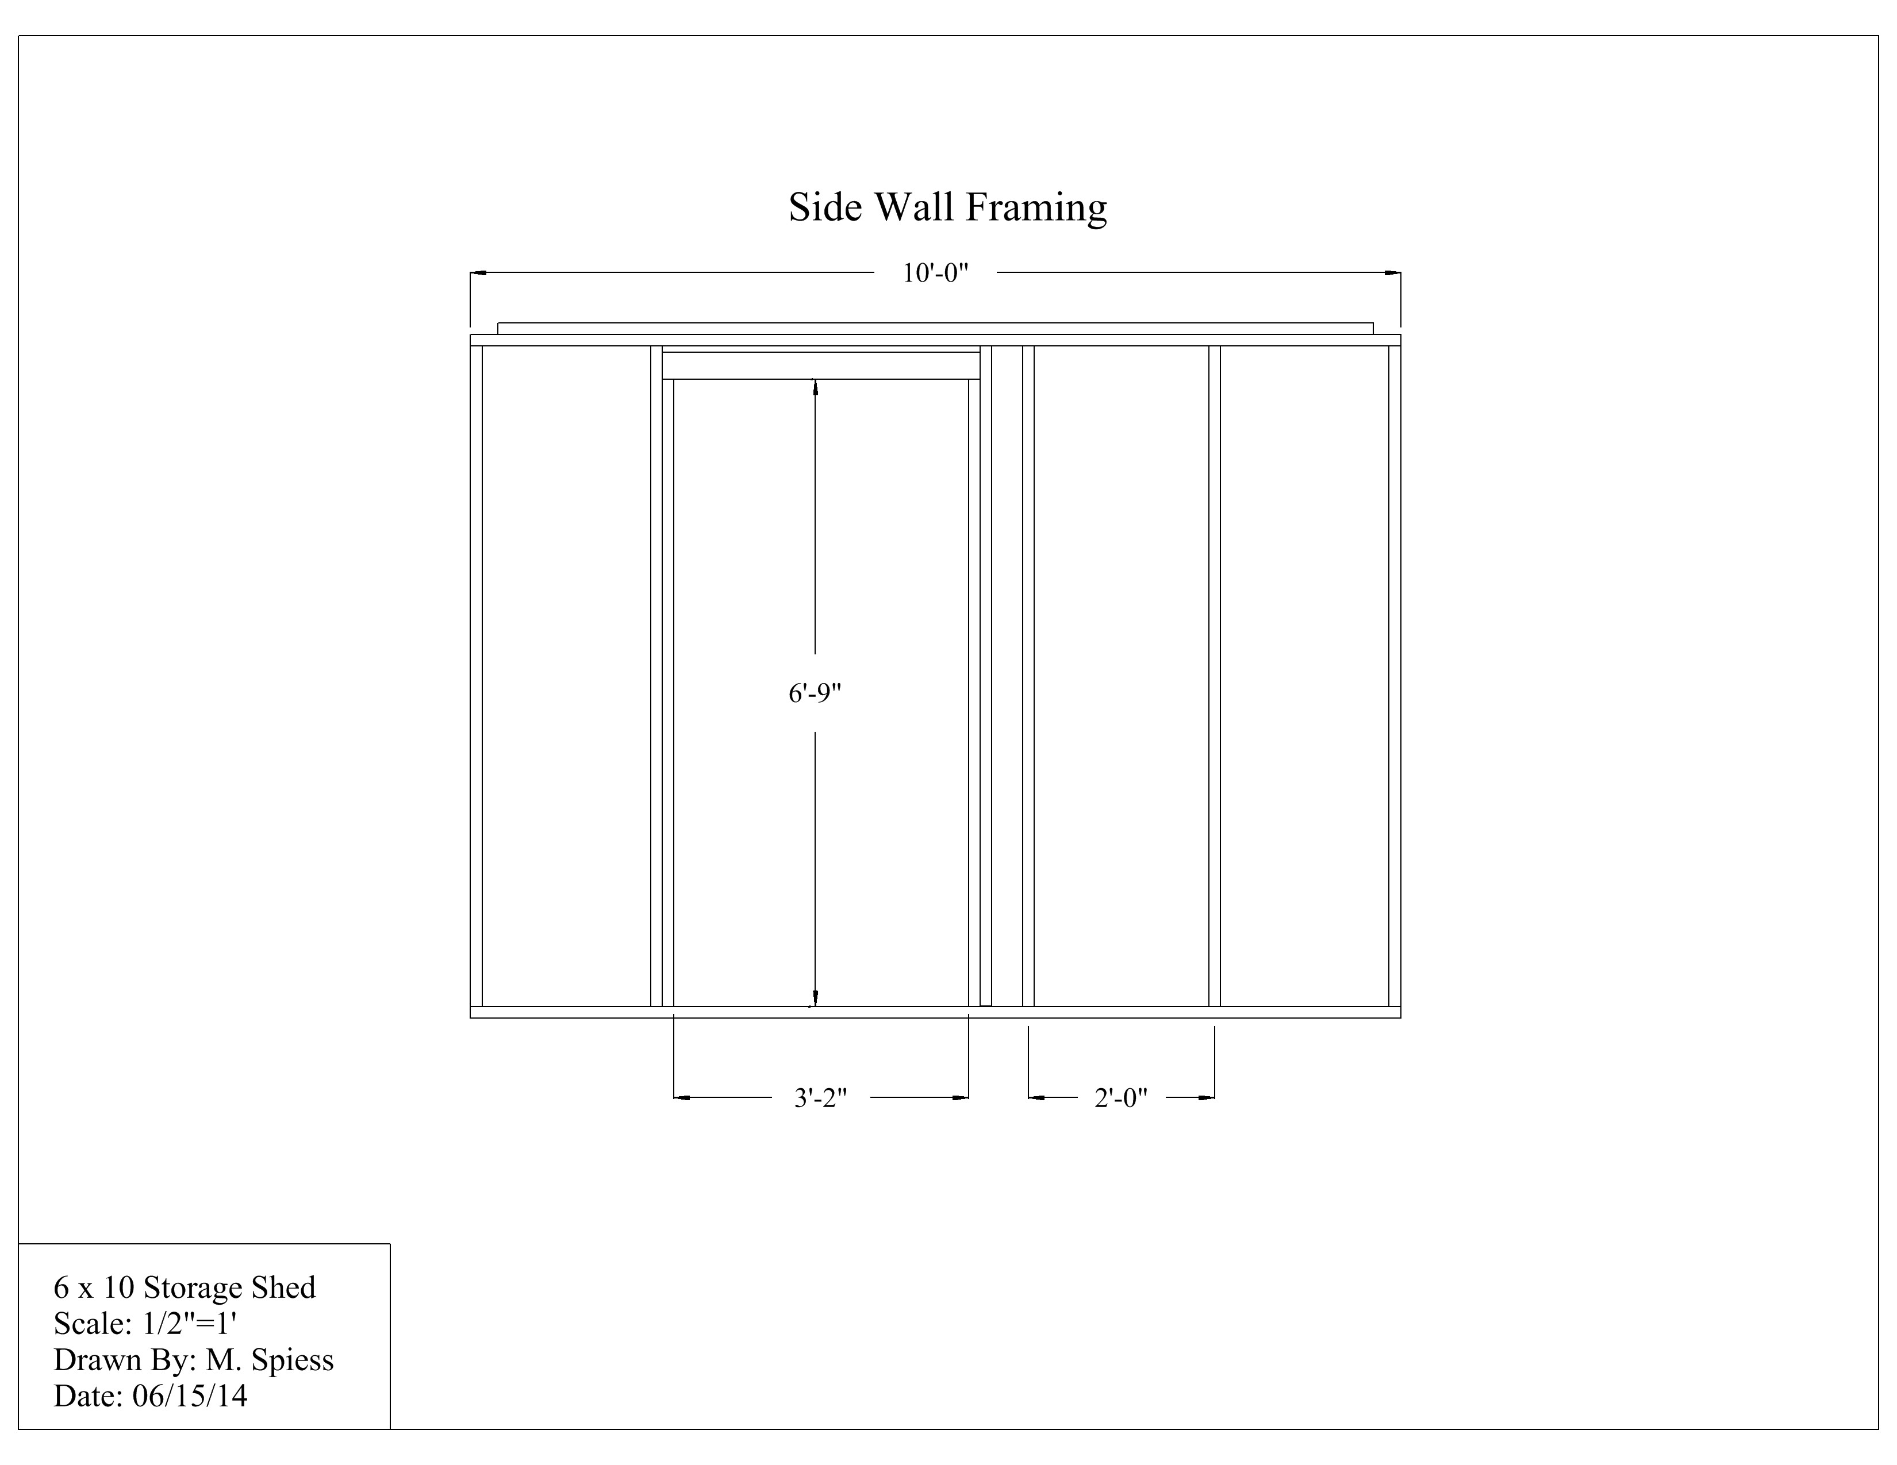
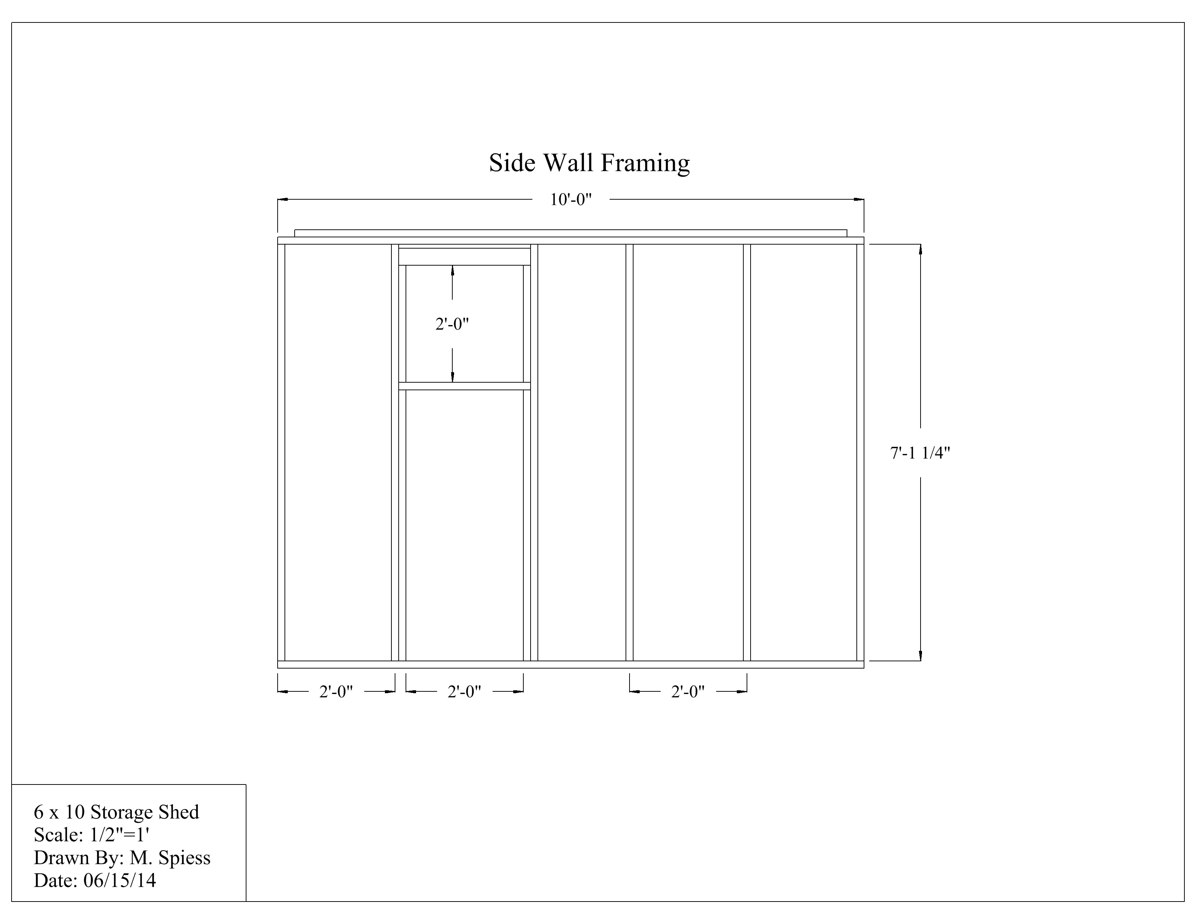

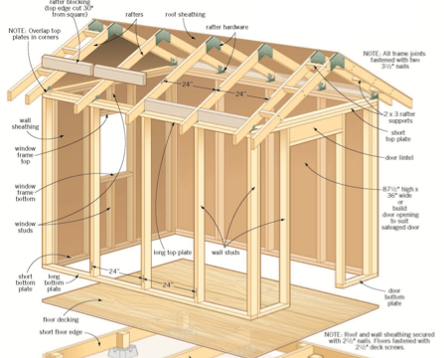
General Construction Detail

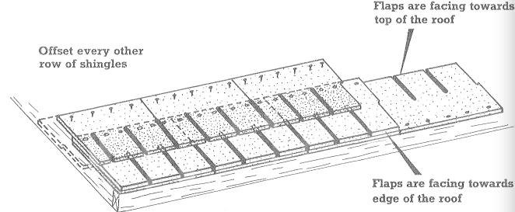
Shingle Installation

Construction Log:
Complete the log below making an entry every day you work on the project. Transfer the logged hours to your record book journal for this SAE enterprise.
Date | Tasks Completed | Skills Used/Learned | Hours

Actual Price Received:
Enter the actual price you received for the project in your record book journal as income. $_________

Project Portfolio:
Complete a portfolio for the project that includes:
- A description of the project and the skills you learned building the project. Include the hours spent on the project and the income (if sold). Use the construction log to complete this narrative. Write in complete sentences.
- The Bill of Materials
- The project plan
- 2-8 photos documenting the project at various stages of construction.

