Clay Pot Hanger

Description:
A simple project to hang clay pots. The project requires some layout skills. The hangers would work well with school plant sales or in greenhouses. Note: Since the pots do not have saucers this should be hung outdoors.

Skills Required:
Students must have the ability to read the plan and layout the project. Student can safely operate e a miter saw and bandsaw.

Materials:
Use redwood or cedar
- 1 - 1x4 x 4' per hanger
- 1 - 2' x 3/8" diameter piece of nylon or poly rope
- 4 – 6” to 8” clay pots
- 120 grit sandpaper
- Exterior stain
Tools Required:
- Combination square
- Miter Saw
- Band Saw or Jigsaw
- Drill press
- 1” Forstner bit
- 1/2” twist drill or Forstner bit
- Random Orbital Sander
- Router (Optional)
- Pencil

Bill of Materials:
Complete the bill of materials below for this project. Use the completed bill of materials for your record book budget by entering the name of the project and the total amount as an expense
Size | Description | Units | Qty/Project | Cost/Unit | Order | Amount

Project Price:
Enter the expected price you will receive for the project in your record book budget (income).

Estimated Construction Time:
2 hours.

Directions:
- Cut the lumber to length with the miter saw
- Layout the center of the hanging hole.
- Layout the center of the pot slot holes (2 per pot slot). See detail drawing.
- Drill the holes.
- Layout the slots using the square as shown in the detail drawing. Connect the two 1” holes (tangent lines).
- Layout the curved top and bottom edges using a compass or just a curved object like a washer.
- Cut out the slots and curved ends using the bandsaw (or jig saw). Note: use a ¼” blade for the corners.
- Optional: Use a small ¼ round router bit to ease the edges of the project.
- Sand the project. Sand in the slots using a piece of scrap wood with 120 grit sand paper wrapped around it.
- Finish with an exterior wood stain.

Recommendations:
Clay pots can vary in size and dimensions. Build a prototype with one slot and test the fit. Adjust the plan to fit the pot as needed.

Variations:
- Instead of hanging the hanger could be mounted on a base to be free standing. A simple stand can be made using additional 1 x 6 as shown in the drawing below. Assemble using glue and 1 ½” wood screws. Be sure the lowest pot clears the stand. For additional strength a dado slot can be cut in the stand using a table saw.
- Change the number of slots to accommodate more or fewer pots.

Photo/Drawing:
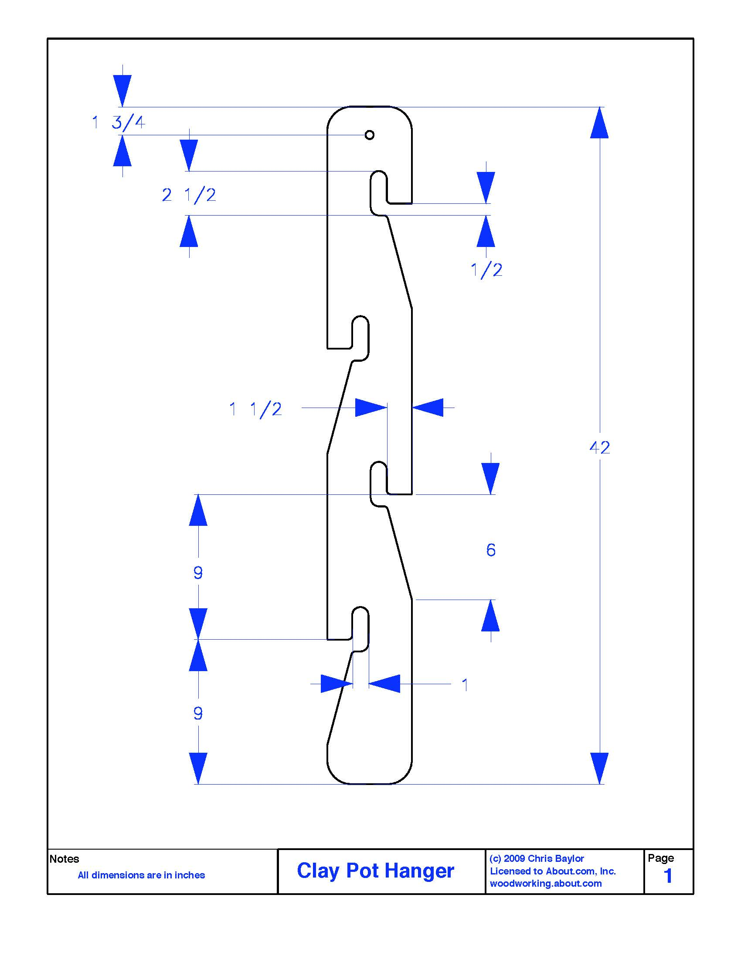

Slot Detail
Optional Stand for hanger (cut 2 per hanger)

Construction Log:
Complete the log below making an entry every day you work on the project. Transfer the logged hours to your record book journal for this SAE enterprise.
Date | Tasks Completed | Skills Used/Learned | Hours

Actual Price Received:
Enter the actual price you received for the project in your record book journal as income. $_________

Project Portfolio:
Complete a portfolio for the project that includes:
- A description of the project and the skills you learned building the project. Include the hours spent on the project and the income (if sold). Use the construction log to complete this narrative. Write in complete sentences.
- The Bill of Materials
- The project plan
- 2-8 photos documenting the project at various stages of construction.
Original plans from https://www.thesprucecrafts.com/build-a-clay-pot-hanger-3537045

