Container Shelf Bracket

Description:
Brackets are designed to connect to the upper tiedowns commonly found in shipping containers. Brackets hook to the container and are secured by adding shelves (must be screwed to bracket). A minimum of two brackets is required, but 5 will support shelves along the length of most containers.
Variations:
- Shelf supports can be moved to any spacing.
- Brackets can be any length to accommodate a different number of shelves.
- Hooks can be welded to the bottom bracket to support ladders, cords, or air hoses. Shelf supports can be used for ladders by not installing shelves but plan on installing at least the top shelf or a 2”x4” across the bottom support to stabilize the brackets side-to-side.
- The hooks on the square tubing can be purchased (see photo).
- To support heavier loads gussets may be added below the shelf supports.
Shelving: Typical span between tiedowns is about 44 inches. Shelving must be sturdy enough to support the load with this span. Some options are: 2”x12” fir or ¾” plywood with a stiffener. If using plywood rip to 11 1/4”, attach a 1”x2” to the front edge (facing down) and a 1”x4” to back edge facing up. Install the shelves once brackets are in place using tress head screws or carriage bolts.

Skills Required:
Hot bending, arc welding, and layout skills are used to construct this project.

Materials:
- 1” x 1” x .120” Steel Tubing
- 1” x 1/8” HR Angle Steel
- ¼” HR Round stock or hooks.
- Primer and Paint

Tools Required:
- Chop saw or horizontal band saw
- Angle grinder
- GMAW Arc Welder
- Blacksmith or engineer’s hammer
- Oxy-Acetylene Cutting Torch with rosebud tip.
- Drill Press
- Center punch
- 1/4” drill bit
- Steel Tape
- Combination square

Bill of Materials:
Complete the bill of materials below for this project. Use the completed bill of materials for your record book budget by entering the name of the project and the total amount as an expense
Size | Description | Units | Qty/Project | Cost/Unit | Order | Amount
 |  |  |  |  | TOTAL

Project Price:
Enter the expected price you will receive for the project in your record book budget (income).

Estimated Construction Time:
4 hours.

Directions:
- Make a cut list for all the brackets.
- Cut the square tubing and angle stock to length.
- Cut and bend the hooks from the ¼” round stock. This is easily done with a torch using a scrap piece of ¾” pipe as a mandrel.
- Notch the angle iron so it will lap the square tubing. Use an angle grinder with a cutoff wheel or a torch.
- Drill the ¼” shelf mounting holes in the supports.
- Cleanup sharp edges with the grinder.
- Weld the hook to the end of the tubing. Note: The critical dimension is from the inside of the hook to the top of the tubing. The must all be the same.
- Build a simple jig to hold the shelf support square to the tubing. You may want to build a jig to hold all the shelf supports at the desired spacing.
- Clamp and weld the shelf supports to the square tubing.
- Cleanup welds.
- Paint as desired.

Photo/Drawing:
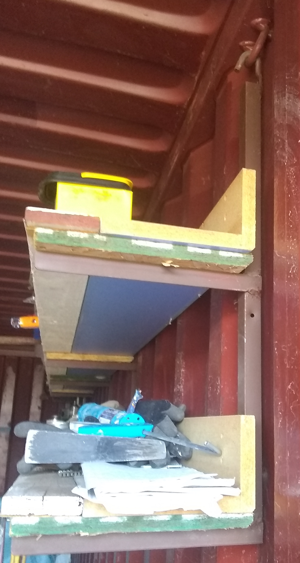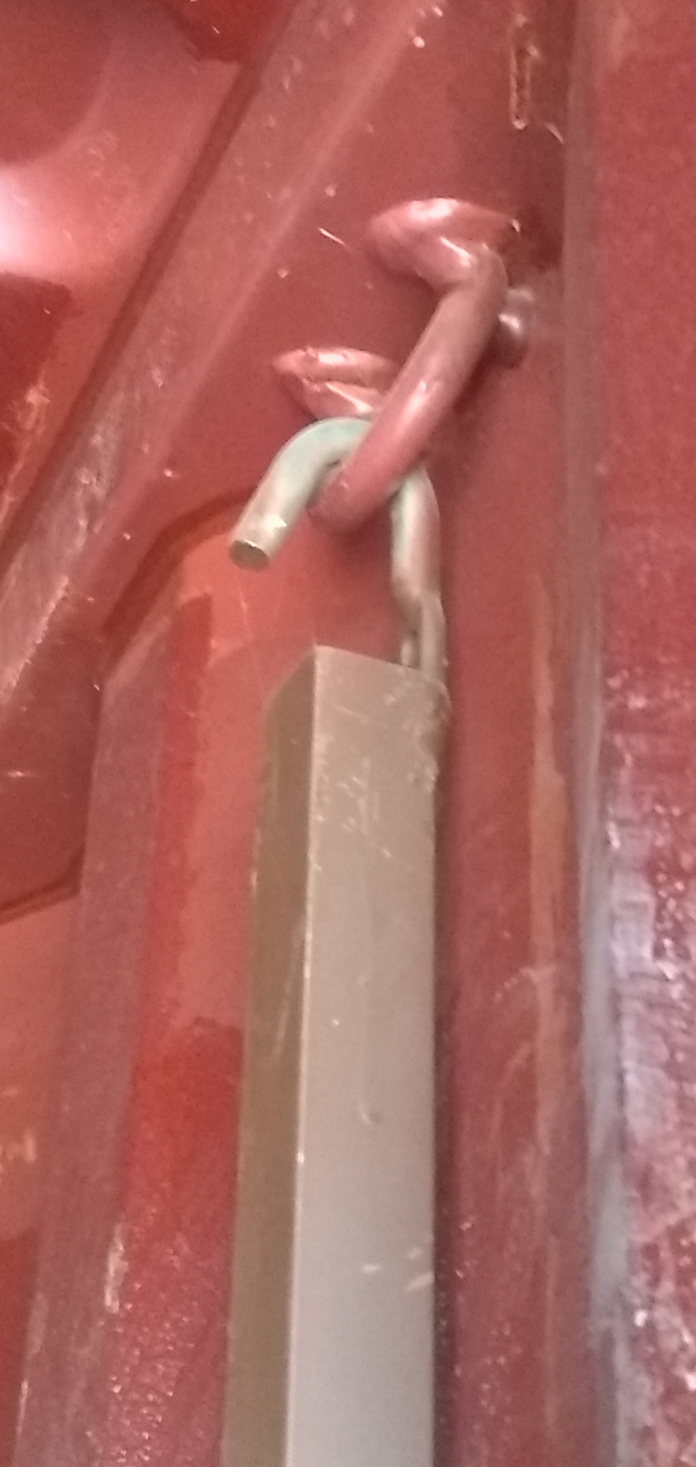

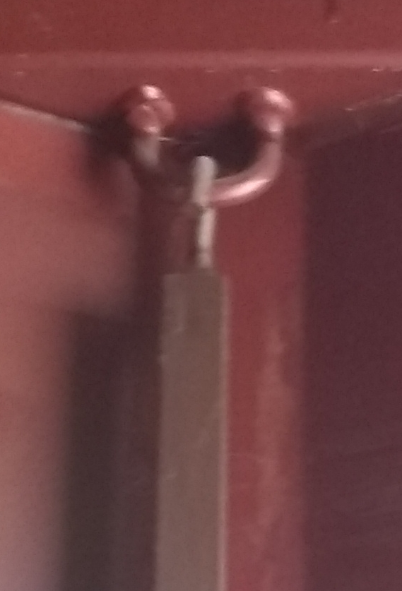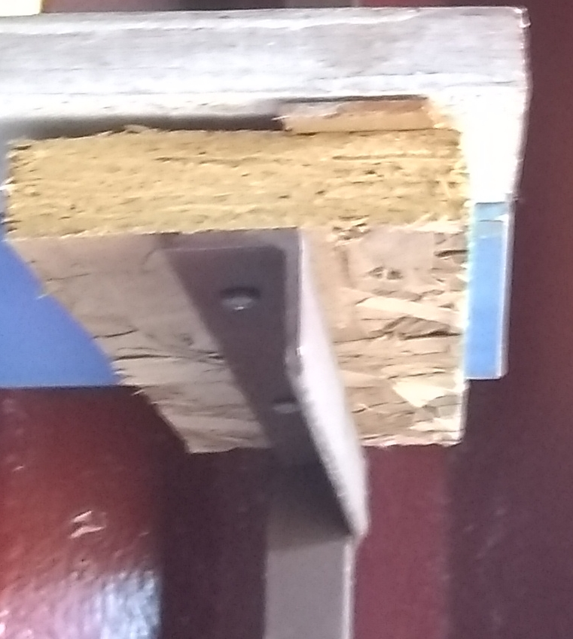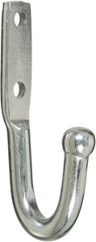
Brackets installed using a purchased hook.

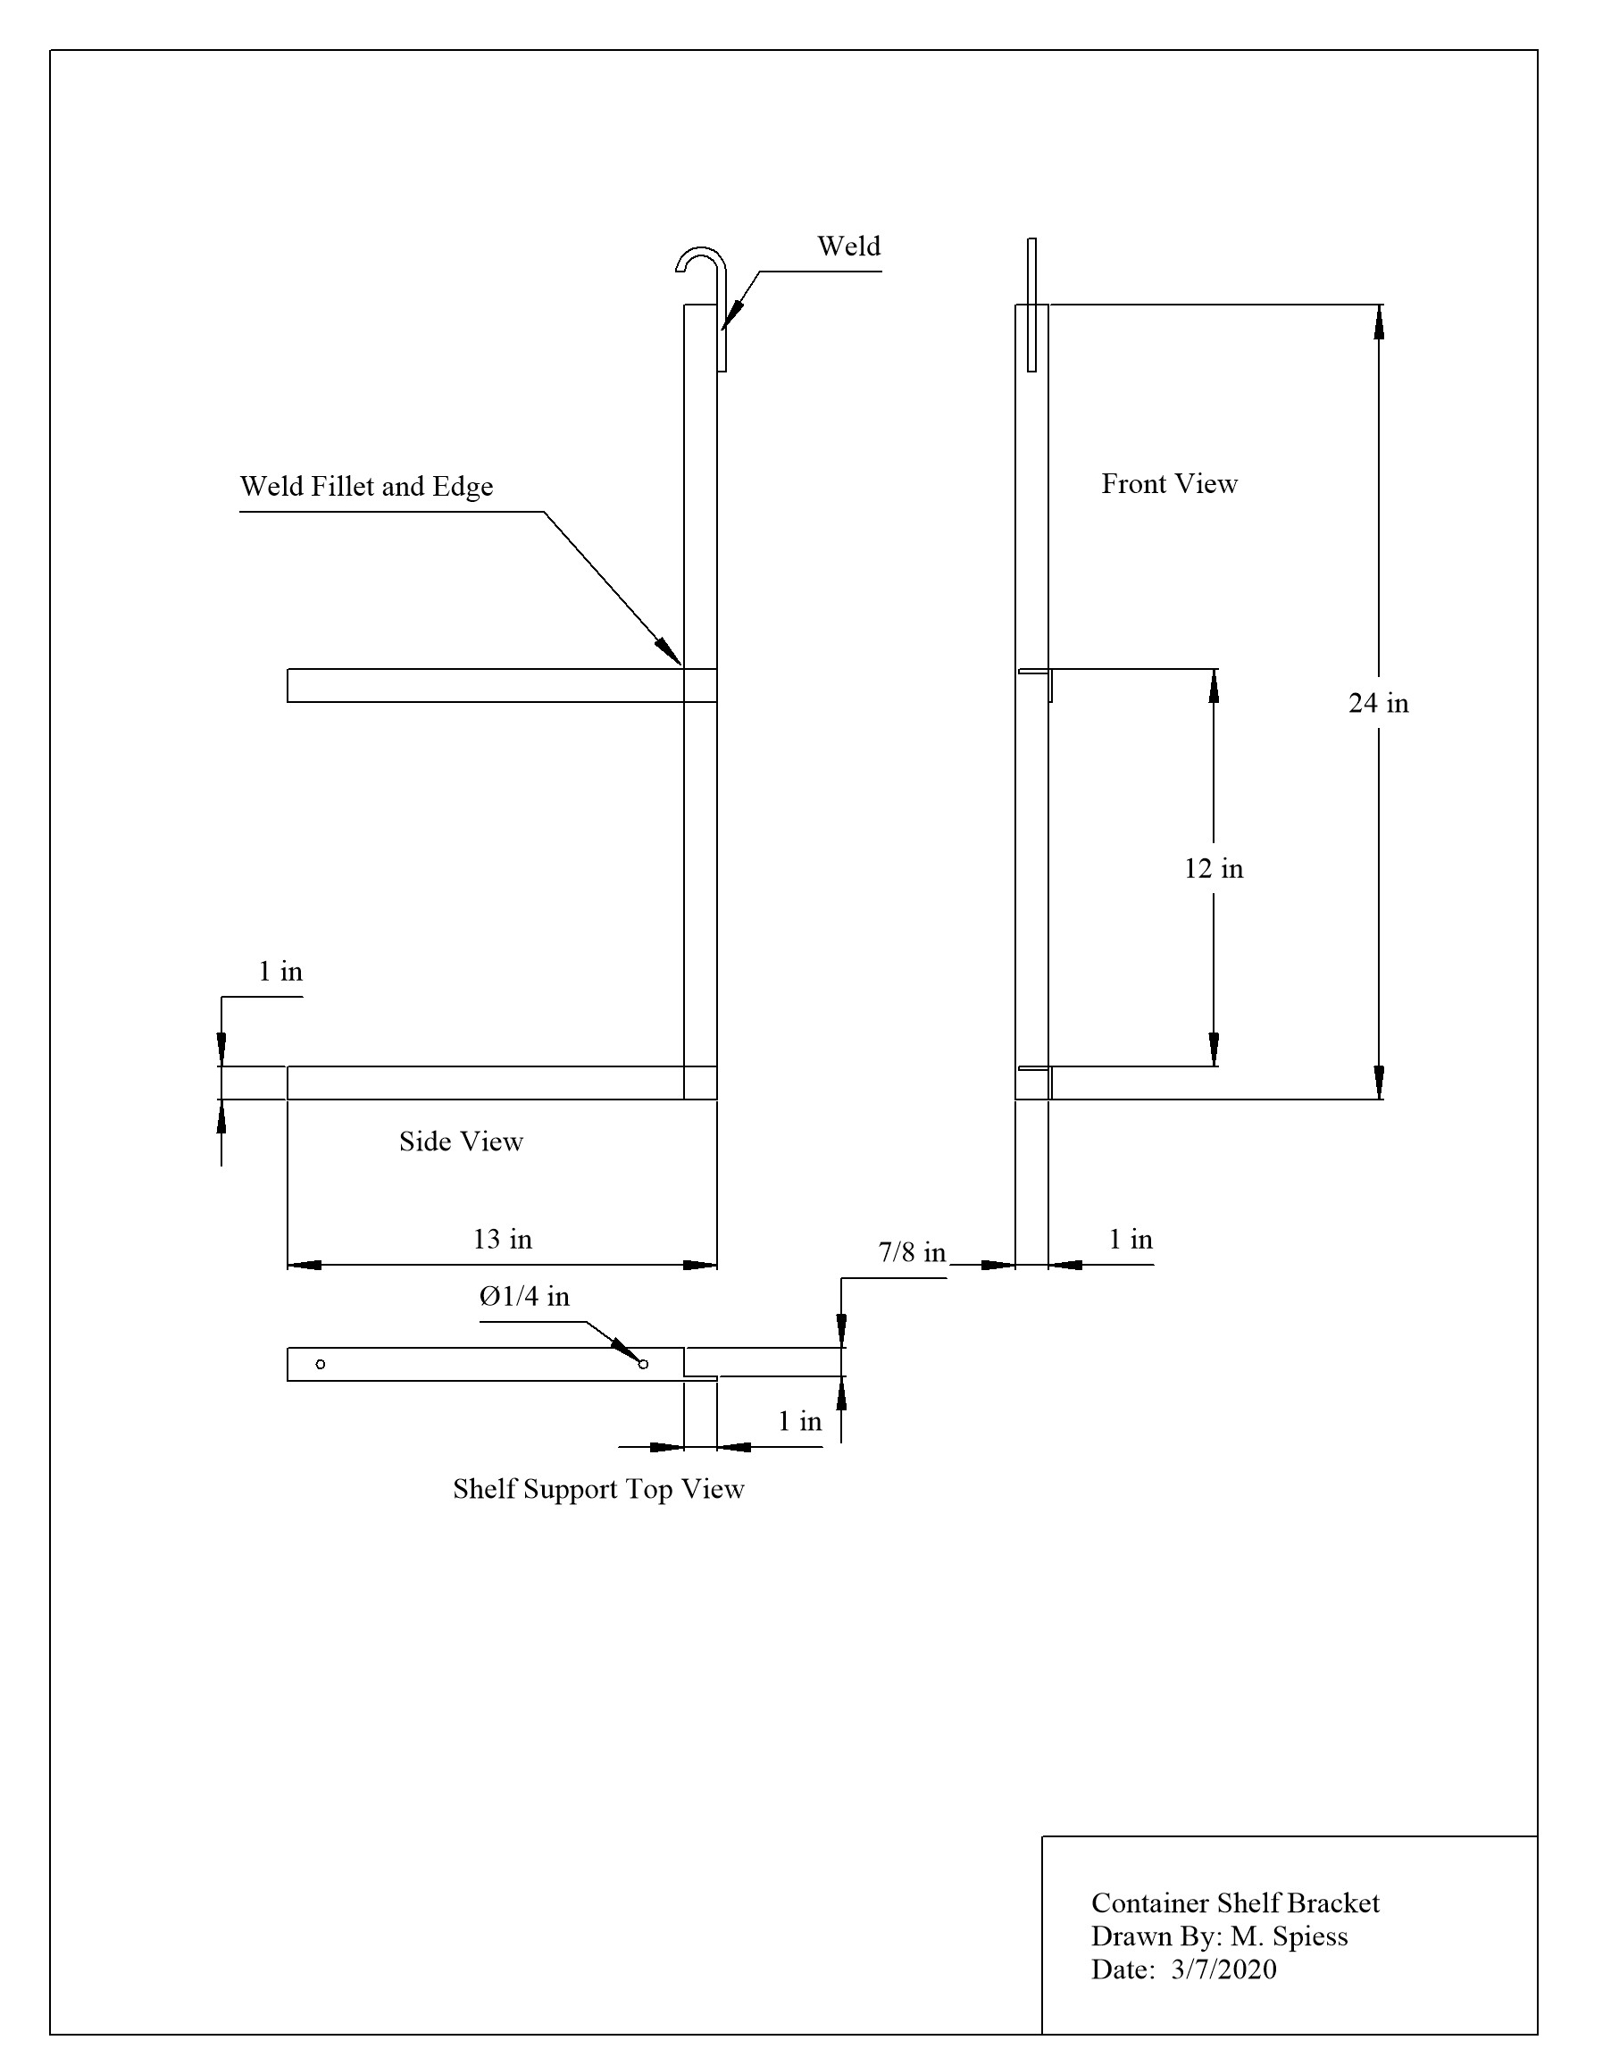

Construction Log:
Complete the log below making an entry every day you work on the project. Transfer the logged hours to your record book journal for this SAE enterprise.
Date | Tasks Completed | Skills Used/Learned | Hours

Actual Price Received:
Enter the actual price you received for the project in your record book journal as income.

Project Portfolio:
Complete a portfolio for the project that includes:
- A description of the project and the skills you learned building the project. Include the hours spent on the project and the income (if sold). Use the construction log to complete this narrative. Write in complete sentences.
- The Bill of Materials
- The project plan
- 2-8 photos documenting the project at various stages of construction.

