Corn Hole Game

Description:
Corn is a game played with bean bags (filled with corn) and two boards. This plan is for regulation boards as specified by the American Corn Hole Association. A variety of layout and wood working skills are used.

Skills Required:
Students must have the ability to read an assembly plan, properly measure, and operate a table saw, miter saw, band saw, and drill press.

Materials:
½” CC Plywood or better*
1” X 4” pine**
#6 FH Wood Screw
4d Finish Nails
Wood Glue
120 Grit sandpaper
¼” x 2” FH machine screw, washer, nut
Paint
* AB ply can be used. ¾” ply can be used and the supports omitted.
** 2 x4s can be used to make a heavier board. These boards are lighter and more easily transported.

Tools:
Tape
Combination Square
Power miter saw
Table saw
Drill/Driver & Bits
Countersink
Claw hammer
Nail set
Drill Press
6” hole saw
Counter sink
¼” drill
Band saw

Bill of Materials:
Complete the bill of materials below for this project. Use the completed bill of materials for your record book budget by entering the name of the project and the total amount as an expense
Size | Description | Units | Qty/Project | Cost/Unit | Order | Amount

Project Price:
Enter the expected price you will receive for the project in your record book budget (income).

Estimated Construction Time:
__5___ hours.

Directions:
- Cut the top from a sheet of plywood using the table saw. Mark the dimensions and cut on the middle of the line. This will make the top slightly shorter the 24” x 48”, but this is allowed by the rules and allows 4 tops to be cut from a 4’ x 8’ sheet.
- Using the hole saw and a slow speed layout the cut the 6” hole in the top. Optionally the hole can be cut with a jig saw and sanded smooth.
- From the 1 x 4 layout and cut the remaining pieces. Note: You may want to reduce the dimensions slightly to fit the top.
- Drill the holes for the leg pivot in the two sides. Countersink on the outside (good side).
- Assemble the frame using glue and wood screws. (Both holes on the same end!)
- Mark the angle on the legs and cut with the band saw.
- Layout the arc on the legs and cut with the band saw.
- Using the center of the arc on the legs drill the pivot hole using the drill press.
- Assemble the legs to the sides with the ¼” screws. Sand the arc as needed for smooth operation.
- Attached the leg brace with wood screws and glue.
- Assemble the top to the frame. Note the frame may be slightly too big. Center on the frame. Attach with finish nails and glue.
- Countersink the finish nails and fill.
- Sand the surface and edges.
- Paint the with a gloss paint and or gloss poly urethane. A design can be painted on the top then coated with poly urethane.
- Optional add handles to the sides for easier carrying.
- Bags may be purchased at any sporting goods stores. Note the bags are 6” x 6” and can be made from any heavy fabric. Traditionally they are fill with feed corn, but dry beans work as well. Bags should weigh 1 pound.

Cutting List:
Qty | Size | Description
1 | 24” x 48” | CC Plywood Top
2 | 3 ½”” X ¾” X 24” | Pine Ends
2 | 3 ½”” X ¾” X 46 1/2” | Pine sides
2 | 3 ½”” X ¾” X 22 ½” | Pine supports
1 | 3 ½”” X ¾” X 21” | Pine brace
2 | 3 ½”” X ¾” X 11 ½”” | Pine leg

Photo/Drawing:

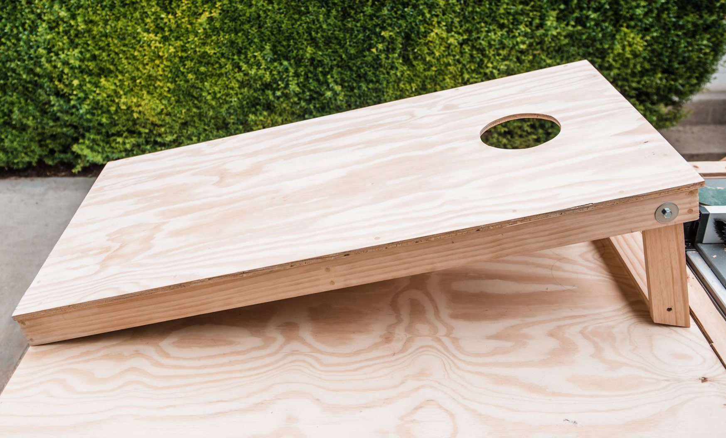
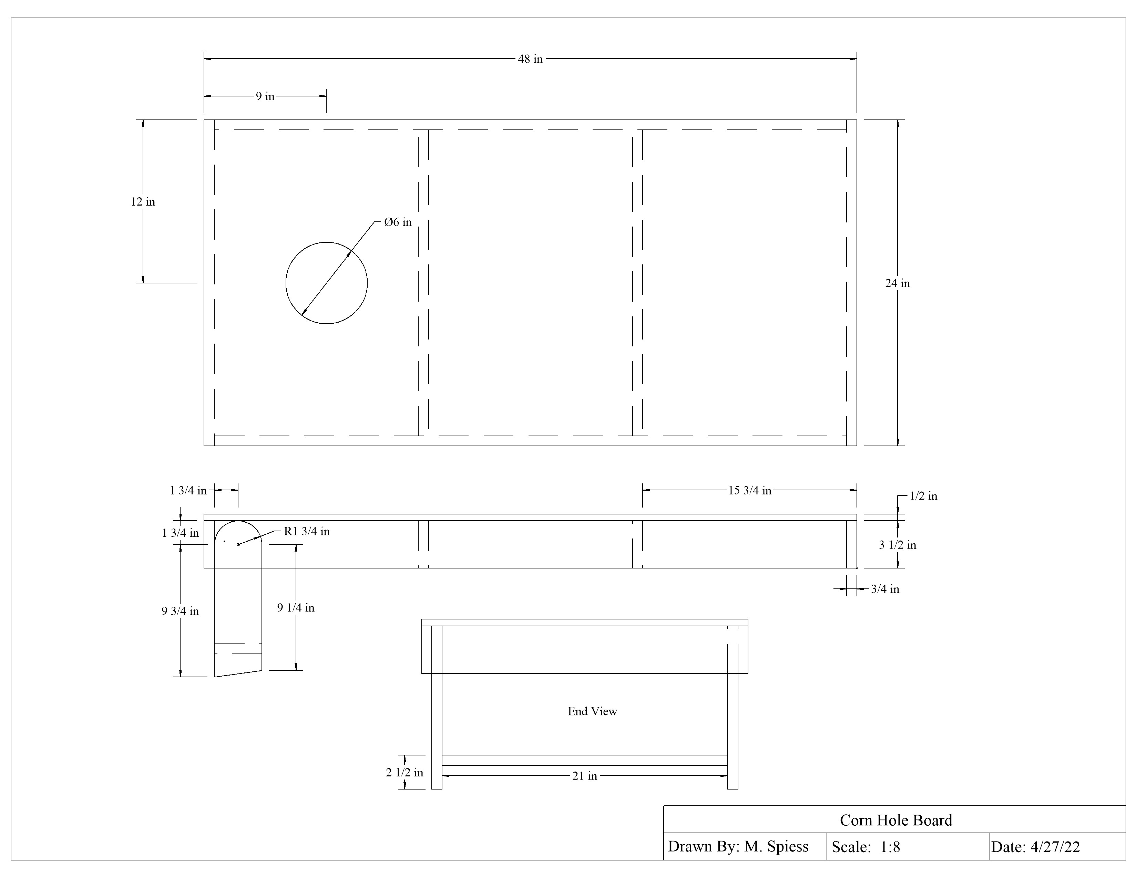

Construction Log:
Complete the log below making an entry every day you work on the project. Transfer the logged hours to your record book journal for this SAE enterprise.
Date | Tasks Completed | Skills Used/Learned | Hours

Actual Price Received:
Enter the actual price you received for the project in your record book journal as income. $_________

Project Portfolio:
Complete a portfolio for the project that includes:
- A description of the project and the skills you learned building the project. Include the hours spent on the project and the income (if sold). Use the construction log to complete this narrative. Write in complete sentences.
- The Bill of Materials
- The project plan
- 2-8 photos documenting the project at various stages of construction.

Corn Hole Rules
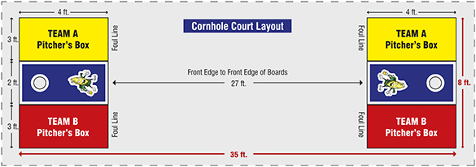

Cornhole Boards
- Place on a flat surface 24/27 feet apart (front to front).
- The cornhole board surface should be 2' x 4'.
- A 6" hole, centered 9" from the back and 12" from either side. (Alternatives - Boards are positioned 24' (casual or amateur) or 27' (professional or sanctioned leagues and tournaments) apart from the front end of the boards. The boards are either 2'x3' (casual backyard or "tailgate" boards) or 2' x 4' ("official" tournament) in size.

Cornhole Bags
- There should be 8 bags, 4 bags of each color.
- Each bag should be 6 inches by 6 inches and have 1 pound of corn inserted into each bag.

Game Play
- Team games consist of two teams of two people. Partners shall stand at opposite cornhole boxes on the same side facing each other.
- Each cornhole team shall have 4 bags of one color and all 8 cornhole bags begin at one end.
- A coin flip will determine which team shall go first and from which side they will pitch from.
- The team who has honors will begin play by one of the partners throwing a cornhole bag at the opposite cornhole board.
- A cornhole player may throw from anywhere behind the front of the cornhole box, this is the games foul line.
- Alternate throws between the two opponents until all 8 cornhole bags have been thrown.
- If a cornhole bag hits the ground first, then bounces up onto the board, remove that bag for it does not count. A simultaneous hit (board and ground) counts as a point if it stays on the board when it's lifted from the ground.
- After all 8 bags are throw, scoring is determined using Cancellation Format scoring. Team A has 1 bag in the hole (3 points) and 2 bags on the board (2 points), Team B has 2 bags on the board (2 points). Team A is awarded 3 points and has honors to throw first in the next round.
- The next round starts when the other cornhole player on the team, which has honors, throws their first cornhole bag.
- The cornhole game continues until one team reaches or goes over 21.

Cornhole Fouls
- A cornhole players foot goes past the foot foul line (the front of the cornhole board).
- Any bag that hits the ground and ends up on the board.
- A Player goes out of turn.

When a foul occurs the result is removal of the bag from the board. If the bag hits another bag or knocks one in the hole, the hit bag shall be put back where it was before the hit.

Scoring
The score shall be taken after all cornhole bags have been thrown for a round.
-3 points for a cornhole bag that goes through the hole.
-1 point for a cornhole bag that is on the playing surface.
-1 point for a cornhole bag that is hanging into the hole.
-1 point for a cornhole bag that is hanging off the edge. If cornhole bag is on the front of the board, board can be lifted. If the bag stays on the board, point counts.
-1 point for a cornhole bag when there is a simultaneous hit (board and ground)
and it stays on the board when the board is lifted from the ground.
-0 points for a cornhole bag that is on the ground.
- The team with the highest round score, adds the difference of the two scores to their game score. (Cancellation Format scoring).
- The team who wins the round is given honors to throw first in the next round.
- If both cornhole teams have the same round score then the game score stays the same and honors stays with the team who had it the previous round.

Accessories:
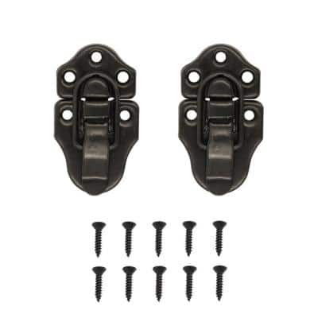
- Cut a length of light rope 27’ long and use to space the boards
- Make a larger bag to hold the rope and bags when not in use. Note: You can add a hinged cover to make a storage box between the cross supports.
- You can connect your boards with over center catches for transport.
- You can cut a hand hold in the side instead of adding handle.

