Wood and Metal Bench

This project was created by J. Kaslin at California State University, Chico in the fall of 2014

Description:
Stand alone metal framed and wood slatted garden bench for recreational use and décor.

Skills Required:
The project requires basic metal and wood working skills. In addition layout of the seat slats will require some problem solving as the builder determines the appropriate spacing.

Materials:
- 3/8 x 2” HR Flat Steel
- 2”x2” 14ga Steel Tubing
- 2” x 4” Redwood or fir lumber
- black metal paint
- metal primer
- 3/8”x 2 1/2” NC galvanized carriage bolts nuts and washers

Tools Required:
- Small Bar Clamps
- Square
- Tape Measure
- 9/16” Socket and Wrench
- Metal Bender or O/A torch
- Hammer
- Drill Press and 3/8” Drill Bit (wood and metal)
- Horizontal Band Saw
- Power Miter Saw
- Angle Grinder
- MIG Welder
- Sander

Bill of Materials:
Complete the bill of materials below for this project. Use the completed bill of materials for your record book budget by entering the name of the project and the total amount as an expense
Size | Description | Units | Qty/Project | Cost/Unit | Order | Amount

Project Price:
Enter the expected price you will receive for the project in your record book budget (income).
$ _______

Estimated Construction Time:
12 hours.

Directions:

Phase I Base.
- Cut the square tubing to length on the band saw or chop saw.
- Assemble with tack welds and insure that the parts are square.
- Complete the welds.
- Cut the flat stock. Dress the ends to remove any sharp edges.
- Tack the crossbar in position. Again check square before final welding.
- On the seat support located and mark where the base will be welded. You cannot have a bolt in this position.
- Using a scrap of your lumber layout the hole locations for the seat supports. One bolt per board. Remember to space extra at the bend since the boards will closer together once the metal is bent.
- Drill the holes in the metal.
- Bend the seat supports as shown in the drawing. Make sure that both supports match. You may bend want to bend cold with a bender or bend hot. A jig will help.
- Tack the seat support in place. Double check the position then weld in place.

Phase II Wood Work
- Cut the seat slats to length.
- Sand edges.
- Position the slats one at a time on the frame. Use clamps to hold the slat in place. Drill through the metal into the slat. Loosely install a bolt to hold the slat in place. Repeat for all slats.
- Number the slats on the bottom so you know where they go and remove from the frame.

Phase III Final Assembly
- Prime and paint the metal base frame.
- Finish the slats with a oil, stain, or exterior finish.
- Assemble the wood to the frame.
Cutting List:
Key | Part | Pcs | Dimensions
A | Legs | 2 | 2”x2” x13” 14ga Tubing
B | Leg Base | 2 | 2”x2” x18” 14ga Tubing
C | Seat Support | 2 | 3/8”x2”x39-1/2”Hot Rolled Flat Steel
D | Front Brace | 1 | 3/8”x2”X 56” Hot Rolled Flat Steel
E | Seat Slats | 9 | 1 ½” x 3 ½” x 62” Redwood Boards

Photo/Drawing:
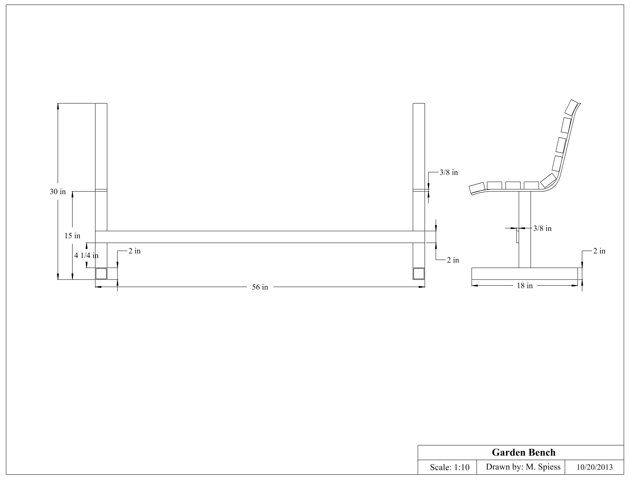
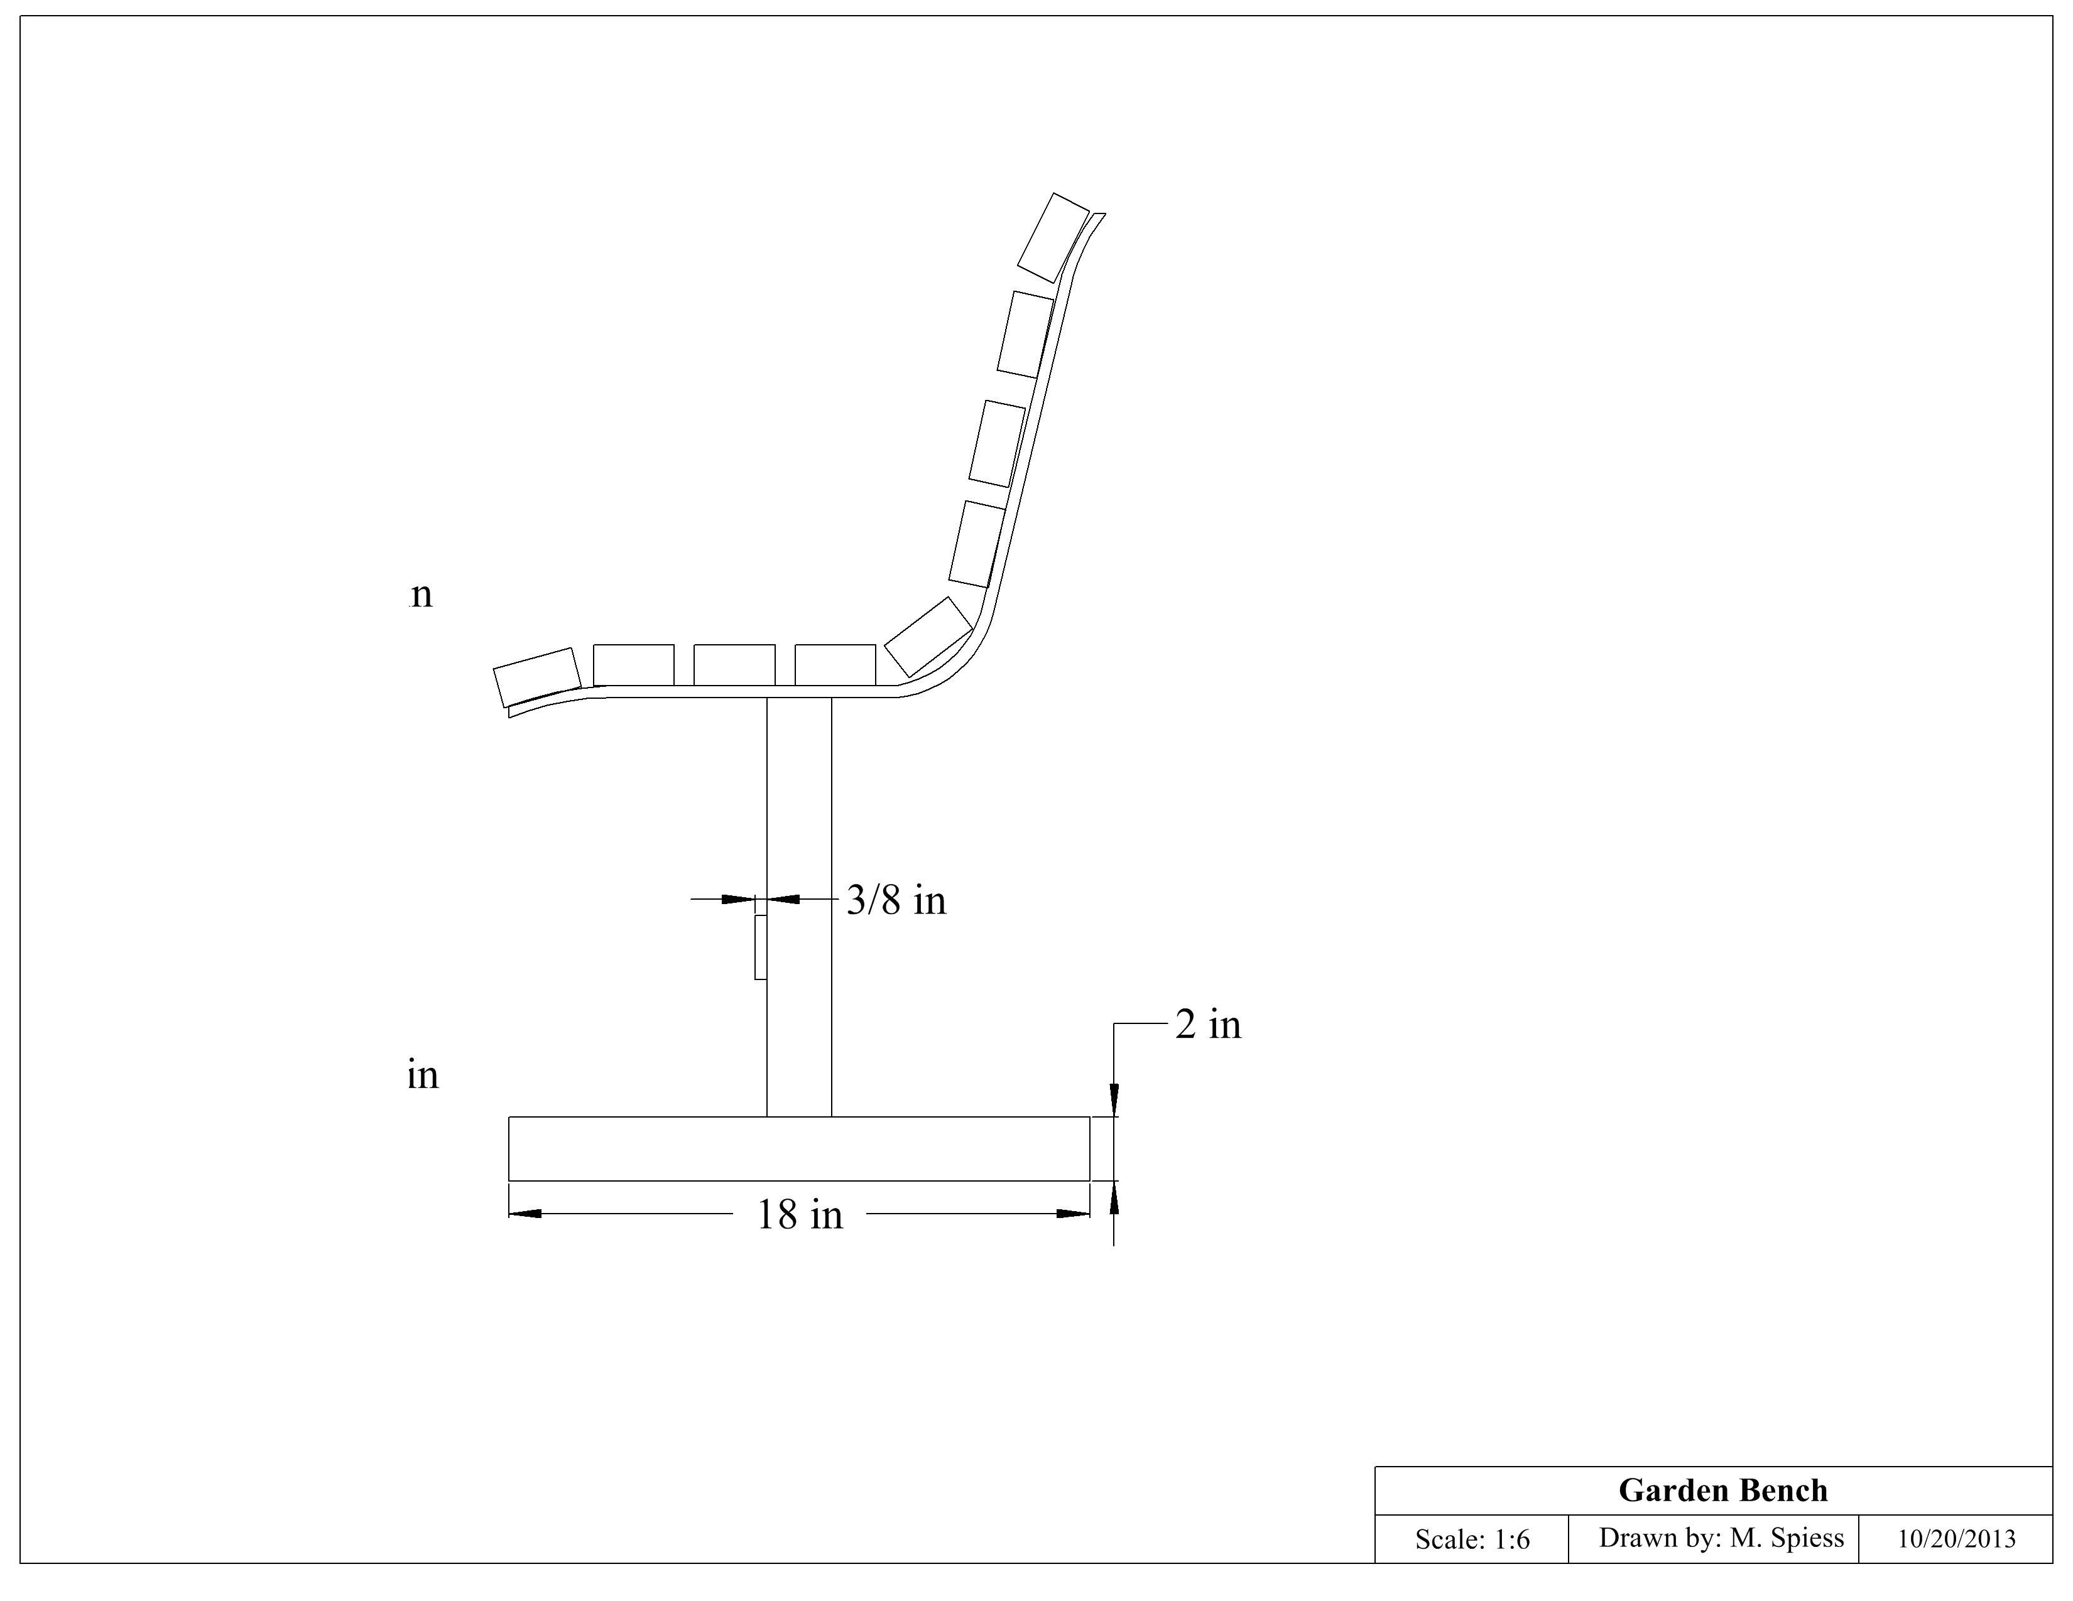
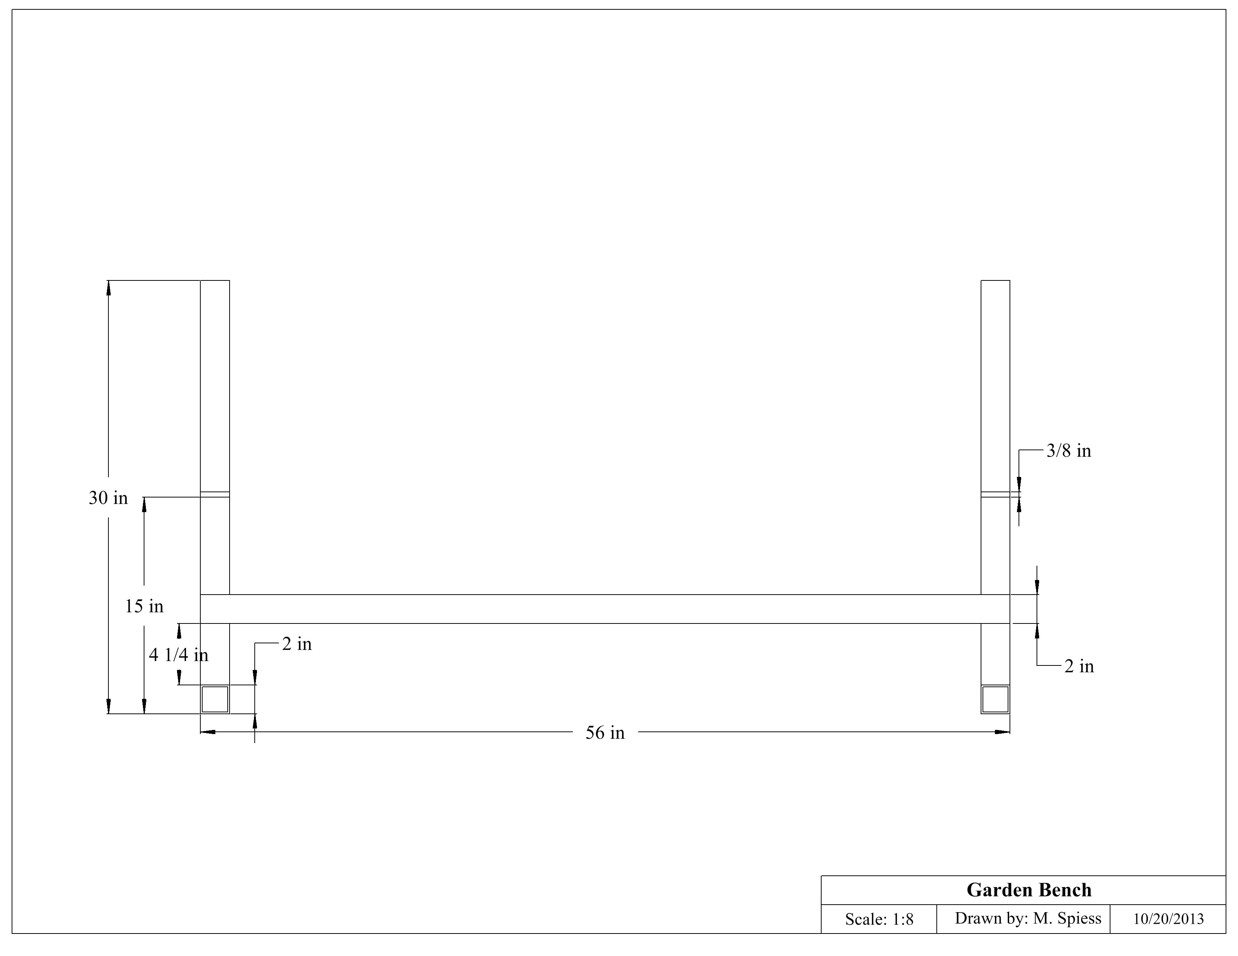
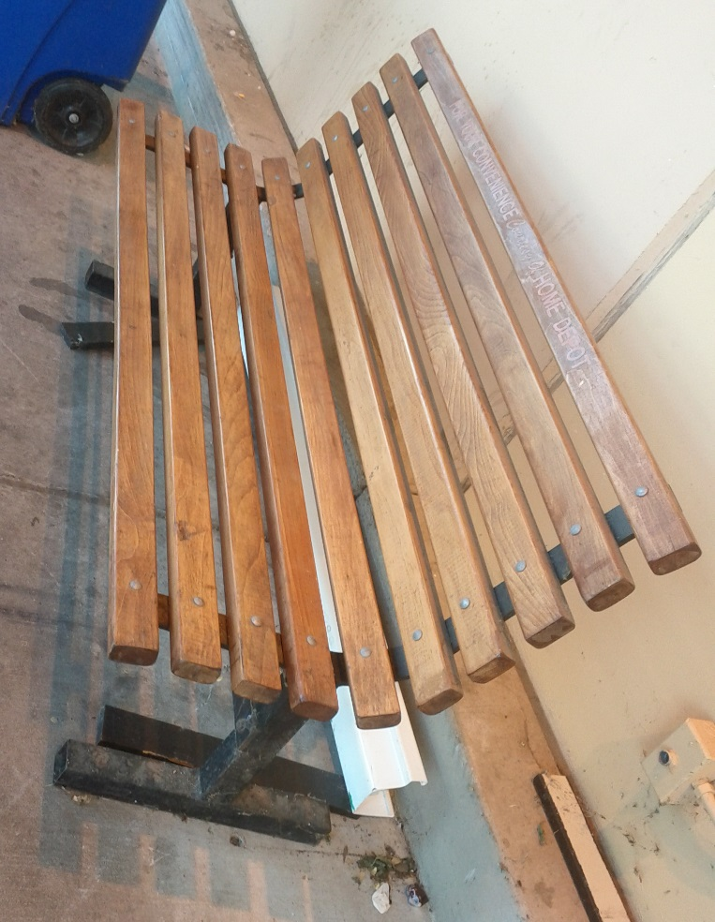
(A manufactured example.)

Construction Log:
Complete the log below making an entry every day you work on the project. Transfer the logged hours to your record book journal for this SAE enterprise.
Date | Tasks Completed | Skills Used/Learned | Hours

Actual Price Received:
Enter the actual price you received for the project in your record book journal as income. $ __________

Project Portfolio:
Complete a portfolio for the project that includes:
- A description of the project and the skills you learned building the project. Include the hours spent on the project and the income (if sold). Use the construction log to complete this narrative. Write in complete sentences.
- The Bill of Materials
- The project plan
- 2-8 photos documenting the project at various stages of construction.

