Simple Garden Bench

Description:
This sturdy simple garden bench is easy to build. The bench is made entirely from dimensional lumber and with only simple cuts and butt joints. The bench can be altered to set in concrete or made wider.

Skills Required:
Students must have the ability to read a plan, properly measure, and operate a power miter saw.

Materials:
- 2x6 redwood or cedar
- 2x4 redwood or cedar
- #10 x 3-4" deck screws; square or Torx drive
- Waterproof wood glue
- Deck stain or Exterior Semi-Gloss Paint
- 120 grit sandpaper
- Wood dough (for paint)
Tools Required:
- Power Miter saw
- Framing Square
- Drill/driver with bit
- Clamps (2)
- Palm sander or sanding blocks
- Router & ¼ round bit (optional)

Bill of Materials:
Complete the bill of materials below for this project. Use the completed bill of materials for your record book budget by entering the name of the project and the total amount as an expense
Size | Description | Units | Qty/Project | Cost/Unit | Order | Amount

Project Price:
Enter the expected price you will receive for the project in your record book budget (income).

Estimated Construction Time:
__4___ hours.

Directions:
- Cut legs from the 4x4.
- Cut frame from 2x4.
- Cut top from 2x6.
- Choose the best side of the wood for the exposed surfaces.
- Assemble the 2x4 frame using 2 screws per joint. Use the framing square to square the frame. Use glue but be careful not to get glue on the exposed wood if you will stain. NOTE: Install screws just below flush.
- With the frame on a flat floor (top down) install the legs in the corners. Use the clamps to achieve a tight fit and hold legs vertical. Use glue and 4 screws per leg.
- Sand the frame and legs. Note: ease the bottom of the legs to prevent splitting when the bench is moved. Edges can be eased with a router or simply sanded.
- With the frame upright set the top on and adjust the spacing. It should overhang the ends 1”, sides ½” and board should be a ¼” apart. Use clamps if needed.
- Install the top with screws. 2 per board on the ends and middle. 2 on each side spaced between the end and middle support. 2 screws for each leg.
- Sand the top. Edges can be eased with a router or simply sanded.
- Stain or paint. If painting do the following:
  - Fill top screw holes with wood dough and sand when dry.
  - Prime and let dry. Note: You may wish to prime lumber before assembly.
  - Apply an exterior semi-gloss paint.

Cut List
Qty | Size | Material | Part
4 | 13” x 3 ½” x 3 ½” | Redwood / Cedar or PT Fir | Legs
3 | 60”x 5 ½” x 1 ½” | Redwood / Cedar | Top
3 | 13” x 3 ½” x 1 ½” | Redwood / Cedar | Support Frame Cross Member
2 | 58” x 3 ½” x 1 ½” | Redwood / Cedar | Support Frame

Variations:
- Pressure treated wood can be used for legs.
- If set in concrete add 6-8” to the leg length. Note: Place the leveled bench on packed soil before pouring concrete so concrete does not cap the end of the leg.
- Top of bench can be made from 2x4. Adjust the width of cross members to maintain the same overlap.
- Top of bench can be wider by adding a 4th 2x6. Adjust the width of cross members to maintain the same overlap.
- Frame corners can be cut on a 45” (mitered joint) to make a more finished appearance. Add 3” to end cross members.

Drawing:
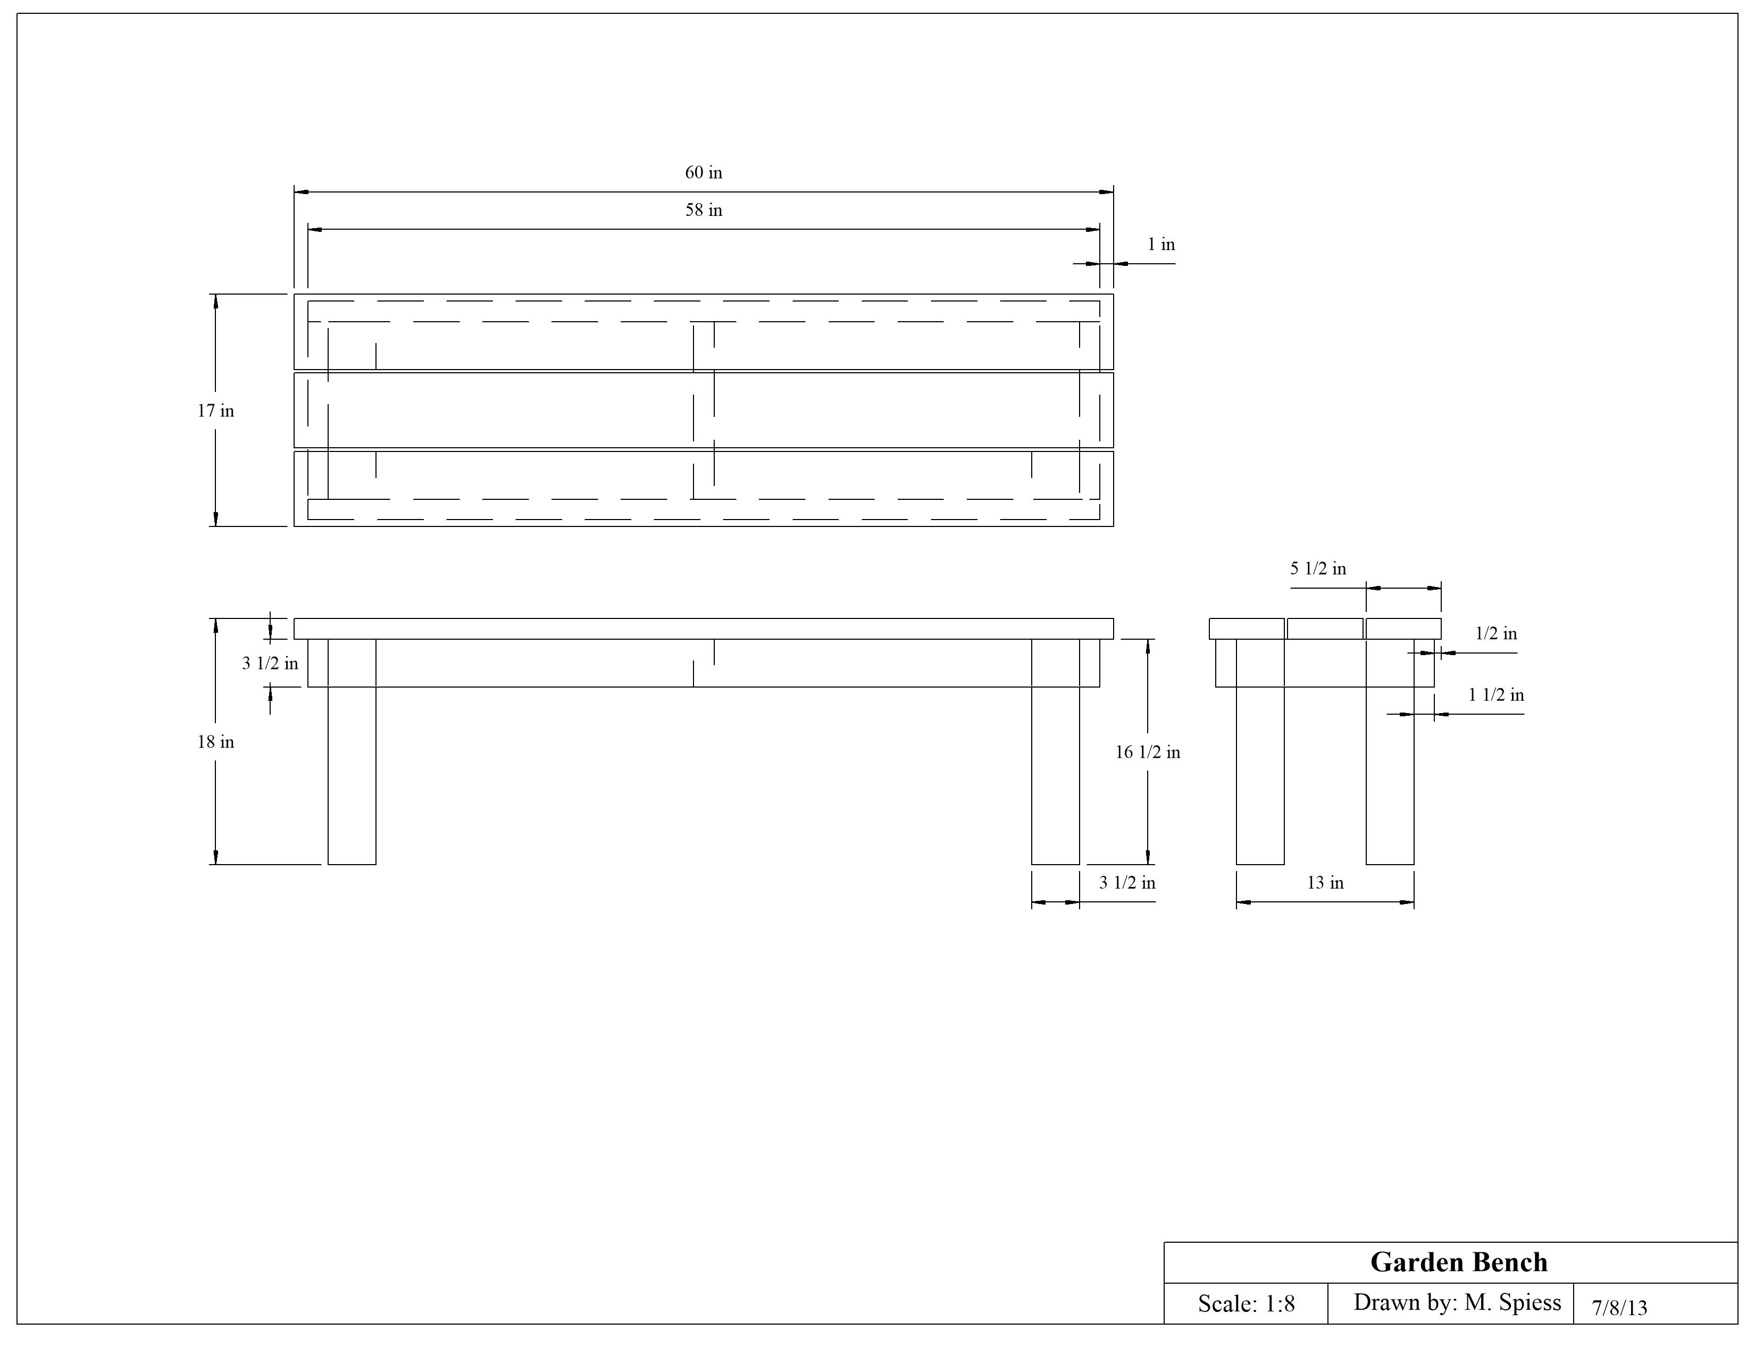

Construction Log:
Complete the log below making an entry every day you work on the project. Transfer the logged hours to your record book journal for this SAE enterprise.
Date | Tasks Completed | Skills Used/Learned | Hours

Actual Price Received:
Enter the actual price you received for the project in your record book journal as income. $_________

Project Portfolio:
Complete a portfolio for the project that includes:
- A description of the project and the skills you learned building the project. Include the hours spent on the project and the income (if sold). Use the construction log to complete this narrative. Write in complete sentences.
- The Bill of Materials
- The project plan
- 2-8 photos documenting the project at various stages of construction.

