Lumber Rack

Description:
Small lumber rack for sheets and dimensional lumber. Three frames are built then assembled in place. Frames mount to the wall. The plans are for an 8’ rack 2’ wide. Dimensions can be easily altered to fit a different space. Plywood shelves support the frames and aid in sliding in sheet goods. Additional shelves can be added if storing short lumber. For a free standing rack connect the three frames with 6 pieces of square tubing.

Skills Required:
GMAW welding, plasma cutting, and layout skills are used to construct this project.

Materials:
- 1” x 1”x .120” square tubing
- ½” or ¾” Shop Plywood (CC).
- 1” bugle head fine thread drywall screws.
- Lag Screws (to mount to wall)
- Paint

- Tools Required:
- Chop saw or horizontal band saw
- Angle grinder
- GMAW Welder
- Drill Press (optional)
- Portable Drill/Driver
- Drill bits & Drivers
- Steel Tape
- Table Saw (or circular saw)

Bill of Materials:
Complete the bill of materials below for this project. Use the completed bill of materials for your record book budget by entering the name of the project and the total amount as an expense
Size | Description | Units | Qty/Project | Cost/Unit | Order | Amount

Project Price:
Enter the expected price you will receive for the project in your record book budget (income). $_______

Estimated Construction Time:
___8__ hours.

Directions:
Read entire directions before beginning
- Cut the square tubing to length for three frames.
- Drill holes in three of the uprights at the top, middle and bottom IF you know where this will be mounted. Otherwise drill the completed frame with a portable drill when installing,
- Tack. Check square by measuring corner to corner.
- Weld tubing. NOTE: If mounting holes are predrilled then be sure to position the uprights with the holes correctly.
- Grind rough edges. Flat sides can be ground smooth if desired.
- Paint as desired.

Installation
- Install the frames 8’ apart (outside to outside). Use a level to ensure that they are plumb.
- Attach to wall at the top, middle and bottom. Note: Weight is on the floor, but the wall stabilizes the rack.
- Center frame is centered between the two outside frames.
- Rip the plywood to the width of the inside of the frame.
- Attach the plywood with two screws on each frame. Be sure to square the frame with the wall (or plywood). Counter sink the screws so wood will not catch when slid in to the rack.
- Shim the outside legs of the frame if needed with sheet metal. This is important so weight is on the leg, not the wall.

Scrap Drawers
Scrap drawers can be constructed to fit below the bottom shelf. Use 4 small fixed castors. Allow about 1” of clearance all around. For an 8’ rack as described above the drawer should be 9” high (with castors), 45” wide and 23” deep. Construct the drawer with plywood using glue and nails. Attach the castors so it will slide straight out. Optionally paint and add a drawer handle.

Photo/Drawing:
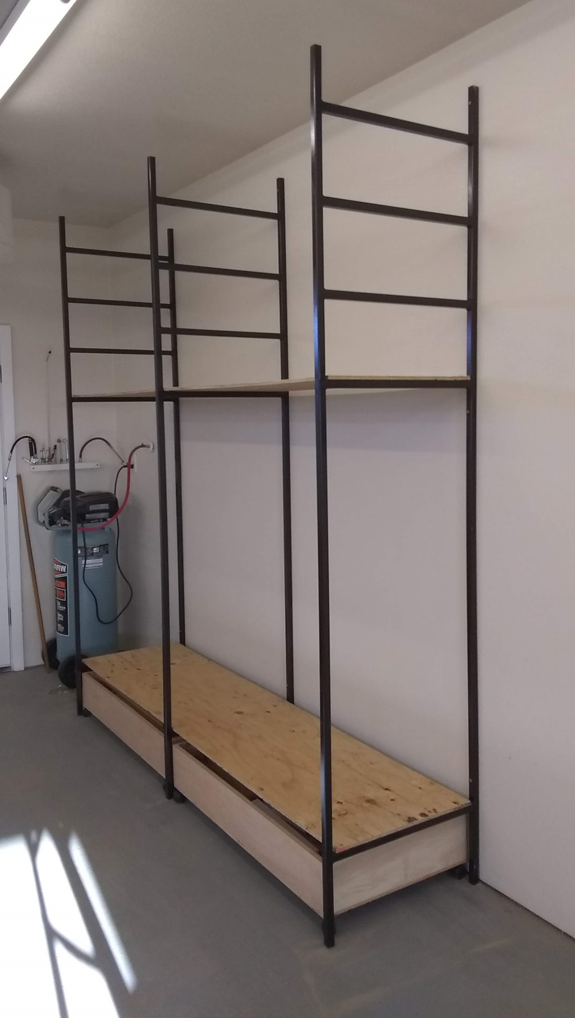

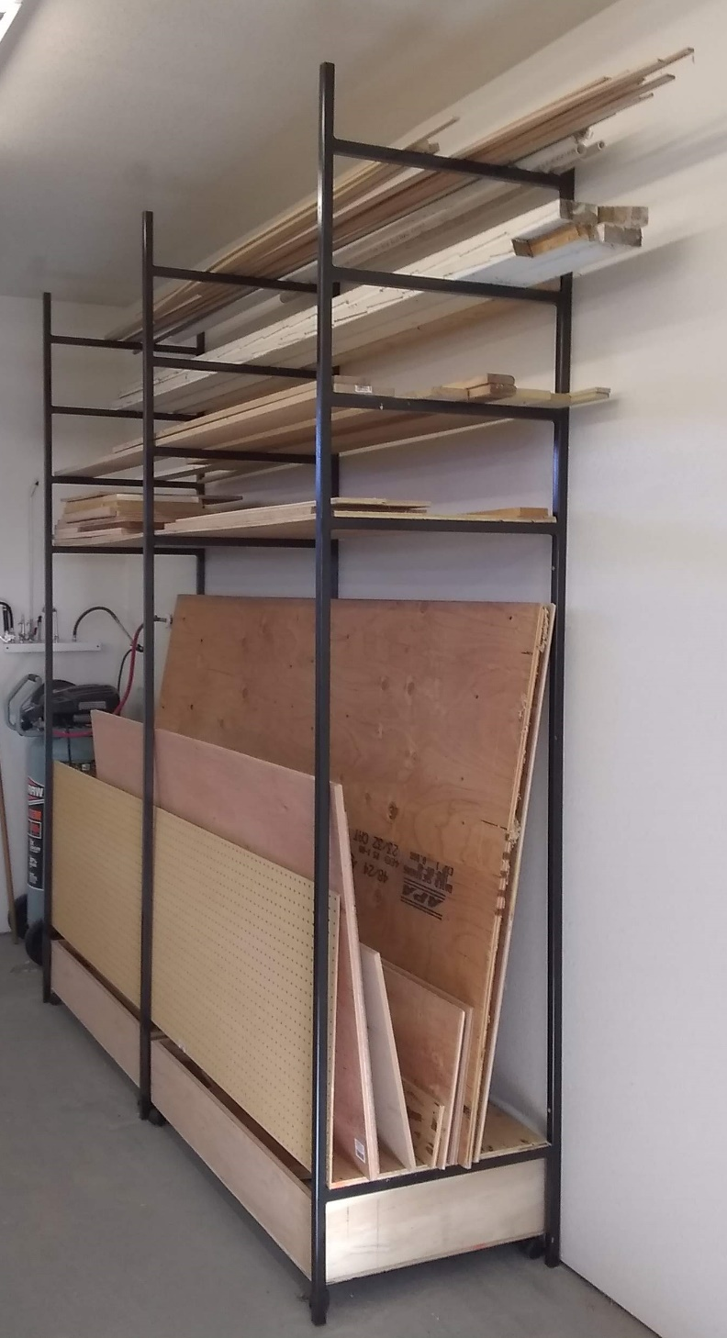

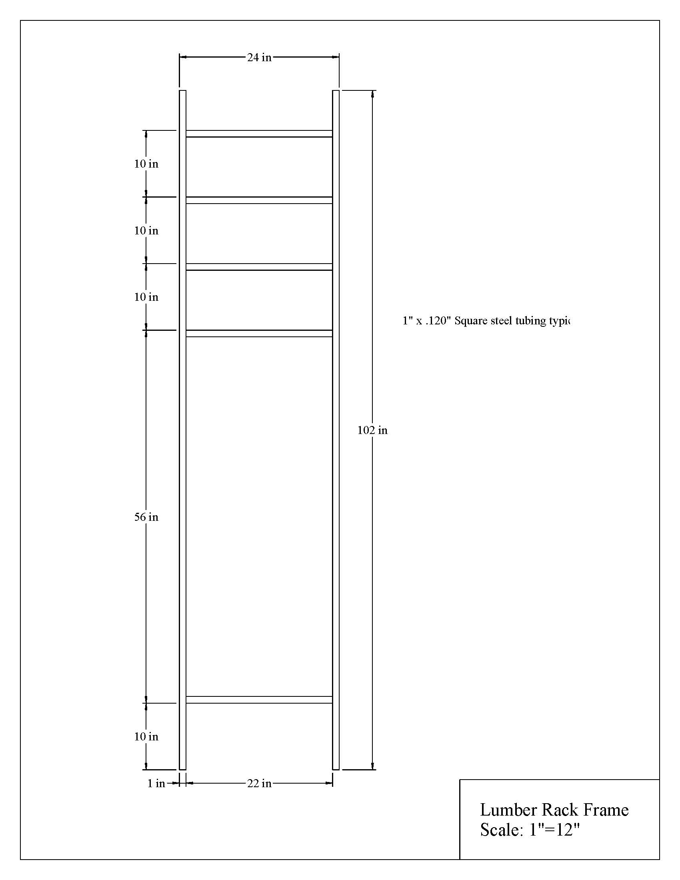

Construction Log:
Complete the log below making an entry every day you work on the project. Transfer the logged hours to your record book journal for this SAE enterprise.
Date | Tasks Completed | Skills Used/Learned | Hours

Actual Price Received:
Enter the actual price you received for the project in your record book journal as income. $_________

Project Portfolio:
Complete a portfolio for the project that includes:
- A description of the project and the skills you learned building the project. Include the hours spent on the project and the income (if sold). Use the construction log to complete this narrative. Write in complete sentences.
- The Bill of Materials
- The project plan.
- 2-8 photos documenting the project at various stages of construction.

