Owl Box

Description:
An owl house designed to attract owls for predator control on farms. On this design the top opens for cleaning. Another option is to cut the side up 6” from the bottom, hinge at the cut. Nail and glue the 12” piece. Attach the 6” piece ((door) with hinges. Secure the door by drilling an 1/8” hole in the back panel and inserting a nail. Note: Box can be built from ½” plywood, but will not be as sturdy. Bottom will be 22” x 23”.

Skills Required:
Basic layout and woodworking skills are required.(List the skills required to build the project).

Materials:
¾ ” x 4’ x 8’ ACX Plywood
- Wood glue
- 4d EG box nails or #6 x 1-5/8” coated deck screws.
- 2” Zinc Plated, Narrow Hinges & ½“ Wood Screws

Tools Required:
- Table Saw with a Hollow Ground Blade
- Jigsaw
- Drill Press or portable drill
- ½” Spade Bit or Forstner bit
- Power Drill & Screwdriver

Bill of Materials:
Complete the bill of materials below for this project. Use the completed bill of materials for your record book budget by entering the name of the project and the total amount as an expense
Size | Description | Units | Qty/Project | Cost/Unit | Order | Amount

Project Price:
Enter the expected price you will receive for the project in your record book budget (income). $_______

Estimated Construction Time:
_____ hours.

Directions:
- Review the layout on the plywood.
- Cut out pieces using a table saw. (See Cutting List)
  - Rip sheet in half at 26” down
  - Using the 22” half, cut the sides and bottom. Refer to drawing)
  - Using the 26” half, cut the top. (Refer to drawing)
- Find the cut piece that will be used as the front of the box, using a jigsaw, cut entrance to box.
- Groves???
- Find the cut piece that will be used as the bottom of the box. Layout the hole locations and using the drill press, drill 8 holes.
- Fasten front and back to bottom. Fasten sides to existing frame. Fasten top.
  - All fastening will be done with a layer of wood glue.
  - Top will be fastened with hinges. Place hinges 4” in from the edge
- Attachment Notes:
  - Box should be placed xxx feet from the ground.
  - To attach to a wooden pole or post use two ¼” lag bolts with fender washers. Pre-drill hole the owl house.
  - To attach to a steel pipe use 2 - two footed conduit clamps. Pre-drill the owl house and use machine screws to attach the clamps. Place heads and flat washers on the inside of the house.

Cutting List:
Part | Quantity | Size | Material
Top | 1 | 22”x26” | ¾ ” x4’x8’ ACX Plywood
Bottom | 1 | 22”x 21 1/2” | ¾ ” x4’x8’ ACX Plywood
Front/Back | 2 | 18” x 22” | ¾ ” x4’x8’ ACX Plywood
Sides | 2 | 18”x 22” | ¾ ” x4’x8’ ACX Plywood

Photo/Drawing:

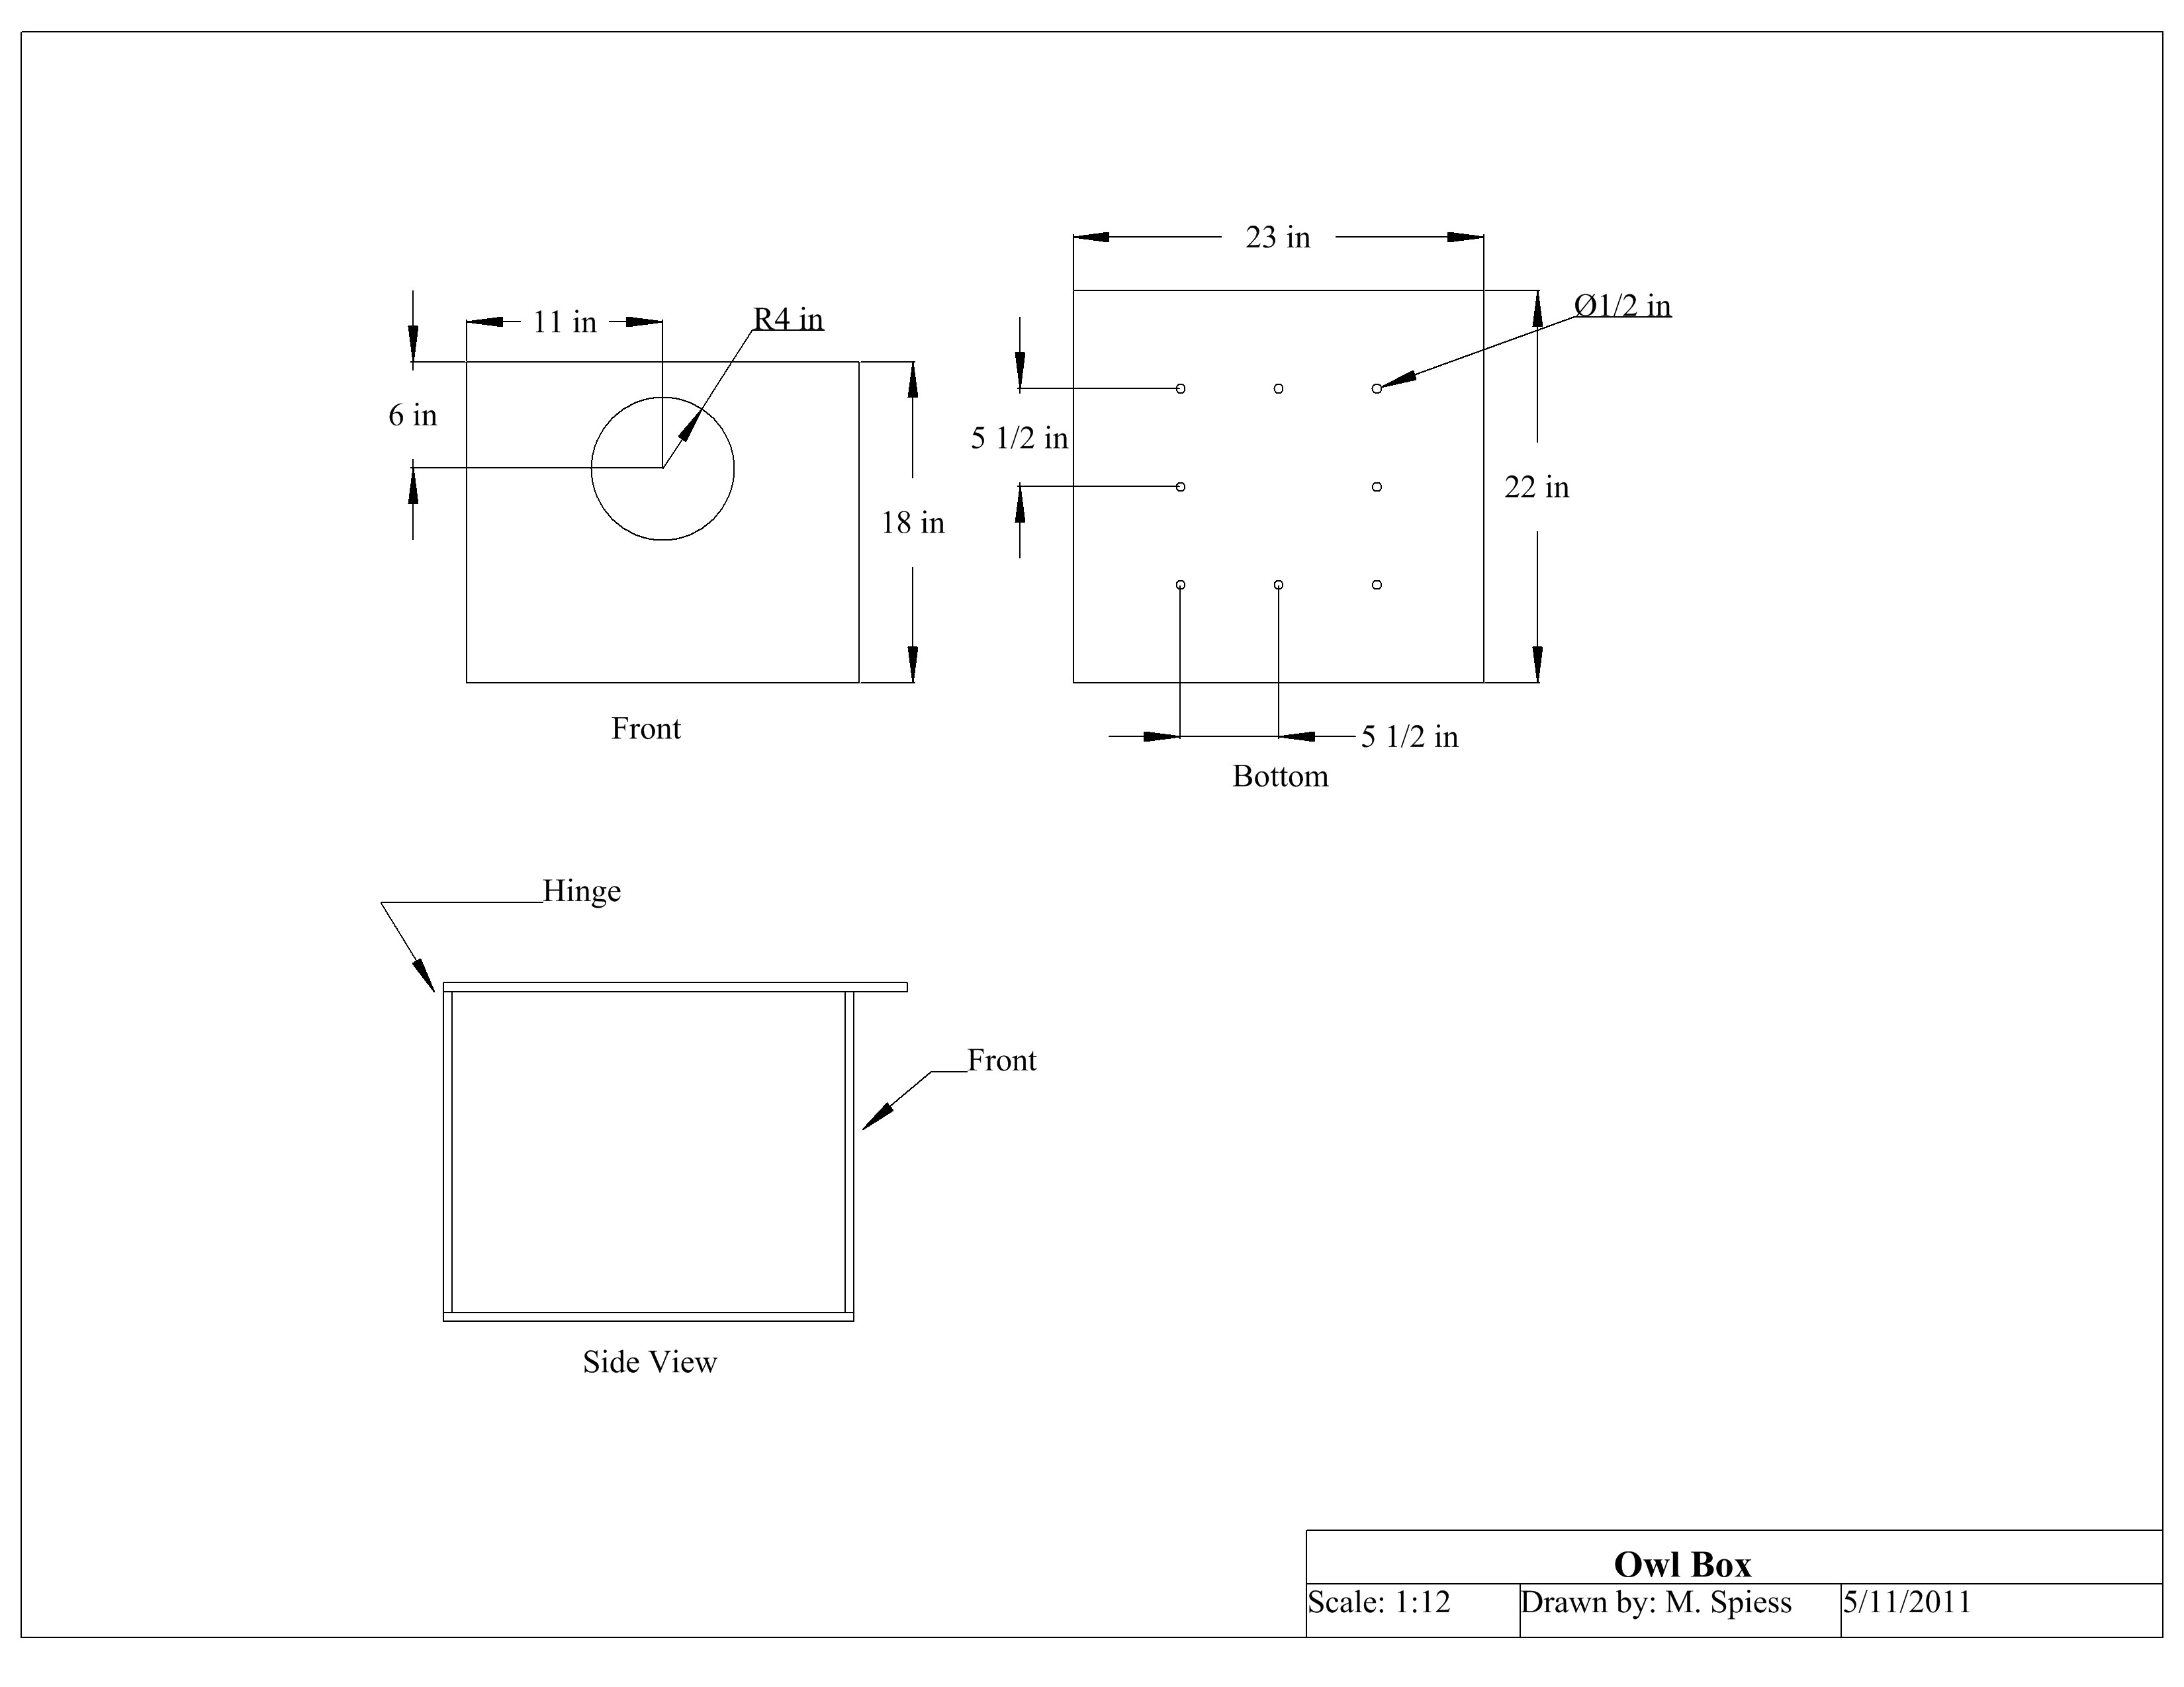

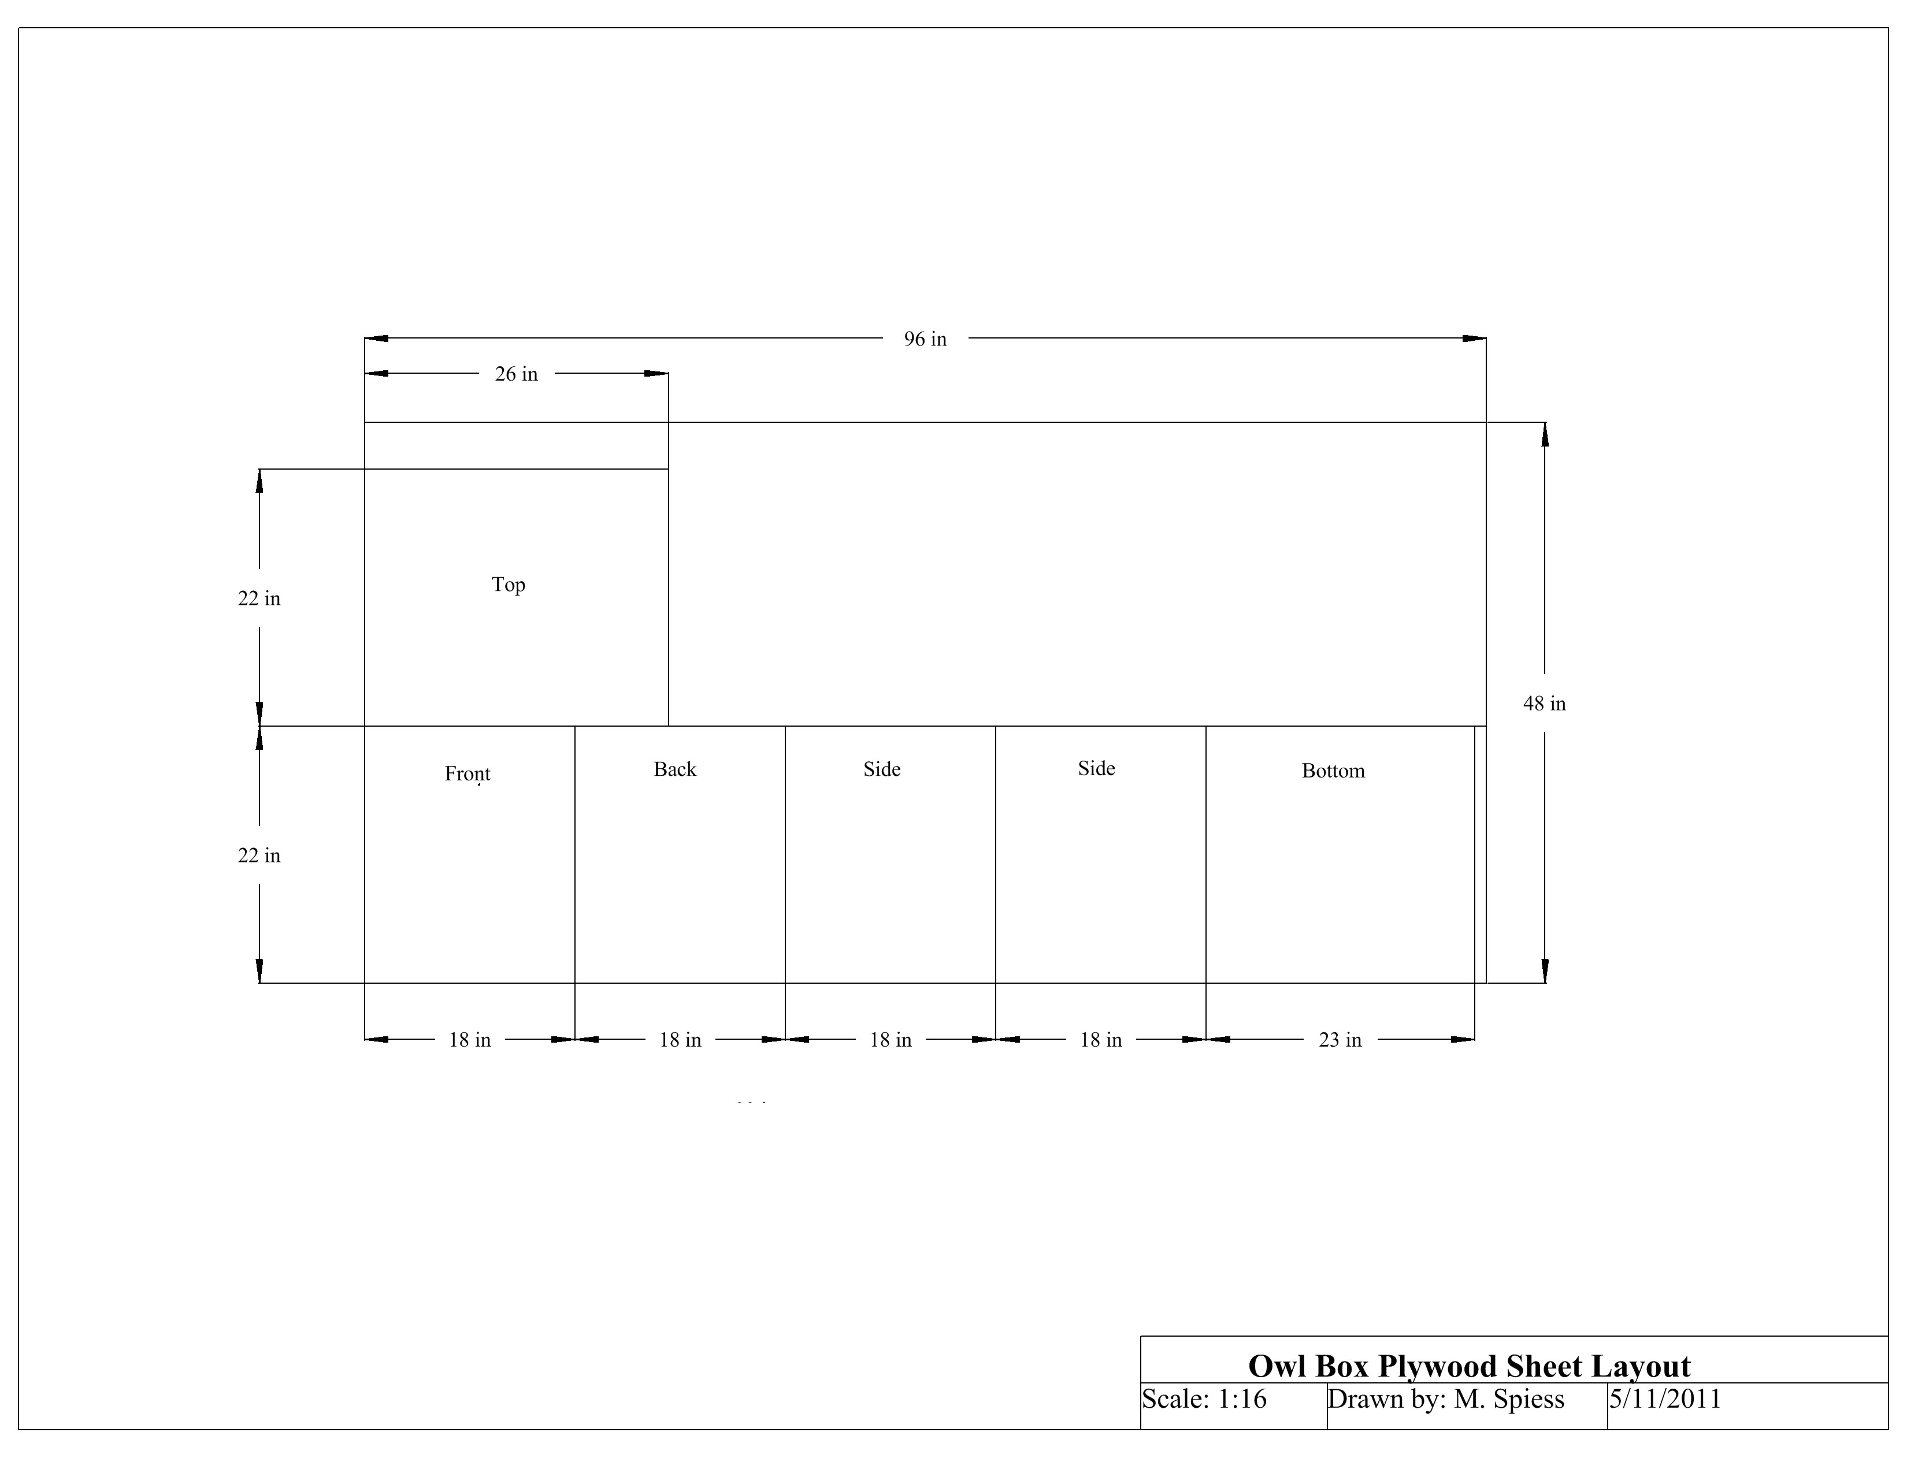

Construction Log:
Complete the log below making an entry every day you work on the project. Transfer the logged hours to your record book journal for this SAE enterprise.
Date | Tasks Completed | Skills Used/Learned | Hours

Actual Price Received:
Enter the actual price you received for the project in your record book journal as income. $_________

Project Portfolio:
Complete a portfolio for the project that includes:
- A description of the project and the skills you learned building the project. Include the hours spent on the project and the income (if sold). Use the construction log to complete this narrative. Write in complete sentences.
- The Bill of Materials
- The project plan
- 2-8 photos documenting the project at various stages of construction.

