Planter Box

This project was created by H. Lawson at California State University, Chico in the fall of 2014. Original plans from Yellawood.

Description:
The planter is used for small scale gardening where space is limited. It can be made with multiple types of material for various uses.

Skills Required:
Students must have the ability to read an assembly plan, properly measure, and operate a table saw, miter saw, and hand saw.

Materials:
- 2 x 4 x 8 ft. pressure treated fir
- 1 x 8 x 10 ft. pressure treated fir
(Redwood or cedar can also be used)
- 1 Lb. #8 x 1 ½“ exterior-grade flat head wood screws
- 8D penny galvanized finish nails
- Wood glue
Tools Required:
- Table saw
- Miter saw
- Jig Saw
- Hammer
- Portable Drill
- ½” drill bit
- Steel tape
- Nail set

Bill of Materials:
Complete the bill of materials below for this project. Use the completed bill of materials for your record book budget by entering the name of the project and the total amount as an expense
Size | Description | Units | Qty/Project | Cost/Unit | Order | Amount

Project Price:
Enter the expected price you will receive for the project in your record book budget (income).

Estimated Construction Time:
__5___ hours.

Directions:
- Cut 4 (A) side pieces to correct measurements provided on cut list using the table saw.
- Cut 4 (B) side pieces to correct measurements provided on cut list using the table saw.
- Correctly rip a 2x4x8 ft. for 4 leg pieces (C) at the correct length of 1x8x18” using table saw.
- Cut 2 cleats (D) to 18” from the scrap above using the table saw.
- Cut 8 corner trim (F) to correct measurements using the table saw.
- Cut 3 bottom pieces (E) to correct dimensions using the table saw. Make sure to notch 2 of the boards using the miter saw. Set (E) pieces to the side.
- Take piece A and piece C and attach the two pieces with wood glue according to the layout plan. Once glue has dried; insert screw to secure piece A to piece C ½ inch from the top and bottom of both piece A.
- Attach D to the side of the side panels labeled A. Make sure to keep the bottom of the cleat roughly even with the bottom edge of the side panel.
- Attach the side pieces B to each panel, keeping all edges and ends flush.
- Next, take E pieces and place inside the box, and take a pencil and mark the cut lines for the notches to fit around the legs. Remove and make cuts.
- Place E pieces back into inside the planter box placing both outside pieces in first, then measure the middle piece and make necessary adjustments. Drill drainage holes in all three E boards.
- Attach corner trim pieces (F) with glue and finishing nails, keeping the tops flush with the box.
- Next attach G and H outside corner pieces to the top of the box to get a top trim layer. Attach these 4 pieces with glue and finishing nails.
- The last step of the planter box is to sand the entire box.
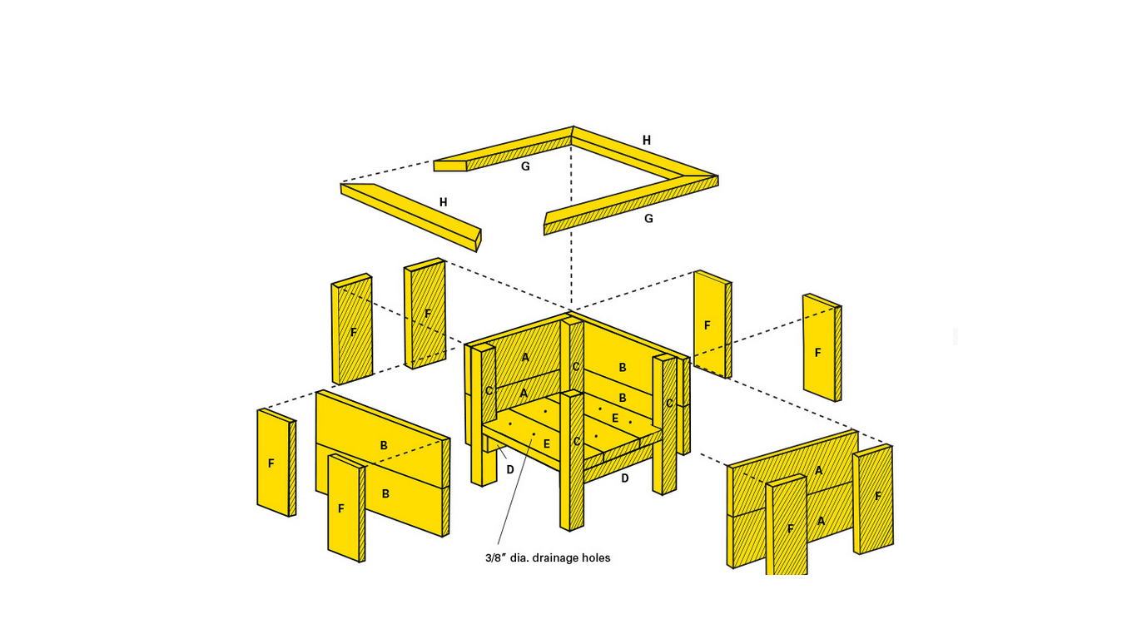

Photo/Drawing:
Photos collected from Yellawood®

Cutting List:
A: (4) 1x8 x 18”
B: (4) 1x8 x 22 ½”
C: (4) 1 ½ x 1 ½ x 24”
D: (2) 1x2 x 18”
E: (3) 1x8 x 18” (2 notched, 1 ripped)
F: (8) 1x4 x15 ½”
G: (2) 1x4 x 25 ½”
H: (2) 1x4 x 19 ½”

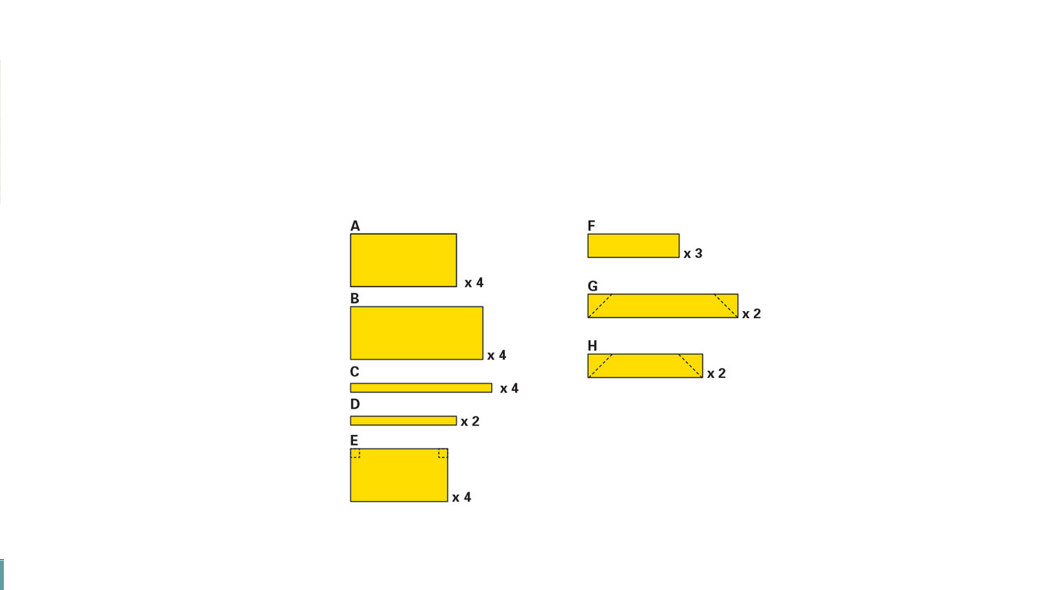

Construction Log:
Complete the log below making an entry every day you work on the project. Transfer the logged hours to your record book journal for this SAE enterprise.
Date | Tasks Completed | Skills Used/Learned | Hours

Actual Price Received:
Enter the actual price you received for the project in your record book journal as income. $_________

Project Portfolio:
Complete a portfolio for the project that includes:
- A description of the project and the skills you learned building the project. Include the hours spent on the project and the income (if sold). Use the construction log to complete this narrative. Write in complete sentences.
- The Bill of Materials
- The project plan
- 2-8 photos documenting the project at various stages of construction.

