Receiver Hitch Cargo Carrier

Description:
The hitch is used with a standard 2” receiver hitch commonly found on trucks and SUVs. The cargo carrier will be a steel frame and base that will allow for additional storage off the receiver hitch at a maximum weight capacity of 500 pounds,

Skills Required:
GMAW welding, plasma cutting, and layout skills are used to construct this project.

Materials:
- 1 ½” x 1 ½”x1/8" Angle Iron
- ¾ x 14 Flattened Expanded Metal
- 2 x 2 x .188” Steel Tubing
- 1 ½” x 1/4” HR Flat Stock

- Tools Required:
- Chop saw or horizontal band saw
- Bench grinder or angle grinder
- GMAW Welder
- Blacksmith or engineer’s hammer
- Drill Press
- 5/32” drill bit
- 1/2” drill bit
- 5/8” drill bit
- Steel Tape

Bill of Materials:
Complete the bill of materials below for this project. Use the completed bill of materials for your record book budget by entering the name of the project and the total amount as an expense
Size | Description | Units | Qty/Project | Cost/Unit | Order | Amount

Project Price:
Enter the expected price you will receive for the project in your record book budget (income). $_______

Estimated Construction Time:
___12__ hours.

Directions:
Read entire directions before beginning
- Set the chop saw to 45º and cut the angle iron to length (You should have four (4) pieces)
- Using the 5/32 drill bit, drill two (2) pilot holes 3” in from the sides of each 20” piece of angle iron. Complete the holes with the ½” drill; these will serve as the down points.
- Repeat the process above on the 60” pieces measuring using the dimensions on the plan.
- GMAW the angle frame:
  - Tack the 45º angles together fist to ensure perfect 90º angles on all four sides.
  - You will want to clamp the pieces to a solid surface so they don’t move during your weld.
- Cut the expanded metal to length and width (this should fit right inside your angle frame)
- GMAW weld the expanded metal to the inside of your angle frame
- Cut the 2” square tube to length.
- Carefully measure the 5/8” hole and drill a pilot hole in the 2” tubing. Complete the hole with a 5/8” drill.
- GMAW weld the square tubing to the bottom center of your angel iron and expanded metal, this will allow it to fit into the receiver hitch.
- Cut flat stock to length.
- Tack weld to the outside of frame, slightly bend to create appropriate angle and support
- Weld in place
- Grind rough edges
- Paint as desired

Photo/Drawing:
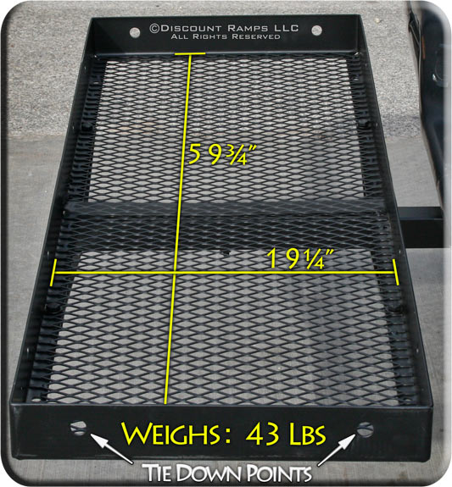

Construction Log:
Complete the log below making an entry every day you work on the project. Transfer the logged hours to your record book journal for this SAE enterprise.
Date | Tasks Completed | Skills Used/Learned | Hours

Actual Price Received:
Enter the actual price you received for the project in your record book journal as income. $_________

Project Portfolio:
Complete a portfolio for the project that includes:
- A description of the project and the skills you learned building the project. Include the hours spent on the project and the income (if sold). Use the construction log to complete this narrative. Write in complete sentences.
- The Bill of Materials
- The project plan
- 2-8 photos documenting the project at various stages of construction.

This project was created by K. Tenneson at California State University, Chico.

