Receiver Hitch Cover

Description:
The hitch cover is used with a standard 2” receiver hitch commonly found on trucks and SUVs. Cover design may be made from any simple graphic such as a team logo on a Plasma Cam. Simple designs can be cut by hand.

Skills Required:
Cold metal, arc welding, and layout skills are used to construct this project.

Materials:
- 2 x 2 x .188” Steel Tubing
- Scrap sheet metal
- 5/8 CR Round Stock

Tools Required:
- Chop saw or horizontal band saw
- Bench grinder or angle grinder
- Arc Welder
- Drill Press
- 9/64” drill bit
- 11/16” drill bit
- Steel Tape
- Plasma Cam or similar

Bill of Materials:
Complete the bill of materials below for this project. Use the completed bill of materials for your record book budget by entering the name of the project and the total amount as an expense
Size | Description | Units | Qty/Project | Cost/Unit | Order | Amount
 |  |  |  |  | TOTAL

Project Price:
Enter the expected price you will receive for the project in your record book budget (income).

Estimated Construction Time:
4 hours.

Directions:
- Cut the 2” square tube to length.
- Cut round stock to length.
- Layout and drill the 9/64” hole in round stock.
- Layout and drill the 11/16” hole in the square tubing. This is a critical dimension as the hole must match the receiver hitch. You may wish to drill a pilot hole first to insure proper placement.
- Using a course bench grinder round the edges of the pin and flat stock.
- Cut out the cover design using the Plasma Cam and clean up any sharp edges.
- Weld the design in place as shown in the drawing.
- Place the round stock in a vise and heat the bend. Bend as shown in the plan.
- Clean up any sharp edges on the project. Test the fit in a hitch and make any needed adjustments.
- Painted or powder coat as desired.

Notes:
Two layer logos are made in separate pieces and attached with studs. Drill both layers. Cut machine screws heads off and weld into top piece from the top. Grind top flat. Paint pieces. Assemble with Nyloc nuts. See example photos.
A 5/8” x 3” bolt may be used with a lock nut instead of the pin. This is more secure.

Photos/Drawing:

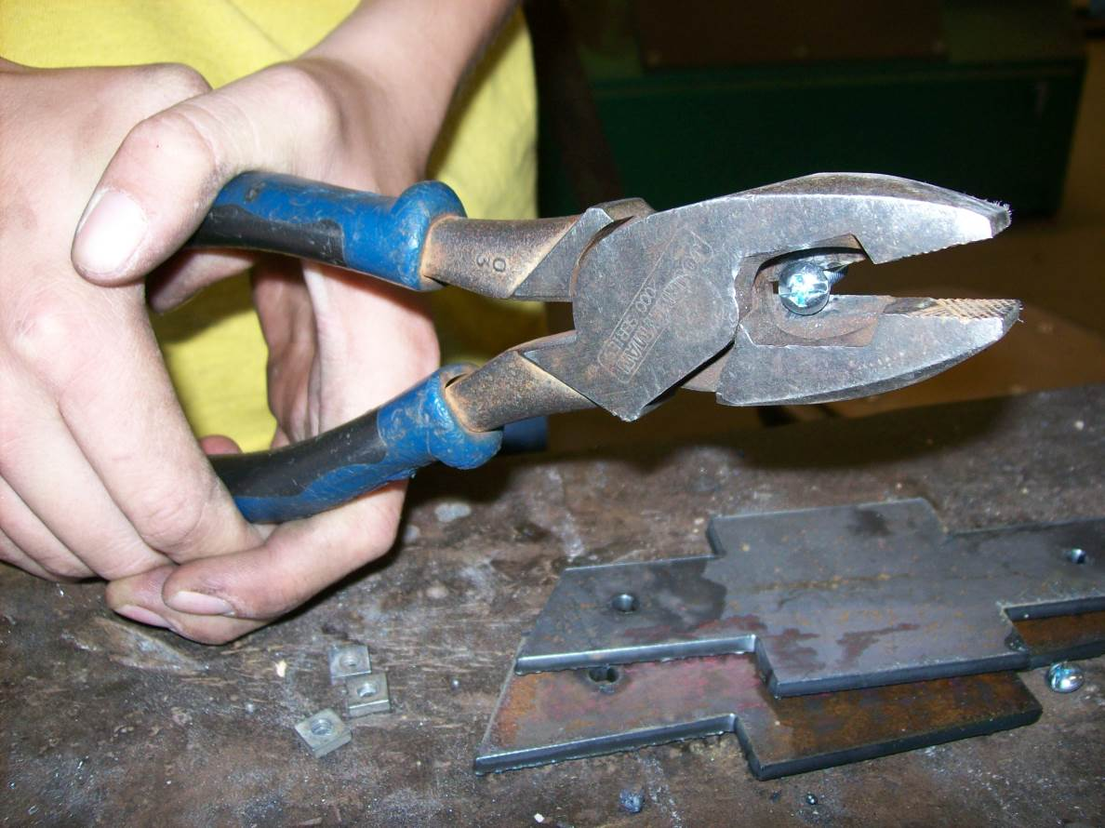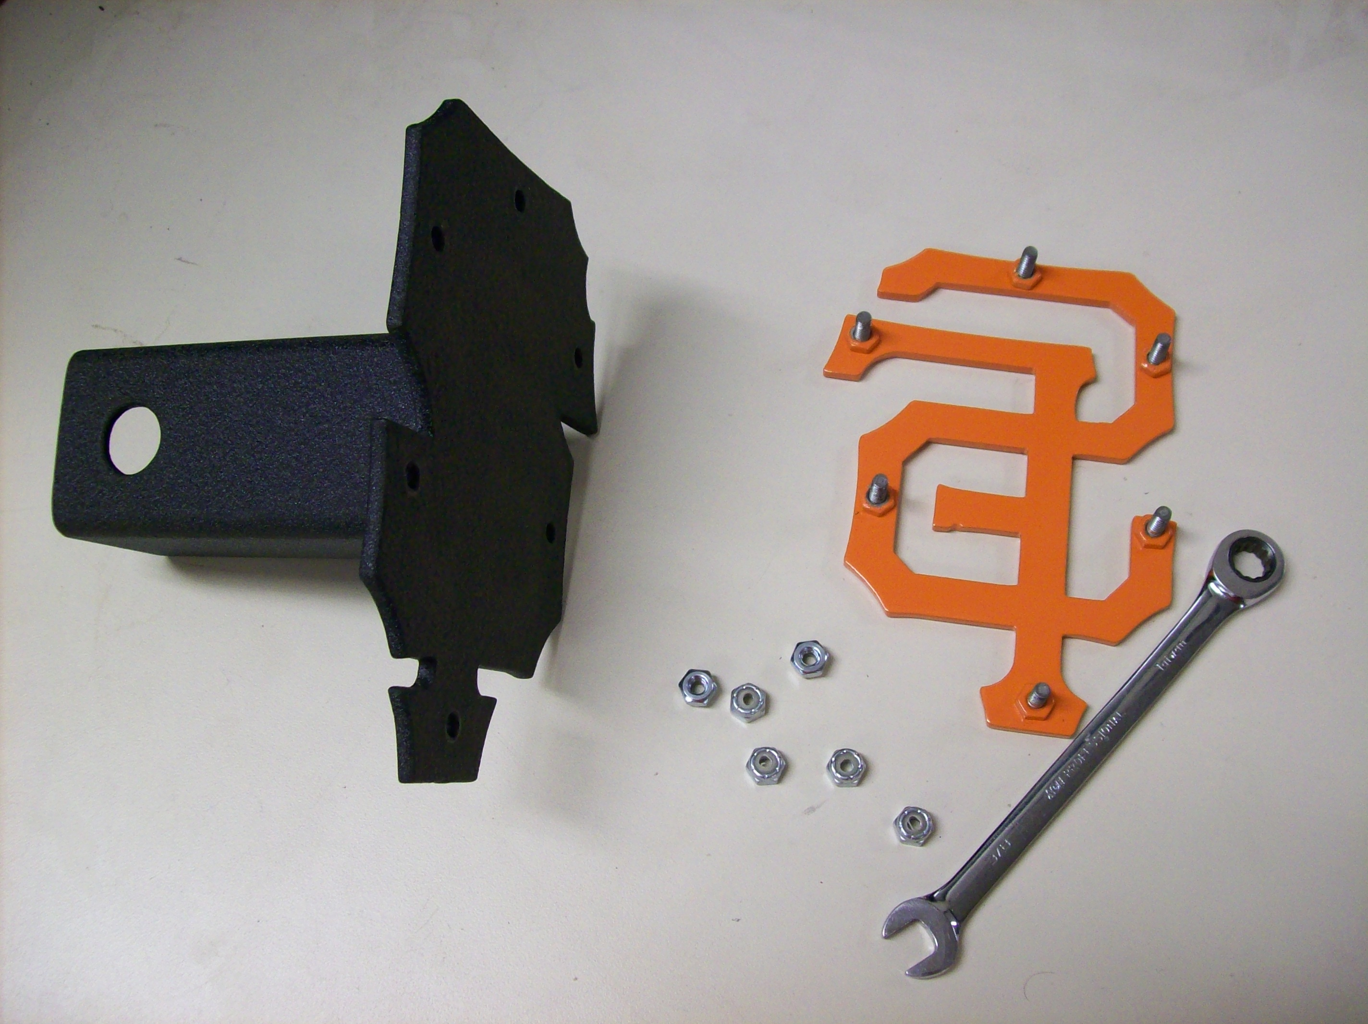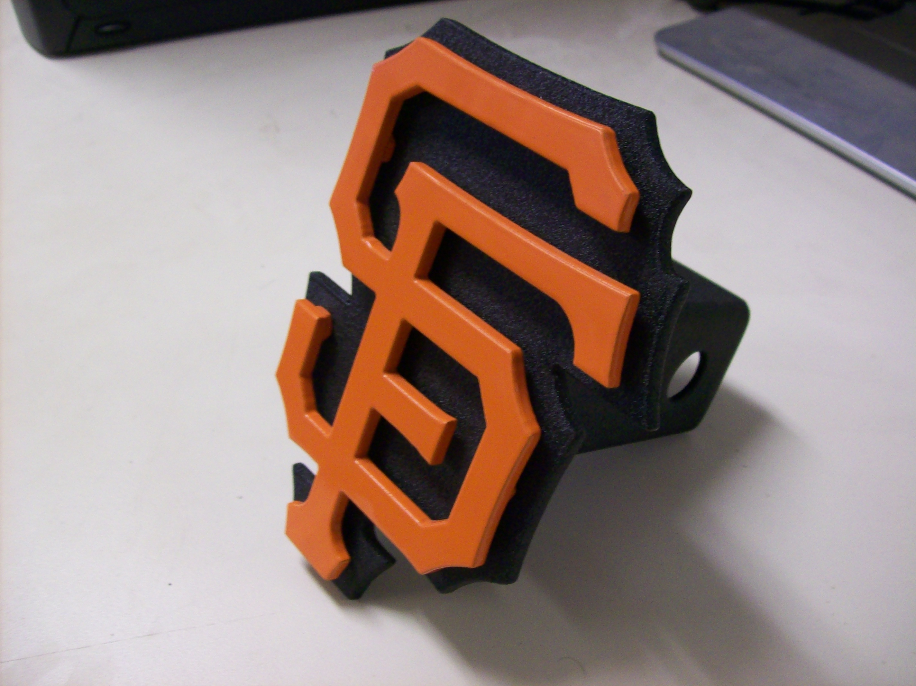

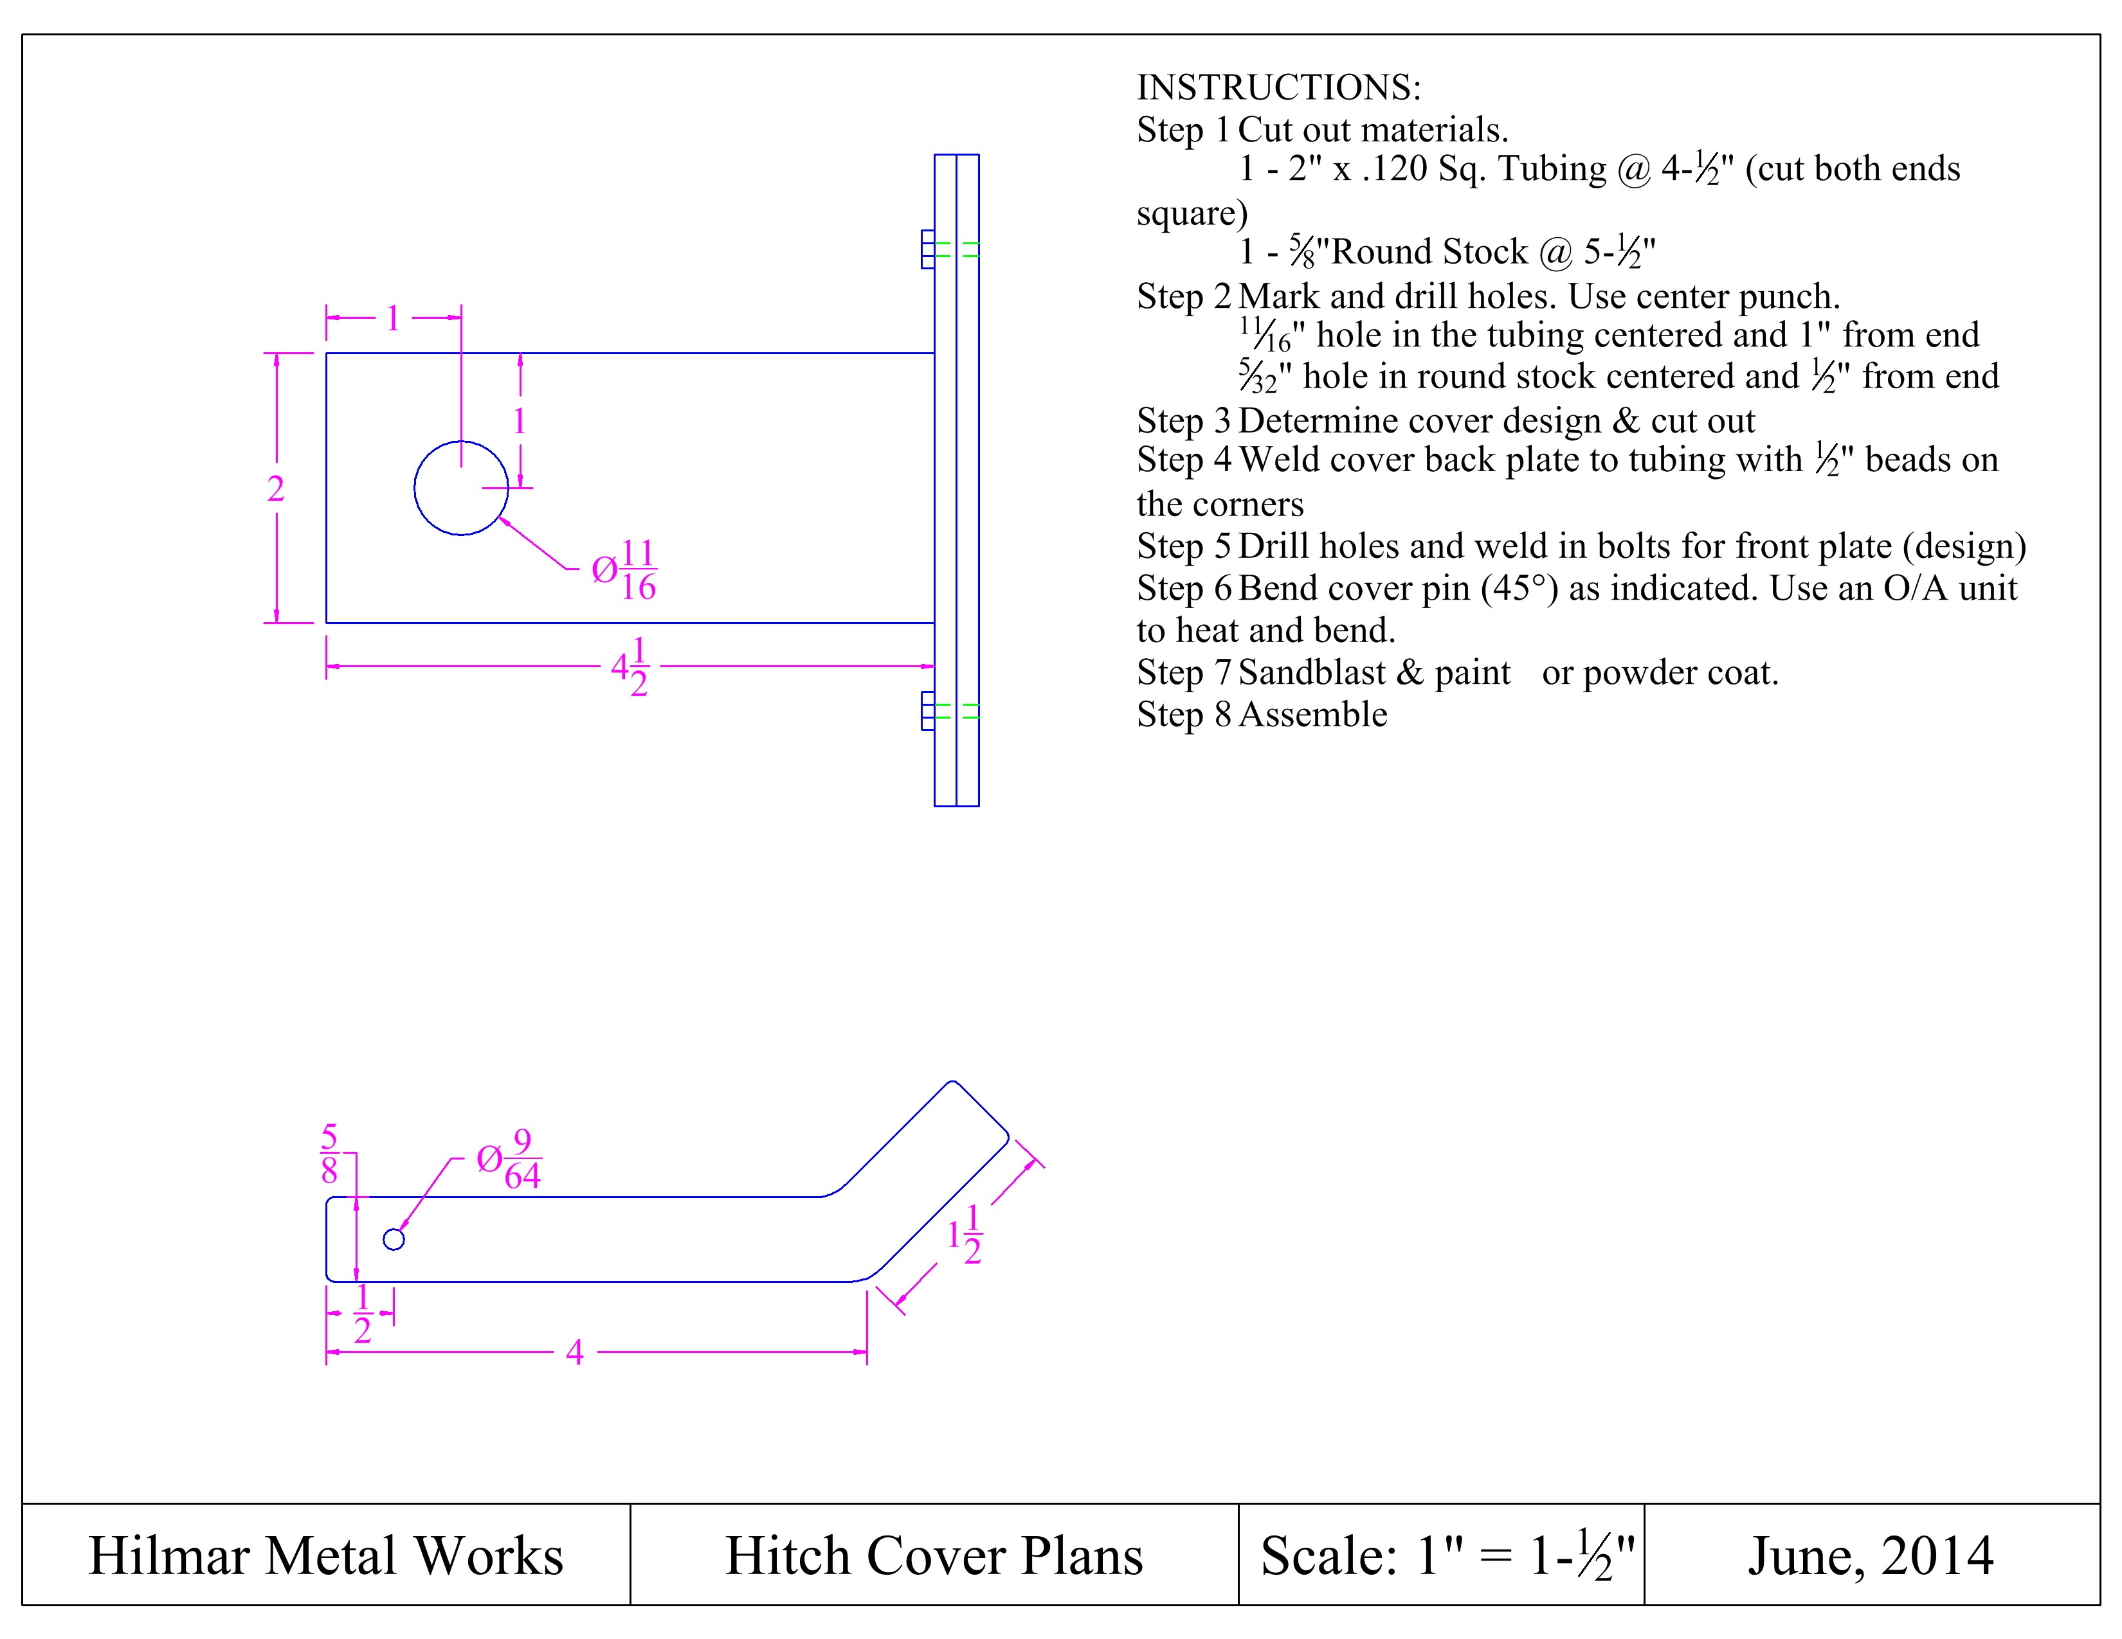

Construction Log:
Complete the log below making an entry every day you work on the project. Transfer the logged hours to your record book journal for this SAE enterprise.
Date | Tasks Completed | Skills Used/Learned | Hours

Actual Price Received:
Enter the actual price you received for the project in your record book journal as income.

Project Portfolio:
Complete a portfolio for the project that includes:
- A description of the project and the skills you learned building the project. Include the hours spent on the project and the income (if sold). Use the construction log to complete this narrative. Write in complete sentences.
- The Bill of Materials
- The project plan
- 2-8 photos documenting the project at various stages of construction.

