Truck Bed Extender

This project was created by K. Hodges at California State University, Chico in the fall of 2014.

Description:
A receiver hitch truck bed extender is designed to extend the bed of the truck. For this particular design it will extend 4 feet and have a 49 inch cross bar with tie downs. It will have five adjustable heights and 350 pound safety limit. The truck bed extender attaches into a standard size tow receiver and assembles and disassembles easily for storage in a short bed. . The extender can be used at bed height or at cab height (with a headache bar). When used at cab height it can be tied to bed with tie downs for increased stability. An option is to add trailer lights and a trailer plug to light the bar for increased safety. The dimensions can be altered for a custom fit.

Skills Required:
The skills that are required to build a truck bed extender are plan reading, layout, and steel fabrication.

Materials:
- 2” x 2”(.188 wall thickness, weight/foot 4.32) Square tube mild steel
- 2 ½” x 2 ½” (.120 wall thickness, weight/foot 3.89) square tube mild steel
- 2 ½” x 1/4” flat steel
- Receiver hitch pins (can be purchased or made from 5/8” CR steel)
Tools Required:
- SMAW (MIG) welder
- Chop saw
- Grinder
- Drill press & 11/16” drill
- Center punch
- Tape measure
- Combination square
- Soap stone

Bill of Materials:
Complete the bill of materials below for this project. Use the completed bill of materials for your record book budget by entering the name of the project and the total amount as an expense
Size | Description | Units | Qty/Project | Cost/Unit | Order | Amount

Project Price:
Enter the expected price you will receive for the project in your record book budget (income). $_______

Estimated Construction Time:
__6___ hours.

Directions:
- Cut 49” piece of square tube mild steel 2 ½” x 2 ½”
- Cut 11” piece of square tube mild steel 2 ½” x 2 ½”
- Cut 4 pieces of 2 ½” flat steel.
- Drill 2 pieces of flat for the end caps (4 ½” long) as shown in the plan and two pieces for the braces (2” long) in the center.
- Drill the remaining 2 pieces as shown in the plan (end caps)
- Carefully layout and drill 5 holes in the 11” piece as shown in the plan.
- Clamp and tack weld the drilled tubing part to the cross bar. Holes run the same direction as the cross bar. Check square and complete the welds on all sides.
- Weld the 2 end caps on the cross bar.
- Weld the braces on the cross bar assembly at a 45º angle.
- Cut a piece of 2” tubing on a 45º angle measuring 11” on the short side.
- Using the scrap make a square cut 50 ½” on the short side.
- Drill both pieces 1 ½” in from the square ends as shown in the plan.
- Clamp and tack weld the support at a 90º angle. Check for square and complete the weld.
- Assemble the two parts and check the fit of the pins. Ream if necessary.
- Grind off any sharp edges.
- Prime and paint the parts.

Photo/Drawing:
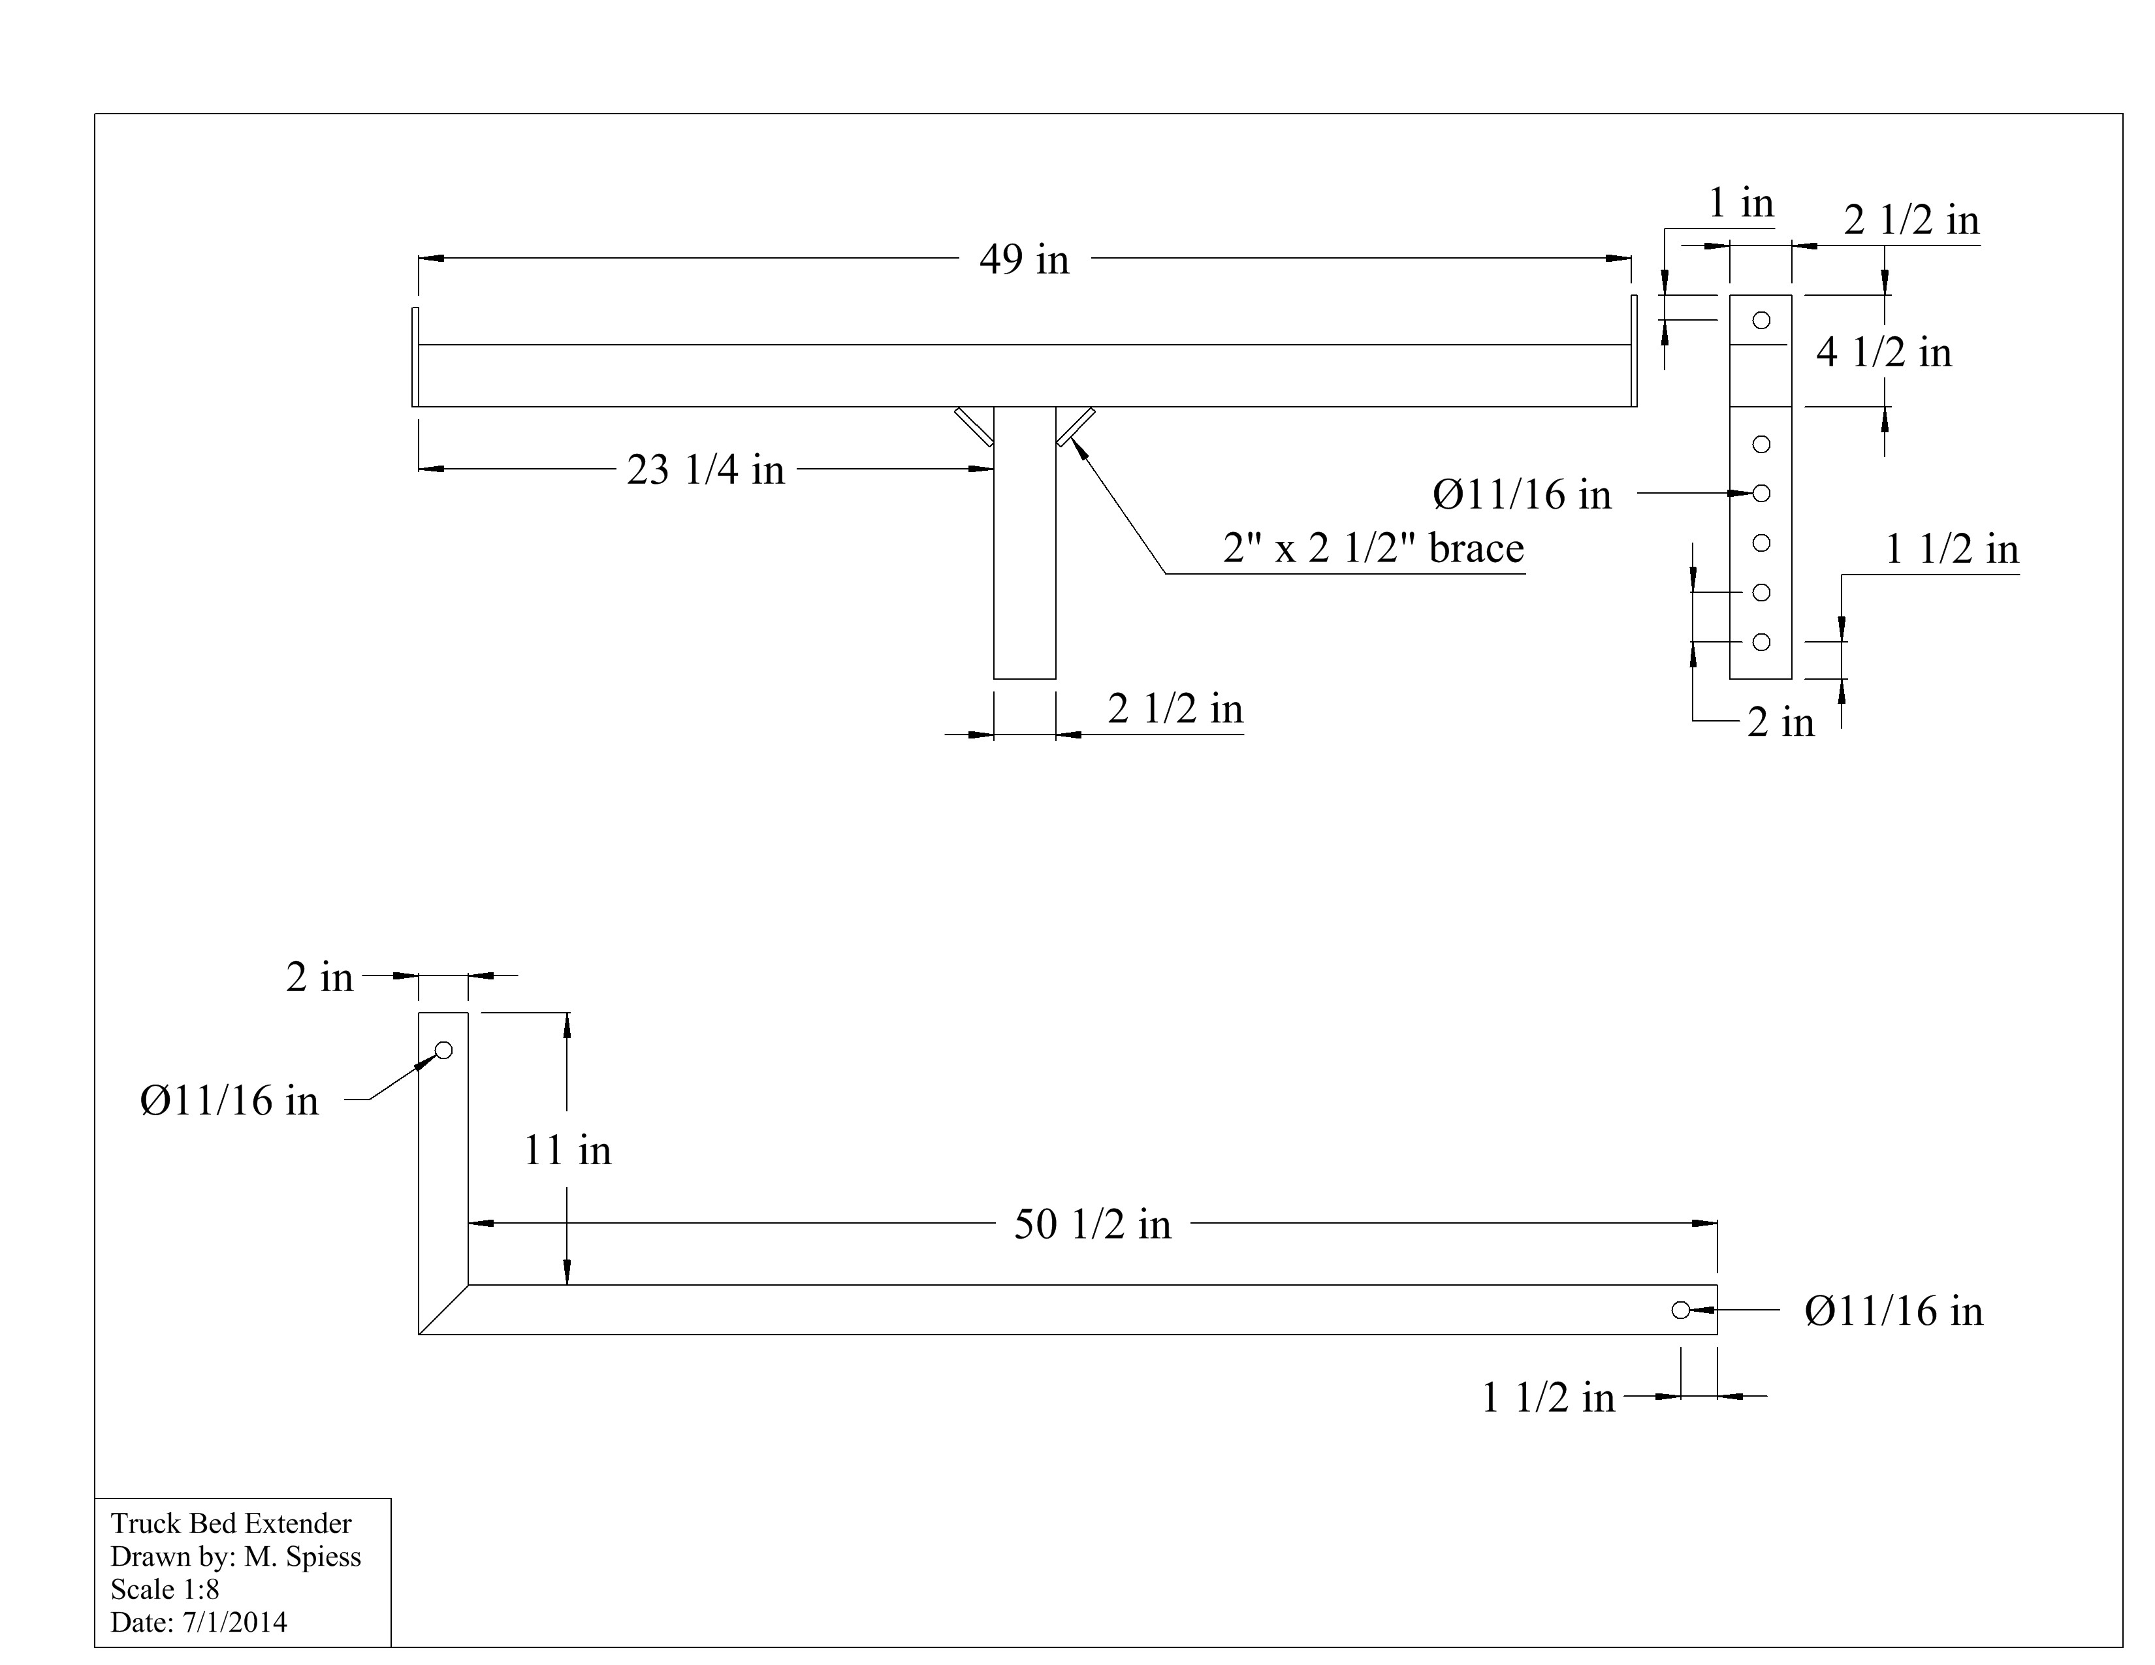

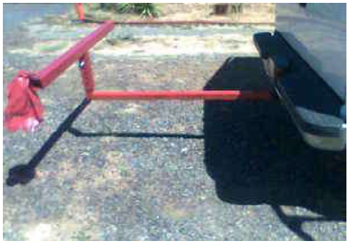

Construction Log:
Complete the log below making an entry every day you work on the project. Transfer the logged hours to your record book journal for this SAE enterprise.
Date | Tasks Completed | Skills Used/Learned | Hours

Actual Price Received:
Enter the actual price you received for the project in your record book journal as income. $_________

Project Portfolio:
Complete a portfolio for the project that includes:
- A description of the project and the skills you learned building the project. Include the hours spent on the project and the income (if sold). Use the construction log to complete this narrative. Write in complete sentences.
- The Bill of Materials
- The project plan
- 2-8 photos documenting the project at various stages of construction.

