Receiver Hitch and Pin

Description:
The hitch is used with a standard 2” receiver hitch commonly found on trucks and SUVs. It can be fitted with any size ball. It may be mounted up or down depending on the desired height.

Skills Required:
Cold metal, hot bending, arc welding, and layout skills are used to construct this project.

Materials:
- 2 x 2 x .188” Steel Tubing
- ¾ x 2 HR Flat Steel
- 5/8 CR Round Stock

Tools Required:
- Chop saw or horizontal band saw
- Bench grinder or angle grinder
- Arc Welder
- Blacksmith or engineer’s hammer
- Oxy-Acetylene Cutting Torch with rosebud tip.
- Drill Press
- 5/32” drill bit
- 1” drill bit
- 5/8” drill bit
- Protractor
- Steel Tape

Bill of Materials:
Complete the bill of materials below for this project. Use the completed bill of materials for your record book budget by entering the name of the project and the total amount as an expense
Size | Description | Units | Qty/Project | Cost/Unit | Order | Amount
 |  |  |  |  | TOTAL

Project Price:
Enter the expected price you will receive for the project in your record book budget (income).

Estimated Construction Time:
4 hours.

Directions:
- Set the chop saw to 65º and cut the 2” square tube to length.
- Cut the flat and round stock to length.
- Layout the 1” hole in the flat stock and drill a pilot hole using the 5/32 drill. Complete the hole with the 1” drill.
- Layout and drill the 5/32” hole in round stock.
- Layout and drill the 5/8” hole in the square tubing. This is a critical dimension as the hole must match the receiver hitch. You may wish to drill a pilot hole first to insure proper placement.
- Using a course bench grinder round the edges of the pin and flat stock.
- Place the welded hitch in a vise and heat the flat stock at the bend until it is red hot. Using a large adjustable wrench or a hammer bend the flat stock as shown in the plan. Be careful not to heat the vise.
- Place the round stock in a vise and heat the bend. Bend as shown in the plan.
- Clean up any sharp edges on the project. Test the fit in a hitch and make any needed adjustments.
- Paint as desired.

Photo/Drawing:
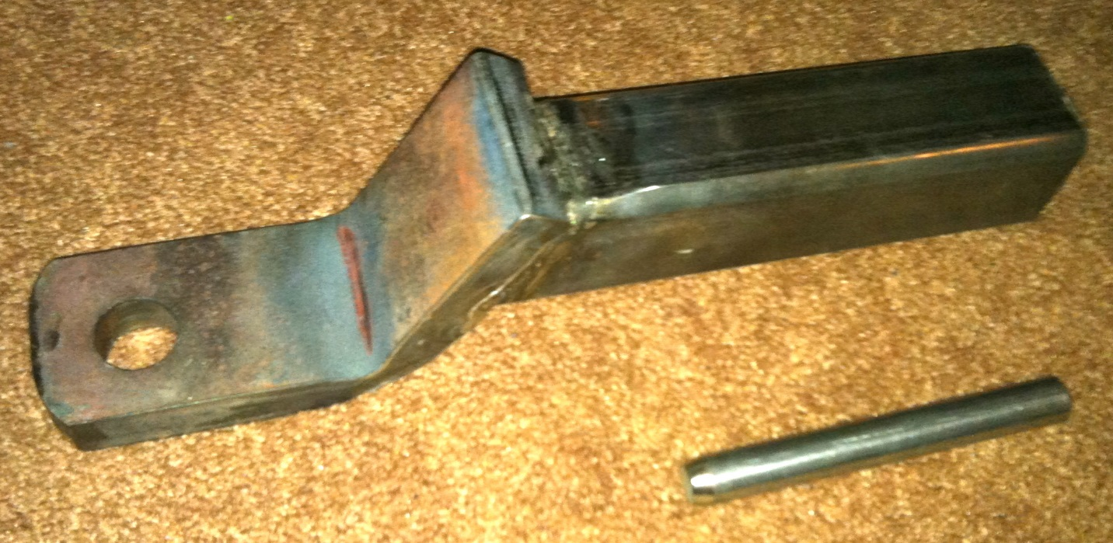
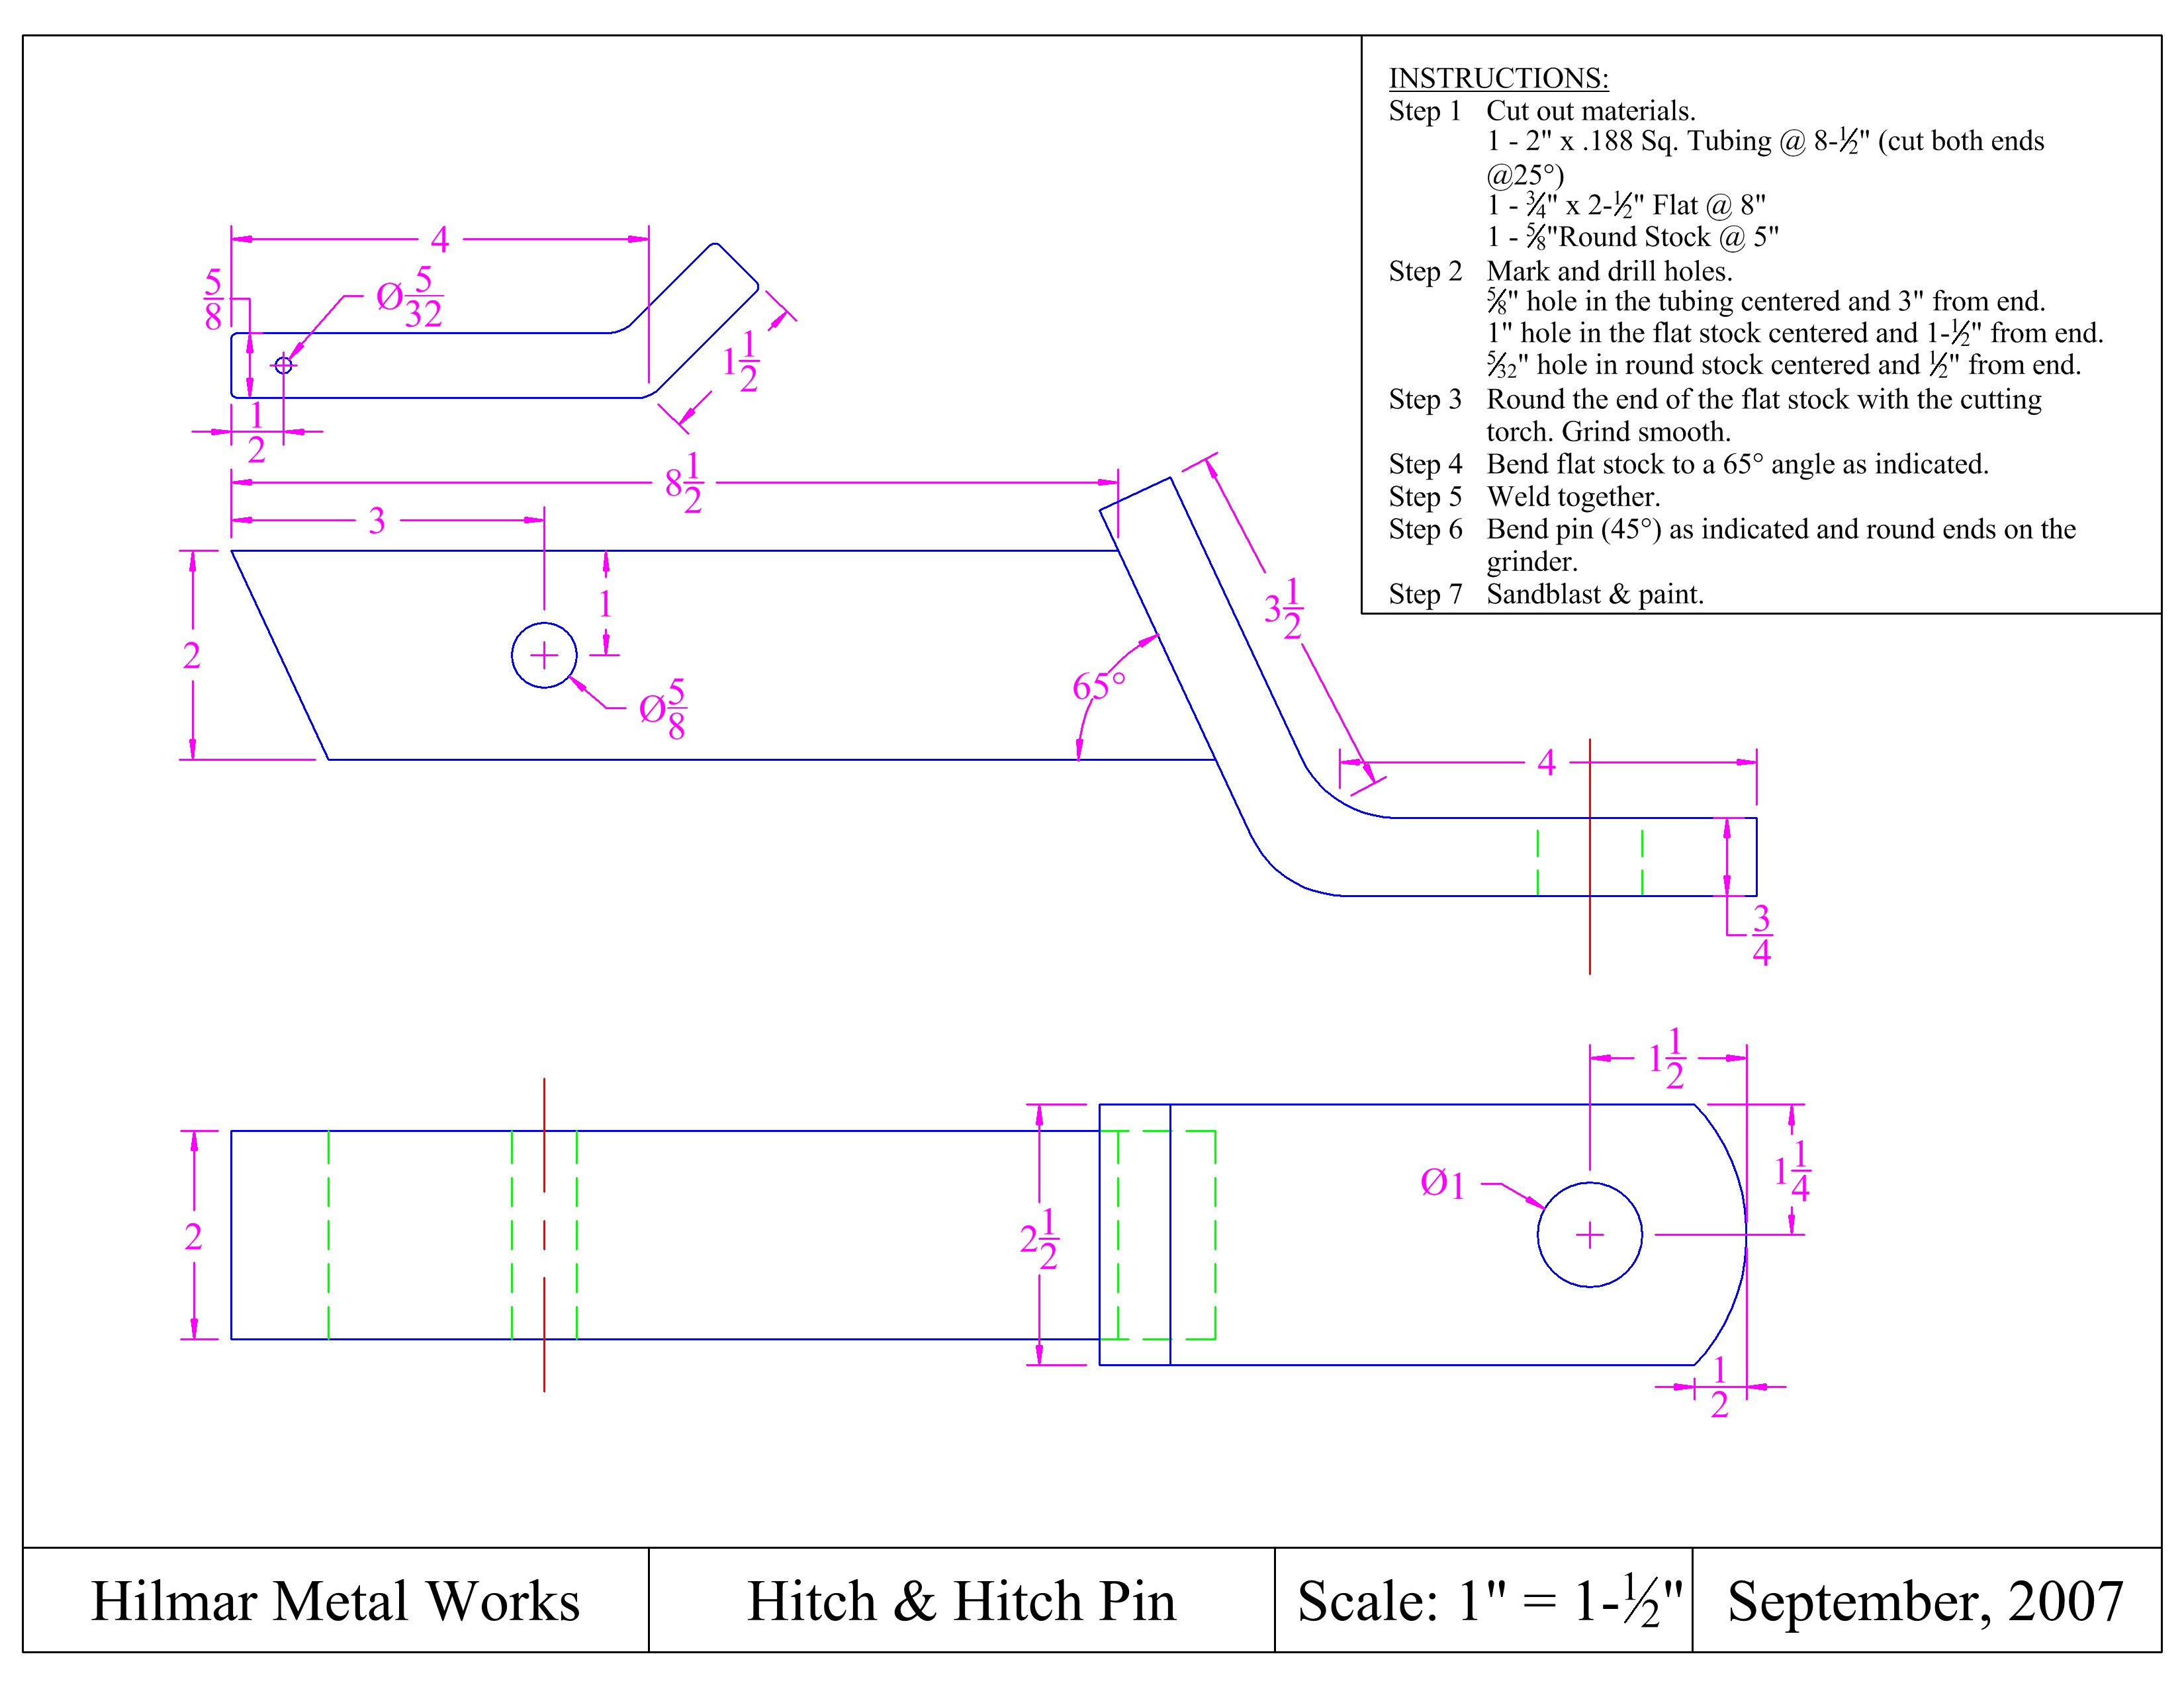

Construction Log:
Complete the log below making an entry every day you work on the project. Transfer the logged hours to your record book journal for this SAE enterprise.
Date | Tasks Completed | Skills Used/Learned | Hours

Actual Price Received:
Enter the actual price you received for the project in your record book journal as income.

Project Portfolio:
Complete a portfolio for the project that includes:
- A description of the project and the skills you learned building the project. Include the hours spent on the project and the income (if sold). Use the construction log to complete this narrative. Write in complete sentences.
- The Bill of Materials
- The project plan
- 2-8 photos documenting the project at various stages of construction.

