Salt Box

Description:
A salt box is designed to hold a salt lick for livestock. It is made out of wood and keeps the salt lick out of the mud and manure.

Skills Required:
Basic plan reading, layout and woodworking skills are required to complete this project.

Materials:
- 2 x 6 Construction Grade Fir
- 1 x 8 Construction Grade Fir
- 1 x 2 Construction Grade Fir
- 16d Galvanized Box nails
- 6d Galvanized common nails
- Tools Required:
- Power Miter Saw
- Band Saw
- Steel tape
- Square
- Claw Hammer

Bill of Materials:
Complete the bill of materials below for this project. Use the completed bill of materials for your record book budget by entering the name of the project and the total amount as an expense
Size | Description | Units | Qty/Project | Cost/Unit | Order | Amount

Project Price:
Enter the expected price you will receive for the project in your record book budget (income). $_______

Estimated Construction Time:
2 hours.

Directions:
- Using a miter saw cut 4- 2 x 6 - 24’’ from a 2 x 6
- Using a square make the correct angle on each of the above boards.
- Using a band saw cut out the angle you just measured on all 4 boards using the band saw.
- Using a miter saw cut 2- 1 x 8 - 15 ½ ‘’ from a 1 x 8
- Using a miter saw cut 4- 1 x 2 - 10 ¾ ‘’ from a 1 x 2. NOTE: Mark these to length to insure a good fit.
- Refer to the diagram and nail all pieces correctly together.
- Remove rough edges with sand paper.

Photo/Drawing:
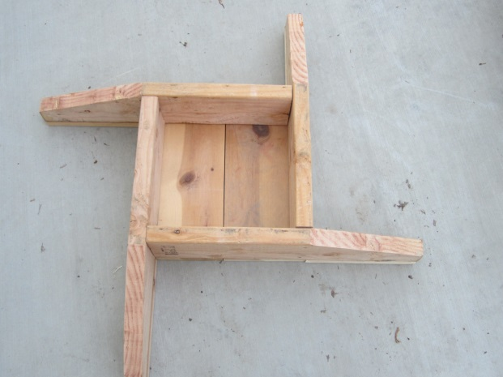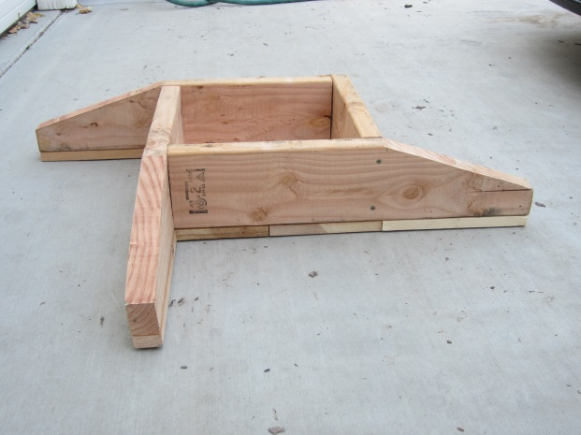
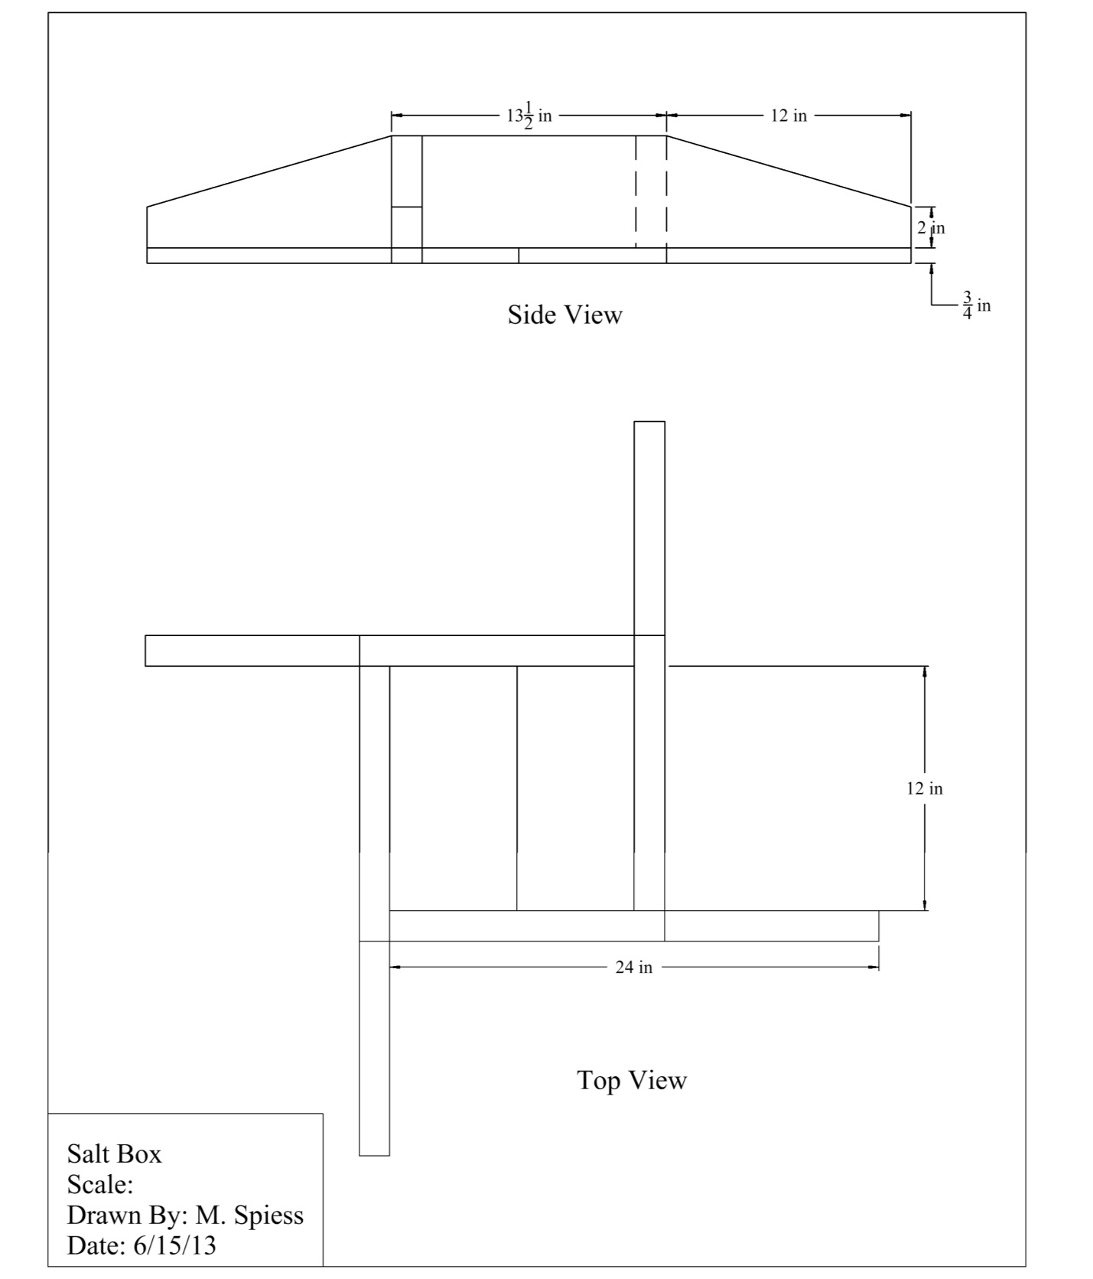

Construction Log:
Complete the log below making an entry every day you work on the project. Transfer the logged hours to your record book journal for this SAE enterprise.
Date | Tasks Completed | Skills Used/Learned | Hours

Actual Price Received:
Enter the actual price you received for the project in your record book journal as income. $_________

Project Portfolio:
Complete a portfolio for the project that includes:
- A description of the project and the skills you learned building the project. Include the hours spent on the project and the income (if sold). Use the construction log to complete this narrative. Write in complete sentences.
- The Bill of Materials
- The project plan
- 2-8 photos documenting the project at various stages of construction.

