Sheep Stand

Description:
This stand can be used to shear sheep and/or goats. This sheep stand has an adjustable head stand for desired height as well as folding legs making it conveniently portable for students to transport to and from shows and auctions.

Skills Required:
Students must have basic skills in reading layouts, arc welding, gas welding, metal cutting, metal grinding, cold metal work, metal drilling, and plasma cutting. In addition, students must demonstrate safe and professional behaviors while working with the materials and tools required.

Materials:
- ¾” 9 gauge Flat Expanded Metal
- 1 ½” x 1 ½” x 16 G.A. (0.065) Structural Square Tubing
- 2” x 2” x ¼” (0.065) Structural Square Tubing (Scrap)
- 2” x 2” x 3/8” Angle Iron
- 1 ½” x ¼” & 2” x ¼” Flat Bar
- ½” Hot Roll Round Stock
- 3/8” Hot Roll Round Stock
- ¼” Hot Roll Round Stock
- ¼” Zinc Plated Chain
- ½” Stainless steel 18-8 flat washers
- ½” x 0.62”(ID) Steel Pipe- Scrap
- ½-13 x 1” Cap Screw
- ½-13 NC Nuts
Tools Required:
- Chop Saw
- Oxy-Acetylene Torch
- Grinder
- Hydraulic Shear
- MIG Welder
- Steel Tape
- Drill (bit size 33/64)
- Carpenter Square

Bill of Materials:
Complete the bill of materials below for this project. Use the completed bill of materials for your record book budget by entering the name of the project and the total amount as an expense
Size | Description | Units | Qty/Project | Cost/Unit | Order | Amount

Project Price:
Enter the expected price you will receive for the project in your record book budget (income). $_______

Estimated Construction Time:
Approximately 20 hours

Cut List:
Materials: | Cut Sizes: | Quantity:
¾” 9 gauge Flat Expanded Metal | 48” x 21” | 1
1 ½” x 1 ½” x 16 G.A. (0.065) Structural Square Tubing | 15” length | 4
1 ½” x 1 ½” x 16 G.A. (0.065) Structural Square Tubing | 46” length | 1
1 ½” x 1 ½” x 16 G.A. (0.065) Structural Square Tubing | 18” length | 3
2” x 2” x 16 G.A. (0.065) Structural Square Tubing (Scrap) | 8” length | 1
2” x 2” x 3/8” Angle Iron | 50” length | 2
2” x 2” x 3/8” Angle Iron | 22” length | 2
1 ½” x ¼” Flat Bar | 21 6/16” length | 2
1 ½” x ¼” Flat Bar | 29” length | 2
2” x ¼” Flat Bar | 21 6/16” length | 1
2” x ¼” Flat Bar | 6” length | 2
2” x ¼” Flat Bar | 2 ½” length | 1
½” Hot Roll Round Stock | 22” length | 2
1/4” Hot Roll Round Stock | 18 3/8” length | 2
3/8” Hot Roll Round Stock | 3 ½” length | 2
½” Hot Roll Round Stock | 3 ½” length | 4
½” x 0.62”(ID) Steel Pipe (Scrap) | ¾” | 4
½” x 0.62”(ID) Steel Pipe (Scrap) | 1 ½” | 1

Directions:
- Cut pieces needed according to cut list. Some small scrap pieces needed may not be listed.
- Weld together your pieces of angle iron so that is looks like the pictures provided. The angles are at 45º.
- On the underside of the welded rectangle frame tack weld the cut piece of expanded steel. (So the angle iron is on top of the expanded steel when viewing from the top. Reference pictures provided.)
- Weld the 21 6/16” x 2” x ¼” Flat bar in the center of the frame as support under the expanded metal.
- Weld on the pieces of 1 ½” flat bar (21 6/16” length) in the center of the halves made by the 2” flat bar support. (Reference photos)
- Drill a hole through all four 15” pieces of the square tubing 2” down from one side of the pieces.
- Back Legs: Weld two 15” x 1 ½” pieces of square tubing with one of the 18” pieces. 18” piece ____ down from the top.
- Front Legs: Weld two 15” x 1 ½” pieces of square tubing with two of the 18” pieces. First piece _____ down from the top, the second piece ____ down from the top.
- Attach legs to frame. Put 22” inch rod through one leg, then put two washers onto the rod, then put the rod through the second leg. Push leg to one end of the rod and weld the other side to the frame, then do the same to tack weld the other end of the rod to the frame. Once welded in place, center the “H” style legs and weld one washer to the rod to keep the legs in place and then do the same to the other side. Do the same steps to attach both front and back set of legs.
- Caps for the bottom of the legs can be welded on using scrap flat bar.
- Tack weld one of the bolts top down in the center of the middle support piece of flat bar (2” width piece).
- Bend and drill holes in both 29” pieces of flat bar according to the picture provided.
- At the end of the flat bar pieces that are not bent, weld on a 3 ½” piece of ½” Rod. (Look at Pictures.) Then Use two of your pipe pieces (3/4” length), and put on either side of the rod welded to the flat bar. Then center onto the lowest Square tubing (18” length) of the legs and tack weld the pipe pieces into place.
- Using a scrap piece of ½” pipe tack (about 3” length), weld a nut to one end of the pipe and on the other weld a three inch length of 3/8” rod. (See pictures). This is piece will keep the legs together when standing and can be removed and then used to secure legs when the legs are folded in.
- Cut two pieces of scrap 2” flat bar to 8” length and weld them slightly diagonal (width between sides toward middle = 2”) to the two pieces of square tubing on the front legs. (See pictures).
- Weld your scrap piece of 2” square tubing (1/4” thickness) to the flat bar pieces just welded. Drill a hole through one side on this piece for the tightening screw.
- Around the hole drilled, tack weld a nut to the square tubing. Then tack weld a 3” piece of 3/8” rod to the top of your other bolt.
- At one end of the 46” piece of square tubing, cut about a 30º angle. Then weld a scrap piece (2 ½” length) of 2” flat bar flat onto the angle.
- Head Piece: Hot metal bend your two pieces of 18 3/8” ¼” Rod into a rectangle with the longer sides being 6 1/8” and the shorter sides being 3 ¼”. Weld together where the ends of rod meet in the rectangles. See picture for reference. Then weld the rectangles at about a 25º angle long side to the flat piece.
- Cut the last link of your 2’ chain and weld it to one side of the head piece. Then weld to chain to the other side. (See picture).
- Finish the project by grinding welds and paint it.

Photos/Drawing:

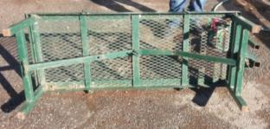
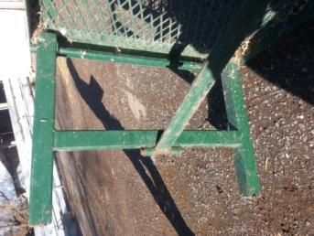
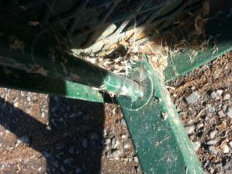
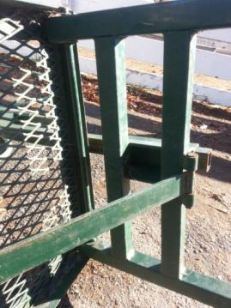

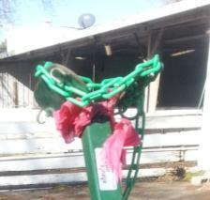

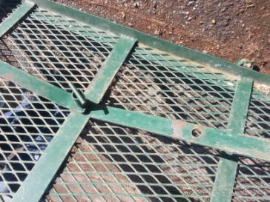

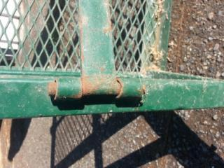
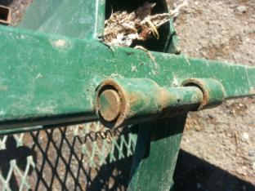
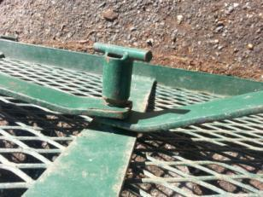

Final Project:

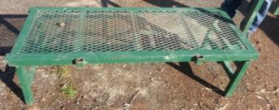

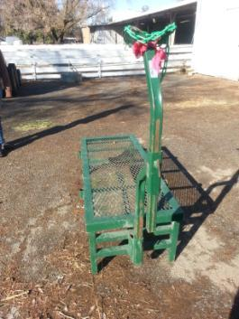

Construction Log:
Complete the log below making an entry every day you work on the project. Transfer the logged hours to your record book journal for this SAE enterprise.
Date | Tasks Completed | Skills Used/Learned | Hours

Actual Price Received:
Enter the actual price you received for the project in your record book journal as income. $_________

Project Portfolio:
Complete a portfolio for the project that includes:
- A description of the project and the skills you learned building the project. Include the hours spent on the project and the income (if sold). Use the construction log to complete this narrative. Write in complete sentences.
- The Bill of Materials
- The project plan
- 2-8 photos documenting the project at various stages of construction.

This project was created by M. Matteucci at California State University, Chico in the fall of 2014.

