Show or Tool Box

Description:
A tough wood box that can be used for showing animals or to store tools. Box can be divided as needed or a sliding tray can be added.

Skills Required:
Use of a table saw and general carpentry skills.

Materials:
- 4’x8’x3/4” AC or Hardwood Veneer Plywood
- 4” Butt Hinges
- Hasp
- Chest handles
- 6d finish nails
- #6 x 1 5/8” course drywall screws
- Exterior wood glue
- Wood dough
- 120 grit sandpaper
- Paint or stain

Tools Required:
- Steel Tape
- Table Saw
- Claw Hammer
- Nail set
- Power screwdriver, bit, countersink
- Steel Tape
Optional
- Palm Sander
- Router with ¼” quarter round bit

Bill of Materials:
Complete the bill of materials below for this project. Use the completed bill of materials for your record book budget by entering the name of the project and the total amount as an expense
Size | Description | Units | Qty/Project | Cost/Unit | Order | Amount
4 x 8 x ¾ | - Plywood
4” | Butt Hinge
Large | Chest Handles
 | 6d Finish Nails
 | #6 x 1 5/8” Course Drywall screws
 | Wood Glue
 | Wood Dough
 | 120 grit sandpaper
 | Paint/Stain
 | Shop Fee (if any)
 |  |  |  |  | TOTAL

Project Price:
Enter the expected price you will receive for the project in your record book budget (income).

Estimated Construction Time:
4 hours.

Directions:
- Review the layout below.
- Rip the plywood to 36”.
- Carefully with a helper cut the panels from the ripped piece.
- Cut the end panels from the 18 ½” x 36” panel
- Dry fit the box to insure you have cut the pieces correctly.
- Assemble the two sides to the ends. You may use any combination of nails and screws. If using screws use the countersink to insure the wood is not split. IMPORTANT: wipe off excess glue with a damp rag. Avoid placing nails or screws near the lid seam. The seam will be 1 ¾” down from the edge of the sides and ends (2 ½” down from the finished box).
- Assemble the top and bottom the sides/ends. Carefully square the side/end assembly to the top and bottom.
- Set your table saw to 1” height. Remove the guard and splitter (like a dado setup). Set the fence to 2 ½”. Check to see that the blade is at 90º.
- With a helper cut the end of the box. The cut one side. Finally cut the remaining side being careful the lid is completely separated from the bottom of the box.
- Replace the saw guard.
- Option 1 – Dividers
  - Interior divider can be added to separate tools/tack.
  - Use the scrap plywood.
  - Mark the position of the divider on the inside and outside of the box.
  - Assemble with glue and nails.
- Option 2 – Sliding Tray.
  - Rip the thin 36” long scrap into two pieces. These will support the tray. Cut to 34 ½” long.
  - Construct the tray from the long scrap (about 12” wide). The finished size of the tray should be about 18 ¼”. Common depths for a tray are 2-4”.
  - Install the two strips in the interior of the box using glue and some 1 ¼” wood screws. Commonly you will want the tray flush with the edge of the opened box. Note: The tray can also rest on the dividers if installed to run lengthwise.
- Set nails and fill with wood dough. Let dry.
- Sand the box with a palm sander or block sander. Ease the sharp edges with sandpaper or use the router on the edges.
- Paint as desired.
- Install the hinges on the long side 4-6” in from the edge.
- Install the chest handles centered on the end, just below the lid seam.

Photo/Drawing:

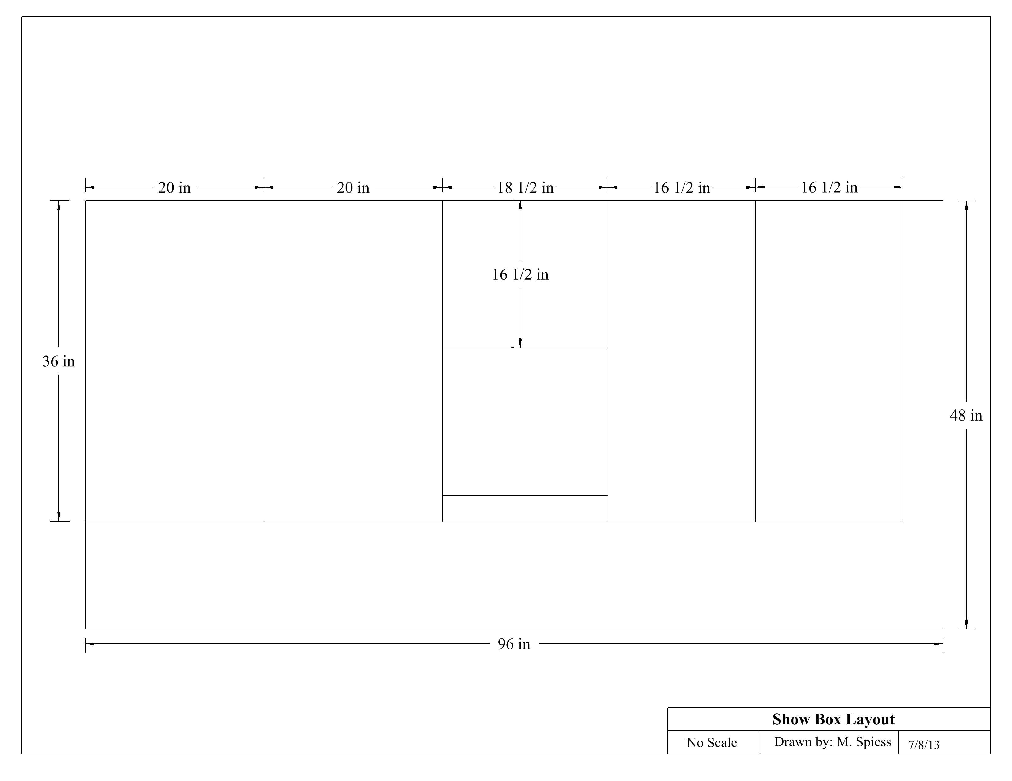
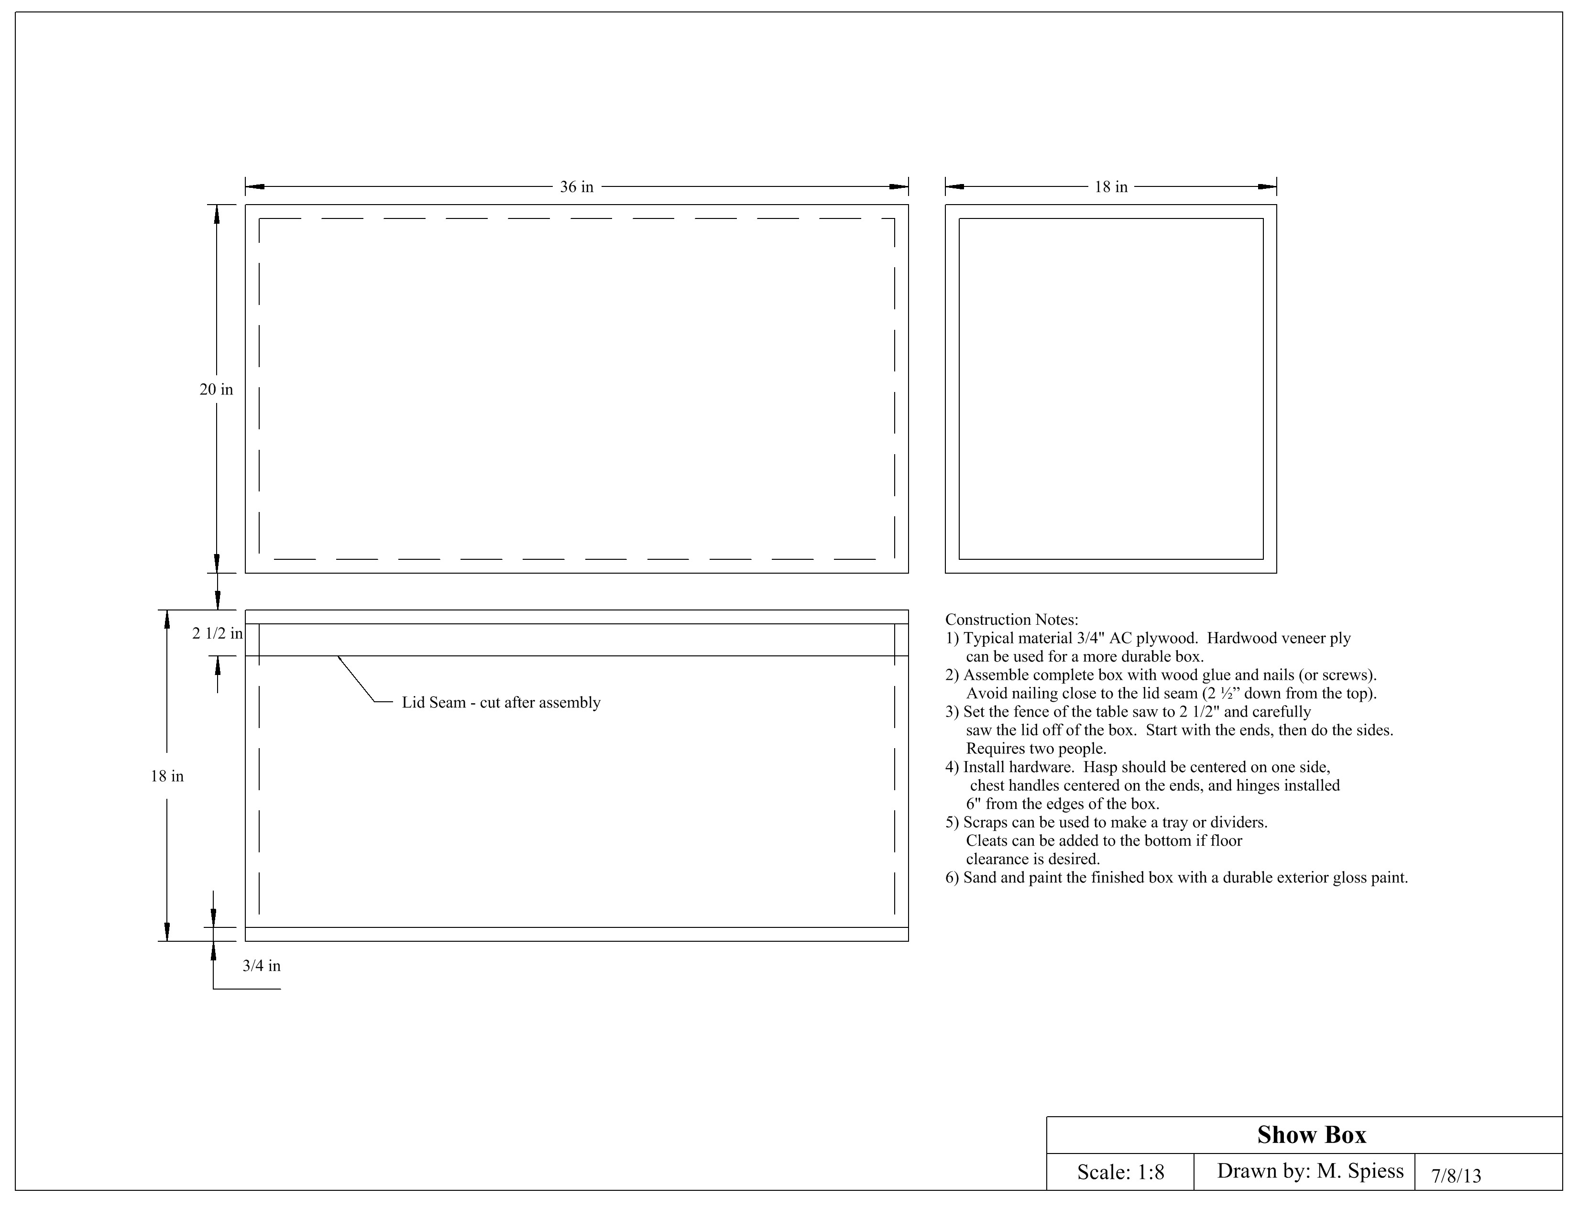

Construction Log:
Complete the log below making an entry every day you work on the project. Transfer the logged hours to your record book journal for this SAE enterprise.
Date | Tasks Completed | Skills Used/Learned | Hours

Actual Price Received:
Enter the actual price you received for the project in your record book journal as income.

Project Portfolio:
Complete a portfolio for the project that includes:
- A description of the project and the skills you learned building the project. Include the hours spent on the project and the income (if sold). Use the construction log to complete this narrative. Write in complete sentences.
- The Bill of Materials
- The project plan
- 2-8 photos documenting the project at various stages of construction.

