Sprinkler Guard

This project was created by Bryan Dodson at California State University, Chico.

Description:
A guard to prevent sprinkler overspray in an orchard.

Skills Required:
Skills demonstrated in completing these projects include: measuring, material identification, use of Acetylene Torch, Chop Saw, MIG Welder, layout, use of metal Grinders, files and rotary wire brushes.

Materials:
4” x 18” - 16 ga HR Sheet Metal
24" - 1/2" Steel round stock
Tack Cloth
Spray Paint
Tools Required:
Chop Saw
Oxy-Acetylene Torch w/ Rosebud Tip
Angle Grinder w/ Wire Wheel
Bench Grinder
Brake
MIG Welder
Round and Flat Bastard Files
T-Bevel
Combo Square

Bill of Materials:
Complete the bill of materials below for this project. Use the completed bill of materials for your record book budget by entering the name of the project and the total amount as an expense
Size | Description | Units | Qty/Project | Cost/Unit | Order | Amount

Project Price:
Enter the expected price you will receive for the project in your record book budget (income). $_______

Estimated Construction Time:
1-2 hours.

Directions:
- Cut out the materials.
- Sharpen on end of the rod on a course grinder.
- Using the torch bend the rod 90 degrees at 4” then again at 7” to create a 3” offset. Note: The offset may be varied depending on the type of sprinklers being used.
- Bend the sheet metal in a vise or brake at 135 degrees (45 degrees from flat).
- Assemble the parts by welding.
- Prime the project then paint with a finish coat.

Photo/Drawing:

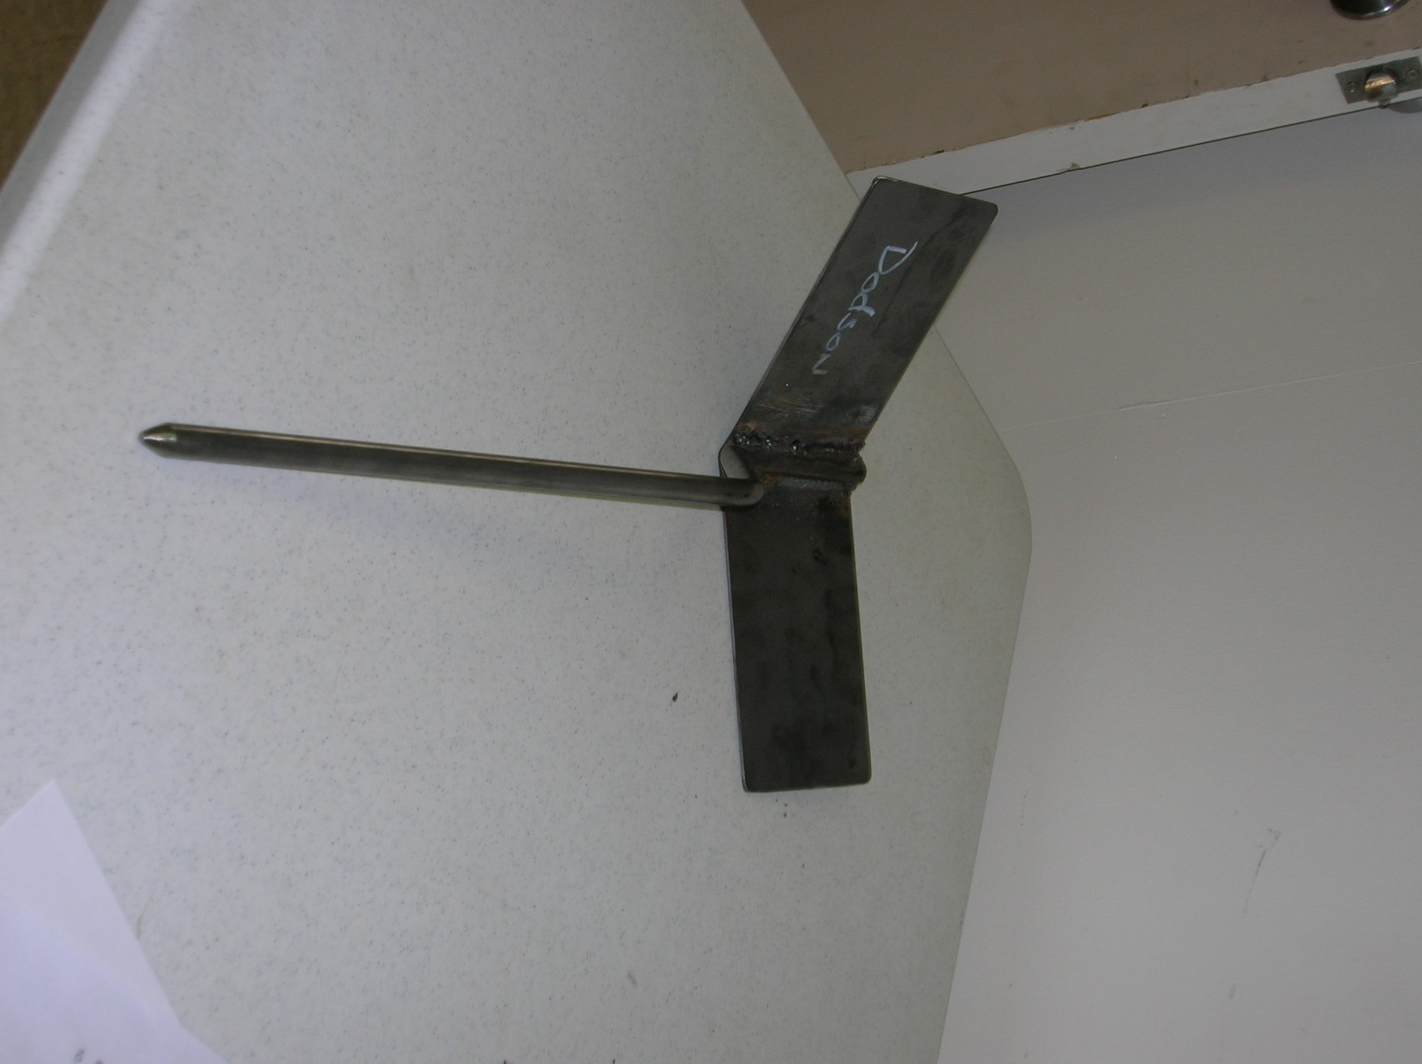

Construction Log:
Complete the log below making an entry every day you work on the project. Transfer the logged hours to your record book journal for this SAE enterprise.
Date | Tasks Completed | Skills Used/Learned | Hours

Actual Price Received:
Enter the actual price you received for the project in your record book journal as income. $_________

Project Portfolio:
Complete a portfolio for the project that includes:
- A description of the project and the skills you learned building the project. Include the hours spent on the project and the income (if sold). Use the construction log to complete this narrative. Write in complete sentences.
- The Bill of Materials
- The project plan
- 2-8 photos documenting the project at various stages of construction.

