Broom or Tool Rack

Description:
A broom or garden tool holder made using a plasma cutter from sheet metal. A good introduction to using a CNC plasma table. Holders work well for brooms, car wash brushes, pitch forks, etc. The larger holder can be used for common garden tools like shovels, rakes, and hoes.

Skills Required:
Cold metal, CNC plasma cutter, and finishing skills.

Materials:
Materials are variable depending on availability.
- 16 gauge sheet metal (14 or 12 will work as well)
- Tools Required:
- CNC Plasma cutter
- Brake (capacity to match sheet metal)
- Flat file
- Grinder with a wire brush

Bill of Materials:
Complete the bill of materials below for this project. Use the completed bill of materials for your record book budget by entering the name of the project and the total amount as an expense
Size | Description | Units | Qty/Project | Cost/Unit | Order | Amount

Project Price:
Enter the expected price you will receive for the project in your record book budget (income). $_______

Estimated Construction Time:
_____ hours.

Directions:
- Files are provided for 1 one tool holder or a larger rack.
- Optional: Provided files can be edited to make larger or smaller racks.
- Load the dxf file in the plasma cutter. (available in a zip folder)
- Cut out one or more racks. Note: racks can be nested by offsetting fingers.
- Clean up the cut with a file. A wire wheel can be used as well.
- Brake at the edge of the finger slots and the ends of the fingers (1/2”). Caution: Do not exceed the capacity of the brake. Set the leaf spacing for the heavy metal before bending.
- Paint

Photo/Drawing:
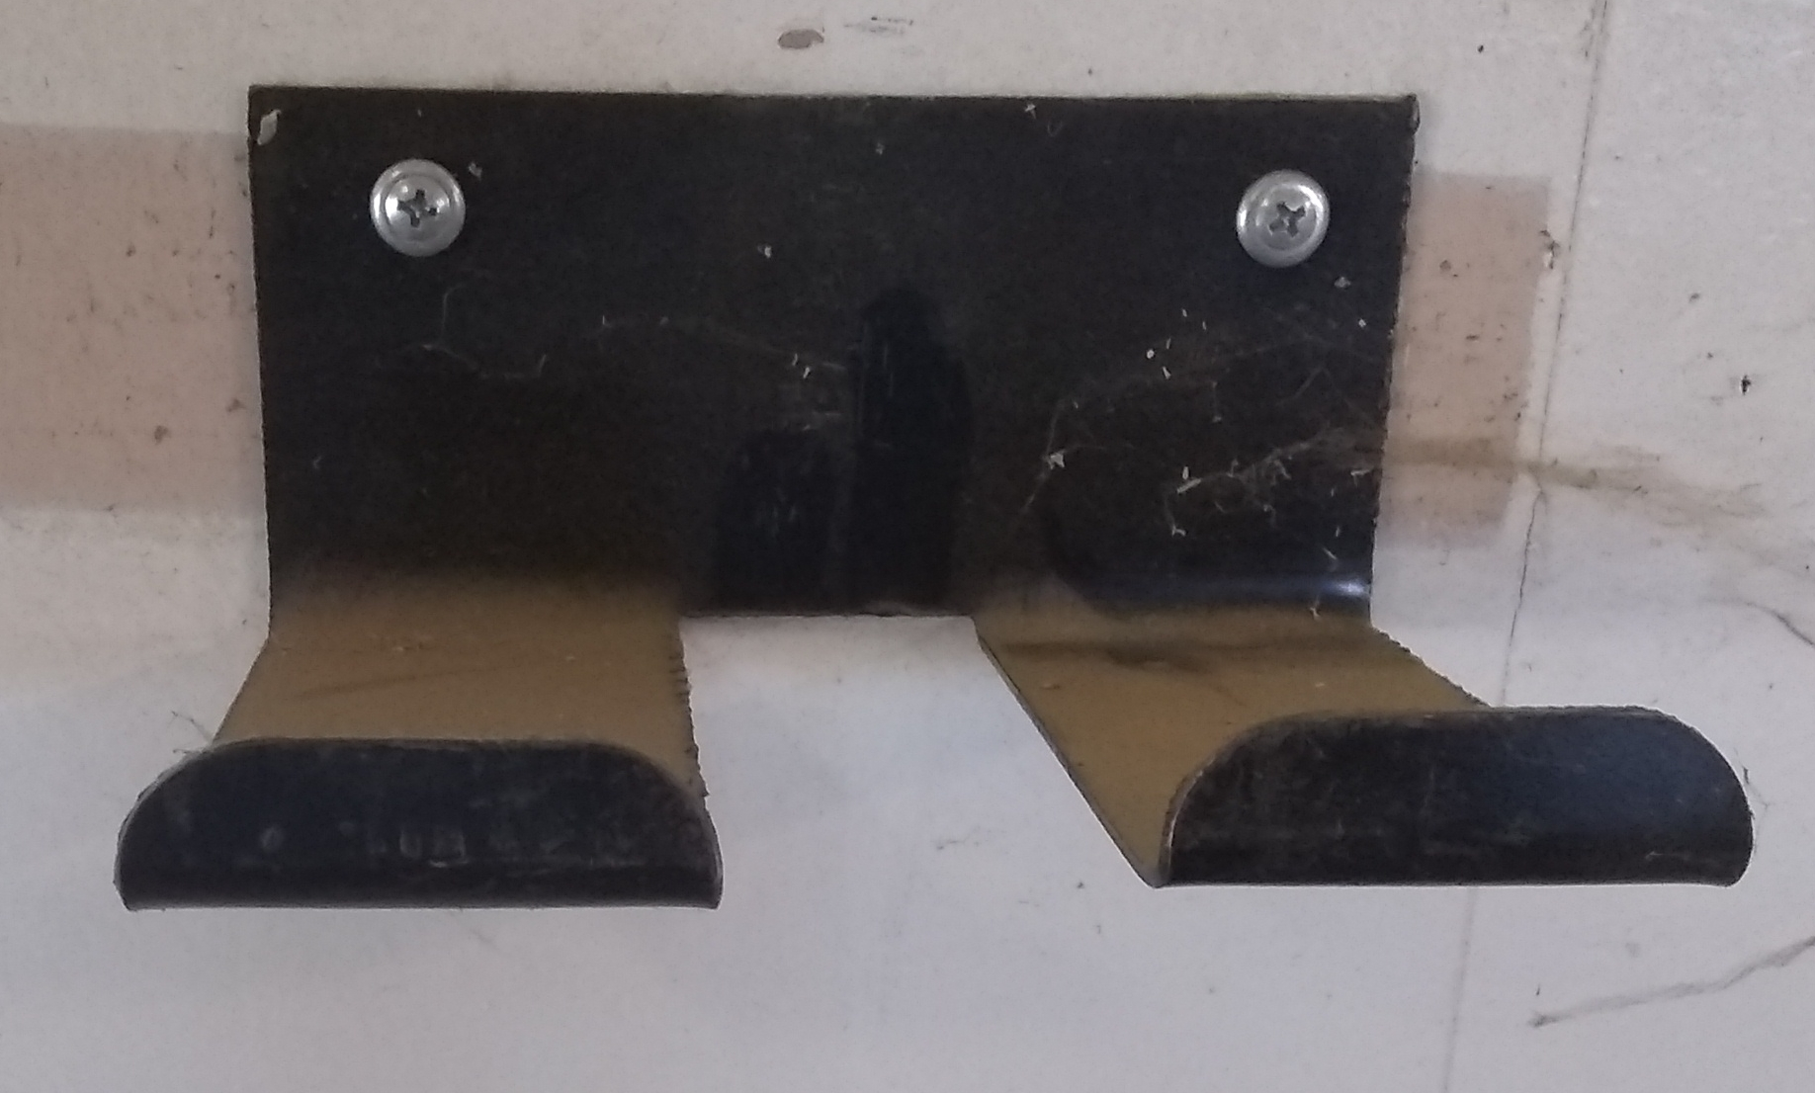
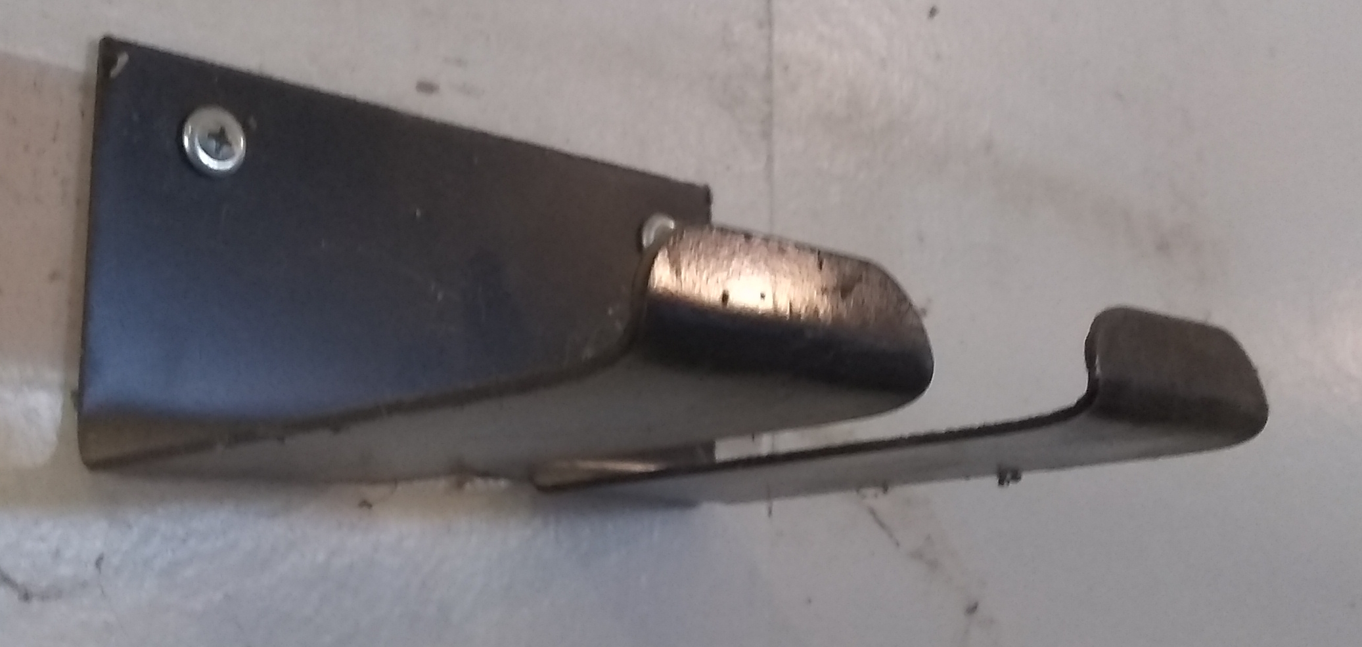
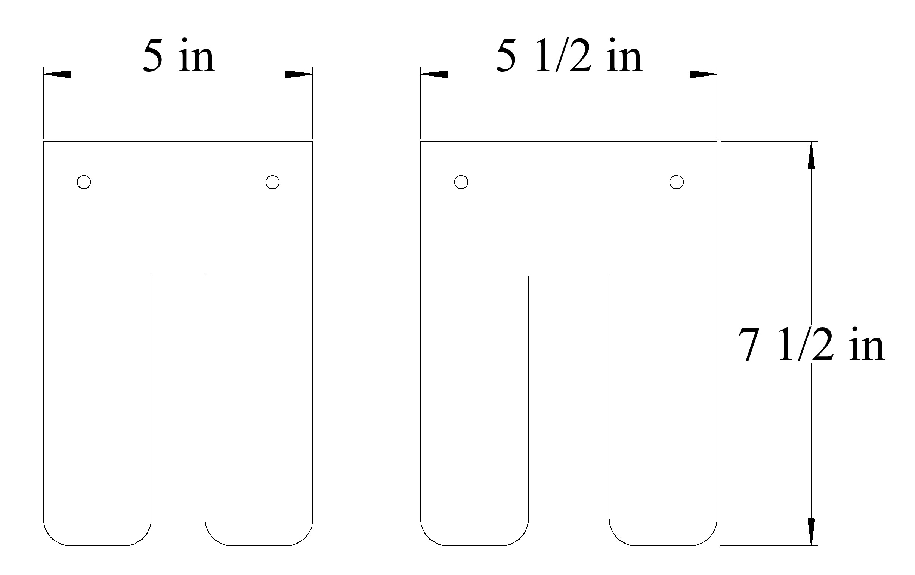
Broom Racks
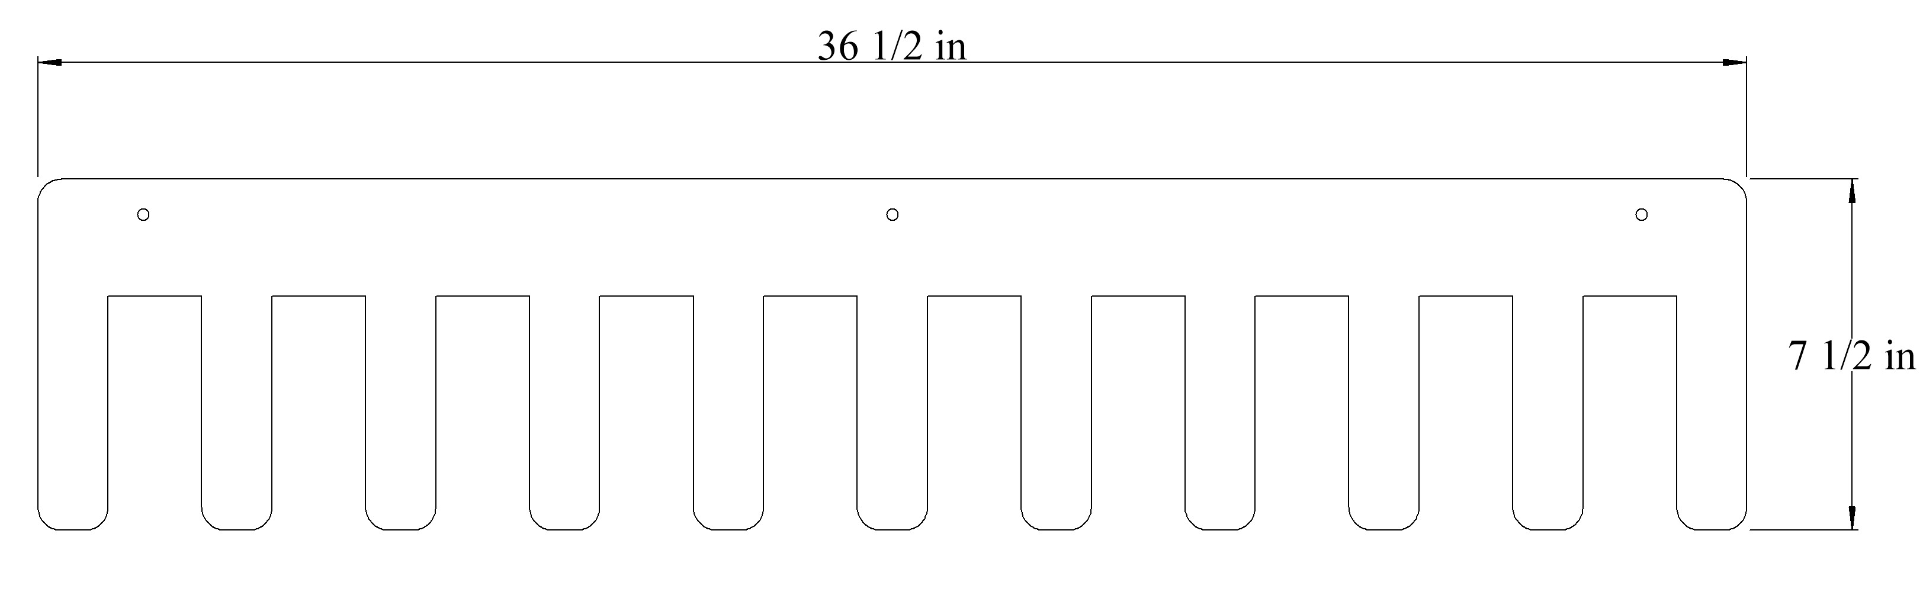
Rack for garden tools

Construction Log:
Complete the log below making an entry every day you work on the project. Transfer the logged hours to your record book journal for this SAE enterprise.
Date | Tasks Completed | Skills Used/Learned | Hours

Actual Price Received:
Enter the actual price you received for the project in your record book journal as income. $_________

Project Portfolio:
Complete a portfolio for the project that includes:
- A description of the project and the skills you learned building the project. Include the hours spent on the project and the income (if sold). Use the construction log to complete this narrative. Write in complete sentences.
- The Bill of Materials
- The project plan
- 2-8 photos documenting the project at various stages of construction.

