Garden Trellis

This project was developed from an example provided by Dick Piersma, Hilmar High School.

Description:
A sturdy trellis made from part of a hog panel. Dimensions can be easily altered to use scraps of a panel. This plan is designed for 5 projects from a single 16’ panel. This plan calls for 34” x 16’ panels, but panels can be purchased 48”, 50”, and 60” heights. A longer trellis can be made by extending the cross member length. For widths exceeding 8’ add a middle leg (slot on both sides) and adjust the notch in the cross members.

Skills Required:
Students must have the ability to read an assembly plan, properly measure, and operate a table saw, miter saw, and band saw..

Materials:
- 2 x 4 x 12’ Pressure treated fir, redwood, or untreated fir
- 2 x 4 x 12’ fir or redwood.
- Hog Panel 34” x 16’
- ¼” x 4” carriage bolts.
- 3” deck screws
- Deck stain if using untreated fir lumber.
- Copper based wood preservative for uprights if using fir lumber.
Tools Required:
- Table saw wit dado blade
- Miter saw
- Jig Saw or band saw.
- Router & bits
- Portable Drill/driver
- Drill Press
- 5” 1/4” drill bit
- Steel tape
- Combination Square
- Bolt cutters

Bill of Materials:
Complete the bill of materials below for this project. Use the completed bill of materials for your record book budget by entering the name of the project and the total amount as an expense
Size | Description | Units | Qty/Project | Cost/Unit | Order | Amount

Project Price:
Enter the expected price you will receive for the project in your record book budget (income).

Estimated Construction Time:
__5___ hours.

Cutting List:
Quantity | Description | Size
2 | Legs | 1 ½” x 3 ½” x 72”
2 | Cross members | 1 ½” x 3 ½” x 44 ½”
1 | Top | 1 ½” x 3 ½” x 48 ½”

Directions:
Notes: When working with pressure treated lumber be sure wear a dust mask when cutting and wash your hands after handling the material. Fir should be treated before assembly with deck stain. Copper preservative should be used on fir below ground.
- If using a new hog pane cut into 5 equal pieces (about 38 3/8”) using bolt cutters.
- Cut lumber to length (see cutting list).
- Set the dado blade to cut a slot about ½ wide. Set the width to match your hog panel as panel wire gauges may vary. Set the depth to ½”. Set the fence to center the dado cut on a 2 x 4.
- Mark on the two legs the bottom of the slot (see plan).
- Mark on the table saw throat plate the center of the dado blade.
- Carefully cut the slot into each leg (2” side) and when the mark on the board aligns with the mark on the throat plate lift the leg straight up off the blade. A helper is recommended.
- Re adjust the fence and cut slots in both cross members (4” side”).
- Layout the notch in the ends of the cross members and cut out with a band saw.
- Drill the holes in the cross member on the drill press.
- On a flat surface assemble the legs and cross members. Locate the lower cross member on the legs. Square the frame. Using a portable drill complete the hole in the leg using the hole in the bottom cross member as a guide.
- Install the carriage bolts in the bottom cross member.
- Install the hog panel in the slot and fit the top cross member to the top of the panel.
- Drill and fasten the top cross member.
- The top piece may be routed to make decorative edge. Center and install with deck screws to complete the project.
- Install in ground at 18”.

Photo/Drawing:
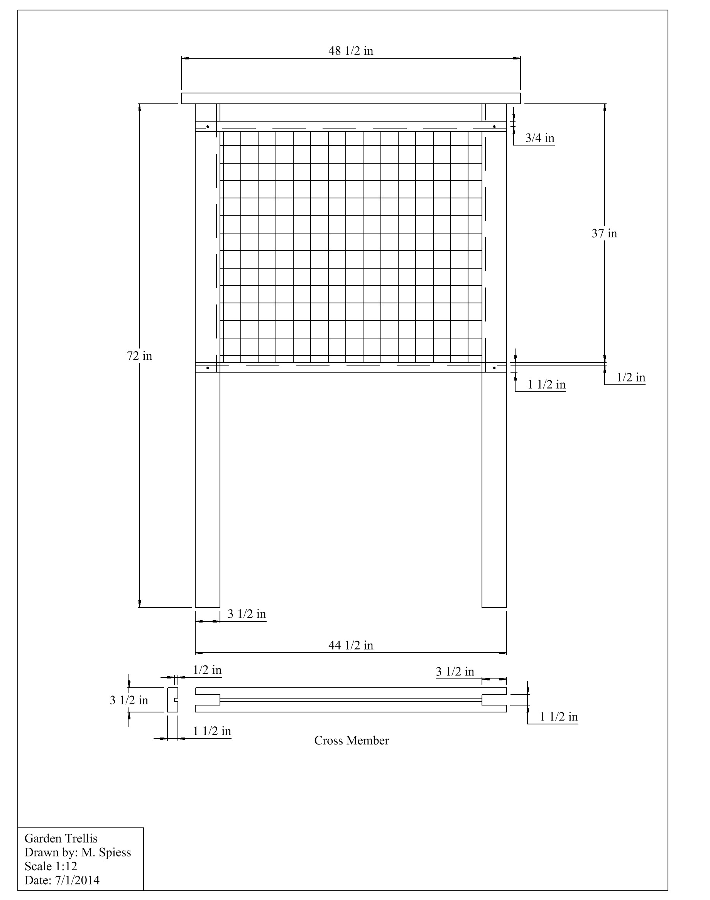

Construction Log:
Complete the log below making an entry every day you work on the project. Transfer the logged hours to your record book journal for this SAE enterprise.
Date | Tasks Completed | Skills Used/Learned | Hours

Actual Price Received:
Enter the actual price you received for the project in your record book journal as income. $_________

Project Portfolio:
Complete a portfolio for the project that includes:
- A description of the project and the skills you learned building the project. Include the hours spent on the project and the income (if sold). Use the construction log to complete this narrative. Write in complete sentences.
- The Bill of Materials
- The project plan
- 2-8 photos documenting the project at various stages of construction.

