Sawhorse
Name:
Date:

Description:
The project is a wood sawhorse that can be used for workspace for future projects. It requires layout and wood working/construction skills. It is constructed from dimensional lumber.

Materials:
4 - 2x4x25" Fir Legs
2 - 2x3x 3" blocks
4 - 1/2" plywood gussets
1 - 2x6x36" Fir Top
8 - #8x2 1/2" Deck Screws
#6 x 1 ¼” course drywall screws
Wood Glue

Tools:
Power Miter Saw
Drill Press and 1” Forstner bit
Circular Saw
Keyhole or Saber Saw
Wood Rasp
Palm Sander
Cordless Drill/Screwdriver & bit

Directions:
- Review the plan. Select your lumber and determine the best layout.
- What is the desired angle for cutting the legs, block, and gusset? ______
- *Cut the legs and block from 2x4 stock on the power miter saw set to the desired angle. Calculate the length of the block by measuring the width of the legs (across the angle cut).
- *Rip plywood to 7 1/2" (gusset height) on the table saw and layout the gusset angles and cut angles on the power miter saw or band saw.
- Assemble the legs and gussets using glue and drywall screws. Note: Assemble plywood first to the legs. Then push the block in to pocket created by the gussets. Align the block even with top of the legs so the top will fit snuggly.
- *Cut the 2x6 top to length using the circular saw.
- Locate and bore the two 1" holes at the ends of the slot.
- Assemble the top and leg assemblies (no glue, so top can be replaced) with four screws/leg. LAYOUT the location so the screws are evenly spaced.
- Cut out the slot with the saber saw and smooth with a rasp and sandpaper. DO NOT use the saber saw to "trim" the slot. This will ruin the blade.
- Sand edges.
* Project can be started at this point.

Notes:
__________________________________________________________________________________
__________________________________________________________________________________
__________________________________________________________________________________

Drawing/Photo:
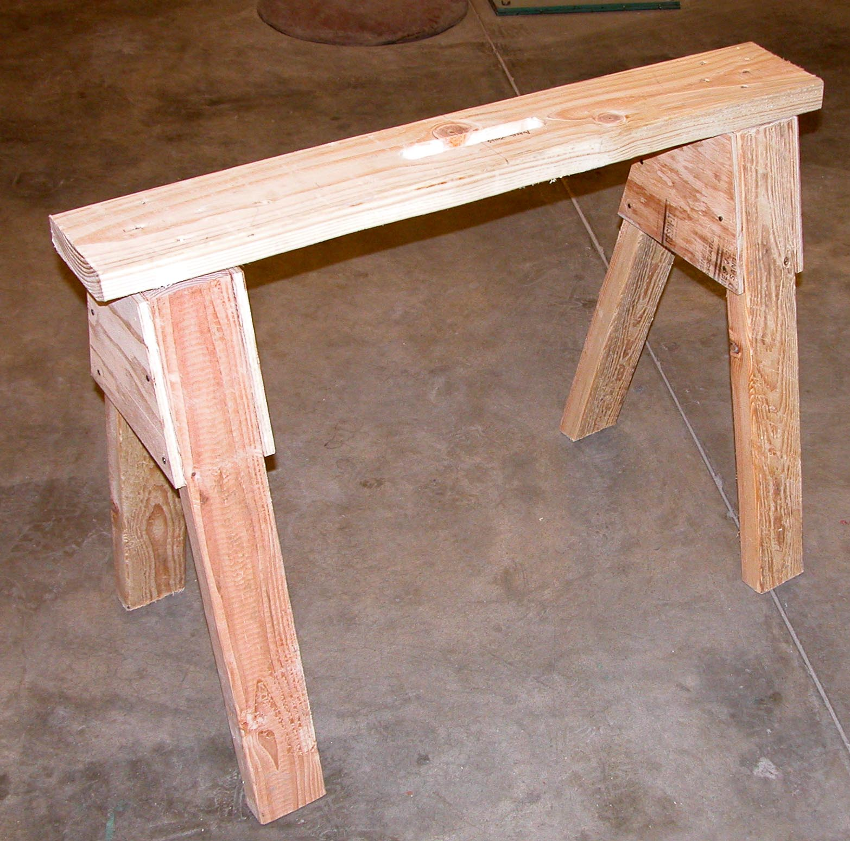

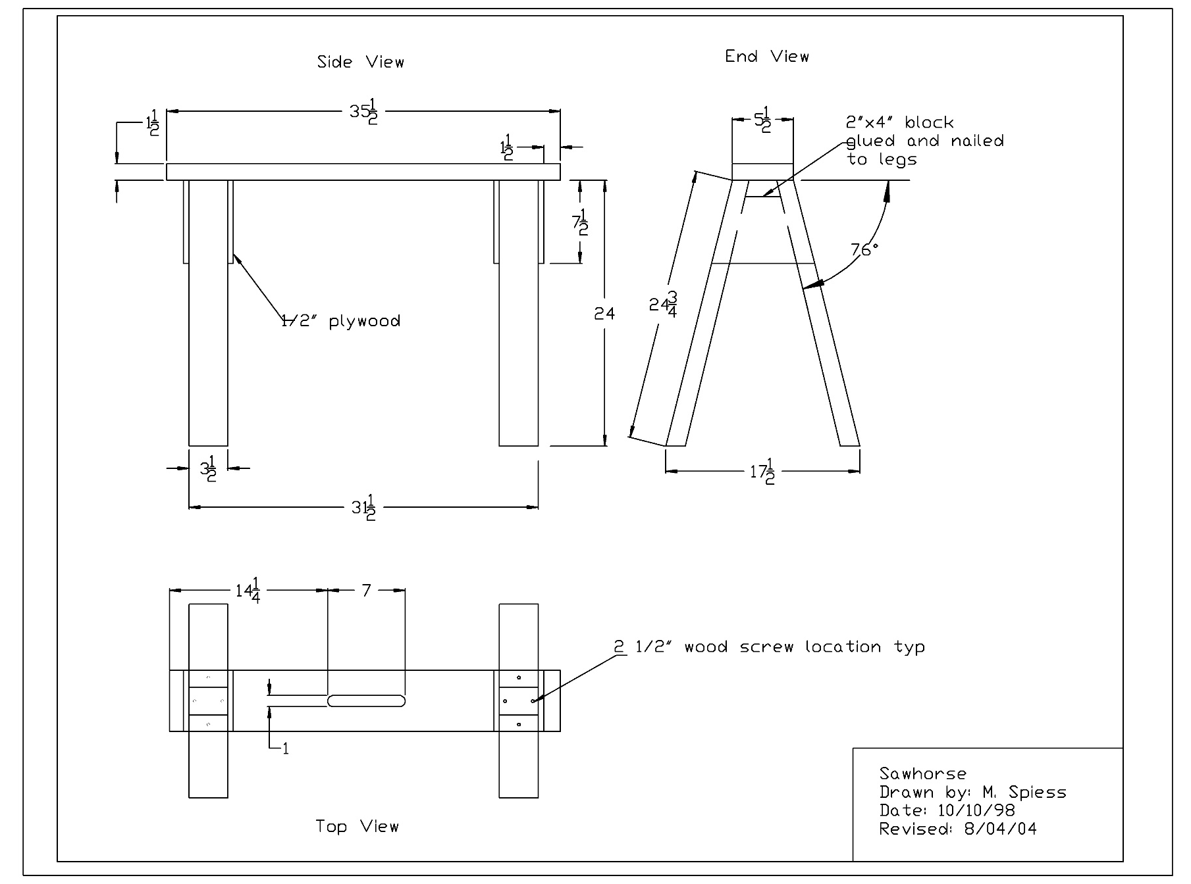

Sawhorse Worksheet:

Name:
Date:
Complete this worksheet prior to starting the project.
- What angle do you set the miter saw to cut the legs for the sawhorse?
- Describe a “gusset”. ____________________________________________________________
- What part of the sawhorse is assembled first?
- What size and type of fasteners are used?
- Why is it important that the 4 legs are the same?

Grading Rubric:
Criteria (tolerance 1/8") | Possible | Score
Top Piece - Accurate Dimensions | 5
Slot (size and position) | 5
Countersink and screw installation on top | 5
Legs, All 4 are the same (no wobble) | 5
Fit up of the legs/ gussets - Accurate and flush | 10
Angles on legs and gussets- Correct | 5
Cuts clean and square | 5
Workmanship (fit, sanding) | 5
TOTAL | 45

Sawhorse Teaching Notes:

Agricultural Standards Met:
4.0 Technology - Students know how to use contemporary and emerging technological resources in diverse and changing personal, community, and workplace environments:
4.6 Differentiate among, select, and apply appropriate tools and technology.
5.0 Problem Solving and Critical Thinking - Students understand how to create alternative solutions by using critical and creative thinking skills, such as logical reasoning, analytical thinking, and problem-solving techniques:
5.1 Apply appropriate problem-solving strategies and critical thinking skills to work-related issues and tasks.
5.3 Use critical thinking skills to make informed decisions and solve problems.
6.0 Health and Safety - Students understand health and safety policies, procedures, regulations, and practices, including the use of equipment and handling of hazardous materials:
6.1 Know policies, procedures, and regulations regarding health and safety in the workplace, including employers’ and employees’ responsibilities.
6.2 Understand critical elements of health and safety practices related to storing, cleaning, and maintaining tools, equipment, and supplies.
6.4 Maintain safe and healthful working conditions.
6.5 Use tools and machines safely and appropriately.
6.6 Know how to both prevent and respond to accidents in the agricultural industry.
B1.0 Students understand personal and group safety:
B1.1 Practice the rules for personal and group safety while working in an agricultural mechanics environment.
B1.2 Know the relationship between accepted shop management procedures and a safe working environment.
B2.0 Students understand the principles of basic woodworking:
B2.3 Know how to identify, select, and implement basic fastening systems.
B2.4 Complete a woodworking project, including interpreting a plan, developing a bill of materials and cutting list, selecting materials, shaping, joining, and finishing.

Objectives:
By successfully completing this project students will be able to:
- Read a plan to obtain critical dimensions
- Measure and layout a wood project
- Identify by name common woodworking tools
- Select and properly used hand and power tools used for wood work
- Cut and assemble wood components successfully

Alternate Tools:
A hand saw can be used to cut the wood to replace the compound miter saw and the circular saw. A band saw can replace the compound miter saw on some cuts.

Safety Review:
- Use of the hand power drill.
- User of the compound miter saw.
- Use of the circular saw.

Project Time:
Demonstration: | 15-30 minutes
Build: | 3 - 5 hours

Demonstration Notes:
(Tips, methods to stage the project)
- Begin by reviewing materials and tools used for the project.
- Review the plan and show how the plan describes the project.
- Demonstrate the proper use of miter saw and a circular saw.
- Demonstrate how to measure and mark the cuts you need, especially the angles. NOTE: All the angles are the same.
- Demonstrate cutting the wood and accounting for the amount the saw takes out of the wood (kerf).
- Demonstrate how to layout and install the legs.
- Review hand power drill safety as you demonstrate drilling and countersinking the screw holes for the legs and gussets.
- Remind students of workmanship. Final project should be clean and free of sharp edges.

Bill of Materials
(Excel, update with local prices)
Project from: Mike Spiess

