Sheet Metal Box

Name: __________________________

Date: __________________________

## Description:

A parts bin type box will be constructed out of sheet metal by using tools and equipment to make proper bends in the metal and fastened by various means.

## Materials:

22 or 26 ga. Galvanized sheet metal

## Tools:

Snips – (aviation or tin)

Sheet metal sheer

Sheet metal brake

Finger Brake

Pop rivet tool

Drill press

#30 (or 1/8”) twist drills

Ball peen hammer

Center punch

Combination square

Steel Rule

Scratch awl

Mill file

Layout fluid (Optional)

Portable drill

## Procedure:

1. Shear a rectangular piece of sheet metal measuring 9”x12”
2. (optional) Spray aerosol layout fluid on the rectangular piece of sheet metal
3. Layout material according to attached plans
4. Drill 1/8” relief holes (in the 4 corners) on a drill press before making any bends
5. Use snips to cut out laid out material
6. Using the ball peen hammer and mill file, flatten and smooth edges as needed
7. If used, wipe away aerosol layout fluid with a rag and paint remover
8. Determine the break order and make notes on the layout
9. Bend project
10. Mark and center punch where the pop rivet holes are to go
11. Drill 1/8” holes for the pop rivets and clean up burrs as needed
12. Install pop rivets
13. Smooth any remaining sharp edges with the mill file

## Cutting List:

|  |  |  |
| --- | --- | --- |
| Quantity | Size | Material |
| 1 | 9”x12” | 22 or 26ga. Galvanized sheet metal |

## Notes:

______________________________________________________________________________________________________________________________________________________________________________________________________________________________________________________________________________________________________________________________________________________________________________________________________________________________________________________________________________________________________________________________________________________________________________________________________________________________________________________________________________________________________________________________________________________________________________________________________________________________________________________________________________________________________________________________________________________________________________________________________________________________________________________________________________________________________________________________________________________________________________________________________________________________________________________________________________________________________________________________________________________________________________________________________________________________________________________________________________________________________________________________________________________________________________________________________________________________________________________________________________________________________________________________________________________________________________

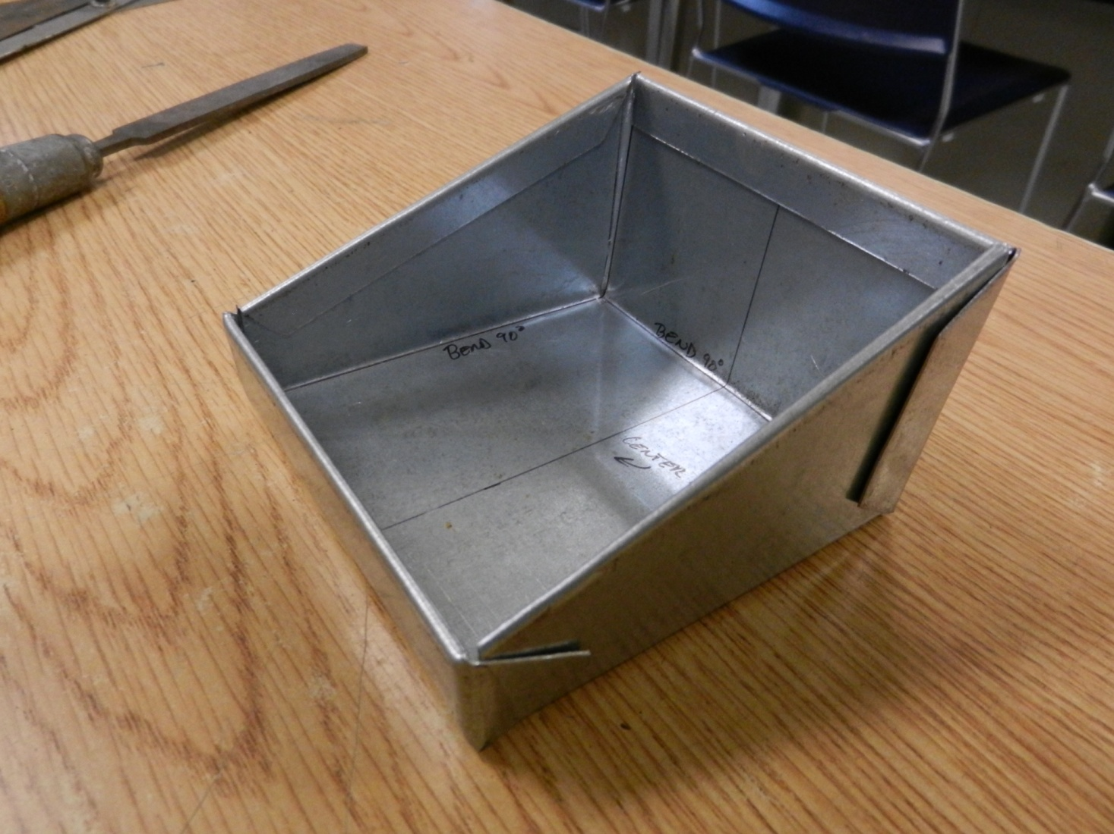Photo/Drawing:

# Plans:



# Sheet Metal Box Worksheet

Name: ________________________

Date: ________________________

1. What is the name of the tool that will make creases and bends in sheet metal?
2. Will the project go together correctly if the bends are made out of order? Why?
3. What is the purpose of the relief holes drilled in the 4 corners?
4. How many pieces of sheet metal will you need for this project?
5. List some possible ways to change or modify this project. ( List 3)

## Grading Rubric:

|  |  |  |
| --- | --- | --- |
| CRITERIA | POSSIBLE | SCORE |
| Correctness of layout (size) | 10 |  |
| Bottom of box lays flat on table | 5 |  |
| Corners meet up true | 5 |  |
| Installation of pop rivets | 5 |  |
| Overall workmanship | 5 |  |
| Worksheet | 10 |  |
| TOTAL | 40 |  |

# Sheet Metal Box Teachers Notes:

## Agricultural Standards Met:

6.0 Health and Safety. Students understand health and safety policies, procedures, regulations, and practices, including the use of equipment and handling of hazardous materials:

6.1 Know policies, procedures, and regulations regarding health and safety in the workplace, including employers’ and employees’ responsibilities.

6.2 Understand critical elements of health and safety practices related to storing, cleaning, and maintaining tools, equipment, and supplies.

6.4 Maintain safe and healthful working conditions.

6.5 Use tools and machines safely and appropriately.

6.6 Know how to both prevent and respond to accidents in the agricultural industry.

B1.0 Students understand personal and group safety:

B1.1 Practice the rules for personal and group safety while working in an agricultural mechanics environment.

B1.2 Know the relationship between accepted shop management procedures and a safe working environment.

B2.0 Students understand the principles of basic woodworking.

B2.3 Know how to identify, select, and implement basic fastening systems.

B5.0 Students understand agricultural cold metal processes:

B5.1 Know how to identify common metals, sizes, and shapes.

B5.2 Know basic tool-fitting skills.

B5.3 Know layout skills.

B5.4 Know basic cold metal processes (eg, shearing, cutting, drilling, threading, bending)

B5.5 Complete a cold metal project, including interpreting a plan, developing a bill of materials, selecting materials, shaping, fastening, and finishing.

## Objectives:

## By properly completing this project, students will:

* Properly layout material for cutting
* Properly cut sheet metal using a sheer and snips
* Properly use a sheet metal break to make bends
* Properly use a drill press and twist drill
* Properly use a pop rivet tool
* Properly use a spot welder

## Alternate Tools and Materials:

* Spot Welder
* Sheet metal screws or tinner’s rivets as fasteners

## Safety Review:

* Safety eyewear
* Break safety
* Spot welder safety
* Sheet metal sheer safety
* Sharp edges

## Project Time:

|  |  |
| --- | --- |
| Demonstration: | 90 minutes |
| Build: | 3 hours |

## Demonstration Notes:

1. Tip: Before handing out the plan, show the students the project and ask them to sketch the flat sheet metal.
2. Tip: Handout a copy of the sheet metal plan, or use the sketch made in step 1, and have the students cut it out with scissors and determine the order of the bends.
3. Be sure to bend the material in the correct order to ensure proper fit
4. (Optional) Be sure to remove the aerosol layout fluid before spot welding
5. (If used) Check and have students check the spot welder to ensure the proper setting (too high will burn a hole through it)
6. Have students assist you in constructing the project at any point
7. Be sure that most students can view what you are doing at all times

## Bill of Materials: (complete this spreadsheet)



Project from: Dick Piersma, Hilmar High School

Plan by: Dick Piersma