Spice Rack
Name: __________________
Date: __________________

Description:
The spice rack is a simple project. It is a great project for Christmas or Mother’s Day. Plan is based on many commercial designs, but shelf height is higher to allow better viewing of the spice jars. Finished project can be sealed, stained, or painted. Overhang of the back shelf allows use in cabinets that have a back rail.

Materials:
1” X 6” X 4’ pine or hardwood
4d galvanized box nails
Wood Glue
Varnish/stain
Spackle or Wood dough
Sand Paper
Tools:
Table Saw
Power Miter Saw
Band Saw
Hammer
Nail set
Tape Measure/Ruler/Combination square

Procedure:
Note: If you wish to make a shorter or longer rack simply cut the shelf pieces to a different length.
- Obtain a piece of wood that is 1” X 6” X 4’ (or some scraps). Length will vary if the
- Determine the best use of the lumber. Where are the knots? Determine the layout before you begin to cut.
- Crosscut the board for the two ends with the miter saw. Set aside these pieces.
- Adjust the table saw rip fence so it measures 2” from the fence to the inside of the saw blade
- Rip (cut) the long piece of wood at 2”. Do this twice to create 2 long 2” pieces for the shelves.
- From these pieces crosscut all the 2” wide pieces to the desired length.
- Layout the ends with the combination square.
- Cut out the notches in the ends with the bandsaw. If necessary, carefully sand the cuts without rounding the edges. Use a scrap piece of 1x2 with sand paper wrapped around it.
- Assemble the shelves and ends using nails.
- Countersink the nails. Fill holes if desired.
- Sand the entire project, removing sharp edges.
- Finish as desired.

Cutting List:
Quantity | Size
3 | 3/4” X 2 ” X 16” | Shelves
2 | 3/4” X 5 1/2” X 5 1/4” | Ends

Notes:

________________________________________________________________________

________________________________________________________________________

________________________________________________________________________

________________________________________________________________________

________________________________________________________________________

________________________________________________________________________

Photo/Drawing:
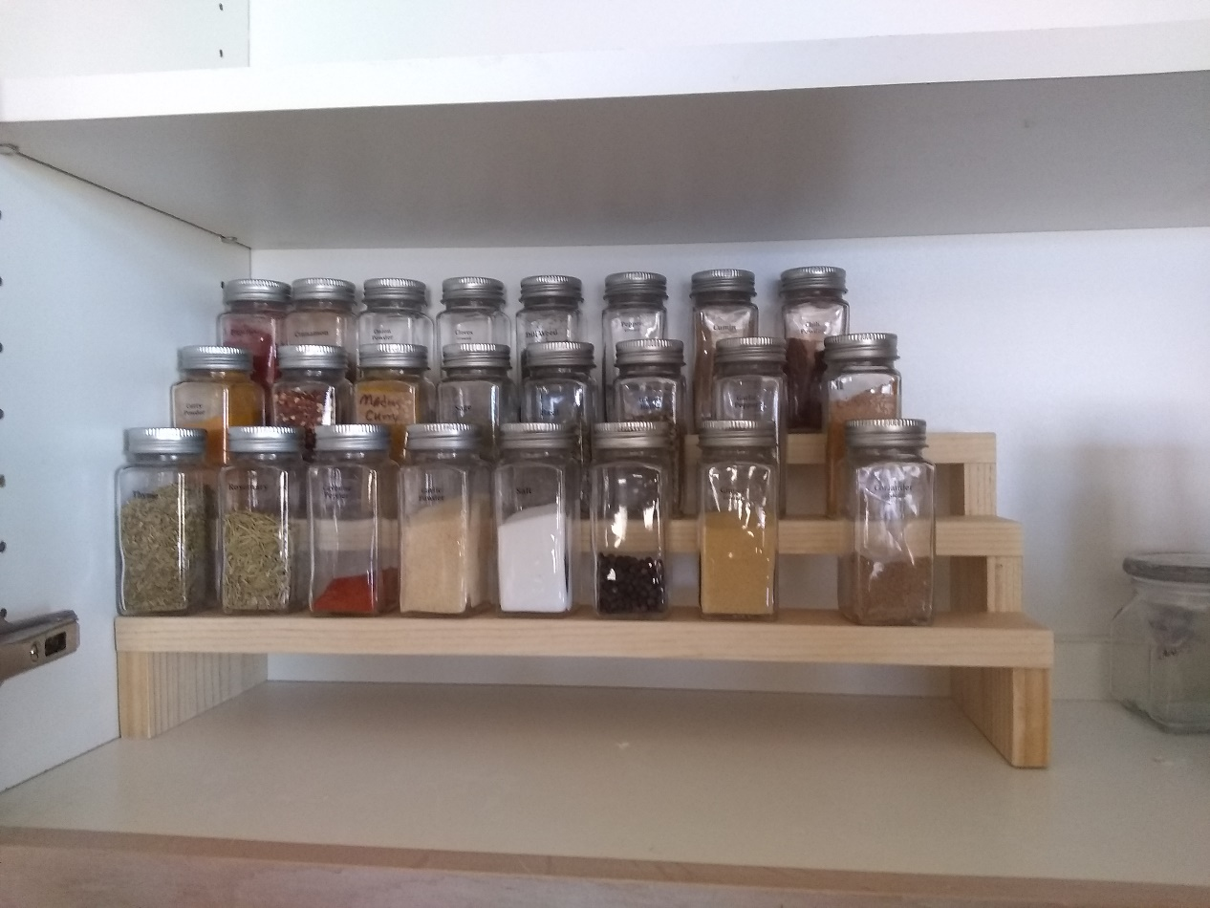

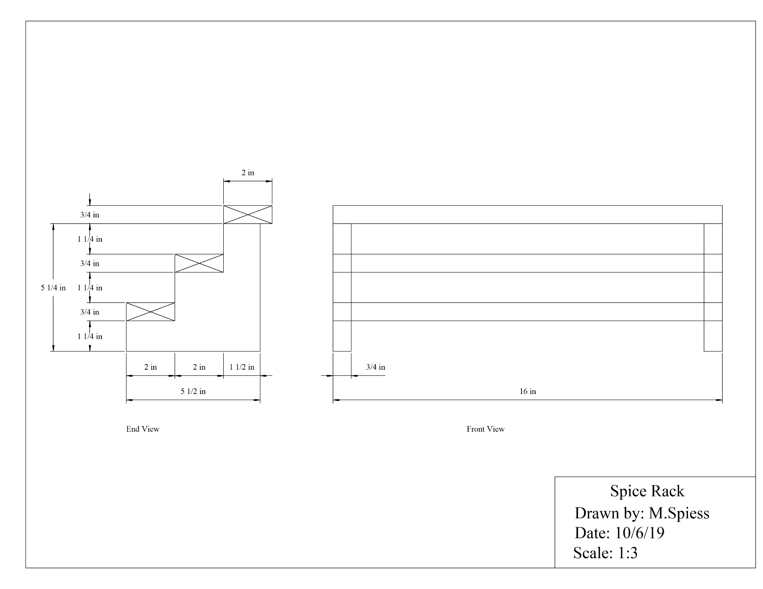

Spice Rack Worksheet
Name: __________________
Date: __________________
- What are the safety precautions when using the table saw?

- When using a table saw to rip thin strips what accessory must be used?

- When using the table saw why must you always measure from the fence to the inside of the saw blade?

- When using the table saw why must the top of the saw blade be 1/8” above the top of the wood?

- What are the safety precautions when using the power miter saw?

Grading Rubric:
CRITERIA | POSSIBLE | SCORE
Length | 5
Width | 5
Assembled square | 5
Joints fit well | 5
Workmanship (sanding, nails, cut quality, etc) | 5
Total | 25

Spice Rack Teachers Notes:

Agricultural Standards Met:
6.0 Health and Safety. Students understand health and safety policies, procedures, regulations, and practices, including the use of equipment and handling of hazardous materials:
6.1 Know policies, procedures, and regulations regarding health and safety in the workplace, including employers’ and employees’ responsibilities.
6.2 Understand critical elements of health and safety practices related to storing, cleaning, and maintaining tools, equipment, and supplies.
6.4 Maintain safe and healthful working conditions.
6.5 Use tools and machines safely and appropriately.
6.6 Know how to both prevent and respond to accidents in the agricultural industry.
B1.0 Students understand personal and group safety:
B1.1 Practice the rules for personal and group safety while working in an agricultural mechanics environment.
B1.2 Know the relationship between accepted shop management procedures and a safe working environment.
B1.0 Students understand personal and group safety:
B1.1 Practice the rules for personal and group safety while working in an agricultural mechanics environment.
B1.2 Know the relationship between accepted shop management procedures and a safe working environment.
B2.0 Students understand the principles of basic woodworking:
B2.1 Know how to identify common wood products, lumber types, and sizes.
B2.2 Know how to calculate board feet, lumber volume, and square feet.
B2.3 Know how to identify, select, and implement basic fastening systems.
B2.4 Complete a woodworking project, including interpreting a plan, developing a bill of materials and cutting list, selecting materials, shaping, jointing, and finishing.

Objectives:
By properly completing this project, students will be able to:
- Read a plan to and layout dimensions.
- Students will identify proper wood type used for the project
- Students will properly layout project design
- Students will safely use a table saw
- Students will safely use a band saw
- Students will safely cut wood using the power miter saw
- Students will learn the proper way to glue and assemble the project
- Students will learn how to sand and finish a wood project

Alternative Tools/Methods/Materials:
- Project can be made of any hard wood.
- End can be cut with a hand miter saw.
- Individual projects can usually be made from scraps.

Safety Review:
- Table Saw
- Power Miter Saw
- Band Saw

Project Time:
Demonstration: | 1 hour
Build: | 2 hours

Demonstration Notes:
- Demonstrate how to select lumber, cutting around knots. Project allows for some waste. You may wish to simply rip all of the boards.
- Be sure to address safety tips as we work on each machine.
- Demonstrate mark-cut-mark-cut technique used for cross cutting so pieces are correct length.
- Demonstrate the layout of the ends using a combination or try square.
- Demonstrate how to carefully cut on the lines with the bandsaw. Note: a wider blade makes straight cuts easier.
- Keep scrap pieces separate to avoid confusion.
- During assembly knots can often be hidden at the back of the project.

Bill of Materials:
Project from: Mike Spiess

