Sprinkler Stand
Name: _______________________
Date: _______________________

Description:
For this project you will work with PVC common plumbing materials to make a sprinkler stand: schedule 40 PVC pipe, PVC Tees, PVC cement.

Materials:
6- 1/2'” x 4” Schedule 40 PVC Pipe
1- ½” x 2” Schedule 40 PVC Pipe
4- ½” PVC Cap
1- ½” PVC SSS Tee
1- ½” SST Tee
1- ½” PVC SSSS Cross
1- ½” x ¾” Hose Adaptor
1- 3” Sprinkler Riser
1- 15’ Radius Sprinkler (use scrub head)
PVC Cement
Pipe Joint Compound
PVC Primer (optional)
Teflon Tape

Tools:
PVC pipe cutter
Pipe Wrench

Procedure:
- Determine the correct length of the seven pipes to fit the diagram. Allow for threads and socket joints
- Use a PVC Cutter or hack saw to cut PVC
- Optionally, prime the exterior of the PVC pipes and interior of the fittings prior to assembly (do step by step not all at once). NOTE: Primer is not generally used on pipe below 1” in size.
- Assemble the project using PVC cement and primer. Be sure to twist in the pipe and hold.
- Install the riser with Teflon Tape. Use a pipe wrench to insure that the threaded fittings are tight.
- Turn in the finished project with the grade sheet for final grading.

Notes:
____________________________________________________________________________________________________________________________________________________________________________________________________________________________________________________________________________________________________________________________________________________
_____________________________________________________________________________________
_____________________________________________________________________________________

Photo/Drawing:
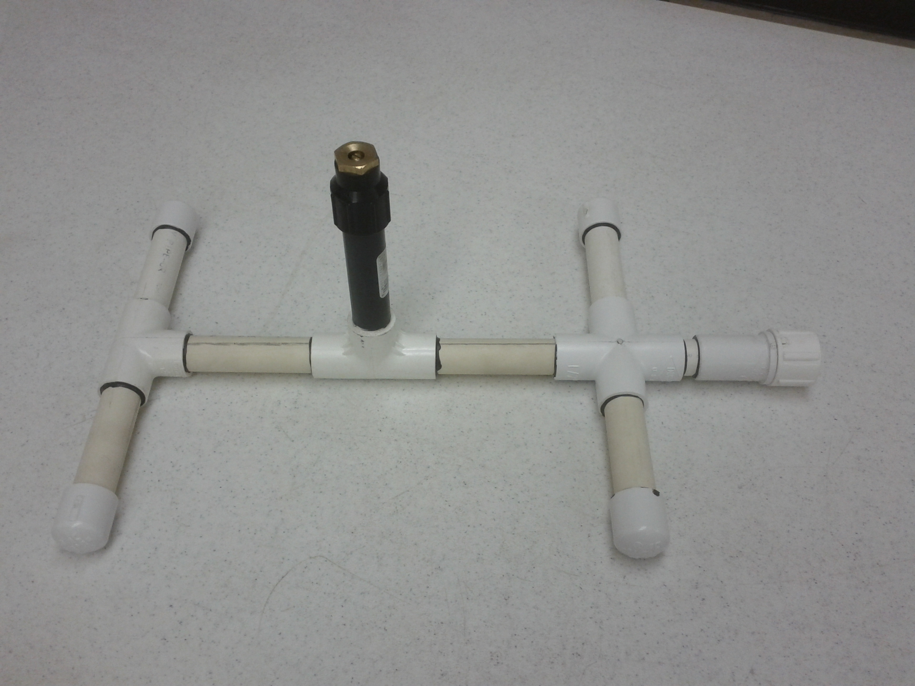

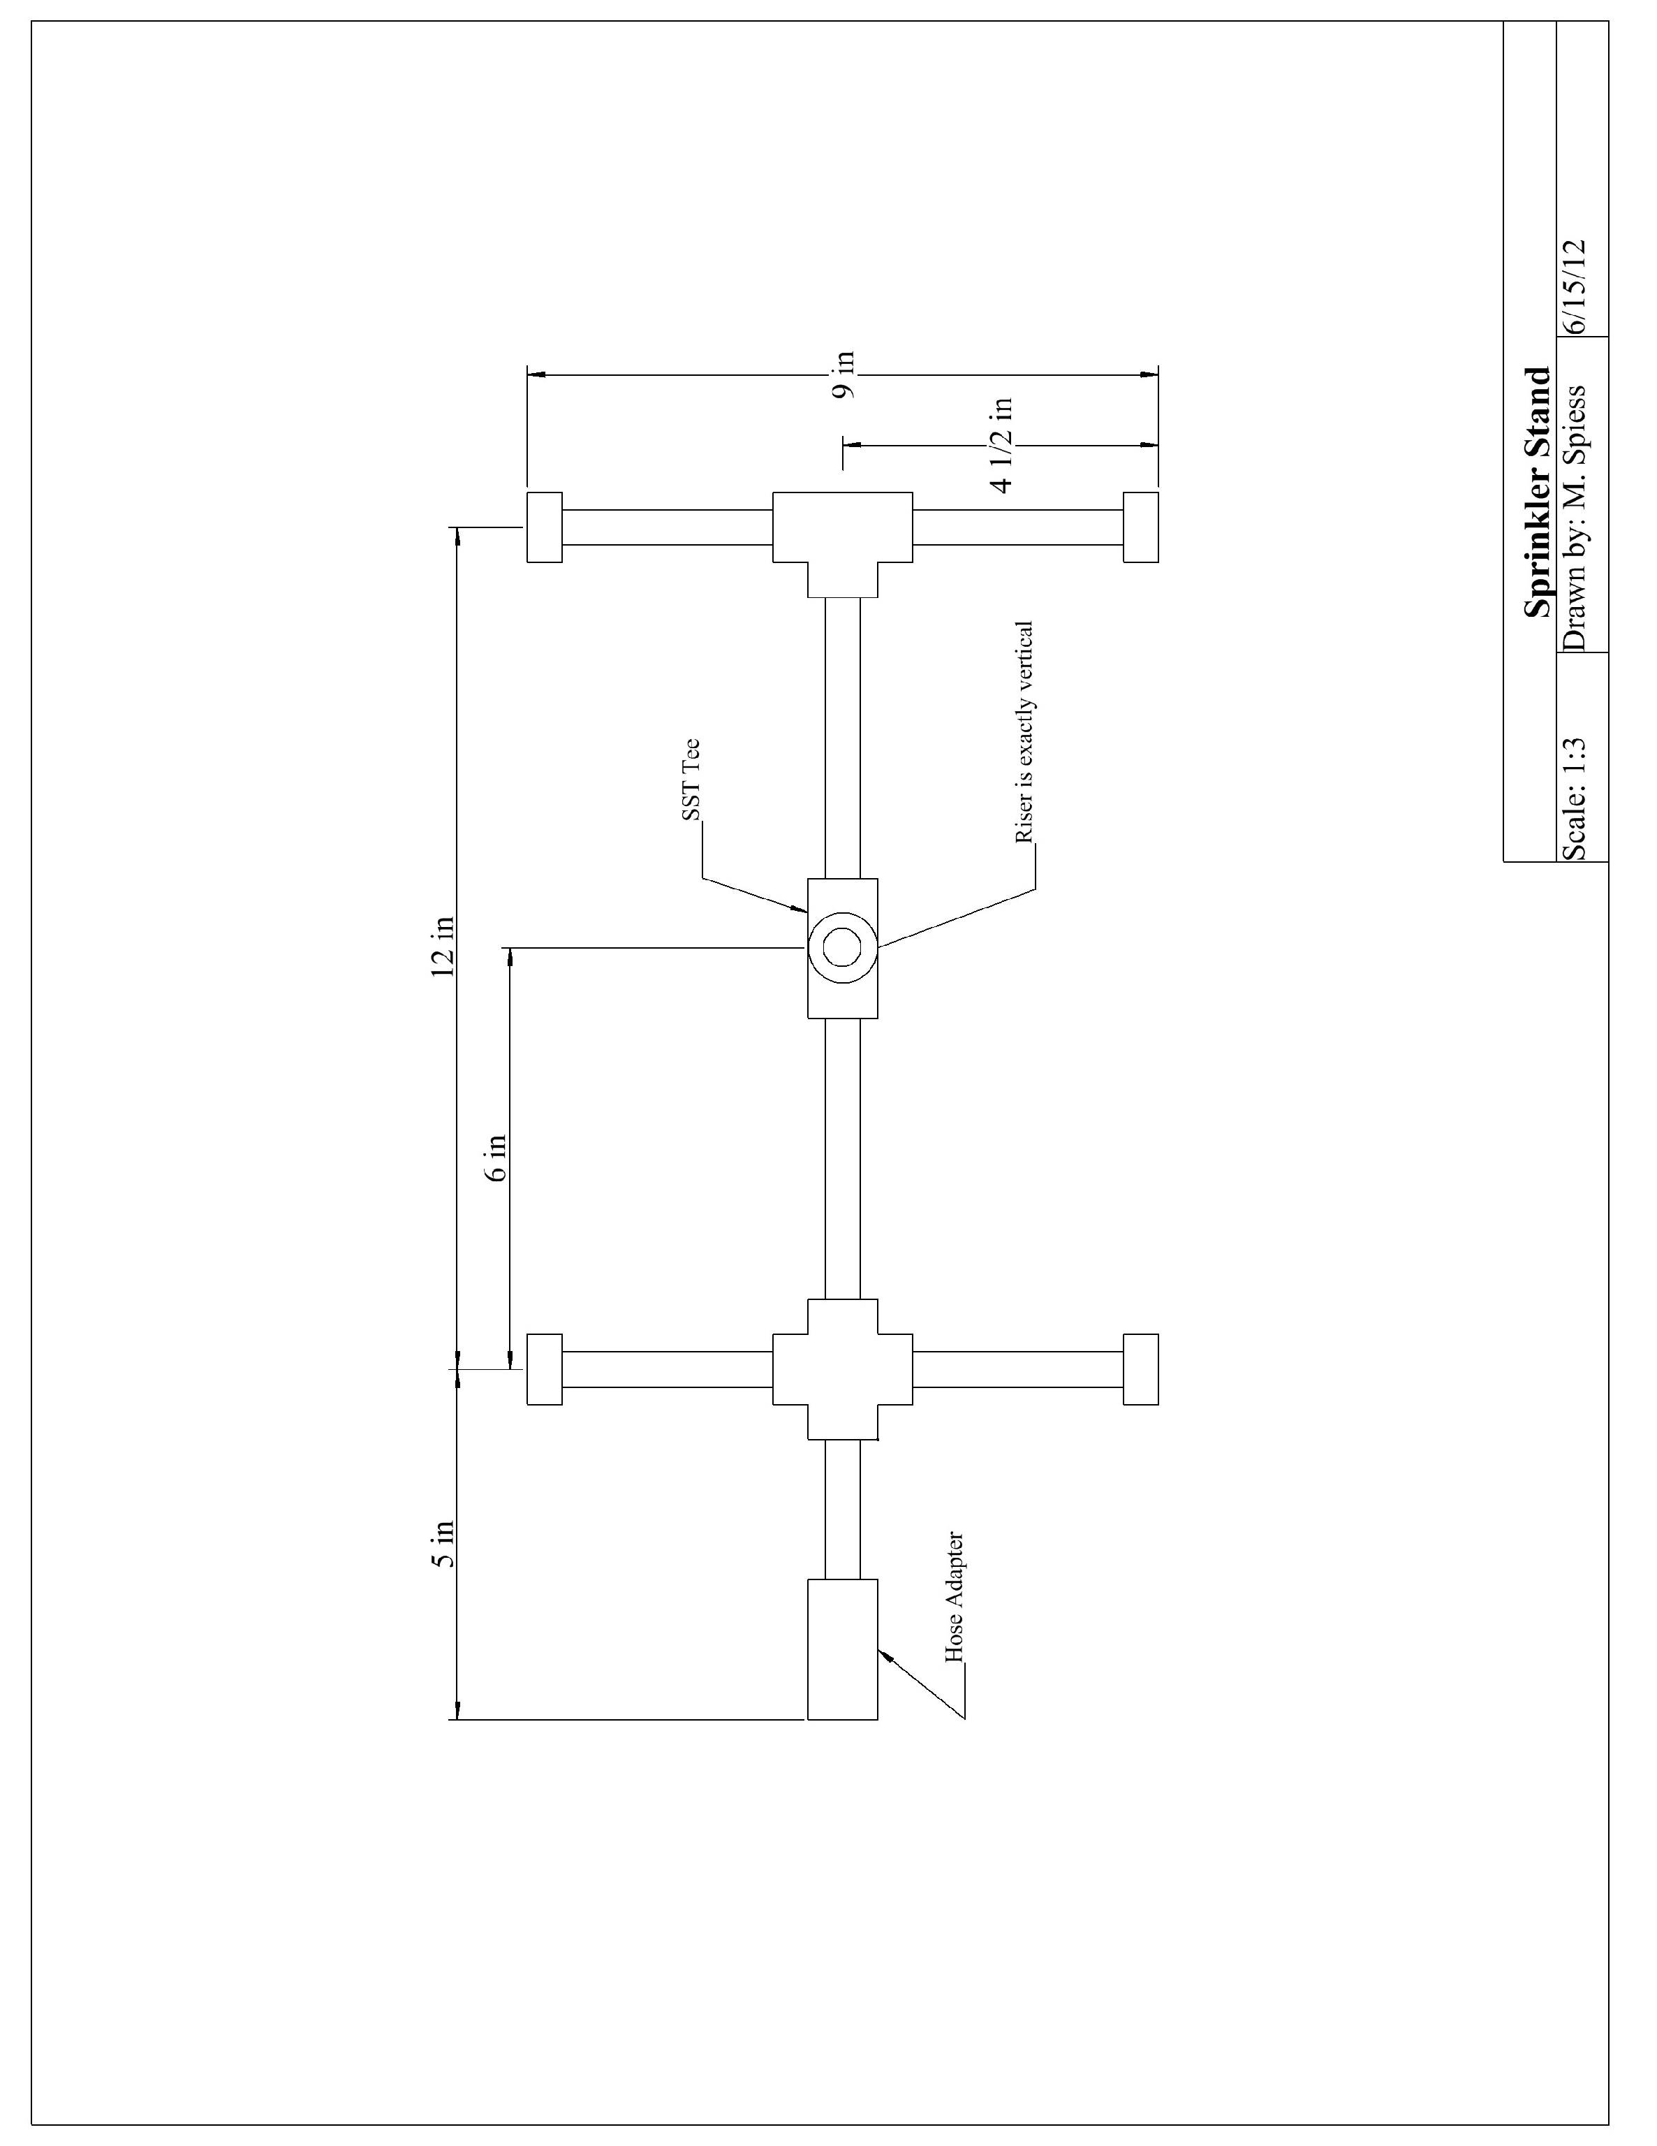
Sprinkler Stand Learning Guide
Name: ________________________
Date: ________________________
- Make a cut list for your pipe:
Quantity | Size | Material
 |  | Sch. 40 PVC
 |  | Sch. 40 PVC
 |  | Sch. 40 PVC
 |  | Sch. 40 PVC
 |  | Sch. 40 PVC
 |  | Sch. 40 PVC
- What does schedule mean when referring to PVC pipe?

- What schedule PVC pipe will we use in this project?

- Differentiate SSS Tee, STS Tee, and SSSS Cross.

- What is the desired radius for the sprinkler nozzle?

- Give an example of how skills utilized in this project can be applied in your daily life.

- Highlight on your diagram the important points of construction (i.e. where will the STS tee go, SSS tee, and cross).

Grading Rubric:
CRITERIA | POSSIBLE | SCORE
There are 6 pieces of ½” x 4” sch. 40 PVC cut within 1/18” (grade prior to assembly) | 5
Tees were used appropriately at the site of SSS vs SST (grade prior to assembly) | 5
Length of entire sprinkler stand does not exceed 20” | 5
There is no smearing of PVC pipe cement on the exterior of the project stand | 5
Project is complete, neat/level, and meets specifications (workmanship) | 5
Pressure Test | 15
Total Possible: | 40

Sprinkler Stand Teachers Notes:

Agricultural Standards Met:
6.0 Health and Safety. Students understand health and safety policies, procedures, regulations, and practices, including the use of equipment and handling of hazardous materials:
6.1 Know policies, procedures, and regulations regarding health and safety in the workplace, including employers’ and employees’ responsibilities.
6.2 Understand critical elements of health and safety practices related to storing, cleaning, and maintaining tools, equipment, and supplies.
6.4 Maintain safe and healthful working conditions.
6.5 Use tools and machines safely and appropriately.
6.6 Know how to both prevent and respond to accidents in the agricultural industry.
B1.0 Students understand personal and group safety:
B1.1 Practice the rules for personal and group safety while working in an agricultural mechanics environment.
B1.2 Know the relationship between accepted shop management procedures and a safe working environment.
B4.0 Students understand plumbing system practices commonly used in agriculture:
B4.1 Know basic plumbing fitting skills with a variety of materials, such as copper, PVC (polyvinyl chloride), steel, polyethylene, and ABS (acrylonitrile butadiene styrene).
B4.2 Understand the environmental influences on plumbing system choices (e.g., filter systems, water disposal).
B4.3 Know how various plumbing and irrigation systems are used in agriculture.

Objectives:
By properly completing this project, students will be able to:
- Read a plan to and layout dimensions.
- Select ideal pipe and fittings to be used in a sprinkler stand
- Differentiate SSS Tee, SST Tee, and SSSS Crosses
- Use problem solving and critical thinking skills to successfully complete

Alternative Tools/Methods/Materials:
- Project could be modified to a different type of stand/shape
- Pipe compound could be used instead of T Tape
- Hack saw could be used to cut PVC

Safety Review:
- Safety glasses
- Clean materials prior to work/assembly
- PVC pipe cement is highly flammable. Vapors of PVC pipe cement may cause flash fire
- Vapors are hazardous. Use in a well ventilated area.
- PVC pipe cement is harmful if swallowed: wash hands immediately after use
- Safety in using the hack saw for cutting the PVC pipe. (Sharp edges)

Project Time:
Demonstration: | 20-30 min.
Build: | 2 hours

Demonstration Notes
- Review the plan.
- Demonstrate how to determine the length of each piece of pipe from the dimensions. Note: Fitting wall vary a bit by manufacturer.
- Emphasize that a square cut is important to the length of the finished stand.
- Develop an order for assembly.
- Describe how to properly glue.
  - Apply to fitting
  - Apply to pipe
  - Insert and twist ¼ turn
  - Hold until set
- Demonstrate how to glue flat.
- Emphasize not to use excess glue and wipe off excess with rag.
- Explain pressure test.
- Pressure Test: Use a PVC threaded cap to block sprinkler riser. Place in a tray of water. Apply 15 psi of pressure via the hose fitting. Look for leaks.

Bill of Materials:

