Sprinkler Project
Name: _______________
Date: ______________

Description:
Use basic plumbing skills and common plumbing materials to create a sprinkler.

Materials:
(1) ½” x ¾” PVC hose adapter
(1) ½” PVC tee SST
(1) ½” PVC tee SSS
(2) ½” PVC cap
(1) 360º Shrub sprinkler head
(2) ½” Copper male adapter (C x M)
½” PVC pipe, Suggest Schedule 40 or Class 315
½” Copper pipe
Teflon tape
PVC primer and glue

Tools:
PVC cutter
Hacksaw
Propane torch
Solder and flux
Adjustable wrench
Copper pipe brushes or emery cloth
File

Procedure:
- Determine length of pipe sections by calculating fitting allowances and overall length of project.
- Write the pipe lengths on your plan
- Cut all pieces of pipe to length.
Copper:
- Clean and flux ends of copper pipe and copper adapters.
- Assemble and check for proper length.
- Solder both adapters to the pipe.
PVC:
- Cut pipe sections (4) to length. Layout pipe sections with the fittings. Do NOT assemble tightly in to PVC fittings as they will get stuck. Double check that you have tees in the correct locations.
- Assemble the two legs using the caps and SSS tee. Use primer (if required) and glue. Be sure to give the fitting a ½ twist as you assemble with the glue and hold for 30 seconds to insure that the pipe does not slide out of the fitting.
- Assemble the COOL copper pipe into the SST tee using Teflon tape to seal the fitting.
- Assemble the SST with the legs. Use the copper pipe as a guide to insure that the tee is in the vertical position. A square is helpful!
- Glue the remaining pipe and hose adapter to complete the PVC pipe assembly.
Pressure Testing and Final Assembly:
- Using Teflon tape temporarily seal the riser with a ½” PVC threaded cap (hand tight).
- Have the project pressure tested.
- Remove the cap and install the shrub sprinkler head. Label the project with your name and turn in for final grading.

Photo/Drawing:
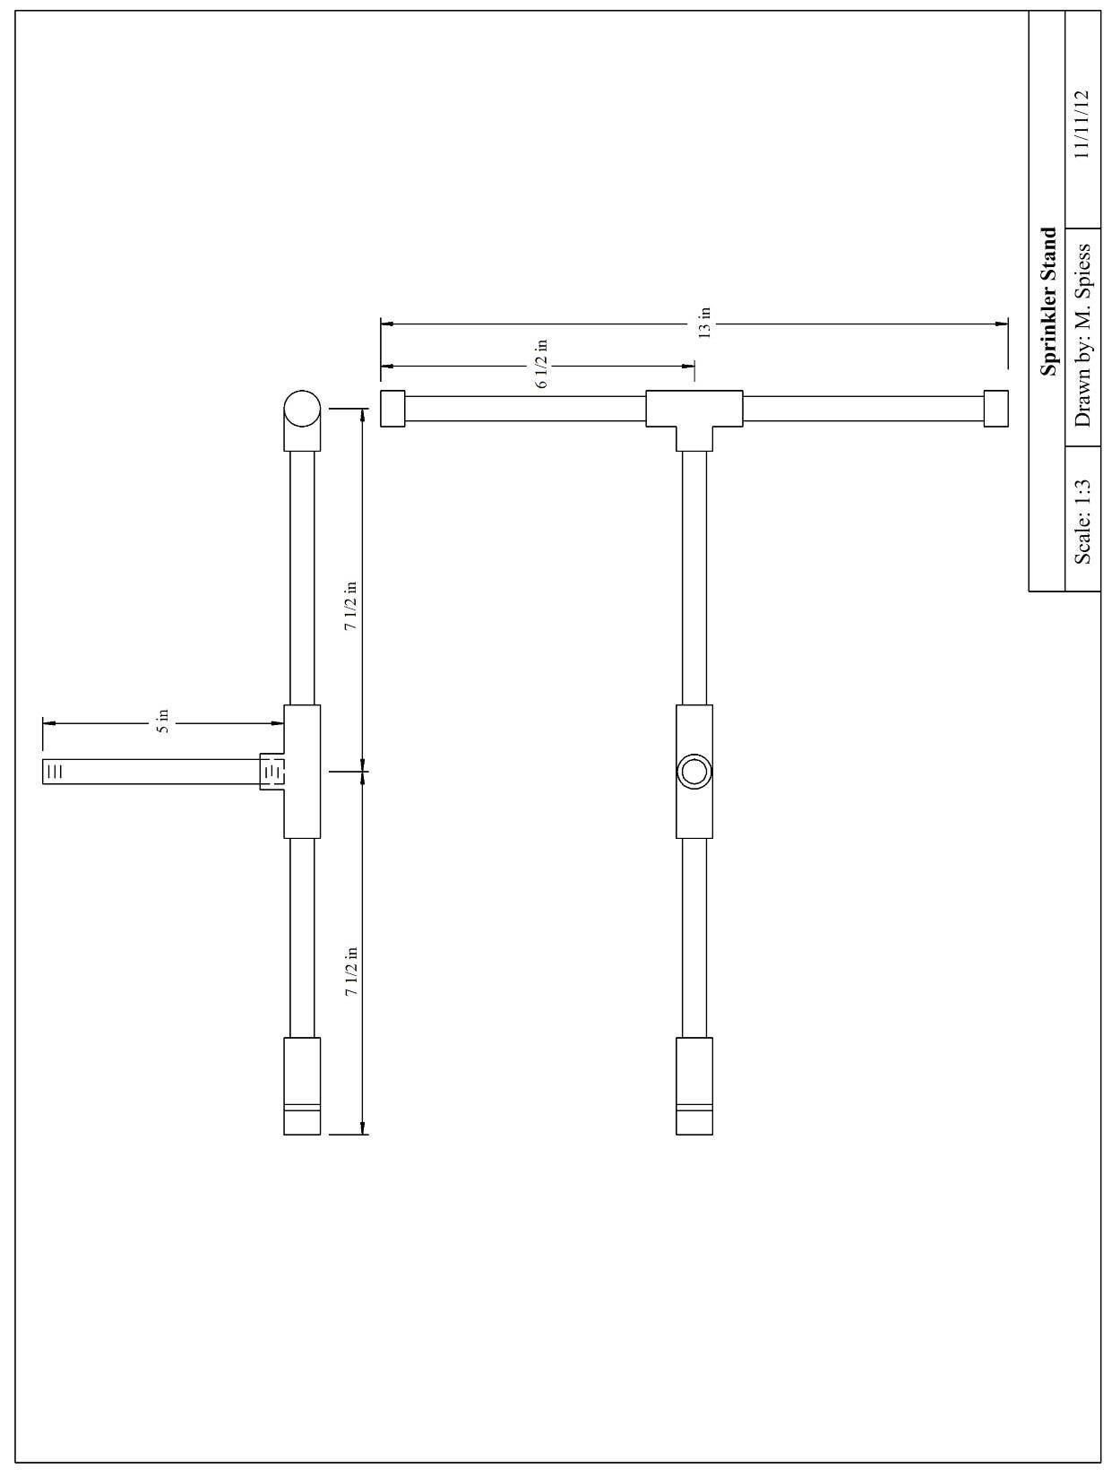
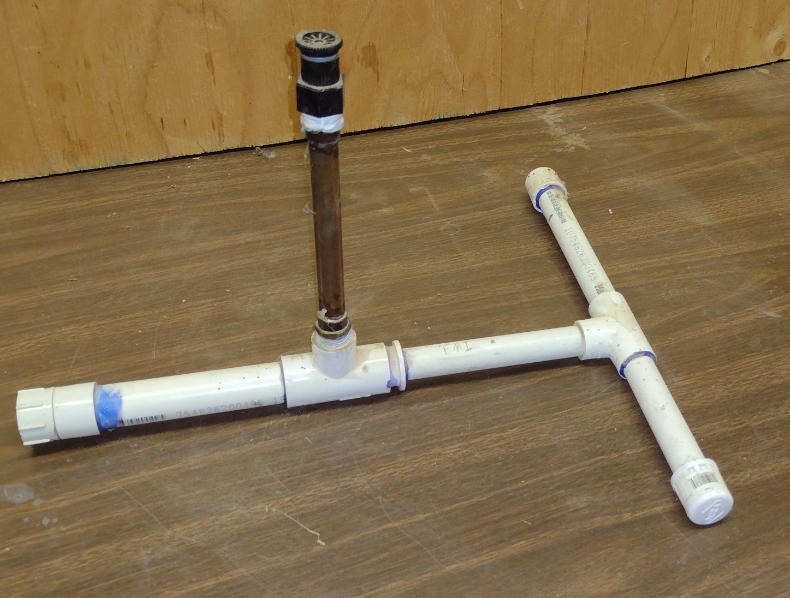

Sprinkler Project Worksheet
Name: _________________
Date: _________________

- How do you calculate the length of the pieces of pipe?

- What are the actual lengths of the PVC pipe pieces?
________________ ___________________ __________________ __________________
- What is the length of the copper pipe?
______________
- Name the two ways to cut PVC pipe.

- What are the steps in soldering copper pipe?

- Why is important to wrap pipe threads in Teflon tape?

Grading Rubric:
CRITERIA | POSSIBLE | SCORE
Length (overall and position of tee) | 5
Width | 5
Assembly (project is flat and angle of riser is 90°) | 5
Workmanship (no excess primer, cement, or solder) | 5
Fitting Test (no leaks) | 10
TOTAL | 30

Sprinkler Project Teacher’s Notes:
Pressure testing of the project can be done with an air supply and a bucket. Make a tester with a pressure regulator, a ball valve, and a ¾” male hose adapter. The tester is attached to the project at the hose fitting and the project is dunked in the bucket. Bubbles are bad….. A water hose can also be small leaks are harder to see.

Agricultural Standards Met:
6.0 Health and Safety. Students understand health and safety policies, procedures, regulations, and practices, including the use of equipment and handling of hazardous materials:
6.1 Know policies, procedures, and regulations regarding health and safety in the workplace, including employers’ and employees’ responsibilities.
6.2 Understand critical elements of health and safety practices related to storing, cleaning, and maintaining tools, equipment, and supplies.
6.4 Maintain safe and healthful working conditions.
6.5 Use tools and machines safely and appropriately.
6.6 Know how to both prevent and respond to accidents in the agricultural industry.
B1.0 Students understand personal and group safety:
B1.1 Practice the rules for personal and group safety while working in an agricultural mechanics environment.
B1.2 Know the relationship between accepted shop management procedures and a safe working environment.
B4.0 Students understand plumbing system practices commonly used in agriculture:
B4.1 Know basic plumbing fitting skills with a variety of materials, such as copper, PVC (polyvinyl chloride), steel, polyethylene, and ABS (acrylonitrile butadiene styrene).
B4.2 Understand the environmental influences on plumbing system choices (e.g., filter systems, water disposal).
B4.3 Know how various plumbing and irrigation systems are used in agriculture.
B4.4 Complete a plumbing project, including interpreting a plan, developing a bill of materials and cutting list, selecting materials, joining, and testing.

Objectives:
By properly completing this project, students will be able to:
- Read a plan and determine layout dimensions.
- Demonstrate proper PVC and Copper plumbing techniques.

Alternative Tools/Methods/Materials:
- Riser: substitute 5" PVC nipple.
- Riser: Make a galvanized nipple.

Safety Review:
- Basic shop safety
- PVC primer/glue fumes
- Torch use

Project Time:
Demonstration: | 30 minutes
Build: | 2 hours

Demonstration Notes
- To find overall length of a section, measure length of the fitting and use standard pipe allowance (~ ½“) to determine how long to cut each piece of pipe. Pieces will be shorter than overall length of the section.
- Primer is not normally used on pipe under 1” in diameter. However you can apply on the project to demonstrate its use.
- Do not dry fit PVC fittings. Fittings are tapered and will bind. If you want to demonstrate a “dry fit” you can cut a slot in the ends of the pipe, but this is not acceptable for an actual project as it will weaken the joint.
- When cementing PVC pieces, give the parts a half turn when joining, then hold in place for several seconds until it sets. This will insure the cement lines the entire fitting and that pipe does not back out of fitting.
- Remember the 3 Cs of good soldering: clean, clean, clean.
- Use the torch on the opposite side of where solder will be applied – the heat will draw the solder into the joint. You need very little solder (1/4”)

Bill of Materials:
Project from: Kingsburg HS Ag Mechanics I Plumbing unit; adapted by Ashley Lincoln

