Swedish Bookends
Name: _______________
Date: _______________

Description:
For this project you will work with pine lumber and use both screws and nail as fasteners. You will practice using power tools and learn about dado joints.

Materials:
1” X 4” pine 16” long
#6 FH Wood Screw
4d Finish Nails
Wood Glue
120 Grit sandpaper

Tools:
Tape
Combination Square
Power miter saw
Table saw (with Dado Blade)
Drill/Driver & Bits
Countersink
Claw hammer
Nail set

Procedure:
- Acquire piece of lumber that is 1”4” X 16” long
- Measure 4” from one end and cut with a miter saw. This is the base.
- CAUTION: Pieces are short so cut carefully.
- Measure 4 ¾” and cut one leg at 45º.
- On the remaining piece measure 6” from the tip of the 45º and make a square cut.
- Use table Saw to cut a dado in the end of the 4” board.
- Mark the base (4”) piece at 1 ¾” on the opposite side of the first dado.
- Cut the 2nd dado.
- Mark nail and screw locations on the base. Drill countersink holes (middle of base).
- Use wood glue to connect pieces then screws on one side and nails on the other to fasten it
- Sand the project to remove rough edges.
- Wipe excess glue
- Optionally project can be painted or stained.

Cutting List:
Qty | Size | Description
1 | 3 ½”” X ¾” X 4” | Pine base
1 | 3 ½”” X ¾” X 6” | Pine leg (long side)
1 | 3 ½”” X ¾” X 4 3/4” | Pine leg (long side)

Photo/Drawing:
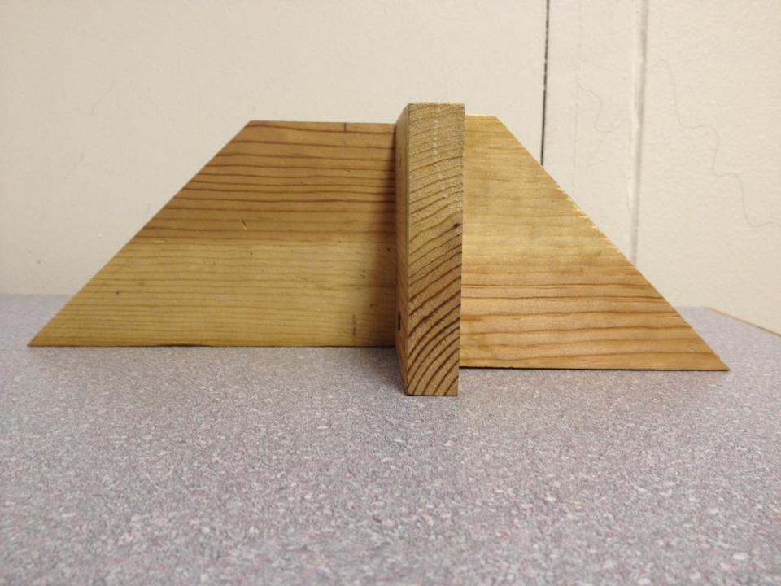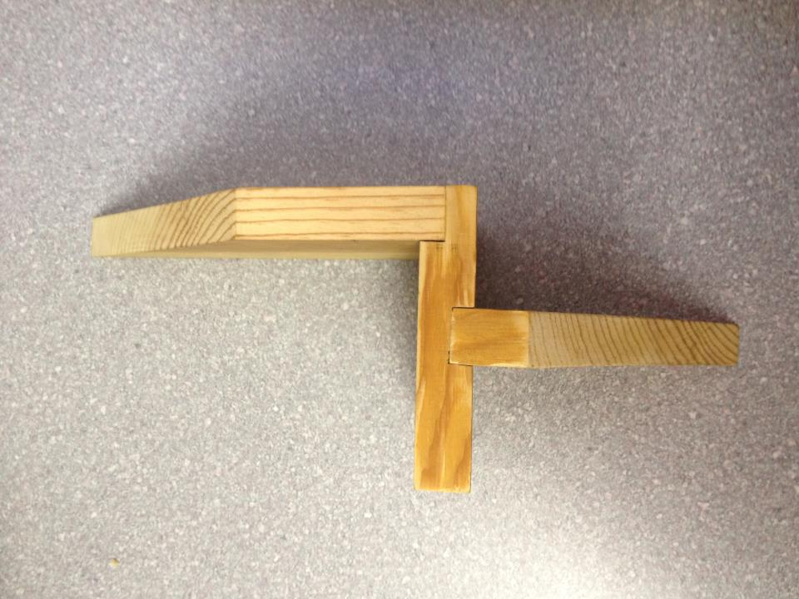

Note: Plan shows the righthand bookend. If you make a pair, be sure to create a “mirror” image for the lefthand bookend. All parts are the same.

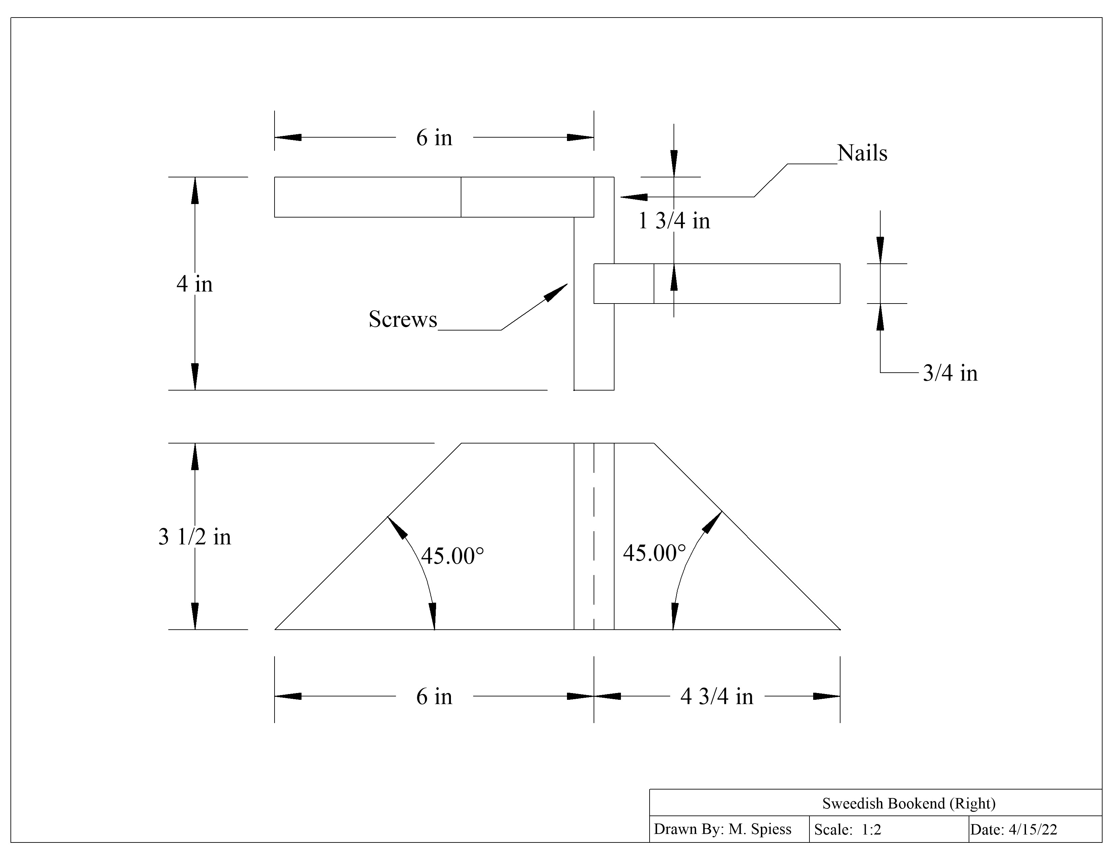

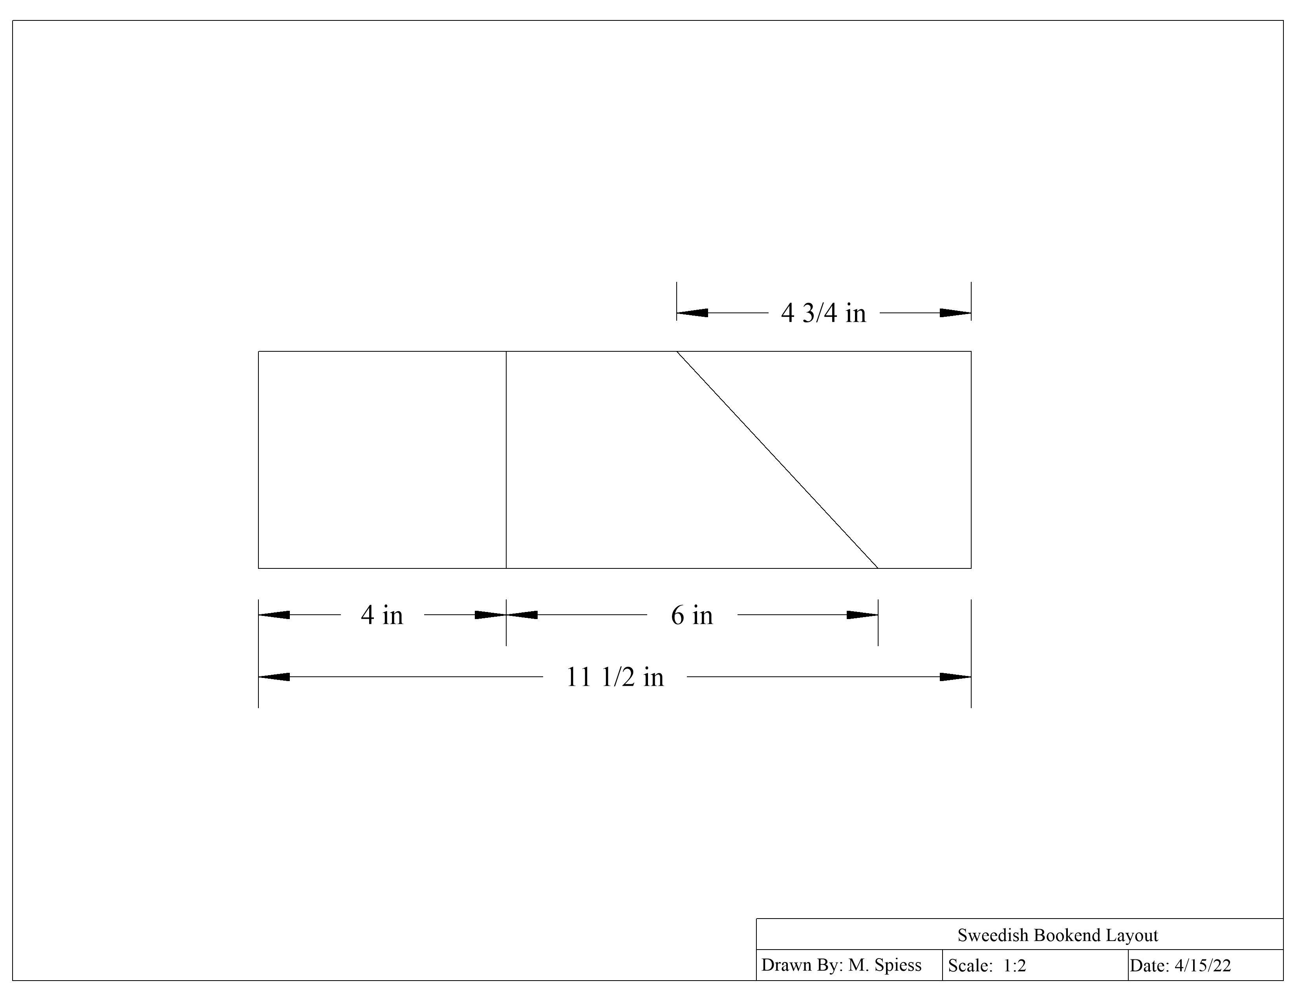

Swedish Bookends Worksheet
Name: ________________________
Date: ________________________

Please answer the following questions in complete sentences.
- What is the very first thing you should do when you are given the Swedish bookends assignment?
_________________________________________________________________________________
_________________________________________________________________________________
- What special cautions should you use when cutting dado cuts on the table saw?
_________________________________________________________________________________
_________________________________________________________________________________
_________________________________________________________________________________
_________________________________________________________________________________
- Why do we counter sink the screws?
_________________________________________________________________________________
_________________________________________________________________________________
- Describe how to adjust the miter saw to 45^{o.}
_________________________________________________________________________________
_________________________________________________________________________________
- Always allow motor to reach full speed before starting to cut on a miter saw. (T/F)

Grading Rubric:
CRITERIA | POSSIBLE | SCORE
Angles | 10
Length | 5
Project Square | 10
Workmanship (Finish, Nails, Screws) | 5
Total | 30

Swedish Bookends Teachers Notes:
- The dimensions of the project are easily altered. For example 1x6 lumber can be used with the same plan.
- This project introduces advanced joinery.
- The project can be built just using butt joints.
- If you have two miter saws considering setting one to 45º.
- Students may wish to build a pair to take home.

Agricultural Standards Met:
6.0 Health and Safety. Students understand health and safety policies, procedures, regulations, and practices, including the use of equipment and handling of hazardous materials:
6.1 Know policies, procedures, and regulations regarding health and safety in the workplace, including employers’ and employees’ responsibilities.
6.2 Understand critical elements of health and safety practices related to storing, cleaning, and maintaining tools, equipment, and supplies.
6.4 Maintain safe and healthful working conditions.
6.5 Use tools and machines safely and appropriately.
6.6 Know how to both prevent and respond to accidents in the agricultural industry.
B1.0 Students understand personal and group safety:
B1.1 Practice the rules for personal and group safety while working in an agricultural mechanics environment.
B1.2 Know the relationship between accepted shop management procedures and a safe working environment.

B2.0 Students understand the principles of basic woodworking:
B2.1 Know how to identify common wood products, lumber types, and sizes.
B2.2 Know how to calculate board feet, lumber volume, and square feet.
B2.3 Know how to identify, select, and implement basic fastening systems.
B2.4 Complete a woodworking project, including interpreting a plan, developing a
bill of materials and cutting list, selecting materials, shaping, joining, and finishing.

Objectives:
By properly completing this project, students will be able to:
- Read the plan and layout the project.
- Safely use a table saw and dado blade.
- Install screws and nails.

Alternative Tools/Methods/Materials:
- Hand Tools: Hand saw instead of miter saw. (Use a hand miter gauge and back saw). Omit dado or cut with the backsaw and a wood chisel.
- Regular table saw blade. Cut the edges and clean slot with a ½” wood chisel.

Safety Review:
- Table Saw (especially with the unguarded dado blade.
- Power Miter Saw
- Driver

Project Time:
Demonstration: | 30 minutes
Build: | 1.5 hours

Demonstration Notes
- Explain the left/right hand of the project. Assembly is key.
- Explain lumber selection. You will need to cut around defects.
- Review hand placement on Power Miter Saw with short pieces.
- Demonstrate how to adjust the miter saw to 45º.
- Demonstrate dado cut using the miter gauge.
- Emphasize the dado cuts are on opposite sides.
- Show how to mark screw and nail locations so they are aligned. Screws on the inside.
- Demonstrate nailing and setting the nails.

Bill of Materials:
Project from Kingsburg

