Tool Sharpening Template
Name ______________________

Description:
The tool sharpening template demonstrates skill in project layout. In addition, the template is a useful tool for maintaining shop tools.

Materials:
26 ga. Galvanized sheet metal, approximately 4" x 7"

Tools:
Combination Square
Scribe
Snips (Straight, Duckbill)
Metal punch
Sheet metal gauge.

Directions:
- Review the drawing and the grading criteria.
- Use the sheet metal gauge to verify the thickness of the material,
- Use the square to create a square corner on the upper right corner (4" side on top) of the sheet metal. Trim to square if necessary.
- Make all measurements from the right or top edges.
- Layout the project using the diagram. Measure carefully.
- Cut out the project using snips.
- Flatten, if needed
- Use the scribe to mark the scale as shown on the template.
- Optional: Punch a hole in the bottom of the handle centered about 1/2" from the bottom.
- Using the scribe, write your name on the project and hand in with this CLEAN sheet.

Notes:

Photo/Drawing:
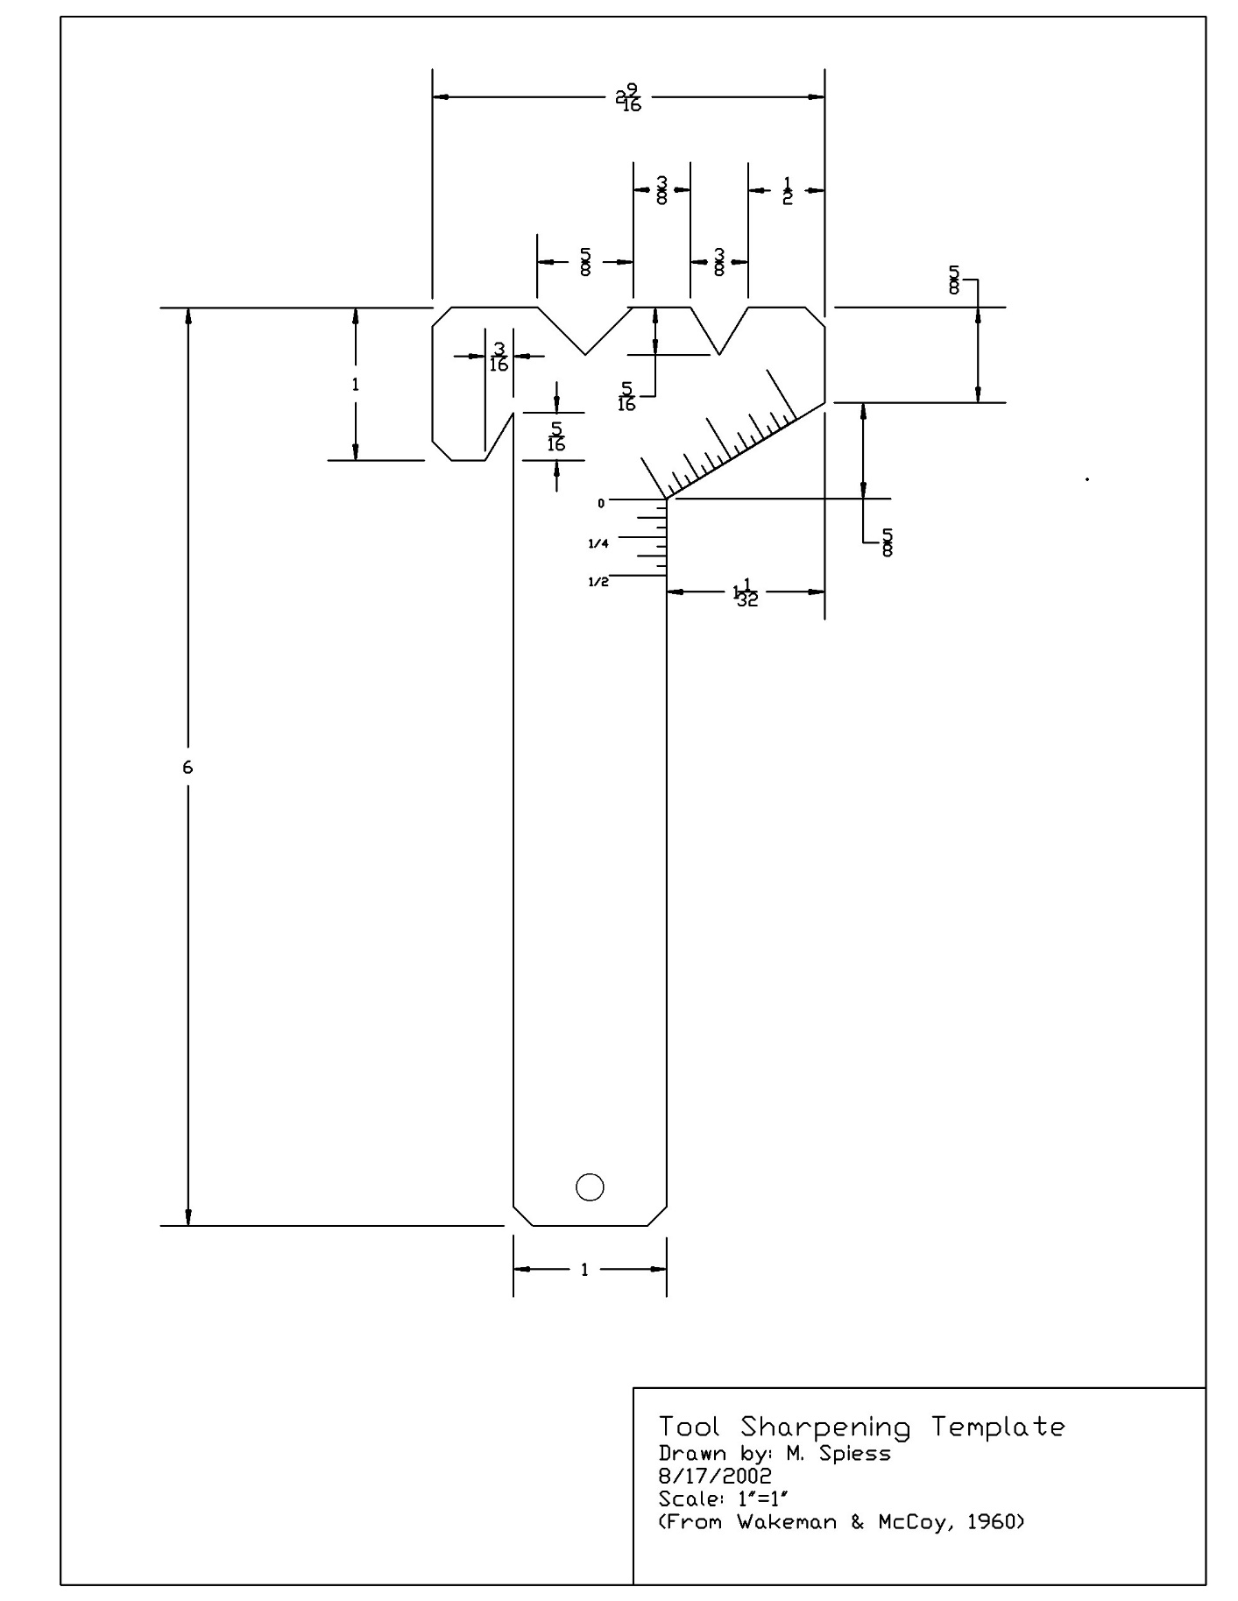

Worksheet
Name: ________________________
Date: ________________________

- What is the thickness of the material you are using?
__________________________________________________________________________
- What scales are found on the combination square?
______________________________________________________________________________
- What type of snips did you use to cut out your project?
____________________________________________________________________________
- What safety hazards are there when working with sheet metal?
_________________________________________________________________________________
- What is the purpose of the galvanized coating on the sheet metal?
__________________________________________________________________________________

Grading Rubric:
Criteria (Tolerance 1/32") | Possible | Score
Length 6" | 3
Width 2 9/16" | 3
Handle Width 1" | 3
Center punch "V" | 3
Cold Chisel "V" | 3
Plane Iron "V" | 3
Drill bit angle 59º | 3
Cutting (minimum over cut, cuts on line) | 4
Marking Scale | 2
General appearance and workmanship  (flat, no sharp edges, no excess markings) | 3
TOTAL | 30

Teachers Notes:

Agricultural Standards Met:
B1.0 Implement personal and group safety practices.
B1.1 Practice the rules for personal and group safety while working in an agricultural mechanics environment.
B1.2 Integrate accepted shop management procedures and a safe working environment.
B5.0 Understand agricultural cold metal processes.
B5.1 Identify common metals, sizes, and shapes.
B5.2 Demonstrate basic tool-fitting skills.
B5.3 Properly lay out materials for a given project.
B5.4 Demonstrate basic cold metal processes (e.g., shearing, cutting, drilling, threading, bending).

Objectives:
By properly completing this project, students will be able to:
- Identify galvanized sheet metal
- Layout a project using a plan and combination square
- Use snips safely and accurately to cut sheet metal

Alternative Tools/Methods/Materials:
None.

Safety Review:
- Safety Glasses
- Metal is sharp!

Project Time:
Demonstration: | 15-25 minutes
Build: | 1-2 hours

Demonstration Notes:
- Prep for the lab by preparing scrapes of metal about 4 x 7 with a shear. You need a square corner.
- This project is primarily a demonstration in layout. Demonstrate how the combination square is used to “construct” the points. Placing a block of wood under the metal makes using the square easier.
- Review the parts and scales of the combination square.
- Use a scribe not a sharpie. The lines are more accurate.
- Always work from the square corner (upper right)).
- Suggestion: Use a piece of white board about 2’x4’ and a framing square to demo. Mark the square so each inch is a 1/16”. Use a dry erase marker as the scribe. This larger scale is easier to see for the class.
- NOTE: It is not recommended using a drill to make a hole in the handle. Templates will catch on the drill and spin (safety hazard). If you want to do this then make sure the template is securely clamped to a block of wood on the drill press table. A jig is recommended.
- Grading hint: Make a perfect template. Use this to grade by laying over the student project. Much faster than measuring.

Bill of Materials:
Use scraps of sheet metal from other projects. Note cost is minimal so have students do the project over if it looks bad!
Project and plan by Mike Spiess.

Use of the Combination Square for Project Layout
Name: ________________________
Date: ________________________
In 1877, Laroy S. Starrett designed and patented the combination square. His invention was a multipurpose layout and measuring tool for machinists and it was rapidly adopted in the trade. This tool is still in common use today and used in the layout of wood and metal projects.
The basic combination square includes a hardened steel graduated rule and movable combination square and miter head with a spirit level and scribe. The square heads have a precision ground 90° square face and a 45° miter face. It is a versatile and useful layout tool for scribing right angles and parallel lines, and a measuring tool that can be used as a try square, miter, depth gage, height gage, and a level. Common rules have 1/8”, 1/16”, and 1/32” scales. Also available are metric scales.
The process of layout is essentially a matter of copying the plan to the material. The square can be used to easily and accurately determine “construction” points on your material. For best results you must start with material that is cut square so you can measure from the square edges.
1.

Square parts:
- The “rule” or blade. This can be removed and used separately.
3.
- The head, fence, or level. This part slides on the rule.
- The clamp is the nut, spring, and bolt that slides in to the grove of the rule.
4.
2.
- The scribe is found in the head and used to mark metal.

Testing the Square:
To insure the square is actually square do the following:
- Set the square with 10” of the rule extending past the head and tighten the clamp.
- Using scrap of sheet metal with a straight edge (a 12” x 12” piece is fine) Scribe a line perpendicular to the straight edge of the metal.
- Now rotate the head on the metal 180 degrees and check that the square is aligned with the scribed line. If not the square is not “square” (or the sheet metal is not square).

Basic Setup of the Square:
- Set the rule so the scale you wish to use is on the inside of the square.
- Slide the rule so an even inch mark is aligned with the head (level).
- Clamp the rule tight.

Marking:
Marks made during layout should be clean and as accurate as possible. Some tips:
- Use a scribe to mark metal. A marker makes a broad line and will be less accurate.
- Don’t make multiple marks. A single clear mark is desired.
- Mark wood with a sharp pencil or a utility knife.

The “Working Edge”:
A working edge is usually the bottom edge of the layout project in relation to the material as it is laid in front of you. It should be a suitable edge from which the majority of your measurements can be made. It is also helpful if this edge is square with the left or right edge.

Locating a Center Point:
Refer to the drawing above. The steps below describe how to mark the center of the left hand hole.
- Select one edge as a “working edge”.
- After setting the square (as described above) place the head against the straight (lower) edge of the material in the approximate location of the hole.
- Measure up the rule the desired distance and make a mark (horizontally). In this case 2 ¾”.
- Now place the head against the other edge of the material (left edge, 90º to the first edge) and align the rule with your mark. It’s important that these two edges be perpendicular.
- Now measure over on the rule to the second dimension (1”) of the point and mark the center.
Hint: It is faster to count the marks on the rule than to calculate a distance. For example if the 10” mark on the rule is aligned with the head and you want to measure in 4 ¼” you could calculate the measurement at 5 ¾” or simply count in 4 inch marks plus ¼”.

Locating Construction Points:
Commonly you will want to locate points (end) of a cut that is not square. This process is simply a matter of locating two points then connecting them using the rule. The directions below refer to layout of the “V” shape in the above drawing.
- After setting the square (as described above) place the head against the straight (lower) edge of the material in the approximate location of Point 1. (the center of the “V”)
- Measure up the rule the desired distance and make a horizontal mark (in this case 2 ¾” from the lower edge).
- Now place the head against the other edge of the material (right, 90º to the first edge) and align the rule with your vertical mark.
- Now measure over on the rule the second dimension of Point 1 and mark the location (4”).
- Repeat the process for Point 2 (upper point of the “V”) and Point 3 (lower point of the “V”). Note: Since Points 2 and 3 are on the edge of the project there is no need to measure in from the edge.
- Now using just the rule draw or scribe a line that connects Points 1 and 2, then connect Points 1 and 3.

Activity:
- Set your square with the 10” mark aligned with the head and the 1/8” scale on the inside of the square (rule extends to your left).
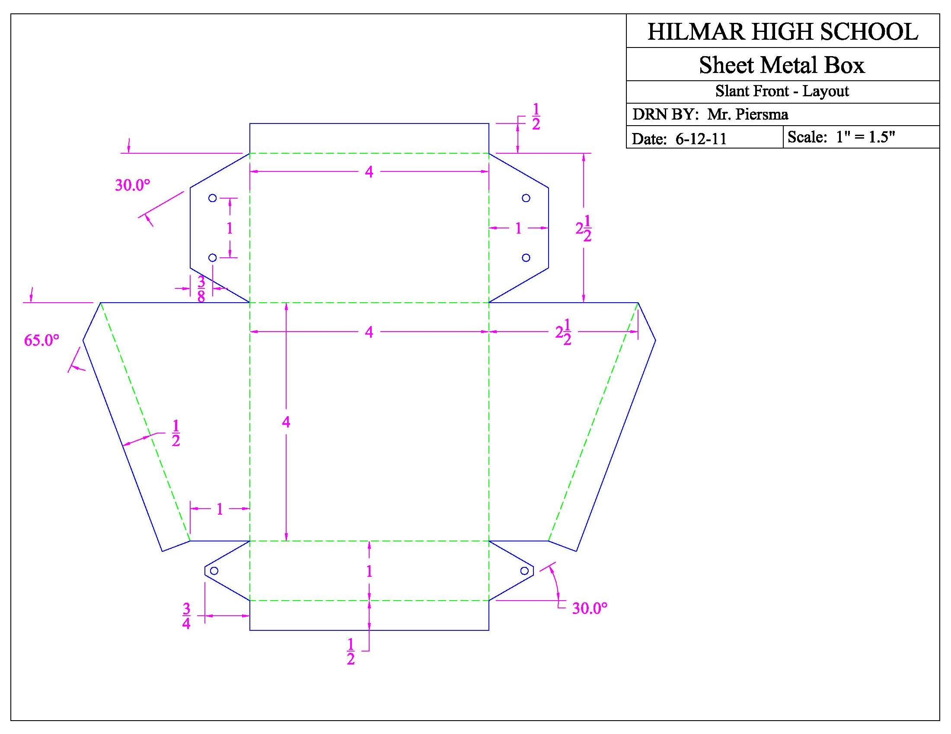
- Using a file folder and sharp pencil layout the project shown above using the procedure described.

