Welding Electrode Holder
Name: ________________________
Date: ________________________

Description:
A simple but useful holder for partially used electrode. Student will practice, layout, cutting, and welded assembly skills.

Materials:
¼” x 1” Flat Mild Steel
¼” x 1 ½” Flat Mild Steel
Electrode (see welding directions)

Tools:
Hydraulic Shear
Chipping Hammer
Wire Brush
Bench grinder
Square
Steel Tape
Soapstone
4” angle grinder.
Locking Pliers

Procedure:
- Review the plan.
- Write the welding instructions on the on the drawing.
- Cut a one piece of 1 ½” bar to 2 ½” using the shear.
- Cut a 4 pieces of 1 ” bar to 3” using the shear.
- Clean up the sheared edges with the bench grinder.
- Assemble the pieces and tack.
- Check for square. Do not proceed unless the project is square and assembled correctly.
- Weld as indicated OR as instructed.
- Clean welds with a wire brush.
- Use a bench grinder or small angle grinder to remove any sharp edges.
- Optionally, paint. (Hammered Black looks good)

Cutting List
Quantity | Size | Material
1 | ¼” x 1 ½” x 2 ½” | mild steel flat bar
4 | ¼” x 1 ” x 3” | mild steel flat bar

Notes:
____________________________________________________________________________________________________________________________________________________________________________________________________________________________________________________________________________________________________________________________________________________

Drawing:
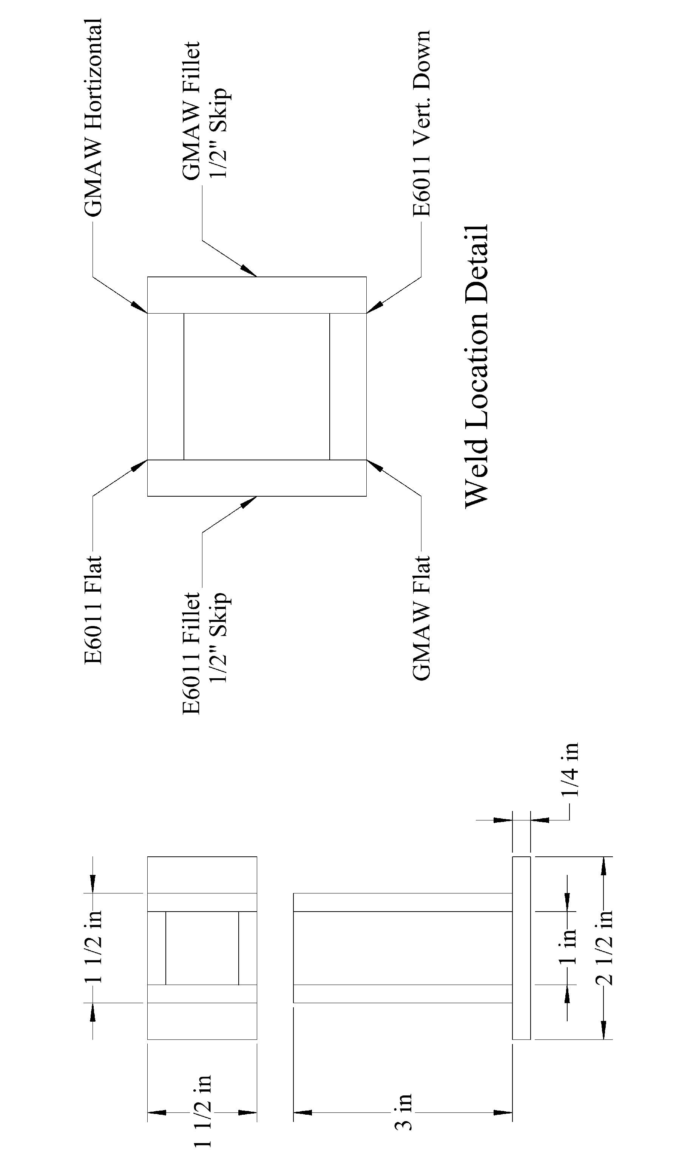

Welding Electrode Holder Worksheet
Name: ________________________
Date: ________________________

Complete this worksheet before starting the project.
- What welding processes will you use to complete this project? ________________________
- What tool(s) will you use to cut the metal? ________________________________________
- Why is it important to use locking pliers when grinding small pieces of metal?
_____________________________________________________________________________
_____________________________________________________________________________
- Why is it important to tack the project before welding?
_____________________________________________________________________________
_____________________________________________________________________________
- What technique did you use to minimize distortion of the project?
_____________________________________________________________________________
_____________________________________________________________________________
_____________________________________________________________________________

Grading Rubric:
CRITERIA | POSSIBLE | SCORE
Proper Assembly (As shown in drawing) | 5
Fillet Welds | 5
Edge Welds | 10
Neatness of Assembly (square, fit of parts) | 5
Neatness of Cuts/Dimensions | 5
Questions from worksheet | 5
Total Score | 35

Welding Rod Holder Teachers Notes:

Agricultural Standards Met:
6.0 Health and Safety. Students understand health and safety policies, procedures, regulations, and practices, including the use of equipment and handling of hazardous materials:
6.1 Know policies, procedures, and regulations regarding health and safety in the workplace, including employers’ and employees’ responsibilities.
6.2 Understand critical elements of health and safety practices related to storing, cleaning, and maintaining tools, equipment, and supplies.
6.4 Maintain safe and healthful working conditions.
6.5 Use tools and machines safely and appropriately.
6.6 Know how to both prevent and respond to accidents in the agricultural industry.

7.0 Responsibility and Flexibility: Students know the behaviors associated with the demonstration of responsibility and flexibility in personal, workplace, and community settings:
7.1 Understand the qualities and behaviors that constitute a positive and professional work demeanor.
7.2 Understand the importance of accountability and responsibility in fulfilling personal, community, and workplace roles.
7.3 Understand the need to adapt to varied roles and responsibilities.
7.4 Understand that individual actions can affect the larger community.
7.5 Understand the importance of time management to fulfill responsibilities.
7.6 Know how to apply high-quality craftsmanship to a product or presentation and continually refine and perfect it.
B1.0 Students understand personal and group safety:
B1.1 Practice the rules for personal and group safety while working in an agricultural mechanics environment.
B1.2 Know the relationship between accepted shop management procedures and a safe working environment.
B5.0 Students understand agricultural cold metal processes:
B5.2 Know basic tool-fitting skills.
B5.3 Know layout skills.
B5.4 Know basic cold metal processes (e.g., shearing, cutting, drilling, threading, bending.).
B8.0 Students understand electric arc welding process.
B8.1 Know how to select, properly adjust, safely employ, and maintain appropriate welding equipment (e.g., gas metal arc welding, shielded metal arc welding, gas tungsten arc welding).
B8.2 Apply gas metal arc welding, shielded metal arc welding, or flux core arc welding processes to fusion-weld mild steel with appropriate welding electrodes and related equipment.
B8.3 Weld a variety of joints in various positions.
B8.4 Know how to read welding symbols and plans, select electrodes, fit-up joints, and control heat and distortion.

Objectives:
By properly completing this project, students will be able to:
- Read a plan to and layout dimensions.
- Cut mild steel with the hydraulic shear.
- Properly set an arc welding machine.
- Choose the correct electrode for the job.
- Properly assemble the project.

Alternative Tools/Methods/Materials:
Lots of variations are possible.
- Consider using different electrode and processes.
- Project makes a good unit test for a specific process.
- Introduce welding symbols
- Part of the project can be cut with a chop saw to induce the tool and alleviate a bottleneck at the shear.
Safety Review:
- Hydraulic Shear
- Arc Welder (PPE)
- Hot metal
- Bench grinder (Especially when working with small pieces)
- Angle Grinder

Project Time:
Demonstration: | 30 minutes
Build: | 2 hours

Demonstration Notes
- Review plan.
- Provide welding directions.
- Demonstrate use of the shear. Note: Setting a stop at 3” can speed up cutting and demonstrate the use of the stop.
- Demonstrate use of locking pliers when bench grinding small pieces.
- Demonstrate the tack up and checking before welding.
- Demonstrate the welding. IMPORTANT: To avoid distortion weld on opposite sides and allow to cool between welds.
- Show how to clean up the project and your expectations for clean welds. If using an angle grinder then clamp project in a vise.

Bill of Materials:

