Floating Wine Bottle Stand
Name: _______________
Date: _______________

Description:
The project is a simple wine bottle stand made out of a single piece of wood. The project involves detail and accuracy. Skills highlighted in this project are measuring and marking, cutting, drilling, sanding, and painting/staining. This project can be very dynamic using a variety of tools to achieve the same result. It can even be taken on step further and use a variety of alternating wood types to make the same product.

Materials:
-pine or hardwood “1 by”
-oil finish, stain, or paint
-painters tape
-sandpaper (fine and medium)

Tools:
Table Saw
Tape Measure
Compound Miter Saw
Rafter Square
Drill Press
1 ½” Forstner Bit
Pencil
Paintbrush

Directions:
Before you Start! Put on your safety glasses. Read all directions and study the plans

Gather it
- Gather the necessary materials. Each student will need a piece of #2 pine.

Measure and Cut It
- If the board is not already ripped use the table saw to rip to 3 ½” wide.
- Measure and crosscut your board using the compound miter saw to 15” in length.
- Mark 14” on the board (long side) and trim the end of the board to 27º using the miter saw.

Mark And Drill
- Opposite the angled edge, draw a line across the width of the board that is 3 1/4” away from the end.
- Measure to the middle of the board (1 ¾”) and draw a vertical line creating a cross hair.
- Using the drill press, drill a 1 1/2” hole in the wood centered on the crosshair. We will be using a Forstner bit. Back your work piece with a clean scrap and ease off as you complete the hole so the wood does not splinter.

Detail and Painting
- Sand down any rough spots on the edges or inside the circle on the board. Wipe clean and either add stain or paint to the board.
- Wipe stain on with a cloth. Wait until dry and add a coat of sealer. Brush or spray paint onto the board, let dry and add a coat of sealer.
- -If using spray paint, many thins coats is the only way to go!!!

*The finish is what is most important. Be creative and pay attention to detail. The finish you put on your project can really make it sell. Take your time, be careful and do a great job!

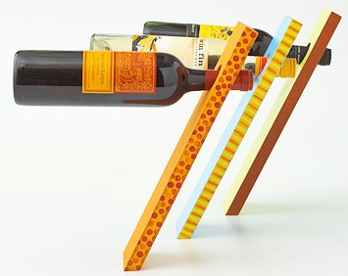
Drawing/Photo:

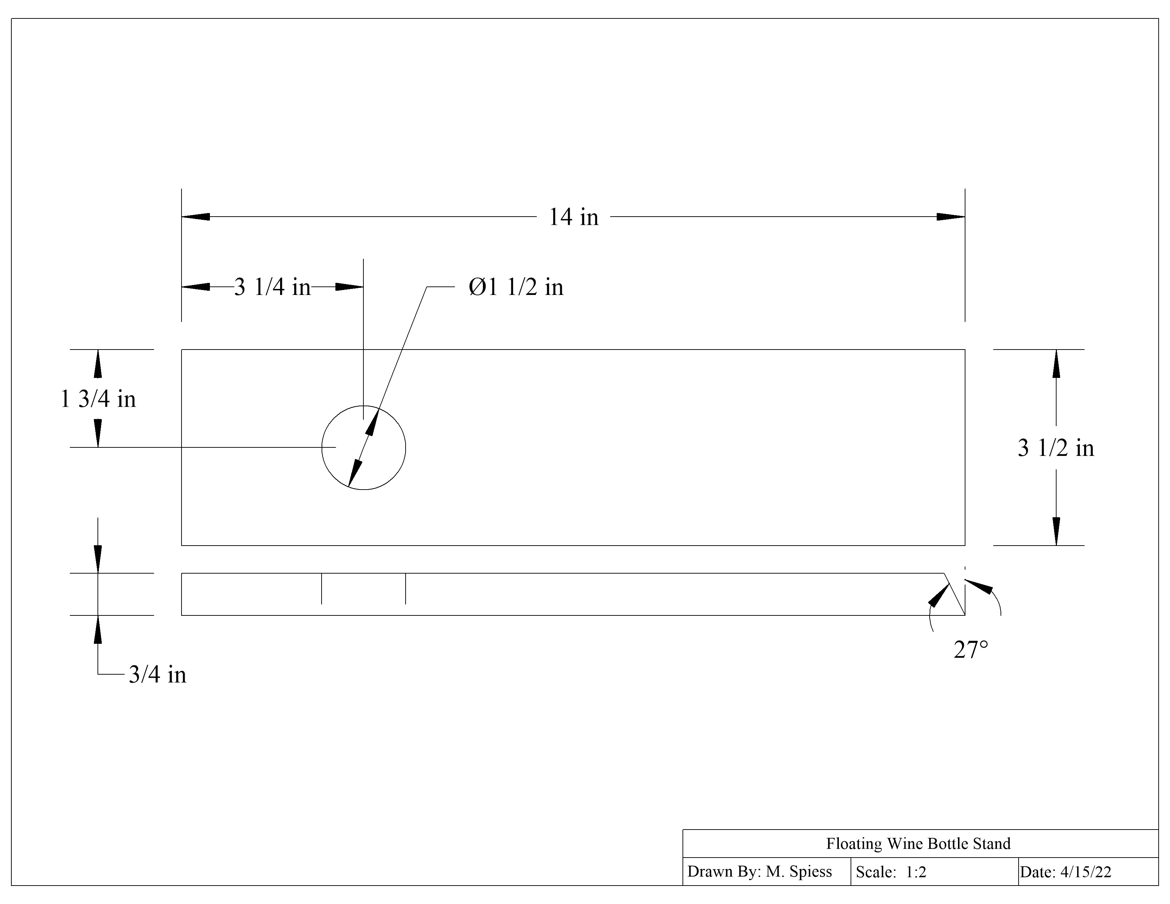

Wine Stand Student Worksheet:
Name: _______________
Date: _______________
Complete this worksheet prior to starting the project.
- What type of wood will you be using for this project? _____________________________

- The wood purchased for the project was 1 x 12. What were the true measured dimensions of the board?
______________ x _______________
- This project requires you to drill a large hole. What type of drill bit and what size bit will you be using on this project?

- DEFINE THE FOLLOWING:
  - Kerf: __________________________________________________________________
  - Crosscut: _______________________________________________________________
  - Rip: ___________________________________________________________________

Grading Rubric:

Criteria (+/- 1/8”) | Possible | Score
Length | 10
Width | 10
Hole location | 10
Worksheet completion | 10
General Workmanship  (Clean edges, sanded smooth, clean use of paint or stain) | 10
TOTAL | 50

Teachers Notes:
- Hardwoods make a nice project and can be stained. Scraps of hardwoods gluded into “butcher block” are also interesting.
- May want to pre-rip strips from 1 x 12 to remove the table saw from the project. Another option is to use 1x4 and not rip.
- If you have two miter saws, set on to cut the angle. NOTE: If you have a compound miter saw the blade can be tilted as opposed to rotating the saw (another skill).

Agricultural Standards Met:
6.0 Health and Safety. Students understand health and safety policies, procedures, regulations, and practices, including the use of equipment and handling of hazardous materials:
6.1 Know policies, procedures, and regulations regarding health and safety in the workplace, including employers’ and employees’ responsibilities.
6.2 Understand critical elements of health and safety practices related to storing, cleaning, and maintaining tools, equipment, and supplies.
6.4 Maintain safe and healthful working conditions.
6.5 Use tools and machines safely and appropriately.
6.6 Know how to both prevent and respond to accidents in the agricultural industry.
B1.0 Students understand personal and group safety:
B1.1 Practice the rules for personal and group safety while working in an agricultural mechanics environment.
B1.2 Know the relationship between accepted shop management procedures and a safe working environment.
B2.0 Students understand the principles of basic woodworking:
B2.1 Know how to identify common wood products, lumber types, and sizes.
B2.2 Know how to calculate board feet, lumber volume, and square feet.
B2.3 Know how to identify, select, and implement basic fastening systems.
B2.4 Complete a woodworking project, including interpreting a plan, developing a bill of materials and cutting list, selecting materials, shaping, joining, and finishing.

Objectives:
By properly completing this project, students will be able to:
- Read the plan and layout the project.
- Construct a wood project with common tools.
- Install nails and finish the project properly.

Alternative Tools/Methods/Materials:
- Entire project could be built with hand tools except the hole.
- A hole saw or spade bit can be used. Note: Hole saws require removal of the cut piece.

Safety Review:
- Power Miter Saw
- Table Saw
- Drill Press

Project Time:
Demonstration: | 30 minutes
Build: | 1.5 hours

Demonstration Notes
- Review the plan and have students make notes and complete the worksheet.
- Demonstrate ripping on the table saw (if used).
- Demonstrate how to set and cut the angle on the miter saw. Stress 14” is the “long” side.
- Demonstrate the layout of the center of the hole with a square (not a tape).
- Demonstrate how to properly back the piece while drilling to make a clean cut. Tip: Drill until the tip of the bit just comes to the back of the board. Then reverse the board and complete the hole.
- Describe the finishing options you have prepared.

Bill of Materials:

Plan by: Joey Silva edits M. Spiess

