Tool Tote - Wood
Name:

Date:

Description:
This project consists of building a small tool tote that is useful in the shop or garden. General skills used to build this project include drawing, measuring, laying out the project and cutting the materials. Nails and screws are used to fasten different parts together. Sanding and finishing are other important skills for this project as well. Emphasis should be placed on craftsmanship.

Materials:
6d finish nails
#6 x 1 5/8” course drywall screws (or woodscrews)
120 grit Sand Paper
1" x 12" x 3’ #3 Pine
1” x 18” hardwood dowel
Wood Glue
Wood filer
Finish

Tools:
Pencil
Table Saw
Power Miter Saw
Band saw
Claw Hammer
Nail set
Portable Drill with Phillips driver
#6 Countersink bit
Drill Press
1” Forstner Bit
Combination square
Steel Tape
Putty knife

Procedure:
- Rip lumber to 4 ½” and 6 ½” width.
- Cut the ends and bottom to length.
- On the ends, layout the angles and center of the handle hole using a pencil and combination square. Refer to the plans for dimensions.
- Cut the angles on the band saw. Dress up cuts with a power sander.
- Drill the holes for the handle using the drill press and Forstner bit.
- Cut the dowel to length. Hint: cut 1/16” long to insure a good fit. You can sand the excess later.
- Cut the side pieces to length.
- “Dry fit” all the parts to be sure you have a good fit.
- Assemble the ends to the bottom with nails and glue. Hint: slip the handle in the ends to help align the parts as they are assembled.
- Pre-drill and install screws that hold the handle in the ends (do not use glue so the handle can be replaced).
- Assemble the sides to the bottom/ends with glue, nails and screws (see plan). Be sure to use the countersink to prevent splitting. Use the sides to square the ends to the bottom.
- With the nail set, “set” all nails. Fill holes with wood filler.
- Sand and finish.
Cutting List:
2 | 3/4"x6 1/2"x8 1/2" | End | #3Pine
2 | 3/4"x4 1/2"17 1/2" | Side | #3Pine
1 | 3/4"x6 1/2"x16" | Bottom | #3Pine
1 | 1"x17 1/2" | Handle | Hardwood dowel

Notes:
____________________________________________________________________________________________________________________________________________________________________________________________________________________________________________________________________________________________________________________________________________________________________________________________________________________________________________________________________________________________________________________________________________________________________________________________________________________________________________________________________________________________________________________________________________________________________________________________________________________________________________________________________________________________________________________________________________________________________________________________________________________________________________________________Photo/Drawing:
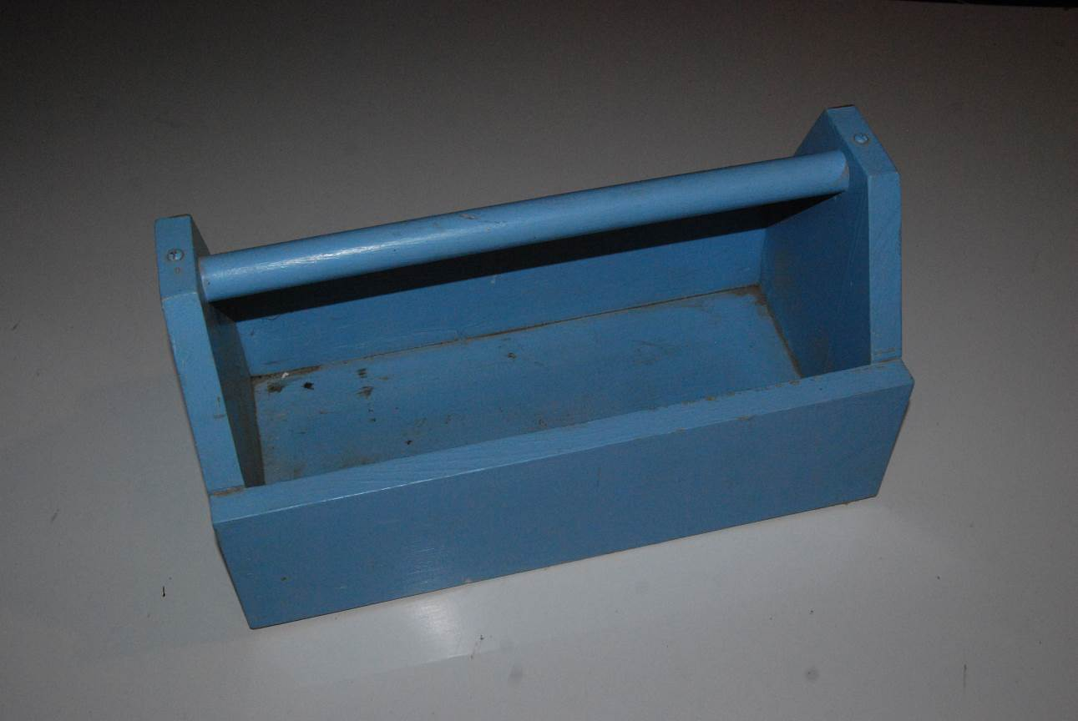

Pre-Building Worksheet
Name:

Date:

- Why is wood selection important for this project?

- What nails specifically are used for this project? How many will you need?

- What screws specifically are used for this project? How many will you need?

- Why is it important to use the countersink bit to drill holes before actually putting the screws in?

- What type of bit is used to drill the holes for the handle?

- Why is this the best bit to use?

- What safety precautions must be observed when using the power miter saw?

Grading Rubric:
CRITERIA | POSSIBLE | SCORE
All cuts made accurately (+/- 1/16”) | 5
Holes for handle drilled and located correctly (+/- 1/16”) | 5
Handle Installation (grain vertical, ends flush) | 5
Screws and nails are counter-sunk | 5
Workmanship (fit, cuts, sanding and finish) | 5
TOTAL | 25

Teachers Notes:

Agricultural Standards Met:
6.0 Health and Safety. Students understand health and safety policies, procedures, regulations, and practices, including the use of equipment and handling of hazardous materials:
6.1 Know policies, procedures, and regulations regarding health and safety in the workplace, including employers’ and employees’ responsibilities.
6.2 Understand critical elements of health and safety practices related to storing, cleaning, and maintaining tools, equipment, and supplies.
6.4 Maintain safe and healthful working conditions.
6.5 Use tools and machines safely and appropriately.
6.6 Know how to both prevent and respond to accidents in the agricultural industry.
B1.0 Students understand personal and group safety:
B1.1 Practice the rules for personal and group safety while working in an agricultural mechanics environment.
B1.2 Know the relationship between accepted shop management procedures and a safe working environment.
B2.0 Students understand the principles of basic woodworking:
B2.1 Know how to identify common wood products, lumber types, and sizes.
B2.3 Know how to identify, select, and implement basic fastening systems.
B2.4 Complete a woodworking project, including interpreting a plan, developing a bill of materials and cutting list, selecting materials, shaping, joining, and finish­ing

Objectives:
By properly completing this project, students will be able to:
- Read a plan and implement layout techniques accurately.
- Fasten all components together using glue and fasteners (nails and screws) with attention to techniques and craftsmanship.
- Select kinds, grades, and quantity of lumber for a given task.
- Prep and finish a project.
- Demonstrate proper use of common woodworking power tools and safe practices in the shop.

Alternative Tools/Methods/Materials:
This project could be built entirely using nails or woodscrews, instead of incorporating both. However, by using two different methods, the students get to demonstrate their knowledge with multiple skills instead of only using one. The project can be altered to use 1” x 6” for all pieces. This removes the need to use a table saw. With 1” x 6” lumber the project can be built with hand tools. See alternate plan below. Alternative tools include using a jig saw instead of the band saw or using all hand tools.

Safety Review:

- Safety Glasses
- Table Saw Safety
- Miter Saw Safety
- Drill Press Safety
- Band Saw Safety
- Proper use of tools (hammer, drill)

Project Time:
Demonstration: | 1 hour
Build: | 5-10 hours

Demonstration Notes:
- Rip 1 x 12 ahead of time on the table saw if you don’t want students to use the table saw. Also, ripping 12’ pieces is safer and more efficient than 3’ pieces.
- Identify all the tools and materials you will be using. It is good to reinforce this even if it is not your first wood project.
- Cut a 3’ piece of each width per project. Talk about where knots might fall and plan accordingly.
- Demonstrate how to cut the square pieces using the power miter saw. Explain that they must mark and cut, mark and cut because of the saw kerf.
- Show how to use the combination square to layout the ends.
- Demonstrate the use of the band saw and drill press to complete the ends. On the drill press explain the need to place a scrap under the work to prevent splitting or damaging the tools.
- Demonstrate a “dry” fit of the parts to insure everything fits OK.
- Assemble in the order of the directions. Key here is to place the handle in the ends first to aid in alignment of the parts. After fastening the ends, bottom, and sides, finish installing the handle. Show how the grain runs in the handle. It should be installed with the grain vertical for strength. Handle can be held in place with a #6 x ¾” screw or a brad. Pre-drill for the screw so the dowel will not split.
- A solder flux brush works well to spread glue. You don’t need much! Have a damp rag handy to wipe off excess.
- Install the screws last. Demonstrate the use of the countersink. It is useful to use two battery powered drills. One with a screw bit and one with the countersink. Screws should be slightly countersunk to make sanding easier.
- Demonstrate “setting” the nails just below the surface and filling the holes.

Bill of Materials: (adjust prices and quantities as needed)
Project and plans by Mike Spiess.
Alternate Plan with 1” x6” lumber

