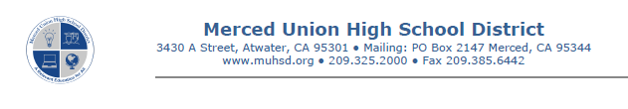

Dear Parents/Guardians:
We would like to advise you that your child will have the opportunity to operate pieces of power machinery while enrolled in the Industrial Arts and/or Agricultural Education course this year. Each student will be given training on the safe and proper use for each piece of machinery before being allowed to operate it. Although safety training is provided, the risk of physical harm is not eliminated. Therefore, we do require that each parent/guardian be notified in advance of the child’s usage of such machinery and ask that you sign the form below to acknowledge such notification.
In class, it is the student’s responsibility to follow all safety rules and obey the instructor at all times. Students that intentionally abuse school property can be held accountable for the damage as a result of their actions. Additionally, students that fail to obey the safety rules may be removed from the program.

I hereby give _____________________________________ permission to use the machinery as a
(Print Student’s Name)
part of his/her studies in the Industrial Arts and/or Agricultural Education Programs.

I do understand the conditions outlined above and will help to insure that my child cooperates fully so that the/she can have a safe learning environment.

____________________________________
Print Name of Parent/Guardian

____________________________________
Signature of Parent/Guardian

