Bevel Tool
Name: ________________________

Description:
The bevel is a useful tool for measuring angles and marking repeating angles. Useful cold metal skills are used to construct the project.

Materials:
1” x 3/8” Aluminum Flat Stock
1” x 1/8” Cold Rolled Steel
¼” 1 ¼” NC Machine Screw
¼” Flat Washer
¼” NC Wingnut
1/8” x 1” Al Pop Rivet
Cutting Oil

Tools:
Hack Saw
Combination square
Scribe or Scratch Awl
Pop Rivet Tool
¼” NC Tap
Tap Handle
Center Punch
Ball Peen Hammer
¼” twist drill
13/64” or #7 twist Drill
1/8” twist drill
Drill Press
Locking Pliers
Machinist’s Vise
Bastard and Mill Files
Letter Stamp

Directions:
- Review the drawing. Determine the location of the rivets and screws and note on the drawing.
- IMPORTANT: Use wood scraps to hold the aluminum in vise to avoid scaring of the soft metal.
- *Dress the cut end of the aluminum stock using a file. Hint: scribe a line then cut on the edge of the line. Cut the stock to length using a hacksaw. Repeat for the second piece.
- *Dress the cut end of the steel stock using a file. Hint: scribe a line then cut on the edge of the line. Cut to length using a hacksaw.
- Layout the hole pattern on one of the aluminum pieces. Mark the drilling locations with a center punch.
- Using locking pliers clamp the three pieces together with the marked piece on top. Drill the two 1/8” holes and the 13/64” hole with the drill press. Clamping will insure that the holes are aligned. IMPORTANT: Mark the edges with a pencil or sharpie so that you know how you drilled the 3 pieces. You will need to assemble in the same order.
- Tap the 13/64 hole in one aluminum piece with a ¼” NC tap. Use a few drops of oil.
- Drill the other aluminum piece and the steel piece 13/64 hole to ¼” using the drill press. Clamp your work.
- Use the ¼” drill to countersink the 1/8” holes on the outside of one handle about ½” way through one hand
- Mark the angle on the steel stock and carefully cut with a hacksaw. Use a fine file to smooth the cut edges.
- Assemble the handle and the short steel piece with the 1/8” pop rivets. The “blind” side of rivet should be in the countersink.
- Assemble the screw and wing-nut.
- Check the entire project for sharp edges and use a file to remove them.
- Optional: Using the letter stamps, stamp your initials neatly on the handle

Notes:
__________________________________________________________________________________
__________________________________________________________________________________
__________________________________________________________________________________
__________________________________________________________________________________
__________________________________________________________________________________
__________________________________________________________________________________
__________________________________________________________________________________

Drawing/Photo:
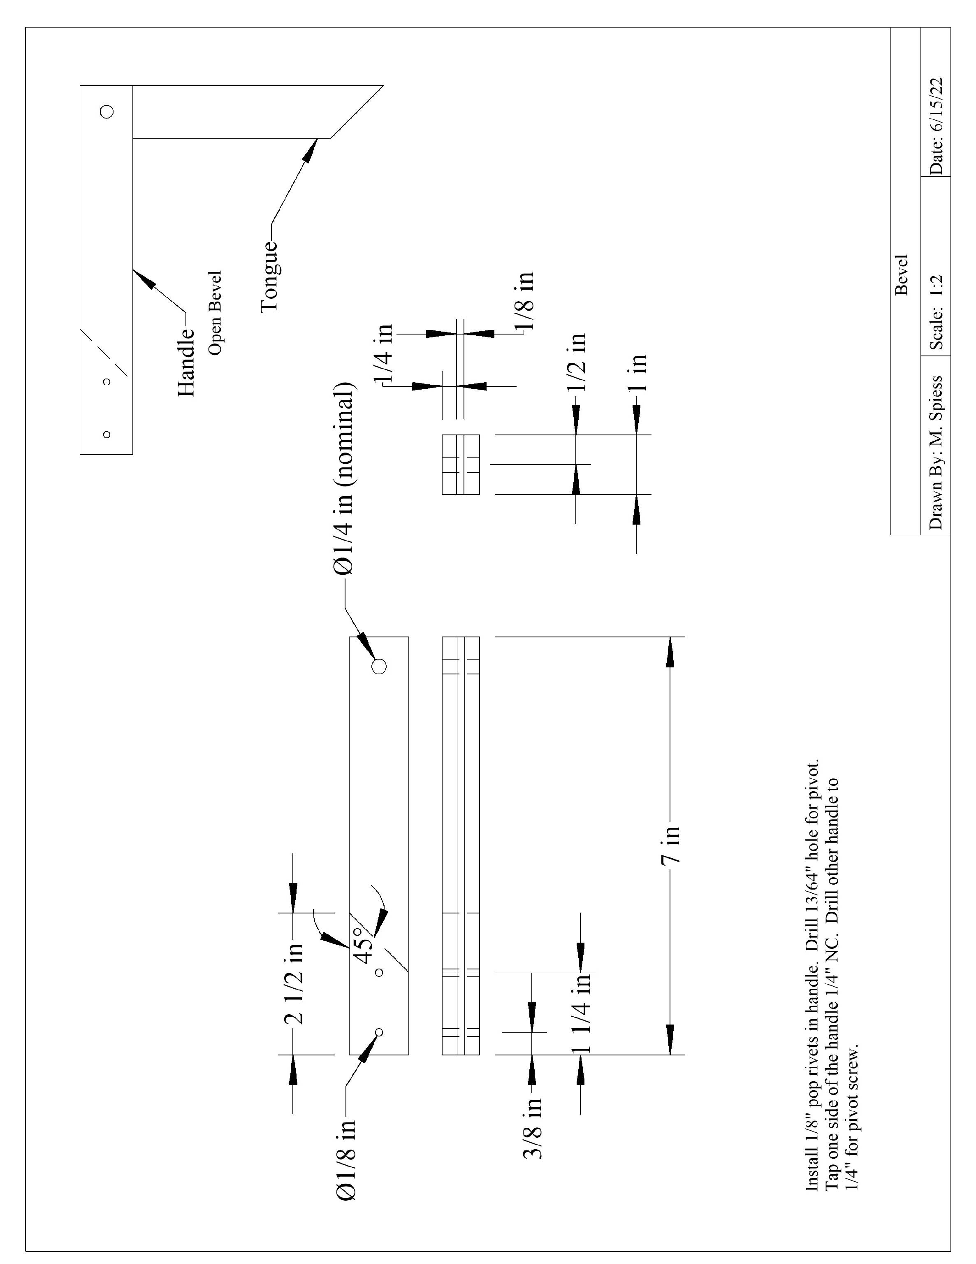

Bevel Student Worksheet:
Name: ________________________
Read the directions and review the plan. Complete this worksheet prior to starting the project.
- How long is the “tongue” piece cut from the flat stock? ____________________
- How long is the “handle” part cut from the angle stock? _________________
- What material is the handle? _____________________
- What material is the tongue? _____________________
- When drilling the “1/4” hole what is the initial size? _______________________
- Why do we drill the “1/4” hole smaller than ¼”?
_____________________________________________________________________
- What do you do to ensure that the holes are all aligned?
_____________________________________________________________________
- How is the aluminum protected from scaring in the machinist’s vice?
_____________________________________________________________________
- What tool is used to mark hole locations for drilling? _________________________

Grading Rubric:
Criteria (tolerance +/- 1/16") | Possible | Score
Dimensions (handle and tongue) | 5
Project ends square and aligned | 5
Tongue cut on 45º. | 5
Screw and Pop Rivet (location and installation) | 5
General Workmanship  (edges, excess marks, scaring of metal) | 5
TOTAL | 25

Bevel Teaching Notes:

Agricultural Standards Met:
4.0 Technology. Students know how to use contemporary and emerging technological resources in diverse and changing personal, community, and workplace environments:
4.6 Differentiate among, select, and apply appropriate tools and technology.
5.0 Problem Solving and Critical Thinking. Students understand how to create alternative solutions by using critical and creative thinking skills, such as logical reasoning, analytical thinking, and problem-solving techniques:
5.1 Apply appropriate problem-solving strategies and critical thinking skills to work-related issues and tasks.
5.3 Use critical thinking skills to make informed decisions and solve problems.
6.0 Health and Safety. Students understand health and safety policies, procedures, regulations, and practices, including the use of equipment and handling of hazardous materials:
6.1 Know policies, procedures, and regulations regarding health and safety in the workplace, including employers’ and employees’ responsibilities.
6.2 Understand critical elements of health and safety practices related to storing, cleaning, and maintaining tools, equipment, and supplies.
6.4 Maintain safe and healthful working conditions.
6.5 Use tools and machines safely and appropriately.
6.6 Know how to both prevent and respond to accidents in the agricultural industry.
B1.0 Students understand personal and group safety:
B1.1 Practice the rules for personal and group safety while working in an agricultural mechanics environment.
B1.2 Know the relationship between accepted shop management procedures and a safe working environment.
B1.3 Know how to safely secure loads on a variety of vehicles.
B5.0 Students understand agricultural cold metal processes:
B5.1 Know how to identify common metals, sizes, and shapes.
B5.3 Know layout skills.
B5.4 Know basic cold metal processes (e.g., shearing, cutting, drilling, threading, bending.).
B5.5 Complete a cold metal project, including interpreting a plan, developing a bill of

Objectives:
By successfully completing this project students will be able to:
- Read a plan to obtain critical dimensions
- Measure and layout a project on metal
- Identify by name common cold metal tools
- Select and properly used hand and power tools used for cold metal work
- Determine proper drill sizes for threads
- Cut threads in metal using a tap

Alternate Tools:
A hydraulic shear could be used to cut the metal, but dressing the ends will take longer. A drill press is not needed, but ensures that the holes are square. It is possible to build this project without a shop. You will need some sort of benches or sawhorses and clamps to hold the work. A hand drill used carefully can be used to drill the holes.

Safety Review:
- Use of the drill press.

Project Time:
Demonstration: | 15-30 minutes
Build: | 3 hours

Demonstration Notes:
(Tips, methods to stage the project)
- Begin by reviewing materials and tools used for the project.
- Review the plan and show how the plan describes the project.
- Review a thread chart and show how drill sizes are determined.
- Demonstrate the proper use of a file.
- Demonstrate how to mark the aluminum with a combination square and scribe.
- Demonstrate cutting to the line with a hacksaw. Show how to place the work in a vise using the protective wood block and place the cutting line close to the vise so it will not move.
- Demonstrate how to layout the drill holes (see worksheet) using a combination square and center punch. Center punch on an anvil or vise anvil (not on the bench). Since aluminum is soft only moderate pressure is required to mark with the center punch.
- Explain why we drill the ¼” hole at 13/16” (or #7).
- Review drill press safety as you demonstrate drilling. If the drill press vise doesn’t have shoulders then place a scrap piece of wood in the bottom of the vise to protect the vise when drilling the flat stock. Remind students that the drill is small and easily broken if work is not secured.
- Explain why we clamp the materials together when drilling. Position the locking pliers so all 3 holes can be drilled.
- Demonstrate tapping. We tap one handle. Taps are small and can easily be broken even if small handles are used. Use a few drops of oil. Show how far to tap to make complete threads. NOTE: Incomplete threads will lead to breaking the brass screw when installing.
- Remind students of workmanship. Final project should be clean and free of sharp edges.
- Demonstrate how the tool is used mark repeated angles

Standard Tap & Drill Sizes
American Std. and Unified Form Threads
Tap Drill Size is approximately 75% Thread
Thread | Drill |  | Thread | Drill |  | Thread | Drill
0-80 | 3/64 |  | 1/4-20 | 7 |  | 1-12 | 59/64
1-64 | 53 |  | 1/4-28 | 3 |  | 1 1/8-7 | 63/64
1-72 | 53 |  | 5/16-18 | F |  | 1 1/8-12 | 1-3/64
2-56 | 50* |  | 5/16-24 | I |  | 1 1/4-7 | 1-7/64
2-64 | 50 |  | 3/8-16 | 5/16 |  | 1 1/4-12 | 1-11/64
3-48 | 47* |  | 3/8-24 | Q |  | 1 3/8 -6 | 1-7/32
3-56. | 45* |  | 7/16-14 | U |  | 1 3/8-12 | 1-19/64
4-40 | 43 |  | 7/16-20 | 25/64* |  | 1 1/2 -6 | 1-11/32
4-48 | 42 |  | 1/2-13 | 27/64 |  | 1 1/2-12 | 1-27/64
5-40 | 38* |  | 1/2-20 | 29/64 |  | 1 3/4 -5 | 1-9/16
5-44 | 37 |  | 9/16-12 | 31/64 |  | 2" - 4 1/2 | 1-25/32
6-32 | 36 |  | 9/16-18 | 33/64 |  | 2 1/4-4 1/2 | 2-1/32
6-40 | 33 |  | 5/8-11 | 17/32 |  | 2 1/2 - 4 | 2-1/4
8-32 | 29 |  | 5/8-18 | 37/64 |  | 2 3/4 - 4 | 2-1/2
8-36 | 29 |  | 3/4-10 | 21/32 |  | 3" - 4 | 2-3/4
10-24 | 25 |  | 3/4-16 | 11/16 |  | 3 1/4-4 | 3 "
10-32 | 21 |  | 7/8-9 | 49/64 |  | 3 1/2-4 | 3-1/4
12-24 | 16* |  | 7/8-14 | 13/16 |  | 3 3/4-4 | 3-1/2
12-28 | 14* |  | 1" -8 | 7/8 |  | 4" - 4 | 3-3/4
 |  |  | 1" -14 | 15/16

Bill of Materials
(Excel, update with local prices)

