Name ___________________
Period ___________________

Electrical Troubleshooting Activities

Station #1 – Resistance Testing

Directions:
- Using your multi-meter measure the resistance of each lamp (light bulb) or resistor.
- Record the resistance.
- Determine which lamps are good.
Lamp | Resistance (ohms) | Good/Bad
A
B
C
D

Station #2 – Wiring Testing

Directions:
Procedure
1. Shorted wire test: Test for continuity between each of the wires. Black & White, Black and Ground, White & Ground. If you measure continuity then the wired are shorted.
2. Broken wire test: Connect a wire pair (Black & White, Black and Ground, or White & Ground) at one end of the cable with a wire nut. Test for continuity at the other end. If you don’t have continuity then one or both of the wires are broken. Repeat the test for the other 2 pairs.
Record the results of the tests below.
Cable | Fault (circle) | Which Wire(s)
A | a. Shorted  b. Broken  c. No Fault
B | a. Shorted  b. Broken  c. No Fault
C | a. Shorted  b. Broken  c. No Fault
D | a. Shorted  b. Broken  c. No Fault

Station #3 – Switch testing

Directions Toggle Switch:
- Test for continuity between the terminals with the switch in off position.
- Test for continuity between the terminals with the switch in on position. Is the switch working (Yes / No)

Directions 3 way Switch:
- Test for continuity between the terminals with the switch in one position. Record your results.
- Test for continuity between the terminals with the switch in other position. Record your results.
- Determine which terminal is the “common” terminal.
- Label the diagrams with the letters of the terminals.
Switch Position | Circle connected terminals
1 | A-B  A-C  B-C
2 | A-B  A-C  B-C

Position 1 | Position 2

Station #4 – DC Voltage Testing

Materials:
4 – 1.5V alkaline batteries

Directions:
- Measure the voltage of each battery and record on the data sheet.
- If a battery voltage > 1.5V which batteries are fully charged? Indicate on the data sheet by circling the letter.
Battery | Voltage
A
B
C
D

Station #5 – DC Voltage Testing Lead Acid Battery

Directions:
- Measure the DC Voltage of the battery.
- Use the chart to determine the amount of capacity (charge). Charge: ______________%
Capacity | Voltage
100% | 12.70 V or higher.
90% | 12.50 V.
80% | 12.42 V.
70% | 12.32 V.
60% | 12.20 V.
50% | 12.06 V.
40% | 11.90 V.
30% | 11.75 V.
20% | 11.58 V.
10% | 11.31 V.
0% | 10.50 V.

Station #6 – Auto/Trailer Testing

Directions:
- Using your multi-meter measure the resistance of each lamp (light bulb).
- Determine which lamps are good.
Lamp | Good/Bad
A
B
C
D

Station #7 – Motor Windings

Directions:
- Using your multi-meter measure the resistance of motor.
- Record the resistance.
- Determine if the motor winding is good.
Motor | Resistance (ohms) | Good/Bad
A
B

Station #8 – Contactor

Directions:
- Measure the resistance of the coil and record. ____________________

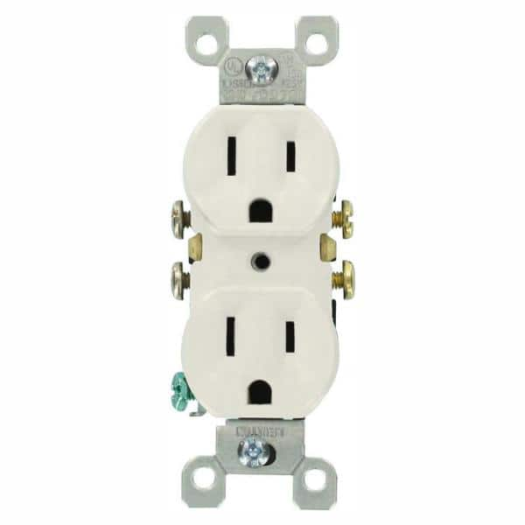
Station #9 AC Voltage Testing
HOT
GROUND
NEUTRAL

Materials:
Power Strip (optional)

Directions:
- Using the multi-meter set to AC Voltage.
- Measure the voltage between each slot on the receptacles. USE CAUTION AS YOU ARE TESTING 120V.
- Record your findings in the table below.
Outlet (DR) | Slot | Voltage Readings
A | Neutral – Ground
 | Neutral – Hot
 | Hot - Ground
B | Neutral – Ground
 | Neutral – Hot
 | Hot - Ground
C | Neutral – Ground
 | Neutral – Hot
 | Hot - Ground
D | Neutral – Ground
 | Neutral – Hot
 | Hot - Ground

Station #10 – Pump Float Switch

Materials:
1 – pump float switch

Directions:
Remove the connection directions (if any)
Using a meter determine if the switch is working.

Station #11 – Transformer

Directions:
- Test the primary for resistance. Unplug first! The primary is the side with the plug. Is the primary good? Yes /No.
- Test the secondary coil for resistance. Unplug first! The secondary is the coil not connected to the plug. Is the secondary good? Yes / No
- Plug in the transformer and test for AC voltage. What is the voltage? ______________

Station #12 – Power Supply

Directions:
- Test the primary for resistance. Unplug first! The primary is the side with the plug. Is the primary good? Yes /No.
- Test the secondary coil for resistance. Unplug first! The secondary is the coil not connected to the plug. Is the secondary good? Yes / No
- Plug in the transformer and test for AC voltage. What is the voltage? ______________
- Plug in the transformer and test for DC voltage. What is the voltage? ______________

Questions
- Determine the expected resistance draw of a good 60W lamp using the formula below. Assume voltage will be 120V.
Electrical Formulas:
Watts = Volt x Amps -> Amps = Watts ÷ Volts
Volts = Amps x Resistance (E=IR) -> Resistance=Volts ÷ Amps
___________ Amps = 60 watts ÷ 120v
___________ Ohms = 120v ÷ _________ Amps
- How does the calculated resistance compare to your measurement at station #1?
____________________________________________________________________________
- What is the expected resistance of a broken wire?
  - Infinite
  - < 5 ohms
  - 6-600 ohms
  - > 600 ohms
- What is the expected resistance of two shorted wires?
  - Infinite
  - < 5 ohms
  - 6-600 ohms
  - > 600 ohms
- What is the expected resistance of a good switch when the contacts are closed?
  - Infinite
  - < 5 ohms
  - 6-600 ohms
  - > 600 ohms
- What is the approximate voltage you would expect to find at a working outlet (DR)? ___________V
- On a transformer like you tested at station #11 (step down) which coil has the most resistance?
  - Primary
  - Secondary
  - Both are the same
- To test to see if an outlet is working what scale would you use on your multi-meter?
  - DC Volts
  - AC Volts
  - Amperes
  - Resistance (ohms)
- When testing a live 120v circuit with a multi-meter what precautions should you take?
_______________________________________________________________________
_______________________________________________________________________
_______________________________________________________________________
- Before replacing an AC device like a DR, what should you do?
_______________________________________________________________________
_______________________________________________________________________
_______________________________________________________________________

