Surveying

Most building construction projects require the layout to be square and either level or at a specific grade. Another common task using surveying tools is measuring the actual grade (slope) of the ground. This is necessary to establish drainage direction or slopes for field irrigation.

# Establishing Square

Laying out a square corner can be easily done with two tapes and stakes. Square corners are commonly needed for building foundations and concrete slabs. The method described below uses a “3-4-5” right triangle to construct the square corner.

## Tools and Materials

2 - 25, 50, 100 tapes (length depends on the size of the project)

Wooden stakes

Engineer’s or similar hammer.

## Procedure

1. Determine the size of the building from plans.
2. Establish one side of the building with two stakes. Locate the stakes so one corner will be on the inside of the building. (See Diagram for 36’x43’ building below. Stakes 1 & 2). The stakes should be spaced the exact distance of the building dimensions.
3. To set a square corner you will need to establish a “3-4-5” triangle. This is a ratio so you can choose any combination of numbers as long as the ratio is maintained. Some examples are:

|  |  |  |
| --- | --- | --- |
| 3 | 4 | 5 |
| 30 | 40 | 50 |
| 300- | 400 | 500 |
| 15 | 20 | 25 |
| 18 | 24 | 30 |

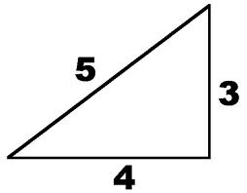

1. Consider the line between the two stakes the “base” of the triangle. Measure from one of the stakes out to the “4” side distance and place a stake (stake 3 in the diagram).
2. Now using two tapes measure up the “3” side to the desired distance and measure from the “4” stake the “5” distance (the hypotenuse of the triangle). Set a stake (stake 4 in the diagram) where the tapes cross. This establishes the right angle (square).
3. Using a tape extend the line from the square stake to the corner of the building and set a stake (stake 5 in the diagram). This is the third corner of the building.
4. Now again using two tapes and the building dimensions measure from the two corner stakes to find the final stake location (stake 6 in the diagram).
5. Stakes 3 and 4 can now be removed.

Sample layout of a 36’x43’ building.

# Checking Square

For layouts that are square or rectangular you can easily check for square by measuring the diagonals. They should be equal if the corners are square. This always assumes that opposite sides are of equal distance. If you are out of square check the sides first. Note: This technique is also useful for measuring the top plates of walls to ensure that the framing is square.

Example of measuring the diagionals to check square.

# Setting Grades with a Level

A level is used to determine level or a specific grade. Some uses are setting foundation forms level, setting the grade of a driveway or determining the height of a support post. A number of different types of levels can be used such as a builder’s level, auto level, or laser level. They all work on the same principle. The level establishes a level line of sight either using a telescope or laser beam. Bu measuring down from that level line of sight we can determine differences in the elevation. A rod is used to measure the vertical distance. Rods are basically a tape measure attached to a rigid pole. Rods commonly used for building are marked in feet and inches. In many cases a steel tape can be used instead of a rod. Rods used for field surveying are marked in feet and hundredths of feet. Common instruments and rods are shown below:

|  |  |
| --- | --- |
| Johnson 22X Builders Level System Tiger Supplies Builder’s Level | AL Auto Levels - Spectra Precision Laser  Auto Level |
| 12V MAX* 3 x 360 Green Line Laser - DW089LG | DEWALT  Laser Level |  |
| AdirPro 9 FT Dual Sided Aluminum Grade Rod - 8ths, 5 Section Telescopic Rod with Carrying Case  Rod (Feet and Inches) | Appendix J. Using an Auto Level and Stadia Rod  Rod in Feet and hundredths of feet |

## Tools and Materials:

* Tripod
* Level
* Rod
* marker

## Setup

1. Setup the tripod at a location near the building site with a clear view of the points to be measured. Points of the tripod should be set firmly and top level (by eye).
2. Install the instrument on the tripod.
3. Leveling of the auto level and laser level should be automatic if the tripod is fairly level. For builders levels use the following procedure:
   1. Rotate the level until it is over one pair of the leveling screws. Adjust the screws until the bubble is centered.
   2. Rotate the level 90 degrees over the other set of screws and adjust until the bubble is centered.
   3. Repeat the process until the bubble remain centered in any position.
4. Caution should be taken not to bump the tripod once the instrument is set.

## Procedure for Determining Level of a Foundation

All corners of the foundation should be the same distance (down) from the line of sight of the instrument. A surveyor’s rod or steel tape measure can be used to measure the vertical distance.

### To establish level

1. Pick a corner and mark a stake with the location that will be the top of the forms.
2. Hold a rod or tape measure on the mark and vertical. Read the measurement with the instrument (or observe the laser beam).
3. Go to next location (corner). Holding the rod vertical adjust until the rod reading was the same as before and make the stake.
4. Repeat for all locations.

### To check level of forms or foundation

1. Place a rod or tape on the top of the forms or foundation corner.
2. Using the instrument take a reading.
3. Repeat for other locations. The readings should be the same. If the reading is larger then the location is low. If the reading is smaller the location is high.

## Procedure for Setting the Grade of a Slab

To properly drain concrete slabs need to be poured to grade (slope). This is easily done with a few calculations.

1. Stake the corners of the slab.
2. Determine the grade (fall) of the slab. For example if you want a ¼” drop per foot (common) for a 25’ driveway then the total fall would be 25’ x ¼”(.25”)=6 ¼”. This means that the top of the slab should be 6 ¼” higher than the bottom.
3. Holding the rod vertical at the top of the slab take a measurement.
4. Compute the measurement needed at the bottom (lower end) of the slab by adding the fall to the measurement taken at the top. For example, if the measurement at the top was 4’ 3 ½” and the fall is 6 ¼” inches the measurement at the bottom should be 4’ 3 ½” + 6 ¼” = 4’ 9 ¾”.
5. Now place the rod at the bottom of the slab. Hold it vertical and move it up or down to achieve the desired reading. Mark the bottom of the rod.

## To measure the grade of an existing slab or ground surface

1. Setup the instrument as described.
2. Establish the points you want to measure with stakes or paint.
3. Holding the rod vertical take readings at each point and record. A simple sketch of the location will help you keep this straight.
4. Pick one point as a starting point (sometimes call a benchmark). Remember higher measurements are lower elevations and lower measurement are higher elevations.

To determine the fall or rise between two points subtract the readings. For example, if the reding at point 1 is 5’ 8” and at point 2 is 5’ 11” the fall (point 2 is lower) is 3”.

To determine the grade (change in elevation per foot) measure the distance between the points and divide it into the difference in elevation. For example, if the fall was 3” and the distance is 24’ then the grade is 1/8” per foot.

# Surveying Land Grade:

Commonly we want to determine the grade of a field. We can do this my taking readings at regular intervals done the field. Commonly we will use a surveyor’s rod marked in feet and hundredths of feet. This greatly simplifies the math. The general procedure is as follows:

1. Pick a starting spot to establish a benchmark (like an irrigation valve).
2. Measure and stake down the field every 100’.
3. Setup the instrument in the middle of the stake line (off set a bit).
4. Take readings and record at the benchmark and each stake. Record the readings as described below.

Consider that the instrument is a level line. If you set an arbitrary elevation to the benchmark say 10’ the measurement (called a backsight or BS) at the benchmark actually measures the elevation of the instrument. This is called the height of instrument (H.I.). Now if we know the HI then all other readings can be used to compute the elevation. The HI is the same unless you move the instrument. Readings to unknow elevations are called foresights (FS). Using the formulas:

$$HI=Benchmark+Rod Reading$$

$$Elevation=HI-Rod Reading$$

The table below shows a sample of the readings and calculations.

|  |  |  |  |  |
| --- | --- | --- | --- | --- |
| Station | Backsight | HI | Foresight | Elevation |
| Benchmark | 4.30 | 14.30 |  | 10 |
| 1 |  |  | 4.00 | 10.30 |
| 2 |  |  | 4.25 | 10.05 |
| 3 |  |  | 4.71 | 9.70 |
| 4 |  |  | 4.86 | 9.35 |
| 5 |  |  | 5.20 | 9.10 |
| 6 |  |  | 5.54 | 8.76 |

Once the readings are taken the grade can be graphed or computed. In the example above the total fall is 1.54 feet and grade (feet/100 feet) is .308 since the distance between the first and last stations is 500’

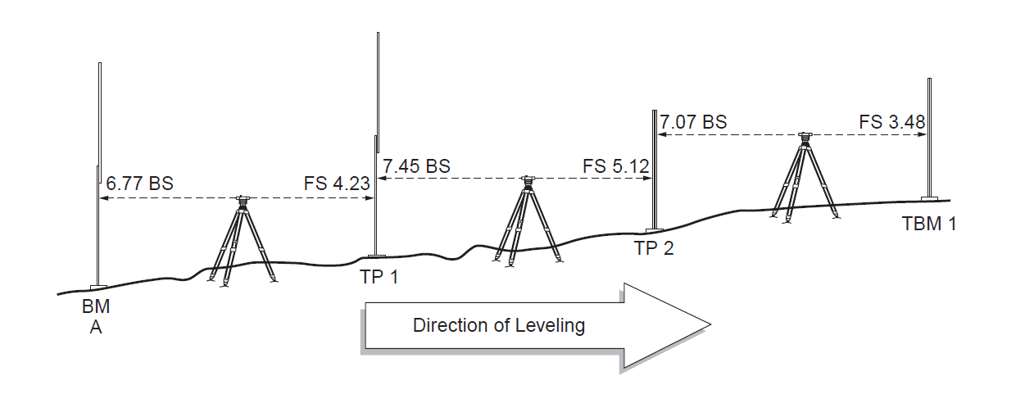

# Reading a Rod

Reading a rod takes a bit of practice. The reading is taken at edge of the mark not the middle. The diagram below shows a Philadelphia Rod (feet and hundredths of feet).

