Electrical Troubleshooting Activities
Name ___________________
In this activity you will use a multi-meter (also called a volt-ohm meter or VOM), a duplex receptacle (DR) tester, a non-contact (induction) tester, and a clamp on amp meter. These are common tools used by electricians and mechanics for troubleshooting electrical problems.
At each station that requires the use of the multi-meter determine the proper settings BEFORE testing. Some stations use 120v power. Be cautious when inserting the meter probes not to touch the metal probe.
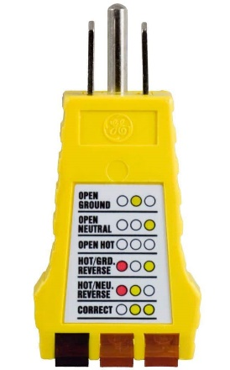 | 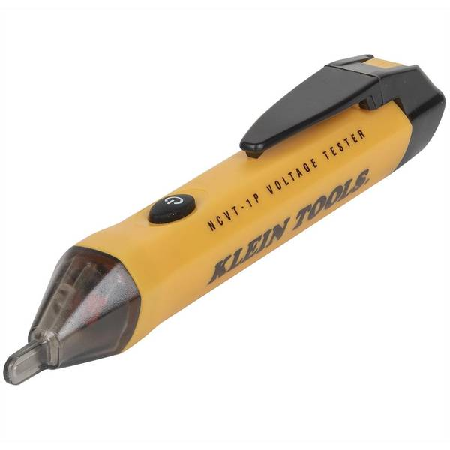 | 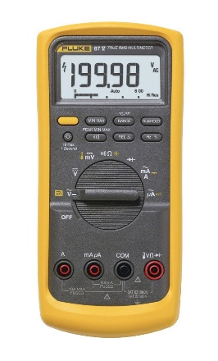 | 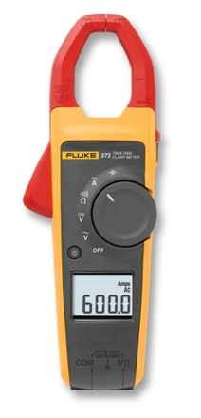
DR Tester | Non-contact tester | Multi-meter | Clamp-on meter

Common Multimeter Symbols
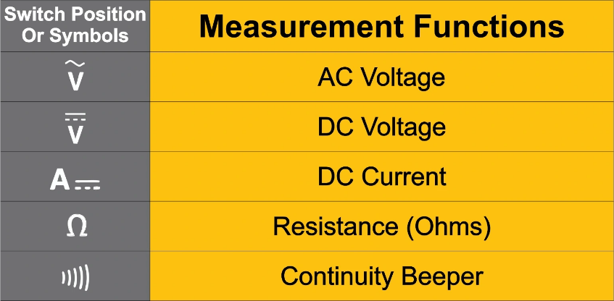

Terms
Continuity | The presence of a complete path for current flow. A closed switch that is operational, for example, has continuity.
Short (Circuit) | A circuit where the resistance is low enough to exceed its ampacity.
Open (Circuit) | A circuit is not connected, current will not flow
Load | A device that uses electricity; the amount of power consumed by a device

Station #1 – Resistance Testing

Directions:
- Using your multi-meter measure the resistance of each lamp (light bulb). Set the meter on the lowest scale (ex. 20 ohms)
- Record the resistance.
- Determine which lamps are good.
Lamp | Resistance (ohms) | Good/Bad
A
B
C
D

Station #2 – Wiring Testing

Directions:
1. Shorted wire test: Test for continuity between each of the wires. Black & White, Black and Ground, White & Ground. If you measure continuity then the wires are shorted.
2. Broken wire test: Connect a wire pair (Black & White, Black and Ground, or White & Ground) at one end of the cable with a wire nut. Test for continuity at the other end. If you don’t have continuity then one or both of the wires are broken. Repeat the test for the other 2 pairs.
Record the results of the tests below.
Cable | Fault (circle) | Which Wire(s)
A | a. Shorted  b. Broken  c. No Fault
B | a. Shorted  b. Broken  c. No Fault

Station #3 – Switch Testing

Directions: Toggle Switch:
- Test for continuity between the terminals with the switch in off position.
- Test for continuity between the terminals with the switch in on position.
Is the switch working (Yes / No)

Directions: 3 way Switch:
- Test for continuity between the terminals with the switch in one position. Record your results.
- Test for continuity between the terminals with the switch in other position. Record your results.
- Determine which terminal is the “common” (can be connected to the other 2 terminals) terminal.
- Label the diagrams with the letters of the terminals.
Switch Position | Circle connected terminals
1 (up) | A-B  A-C  B-C
2 (down) | A-B  A-C  B-C

Position 1 (up) | Position 2 (down)
Why does a 3 way switch not have on/off markings?

Station #4 – DC Voltage Testing

Directions:
- Measure the voltage of each battery and record on the data sheet.
- If a battery voltage > 1.5V it is fully charged. Which batteries are fully charged? Indicate on the data sheet by circling the letter.
Battery | Voltage
A
B

Station #5 – DC Voltage Testing Lead Acid Battery

Directions:
- Measure the DC Voltage of the battery. IMPORTANT: Be sure probes make good contact with the terminals.
- Use the chart to determine the amount of capacity (charge). Charge: ______________%
Capacity | Voltage
100% | 12.70 V or higher.
90% | 12.50 V.
80% | 12.42 V.
70% | 12.32 V.
60% | 12.20 V.
50% | 12.06 V.
40% | 11.90 V.
30% | 11.75 V.
20% | 11.58 V.
10% | 11.31 V.
0% | < 10.50 V.

Station #6 – Auto/Trailer Lamp Testing
Vehicles, tractors, and trailers use incandescent lamps for lighting. Note: This test may not work on some LED lamps.

Directions:
- Using your multimeter measure the resistance of the lamp. This lamp has 2 filaments. Test each by connecting the multimeter to the case and one of the contacts.
- Determine which filaments are good.
Lamp Filament | Good/Bad
A
B

Station #7 – Wiring Testing

Directions:
1. Shorted wire test: Test for continuity between each of the wires. Black & White, Black and Ground, White & Ground. If you measure continuity then the wires are shorted.
2. Broken wire test: Connect a wire pair (Black & White, Black and Ground, or White & Ground) at one end of the cable with a wire nut. Test for continuity at the other end. If you don’t have continuity then one or both of the wires are broken. Repeat the test for the other 2 pairs.
Record the results of the tests below.
Cable | Fault (circle) | Which Wire(s)
C | a. Shorted  b. Broken  c. No Fault
D | a. Shorted  b. Broken  c. No Fault

Station #8 AC Voltage Testing

Directions:
- Using the multimeter set to AC Voltage.
- Measure the voltage between each slot on the receptacles. USE CAUTION AS YOU ARE TESTING 120V.
- Record your findings in the table below.
Outlet (DR) | Slot | Voltage Readings
A | Neutral – Ground
 | Neutral – Hot
 | Hot - Ground
B | Neutral – Ground
 | Neutral – Hot
 | Hot - Ground
C | Neutral – Ground
 | Neutral – Hot
 | Hot - Ground
D | Neutral – Ground
 | Neutral – Hot
 | Hot - Ground

Is outlet #A wired correctly? __________________
Is outlet #B wired correctly? __________________
Is outlet #C wired correctly? __________________
Is outlet #D wired correctly? __________________
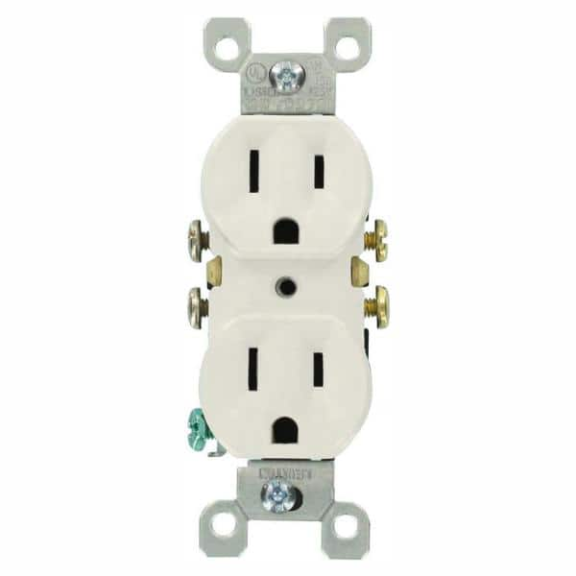
HOT
NEUTRAL
GROUND

Station #9 – Power Supply (Transformer)

Directions:
- Unplug the transformer. Test the primary for resistance between the two prongs. The primary is the side with the plug. Is the primary good (some resistance)? Yes /No.
- Plug in the transformer.
- Test for AC voltage. What is the voltage? ______________
- Test for DC voltage. What is the voltage? ______________

Station # 10 – Duplex Receptacle Tester

Directions:
- Test all four outlets using the tester.
- Record problems if any in the table below.
- Determine how the tester works.
Outlet | Fault
A
B
C
D
HOT
NEUTRAL
GROUND

Station # 11 – Power Present

Directions:
- Identify the two 120V breakers. These breakers control power to two circuits powering the duplex receptacles (A and B).
- Using the breakers and the non-contact tester determine which breaker controls which outlet.
- Use the letters on the outlet to record the results of your test.
Breaker | Outlet
15 A
20 A

Station # 12 – Current draw.

Directions:
Using the clamp on meter determine the current draw (amps) by clamping the meter over each wire.
Start with the load off. What does each wire measure?
Wire | Current
Black
White
Bare or Green
Now clamp the probe over the black wire and turn the load on. Observe the readings. With the load on measure the other two wires.
Wire | Current
Black
White
Bare or Green
Can you explain the readings?

Station # 13 – Fuses
Measure the continuity of the two fuses. The fuse is good if you measure continuity. Circle your finding.

Fuse A: Good/Bad
Fuse B: Good/Bad

Station #14 – Resistor
Measure the resistance of the resistor. Resistance = _____________ ohms. Hint: you may need to adjust the scale and be careful in reading the meter.

Questions
- Before replacing an AC device like a DR, what should you do to work safely?
_______________________________________________________________________
_______________________________________________________________________
- When testing a live 120v circuit with a multimeter what precautions should you take?
_______________________________________________________________________
_______________________________________________________________________
- Determine the expected current draw of a good 60W lamp using the formula below. Assume voltage will be 120V.
Electrical Formulas:
Watts = Volt x Amps -> Amps = Watts ÷ Volts
___________ Amps = 60 watts ÷ 120v
- What is the expected resistance of a broken wire?
  - Infinite
  - < 5 ohms
  - 6-600 ohms
  - > 600 ohms
- What is the expected resistance of two shorted wires?
  - Infinite
  - < 5 ohms
  - 6-600 ohms
  - > 600 ohms
- What is the expected resistance of a good switch when the contacts are closed?
  - Infinite
  - < 5 ohms
  - 6-600 ohms
  - > 600 ohms
- What is the approximate voltage you would expect to find at a working outlet (DR)? ___________V
- To test to see if an outlet (DR) is working what scale would you use on your multimeter?
  - DC Volts
  - AC Volts
  - Amperes
  - Resistance (ohms)

