Calculating Concrete Volume
Name: ________________________
Date: ________________________

Description:
How to calculate concrete volume for ordering concrete.

What’s in the Box?

Materials:
None.

Tools:
100’ tape (or 25’ tape)

Introduction
Volume is length X width x thickness. For a simple driveway that is 40’ long by 20’ wide by 4” thick the calculation is as follows:
All units need to be in feet so first convert 4 inches to feet by dividing by 12 (inches/foot). 4 ÷ 12 = .33
Now compute the volume in cubic feet.
40’ X 20’ X .33’ = 264 cubic feet.
However we order concrete by the cubic yard. A cubic yard = 27 cubic feet. To convert divide the cubic feet by 27 (cubic feet/yard).
264 cu.ft. ÷ 27 = 9.77 cubic yards.
Typically we would round up to 10 cubic yards to allow for waste. If concrete costs $100/cu yard then the cost would be $1000
10 cu yards X $100/Cu Yard = $1000

Practice
Compute the cu. feet, cubic yards, and the cost for a sidewalk that is 6’ wide X 40’ long and 4” thick. Assume concrete costs $100/cu yard. (First try this on your own but the answer is at the end of the worksheet.)
Cubic Feet= _________
Cubic Yards = ________
Cost = ________

Procedure:
Determine the concrete cost to replace an existing concrete slab. Remember that the hardest part of this task is keeping the units straight.
Unit conversions:
1 foot = 12 inches
1 cubic yard = 27 cubic feet
- Find a sidewalk section or a driveway. To keep things simple choose a rectangular shape. Make a sketch on your worksheet. (See example below.) 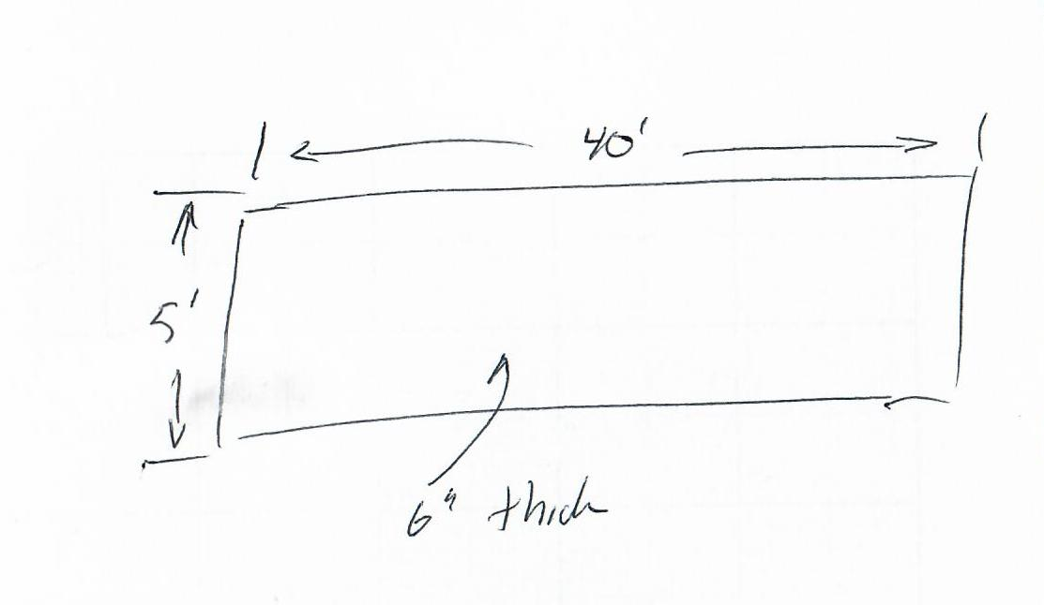
- Using the tape measure the dimensions. Record these on your work sheet as part of your sketch.
- Compute the cubic feet, cubic yards, and cost. Assume that concrete cost $100/yd.
- Repeat 1-3 at another location.

Worksheet
- Describe the first location (ex. sidewalk at the park). _________________________________
  - Make a neat sketch of the concrete.

  - Compute the cubic feet required to pour the slab. Show your work.

____________
  - Compute the cubic yards required to pour the slab. Show your work.

____________
  - Compute the cost of the concrete. Show your work.

____________
- Describe the second location (ex. sidewalk at the park). ________________________________
  - Make a neat sketch of the concrete.

  - Compute the cubic feet required to pour the slab. Show your work.

____________
  - Compute the cubic yards required to pour the slab. Show your work.

____________
  - Compute the cost of the concrete. Show your work.

Practice Answers

6’ X 40’ x .33’ (don’t forget to convert inches to feet) = 80 cubic feet
80 cubic feet ÷ 27 (cu feet/cu yard) = 2.96 cu yards -> round up to 3.
3 cubic yards X $100/cu yard = $300.

