Electrical Wiring Around Your House
Name: ________________________
Date: ________________________

Description:
Exploring how you house is wired.

What’s in the Box?

Tools:
Multi-meter

Procedure:
Follow the steps below and complete the worksheet. SAFETY FIRST! Do not open the service entrance panel to expose any wires. When testing voltage use extreme caution not to touch the bare electrodes of the meter.
- Locate your service entrance and breaker box (panel). See sample photo.
- Open the box (may require a screwdriver) and take a photo. Send the photo to the teacher.
- Identify the different types of breakers and the ampacity. Main Disconnect, Single pole, double pole (240), Arc Fault (newer construction).
- Close panel.
- Find a 3 way switch circuit in your home. These are commonly found in hallways or large rooms.
- Find a GFCI circuit. The are commonly found in bathrooms and garages. Note: Older homes may not have these. Press the “test” button to see if the device is functioning properly. Press the “RESET” button to return the outlet to service.
- Inventory the types of lighting found in your home. You should be able to identify the following, but not all will be found in your home.
  - Incandescent
  - Florescent Tubes
  - Compact Florescent
  - LED

- Identify electrical appliances. If your breaker box was labeled, these should be easy to identify. In the list below appliances marked with an “*” may be gas and not electric. Large appliances use more electricity. Looks for:
  - Hot water heater*
  - Range (stove)*
  - Clothes Dryer*
  - Clothes Washer
  - Air Conditioner
- If supplied use the multi-meter to test the following on an outlet. Set the meter to read AC voltage. The range should be greater then 200 volts. Refer to the picture below. Make the following tests and record on the data sheet.
  - Test the voltage between A and B.
  - Test the voltage between A and C
  - Test the voltage between B and C
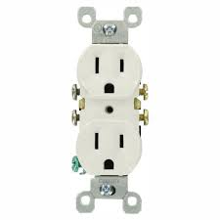
A
B
C
- If supplied use a multi-meter to test the voltage of a flashlight battery. Record the size (commonly AAA, AA, C, or D) and voltage on your worksheet.
- If supplied use a multi-meter to test the voltage of a car battery. Record the voltage on your worksheet.

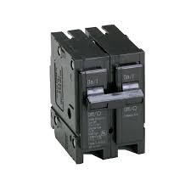
2 Pole Breaker
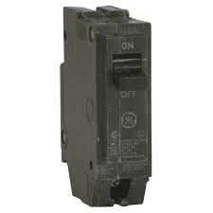
Single Pole Breaker
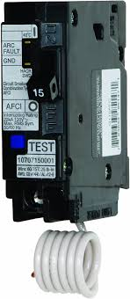
Arc Fault Breaker (note amperage on handle)
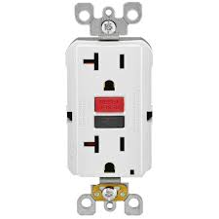
Ground Fault Circuit Interrupter (GCFI)
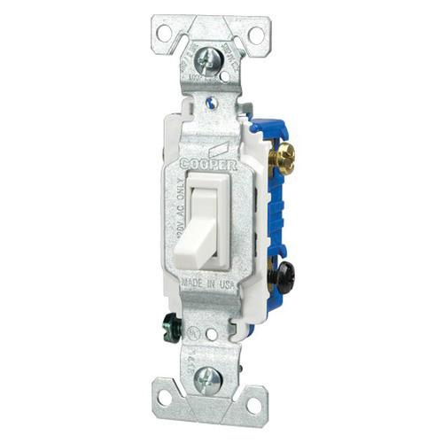
3 way switch (Note: No marking for on/off)

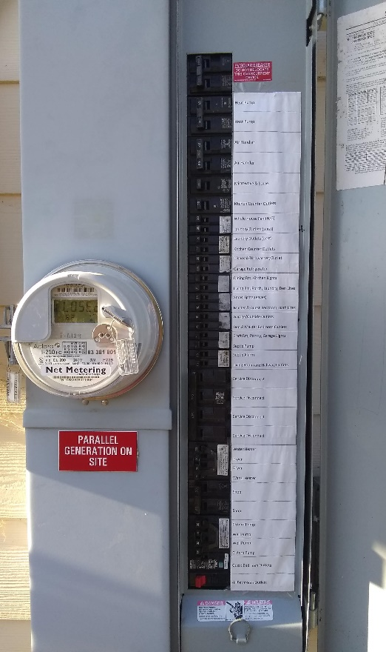
Service Entrance
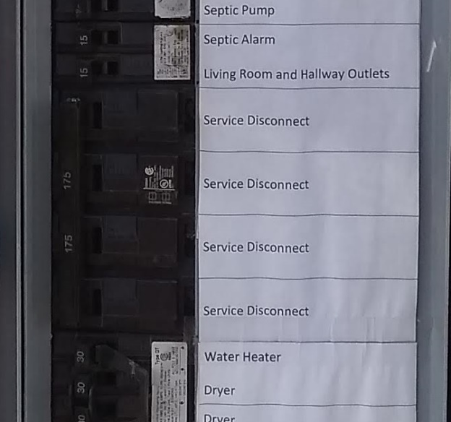
Main Disconnect (175 Amps)

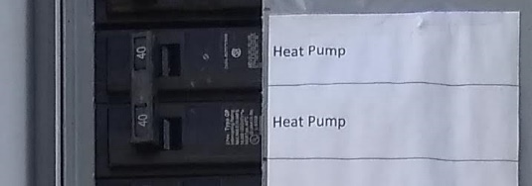
2 Pole Breaker (40 amp)

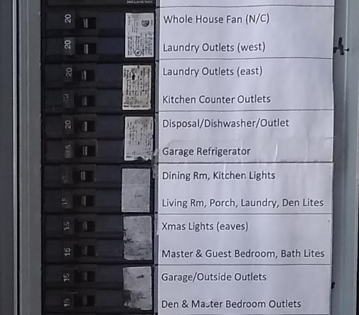
Single Pole Breakers (note amperage on the handle)

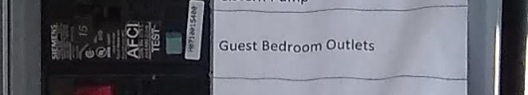
Arc Fault Breaker

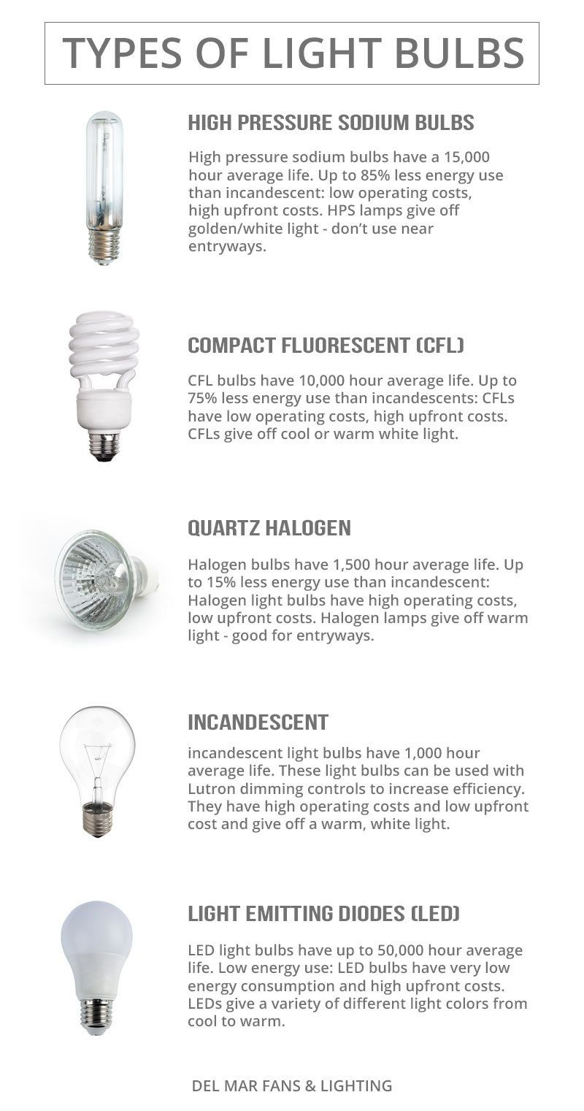
Fluorescent Tube Fixture

Worksheet
- Which of the following breakers did you find (check)?
- Main Disconnect
- 15 Amp Single pole breaker
- 20 Amp Single pole breaker
- 30 Amp 2 pole breaker
- Arc Fault breaker
- Where was the 3 way circuit you found? ____________________________________
- Draw a sketch (plan view) of the 3 way circuit you found. Show the switches and the light(s) they control.
- Where was the GFCI circuit you found? ____________________________________
- Which kind of light bulbs did you find (check)? Give a location where you found these.
  - Incandescent. Location: _________________________________
  - Florescent Tubes. Location: _________________________________
  - Compact Florescent. Location: _________________________________
  - LED. Location: _________________________________
- What electric appliances did you find?
  - Hot water heater
  - Range (stove)
  - Clothes Dryer
  - Clothes Washer
  - Air Conditioner
- What outlet voltages did you measure?
Between A and B ____________________
Between A and C ____________________
Between B and C ____________________
- Which letter is the “Hot” wire connected to? ________
- Which letter is the “Ground” wire connected to? _________
- What is the voltage of the flashlight battery? ____________
- What is the voltage of the Car Battery? ____________
- Using the table below what is the state of charge (%)? ________
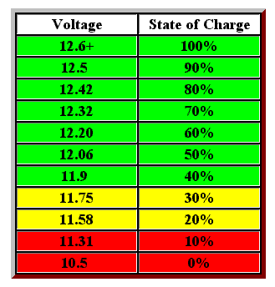

Teacher’s Notes
The multi-meter is optional. Measuring like voltage should be done after some instruction and a parents supervision.

