Introduction to Drawing
Name: ________________________
Date: ________________________

Description:
Basic introduction to orthographic drawing. See: https://en.wikipedia.org/wiki/Multiview_projection

What’s in the Box?

Materials:
Graph Paper

Tools:
Sharp Pencil
Ruler

Procedure:
You will make two drawings of household objects.
1. Find a common can (soup, beans, etc.). Measure the diameter of the can (round part) and the height. We will assume that this is a solid object.
2. Determine the scale needed. If you can draw it full (actual) size then use a 1”=1” scale. If it is too big to fit on the paper at actual size then use a 1”=2” scale.
3. Using the graph paper and ruler draw two views (see the example), add dimensions, and a title box.
4. Find a common Kleenex (facial tissue) box. Measure the height, width, and length of the box. We will assume that this is a solid object.
5. Determine the scale needed. If you can draw it full (actual) size then use a 1”=1” scale. If it is too big to fit on the paper at actual size then use a 1”=2” scale.
6. Using the graph paper and ruler draw three views (see the example), add dimensions, and a title box.

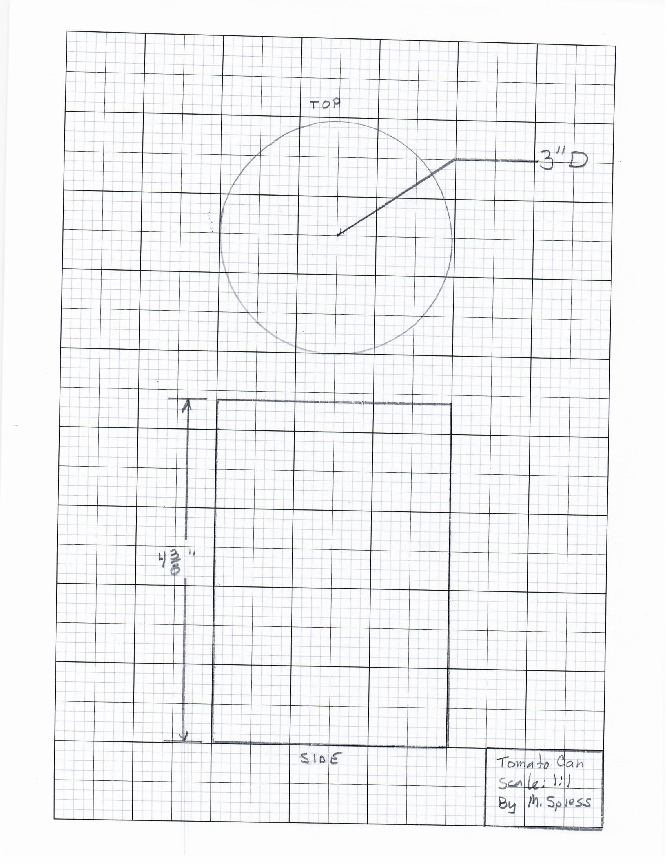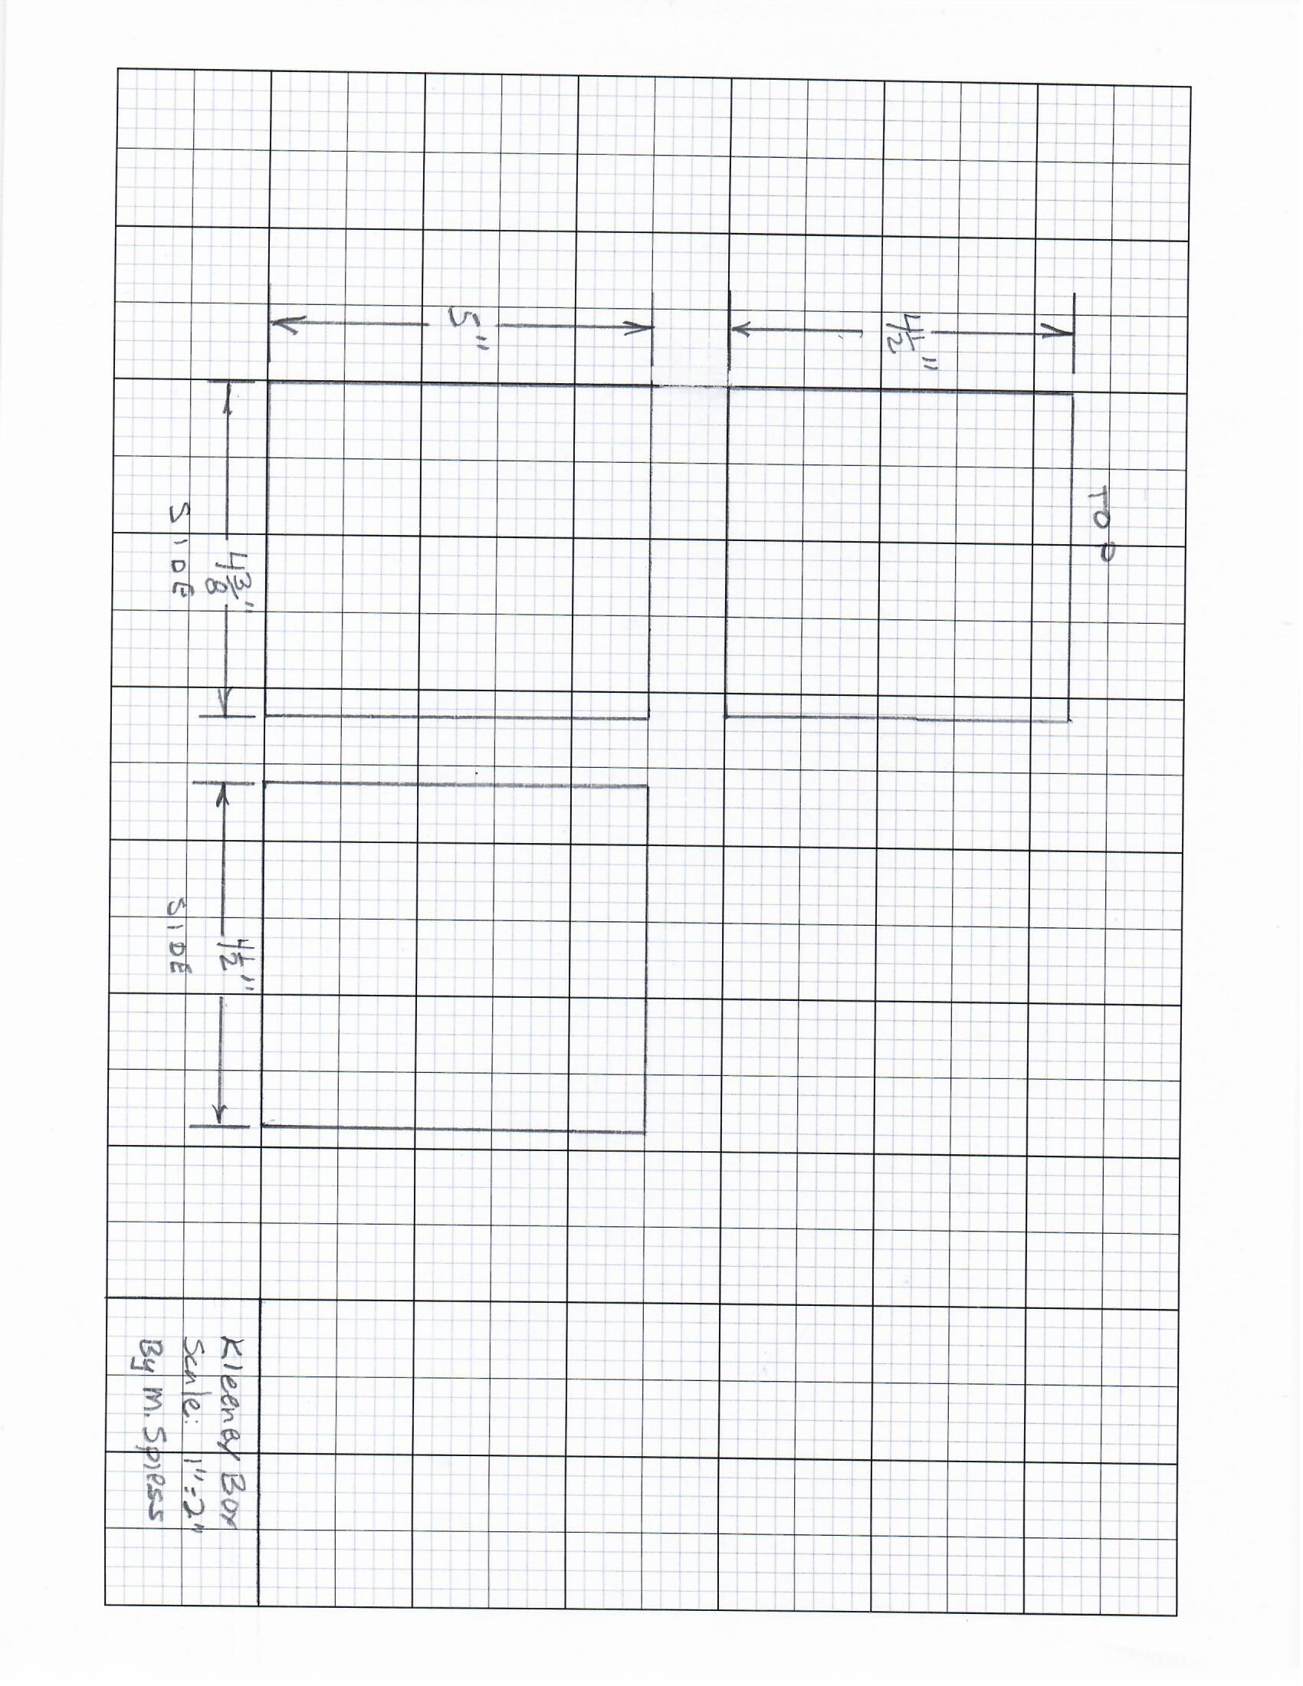

Teacher’s Notes
Use the link to the graph paper to create 1/8” graph paper. Note: Be sure to print actual size.

