Obtain permission from instructor before operating this machine |  | Horizontal Band Saw
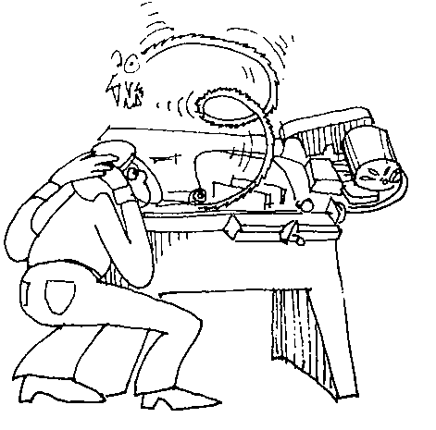
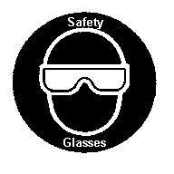

Safety suggestions
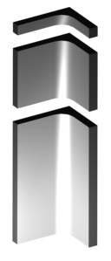
- Ensure all guards are in place.
Cut metal to length
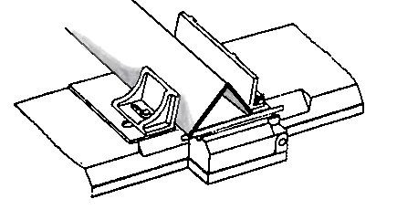
- All adjustments should be made with the power “Off”.
- Ensure the material is properly positioned and securely clamped.
- Do not allow the blade to drop on the material to be cut.
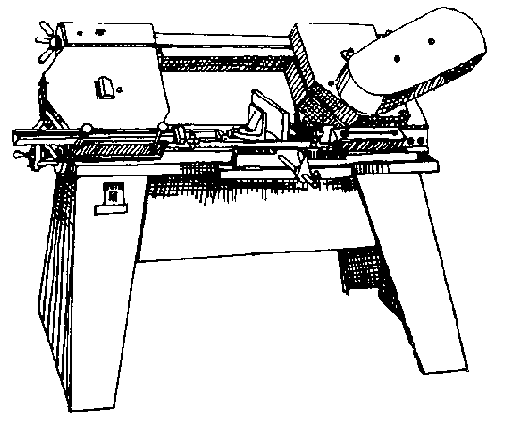
- Keep your hands away from the moving blade, remove chips with a brush after the blade has stopped moving
Wheel guard
Vise knob
Power switch
Blade
Belt guard
Vise
.

Horizontal Band Saw

Name …………………..

Class …………………….

Date ………………………

Safety Quiz

1. | Metal chips should be removed while the machine is operating. | T | F
2. | Eye protection is not necessary when sawing. | T | F
3. | 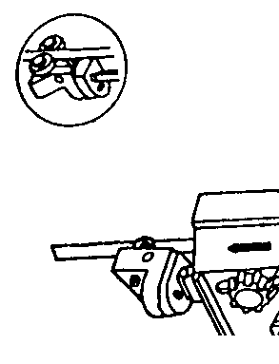  The blade guides should be adjusted close to the blade. | T | F
4. | All adjustments should be made with the power “Off”. | T | F
5. | Tighten material securely in the vise. | T | F
6. | Turn the machine on and lower the blade gently onto the material. | T | F
1.
2.
3.
4.
5.
6.

