Name___________________

Date____________________

# Identifying Organic Compounds in Food

**Purpose**

The purpose of this exercise is to identify the major types of organic compounds in common foods.[1]

**Background**

The most common organic compounds found in living organisms are lipids, carbohydrates, proteins, and nucleic acids. Common foods, which often consist of plant materials or substances derived from animals, are also combinations of these organic compounds. Substances called indicators can be used to test for the presence of organic compounds. An indicator is a substance that changes color in the presence of particular compounds. In this investigation, you will use several indicators to test for the presence of sugars, lipids, carbohydrates, and proteins in various foods.

**Procedure:**

**Materials**

1. Honey
2. Egg white
3. Corn oil
4. Lettuce
5. Gelatin
6. Butter
7. Potato
8. Apple Juice
9. Water
10. Mayonnaise
11. (Teacher only) Test tubes (10)
12. (Teacher only) Benedicts solution
13. Iodine
14. Biuret reagent
15. Toothpicks
16. Plastic tray or cups

**Sequence of Steps**

**C:\Users\Angela\AppData\Local\Microsoft\Windows\Temporary Internet Files\Content.IE5\DRP2N1IJ\MCj04242300000[1].wmf**

Develop your hypothesis for each food, hypothesizing whether it will contain the tested compound or not. Record your hypothesis for each food on the tables under “observations”.

**Sugar Test – Teacher Demo**

1. Fill each test tube with 5 ml of the food indicated on labeled test tubes.
2. Add 10 drops of Benedict’s solution to each test tube.
3. Heat the test tubes in a hot water bath for 3-5 minutes.
4. If the food turns orange, it is positive for sugar.
5. Record Results

**Lipid Test**

1. Obtain a piece of paper towel. Using a pen or pencil draw a labeled grid on the paper towel as shown below.

|  |  |  |  |  |
| --- | --- | --- | --- | --- |
| **Honey** | **Egg White** | **Corn Oil** | **Lettuce** | **Gelatin** |
| **Butter** | **Potato** | **Apple Juice** | **Water** | **Mayonnaise** |

1. Add one drop of each food to the paper towel in the appropriate box.
2. Allow the paper to dry. Hold the paper up to the light. If the paper is translucent, the food is positive for lipids.
3. Record results

**Starch Test**

1. Obtain a white tray. Add two drops of each food into the given wells. Follow the diagram below so that you will remember which foods are in which wells.

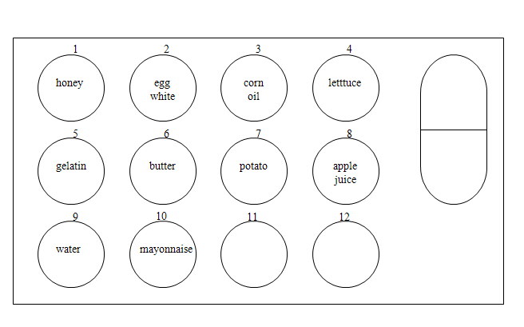

1. Add two drops of iodine to each food. Stir with a toothpick if necessary.
2. If the food turns a very dark color (nearly black), it is positive for starch.
3. Record results
4. Clean out the tray for the next activity.

**Protein Test**

1. Repeat step one of the starch test.
2. Add two drops of biuret reagent to each food. Stir with a toothpick if necessary.
3. If the food turns violet, it is positive for protein.
4. Record results
5. Clean out the tray.

**C:\Users\Angela\AppData\Local\Microsoft\Windows\Temporary Internet Files\Content.IE5\DRP2N1IJ\MCj04242300000[1].wmf**

**Observations**

**Sugar Lipid**

|  |  |  |  |
| --- | --- | --- | --- |
| Food | Hypothesis | Benedict Color | Sugar (+) |
| Honey |  |  |  |
| Egg White |  |  |  |
| Corn Oil |  |  |  |
| Lettuce |  |  |  |
| Gelatin |  |  |  |
| Butter |  |  |  |
| Potato |  |  |  |
| Apple Juice |  |  |  |
| Water |  |  |  |
| Mayo |  |  |  |

|  |  |  |  |
| --- | --- | --- | --- |
| Food | Hypothesis | Translucent | Lipid (+) |
| Honey |  |  |  |
| Egg White |  |  |  |
| Corn Oil |  |  |  |
| Lettuce |  |  |  |
| Gelatin |  |  |  |
| Butter |  |  |  |
| Potato |  |  |  |
| Apple Juice |  |  |  |
| Water |  |  |  |
| Mayo |  |  |  |

**Starch Protein**

|  |  |  |  |
| --- | --- | --- | --- |
| Food | Hypothesis | Iodine Color | Starch (+) |
| Honey |  |  |  |
| Egg White |  |  |  |
| Corn Oil |  |  |  |
| Lettuce |  |  |  |
| Gelatin |  |  |  |
| Butter |  |  |  |
| Potato |  |  |  |
| Apple Juice |  |  |  |
| Water |  |  |  |
| Mayo |  |  |  |

|  |  |  |  |
| --- | --- | --- | --- |
| Food | Hypothesis | Biuret Color | Protein (+) |
| Honey |  |  |  |
| Egg White |  |  |  |
| Corn Oil |  |  |  |
| Lettuce |  |  |  |
| Gelatin |  |  |  |
| Butter |  |  |  |
| Potato |  |  |  |
| Apple Juice |  |  |  |
| Water |  |  |  |
| Mayo |  |  |  |

**Conclusion:**

1. Which foods contain fat?
2. Which foods contain sugar?
3. Which foods contain starch?
4. Which foods contain protein?

**Discussion:**

1. Which test substance did not test positive for any of the organic compounds?
2. People with diabetes are instructed to avoid foods that are rich in carbohydrates. How could your observations in this investigation help you decide whether a food should be served to a person with diabetes?
3. Your fast food bag has large, translucent spot on the bottom. What explanation could you give for this occurrence?

1. Knapp, Beth (2008). Identifying Organic Compounds in Food, Lab. *Atwater High School Agriculture Department*.