Name___________________

Date____________________

# Using the Microscope

**Purpose**

The purpose of this exercise is to introduce you to the compound microscope and to give you practice in its use. [1]

**Procedure:**

**Materials**

1. Compound microscope 6. Soft cloth
2. Lens Paper 7. Medicine dropper
3. Microscope slides 8. Fibers of cotton, wool, human hair
4. Cover slips 9. Water
5. Fine-Print newspaper with the letter “e” 10. Pond water or trough water

**Sequence of Steps**

1. Evaluate the attached diagram of the microscope. Label the diagram with the names of the following parts and learn their functions:

|  |  |  |
| --- | --- | --- |
| **Eyepiece**  Magnifying lens at the top of the microscope | **Low Power Objective (LP)**  Magnifying lens near the object to be viewed (smallest one) | **High Power Objective (HP)**  Larger magnifying lens |
| **Medium Power Objective (MP)**  Medium magnifying lens | **Base**  Bottom of microscope | **Coarse Adjustment Knob**  Knob used for beginning to focus a sample |
| **Fine Adjustment Knob**  Knob used for fine tuned focusing | **Arm**  Handle of microscope | **Diaphragm**  Controls amount of light that enters the microscope |
| **Stage**  Platform on which the slide will be placed | **Light Source**  Lamp or mirror used to view sample | **Body Tube**  Establishes distance between eyepiece and objective |
| **State Clips**  Metal springs that keep the slide in place | **Revolving Nosepiece**  Revolves to allow you to switch objectives |  |

1. Prepare a dry mount of the letter “e”.
   1. Cut a letter “e” out of a newspaper and place it in the center of a glass slide. Place a cover slip over the letter “e”.
   2. If your microscope has a lamp, turn it on; if it has a mirror, position the mirror so that light is reflected through the hole on the stage.
   3. The microscope must be adjusted so that the Low Power Objective lens is in place. Turn the lens so that you hear or feel it click into place over the hole in the stage.
   4. Place the prepared slide on the stage with the letter “e” centered over the hole on the stage. You are now ready to view the specimen.
2. C:\Users\Angela\AppData\Local\Microsoft\Windows\Temporary Internet Files\Content.IE5\DRP2N1IJ\MCj04242300000[1].wmfViewing and focusing the microscope
   1. Observe the letter “e” on the slide. Make a drawing of it as it appears on the stage. *Remember to do all drawings in the “Observations” section.*
   2. C:\Users\Angela\AppData\Local\Microsoft\Windows\Temporary Internet Files\Content.IE5\DRP2N1IJ\MCj04242300000[1].wmfFocus the microscope by looking through the eyepiece and making sure the letter “e” is centered. Use the Coarse Adjustment Knob to focus by gently turning.
   3. Draw the letter “e” as it now appears.
   4. C:\Users\Angela\AppData\Local\Microsoft\Windows\Temporary Internet Files\Content.IE5\DRP2N1IJ\MCj04242300000[1].wmfWhile looking through the eyepiece, gently move the slide to your left. Under “Observations” record the direction the letter moves.
   5. Move the slide forward on the stage. What direction does the letter “e” move?
   6. C:\Users\Angela\AppData\Local\Microsoft\Windows\Temporary Internet Files\Content.IE5\DRP2N1IJ\MCj04242300000[1].wmfCarefully change the LP lens to the H lens. Look through the eye piece and focus with the Fine Adjustment Knob if necessary.
   7. Make a drawing of the letter “e” as you see it under HP.
3. Calculating the magnification

To know how many times an object is magnified, simply multiply the magnifying power of the objective lens. Usually the eyepiece lens has a magnification of 10X (Ten times). The power is usually indicated by the number of the lens. The objective lenses can have magnification from 5X to 100X. Their power is also located on the lens.

***C:\Users\Angela\AppData\Local\Microsoft\Windows\Temporary Internet Files\Content.IE5\DRP2N1IJ\MCj04242300000[1].wmfExample:*** *If your eyepiece has a power of 10X and the objective lens has a power of 20X, then the total magnification is 10 x 20 or 200X.*

**Observations**

1. Microscope parts: label the attached diagram
2. Draw a picture of the letter “e” as it appears on the stage without looking through the microscope, and looking through the microscope.

Without Microscope With Microscope

1. When you moved the slide to the left, which way did the letter “e” appear to move? ______
2. When you moved it forward, which way did it appear to move? ________
3. Magnification Practice

If the eyepiece lens has a magnification of 10X, give the total magnification for the following objective lenses.

25X = _____ 30X = _____ 40X = _____ 45X = _____

**Conclusion:**

Compare and contrast the image you see through the microscope compared to the same object viewed without a microscope.

# Student Copy[2]

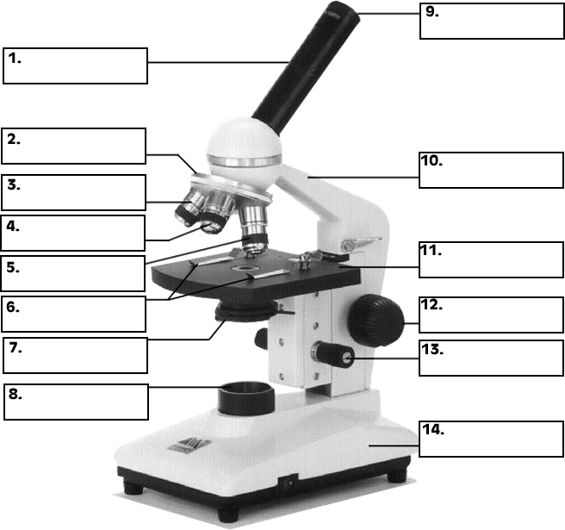

# Key



Stage

Eyepiece

(HP)

(MP)

(LP)

Revolving Nose Piece

Body Tube

Arm

Base

Fine Adjustment

Coarse Adjustment

Light Source

Diaphragm

State Clips

1. Agricultural Biology Curriculum Lesson Plans. Sacramento: California State Department of Education, Agriculture Education Unit, 1990.
2. "Microscope Parts Identification." Dive Into Science. Woodford Science. 3 Oct 2008

   <http://www.woodfordscience.com/microscope_parts_identification>.