Name___________________

Date____________________

# Root Anatomy

**Purpose**

The purpose of this exercise is to examine the cells and tissues of a mature root and identify the regions of the root after secondary thickening.[1]

**Procedure:**

**Materials**

1. Prepared slides of a cross section of root and carrot
2. Knife
3. Hand lens/ Magnifying glass

**Sequence of Steps**

1. C:\Users\Angela\AppData\Local\Microsoft\Windows\Temporary Internet Files\Content.IE5\DRP2N1IJ\MCj04242300000[1].wmfExamine a cross section of a mature root under low power and high power. Compare your sample with the picture in “observations”.
   1. In “observations”, label the following parts on the mature root: epidermis, cortex, endodermis, and pericycle.
2. Using an ordinary carrot, take a sharp knife and carefully slice the root lengthwise. Be careful to make the cut through the center of the root, since that region contains one of the important tissues of this organ.
   1. Before examining the inner tissues, look on the outside of your root and find the secondary roots.
   2. C:\Users\Angela\AppData\Local\Microsoft\Windows\Temporary Internet Files\Content.IE5\DRP2N1IJ\MCj04242300000[1].wmfFind the crown, which is the point where the stem joined the top of the root and from which leaves arose.
   3. In “observations”, complete an external, longitudinal and cross section illustration of the carrot.

**C:\Users\Angela\AppData\Local\Microsoft\Windows\Temporary Internet Files\Content.IE5\DRP2N1IJ\MCj04242300000[1].wmf**

**Observations**

1. Label the parts of the cross section of mature root.[2]

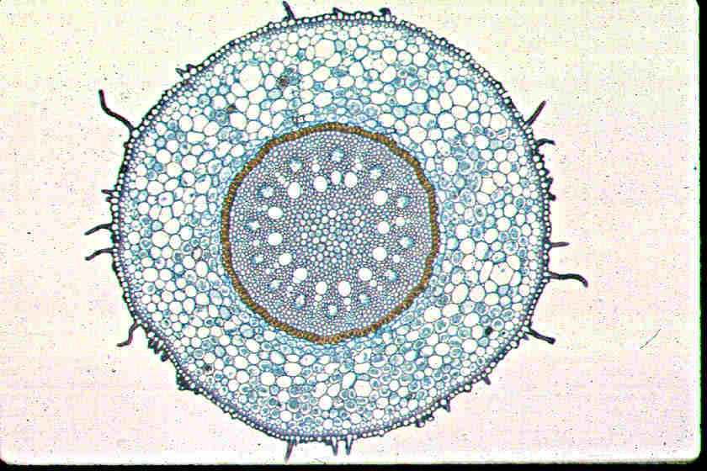

1. Illustrations of carrot sample

External Outline Longitudinal Section Cross Section

**Conclusions:**

1. In the slide, how many cells thick is the epidermis?
2. Count the number of cortex cells from the epidermis to the central cylinder on 2 opposite sides of the root. What is the average cell thickness of the cortex?
3. Are intercellular spaces present in the cortex of your section?
4. How many cells thick are the endodermis and the pericycle?
5. What are the 2 conduction tissues that lie in the central cylinder?
6. What are the most important functions of roots?
7. How are more root cells made? (Mitosis or Meiosis) Explain
8. Agriculture Application: Why are roots important for plant growth?
9. How do production agriculturists (farmers) help roots grow? Brainstorm at least 2 ideas.

1. Agricultural Biology Curriculum Lesson Plans. Sacramento: California State Department of Education, Agriculture Education Unit, 1990.
2. Grech, Josephine Ebejer. "Transport in Plants." 3 Oct 2008 <www.nsci.plu.edu/.../images/mono_root.jpg>.