Name___________________

Date____________________

# Stem Anatomy

**Purpose**

The purpose of this exercise is to use a diagram to identify the parts of an herbaceous stem (dicot). You will color and label the parts of the diagram. You will also identify the many different cells of the stem by examining prepare slides.[1]

**Procedure:**

**Materials**

1. Diagrams & models of stems
2. Microscope
3. Prepared stem slides
4. Colored pencils

**Sequence of Steps**

*Examining the Herbaceous Stem*

1. Find Diagram A in this lab and look at it closely. This is an herbaceous stem. All herbaceous stems have the same design.
2. C:\Users\Angela\AppData\Local\Microsoft\Windows\Temporary Internet Files\Content.IE5\DRP2N1IJ\MCj04242300000[1].wmfThe first layer of cells found on the outside of an herbaceous stem is called the *Epidermis.* This is a layer of cells to help protect the plant from loss of water and infection. It is usually 2 cells thick. Label and color the *Epidermis* yellow on your diagram.
3. C:\Users\Angela\AppData\Local\Microsoft\Windows\Temporary Internet Files\Content.IE5\DRP2N1IJ\MCj04242300000[1].wmfAs we look deeper into the center of the stem, the next layer of cells is called the *Cortex*. This is usually 4 or 5 layers thick and helps protect the stem from structural damage. It is hard and spongy. Label and color the *Cortex* blue.
4. C:\Users\Angela\AppData\Local\Microsoft\Windows\Temporary Internet Files\Content.IE5\DRP2N1IJ\MCj04242300000[1].wmfThe next layer of cells is the most important in the stem. They are found in groups of cells that are in a circle along the edge of the stem. These round structures are called *Vascular Bundles*. They help to transport water and food in the plant. Label the *Vascular Bundles*.
5. C:\Users\Angela\AppData\Local\Microsoft\Windows\Temporary Internet Files\Content.IE5\DRP2N1IJ\MCj04242300000[1].wmfThere are 2 kinds of cells in the Vascular Bundles. The smaller is called the *Phloem*. These tubular cells carry the food produced by the plant. Label the *Phloem* and color these cells brown.
6. C:\Users\Angela\AppData\Local\Microsoft\Windows\Temporary Internet Files\Content.IE5\DRP2N1IJ\MCj04242300000[1].wmfThe other kind of cells found in the Vascular Bundles is called *Xylem*. These cells carry water in the plant. They are larger and thicker walled. Label the *Xylem* and color them red.
7. C:\Users\Angela\AppData\Local\Microsoft\Windows\Temporary Internet Files\Content.IE5\DRP2N1IJ\MCj04242300000[1].wmfThe cells between each of the Vascular Bundles are small and look like a line connecting these bundles. These cells are called the *Cambium*. They are the dividing place between Xylem and Phloem. Notice that the Xylem is on the inside and the Phloem is on the outside.

Label the *Cambium*.

1. C:\Users\Angela\AppData\Local\Microsoft\Windows\Temporary Internet Files\Content.IE5\DRP2N1IJ\MCj04242300000[1].wmfThe middle of the herbaceous stem is called the *Pith*. This is the filling of the stem which gives support. Label and color the *Pith* orange.
2. Obtain the prepared slide of the herbaceous stem from your instructor and find the following parts: epidermis, cortex, vascular bundles, xylem, phloem, cambium, and pith.

*Examining the woody dicot stem:*

1. Find diagram B. This is a woody stem. All woody stems have the same basic design.
2. C:\Users\Angela\AppData\Local\Microsoft\Windows\Temporary Internet Files\Content.IE5\DRP2N1IJ\MCj04242300000[1].wmfThe first kind of cell is called the *Cork*. This layer is the first defense against disease and destruction. Label and color the layer of 3 cells that make up the *Cork* yellow.
3. C:\Users\Angela\AppData\Local\Microsoft\Windows\Temporary Internet Files\Content.IE5\DRP2N1IJ\MCj04242300000[1].wmfThe next layer of cells found is a 2 or 3 celled layer called *Cork Cambium.* This is where new cork is made when needed. Label and color the *Cork Cambium* blue.
4. C:\Users\Angela\AppData\Local\Microsoft\Windows\Temporary Internet Files\Content.IE5\DRP2N1IJ\MCj04242300000[1].wmfThe next group of cells makes up the *Cortex,* a protective layer between the cork cambium and the next kind of cells. Label and color the *Cortex* green.
5. C:\Users\Angela\AppData\Local\Microsoft\Windows\Temporary Internet Files\Content.IE5\DRP2N1IJ\MCj04242300000[1].wmfThe wavy group of cells that go all the way to the inside circular bundle are called *Phloem*. These cells carry food in the plant. Label and color the *Phloem* brown.
6. C:\Users\Angela\AppData\Local\Microsoft\Windows\Temporary Internet Files\Content.IE5\DRP2N1IJ\MCj04242300000[1].wmfThe line that forms a circle next to the phloem is called the *Vascular Cambium*. This layer makes new phloem and xylem as the stem grows. Label the *Vascular Cambium*.
7. C:\Users\Angela\AppData\Local\Microsoft\Windows\Temporary Internet Files\Content.IE5\DRP2N1IJ\MCj04242300000[1].wmfThe cells found inside the pie-like shapes are called Xylem. As water changes during the season, new xylem is made causing the stem to grow. The newest xylem is next to the vascular cambium. Old xylem is called wood. Label and color the xylem cells red.
8. C:\Users\Angela\AppData\Local\Microsoft\Windows\Temporary Internet Files\Content.IE5\DRP2N1IJ\MCj04242300000[1].wmfThe very center of the stem has a group of cells called the *Pith*. The *Pith* is the core of the stem and provides structure. Label and color the *Pith* orange.
9. Obtain the prepared slide of a woody dicot stem and find the following parts: cork, cork cambium, cortex, phloem, vascular cambium, xylem and pith.

C:\Users\Angela\AppData\Local\Microsoft\Windows\Temporary Internet Files\Content.IE5\DRP2N1IJ\MCj04242300000[1].wmf

**Observations**

1. Label and color all parts as directed above.

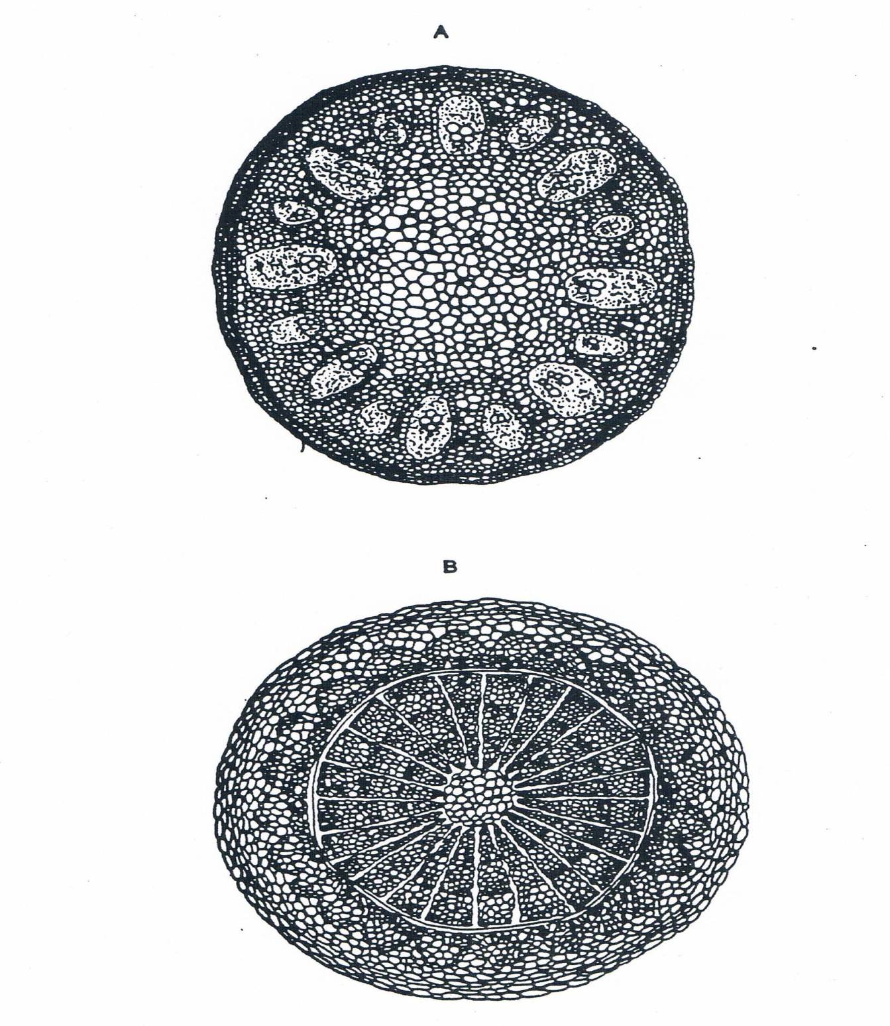

**Conclusions**

1. What is the function of the cambium?
2. What is the function of the xylem?
3. What is the function of the phloem?
4. How is the woody stem better designed for growing from year to year than the herbaceous stem?
5. What is another name for old xylem that no longer transports water?
6. By what process are new cells made as the stem grows? Explain.

1. Agricultural Biology Curriculum Lesson Plans. Sacramento: California State Department of Education, Agriculture Education Unit, 1990.